Compound No. | Compound Structure | Ingredient name | English name | Latin name | References to their activity as anti tubercular/antimicrobial agents
1. | 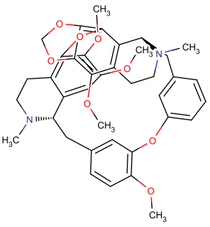 | Thalfinine | Tibetan Meadowrue, Rugose Meadowrue, Low Meadowrue,  Manyleaf Meadowrue, Faber Meadowrue | Thalictrum foetidum,  Thalictrum rugosum,  Thalictrum minus,  Thalictrum foliolosum,  Thalictrum faberi, | Zhou et al., 2011
2. | 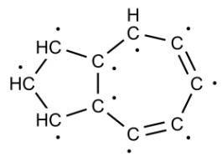 | Azulene | Camphortree,  Common Yarrow | Cinnamomum camphora,  Achillea millefolium | Kurti & Uldrich, 1958
3. | 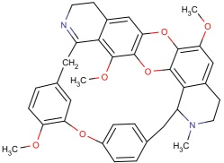 | Menisarine | Japanese Snailseed, Arboreous Coriaria | Cocculus trilobus, Coriaria arborea
4. | 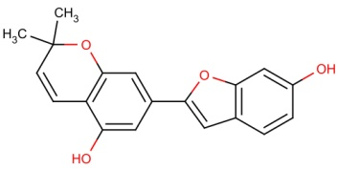 | Moracin d | White Mulberry Leaf,  Common Papermulberry | Morus alba,  Broussonetia papyrifera
5. | 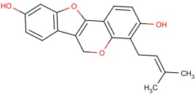 | Erypoegin e | Mountain Immortelle | Erythrina poeppigiana | Sato et al.,2006
6. | 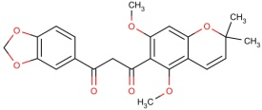 | Pongapinone a | Poongaoil Pongamia | Pongamia pinnata | Mary et al., 2013
7. | 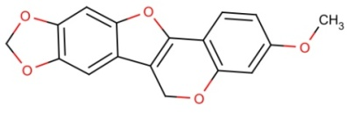 | Flemichapparin b | Climbing Jewelvine | Derris scandens
8. | 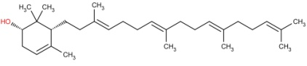 | Achilleol c | Ancients Euphorbia,  Beautiful Garcinia | Euphorbia antiquorum, Garcinia speciosa | Iinuma et al., 1996
9. | 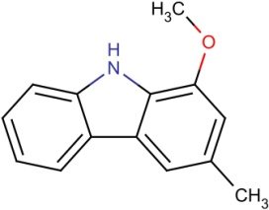 | Murrayafoline a | Taiwan Common Jasminorange, Indian Common Jasminorange, Euchretaleaf Common Jasminorange, Narrowfruit Glycosmis Root | Murraya crenulata, Murraya koenigii, Murraya euchrestifolia [Syn. Clausena euchrestifolia ], Glycosmis stenocarpa | Choi et al., 2006

