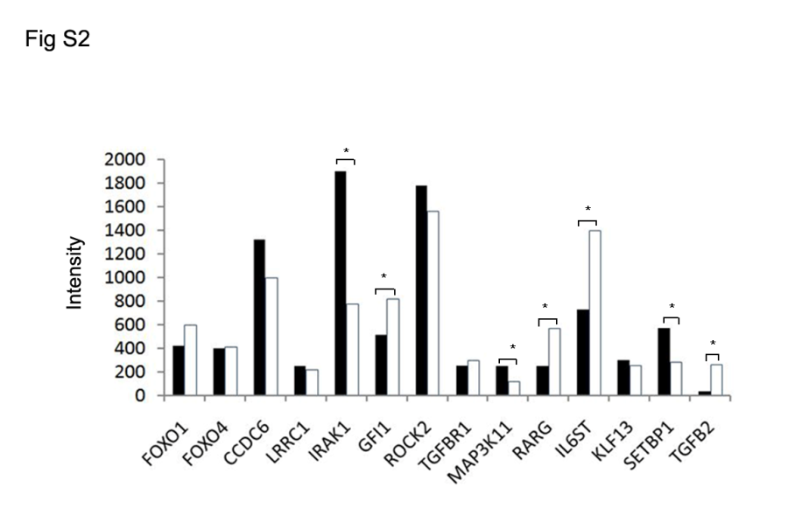

Figure S2. The expression of putative targets of miR-142a in CCR6⁺Tregs.
CCR6⁺Tregs and CCR6⁻Tregs were purified from splenocytes in Balb/c mice by FACS sorting. The global expression of genes in cells was analyzed by microarray array and then the expression of putative target genes was listed (. CCR6⁻Tregs; CCR6⁺Tregs)

