Supplementary Figure 1. Flowchart of the participants included in the prospective analysis. The Young Lives Study, Younger Cohort, Peru.

Excluded because of prematurity (n=549)
Excluded because of missing values (n=529)
Potential Participants (n=1,503)
Younger Cohort (n=2,052)
Included at Baseline (n=974)

Overweight (n=132)
Obesity (n=34)
Overnutrition (n=166)
Outcome: Obesity
Incidence Analysis (n=940)

Outcome: Overweight
Incidence Analysis (n=808)

Outcome: Overnutrition
Incidence Analysis (n=808)

Supplementary Figure 2: Time at which variables were assessed and number of children-years included in the analysis according to each outcome.

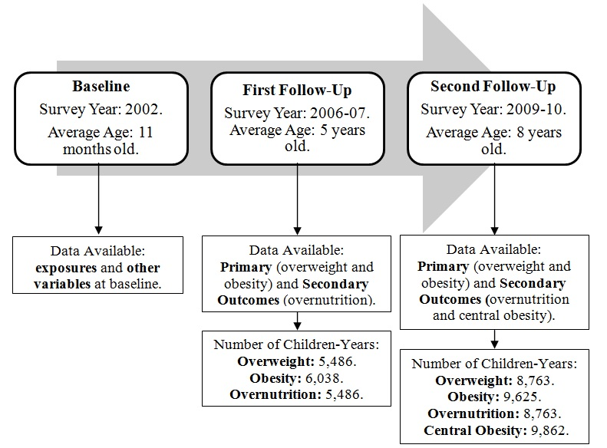

Supplementary Table 1. Excluded and included participants due to missing values. The Young Lives Study, Younger Cohort, Baseline, Peru.
Variable | Excluded (%) | Included (%) | p¥
Mothers
Maternal BMI | n=516 | n=956
Normal Weight | 72.09 | 54.71
Overweight | 23.45 | 34.73 | <0.001
Obesity | 4.46 | 10.56
Maternal Education | n=497 | n=926
None/Primary | 79.28 | 33.91
High School | 17.51 | 43.84 | <0.001
Higher Education | 3.22 | 22.25
Wealth Index | n=528 | n=973
Bottom | 61.36 | 22.92
Middle | 31.82 | 35.15 | <0.001
Top | 6.82 | 41.93
Location | n=529 | n=974
Urban | 38.00 | 79.57
Rural | 62.00 | 20.43 | <0.001
Children
Gender | n=529 | n=974
Male | 46.31 | 50.10
Female | 53.69 | 49.90 | 0.160
Age | n=529 | n=974
<1 year | 49.15 | 48.15
≥1 year | 50.85 | 51.85 | 0.712
Birth Weight | n=343 | n=927
2500-4000 | 89.21 | 91.26
≤2500 | 5.54 | 2.27 | 0.010
≥4000 | 5.25 | 6.47
Breastfeeding | n=527 | n=961
Yes | 99.81 | 99.27
No | 0.19 | 0.73 | 0.174
BMI | n=503 | n=964
Normal Weight | 91.65 | 87.14
Overweight | 6.16 | 10.48 | 0.022
Obesity | 2.19 | 2.39
Hospitalised after birth | n=527 | n=961
Yes | 1.52 | 9.47
No | 98.48 | 90.53 | <0.001
Birth Order | n=516 | n=947
1st | 18.99 | 42.13
2nd | 19.38 | 26.50 | <0.001
≥3rd | 61.63 | 31.36
Delivery | n=4 | n=974
No Caesarean section | 100.00 | 84.39
Caesarean section | 0.00 | 15.61 | 0.390
¥Chi2 test

Supplementary Table 2. Sociodemographic characteristics of both mothers and children according to children nutritional status. The young lives study, Younger Cohort, Baseline, Peru.
 | Normal Weight (%) | Overweight (%) | Obesity (%) | p¥
Mothers
Maternal BMI | n=823 | n=100 | n=23
Normal Weight | 56.14 | 46.00 | 34.78
Overweight | 33.90 | 41.00 | 43.48 | 0.069
Obesity | 9.96 | 13.00 | 21.74
Maternal Education | n=798 | n=95 | n=23
None/Primary | 35.84 | 16.84 | 34.78
High School | 43.23 | 51.58 | 43.48 | 0.005
Higher Education | 20.93 | 31.58 | 21.74
Wealth Index | n=839 | n=101 | n=23
Bottom | 24.31 | 9.90 | 17.39
Middle | 35.76 | 30.69 | 30.43 | 0.001
Top | 39.93 | 59.41 | 52.17
Location | n=840 | n=101 | n=23
Urban | 77.74 | 94.06 | 82.61
Rural | 22.26 | 5.94 | 17.39 | 0.001
Children
Gender | n=840 | n=101 | n=23
Male | 49.88 | 52.48 | 43.48
Female | 50.12 | 47.52 | 56.52 | 0.725
Age | n=840 | n=32 | n=23
<1 year | 45.24 | 68.32 | 69.57
≥1 year | 54.76 | 31.68 | 30.43 | <0.001
Birth Weight | n=798 | n=97 | n=22
2500-4000 | 91.10 | 93.81 | 86.36
≤2500 | 2.63 | 0.00 | 0.00 | 0.279
≥4000 | 6.27 | 6.19 | 13.64
Breastfeeding | n=830 | n=98 | n=23
Yes | 99.16 | 100.00 | 100.00
No | 0.84 | 0.00 | 0.00 | 0.598
Hospitalized after birth | n=830 | n=98 | n=23
Yes | 9.52 | 9.18 | 8.70
No | 90.48 | 90.82 | 91.30 | 0.986
Birth Order | n=816 | n=100 | n=22
1st | 41.05 | 50.00 | 45.45
2nd | 26.72 | 24.00 | 31.82 | 0.423
≥3rd | 32.23 | 26.00 | 22.73
Delivery | n=840 | n=101 | n=23
No Caesarean section | 85.60 | 76.24 | 69.57
Caesarean section | 14.40 | 23.76 | 30.43 | 0.008
¥Chi2 test

