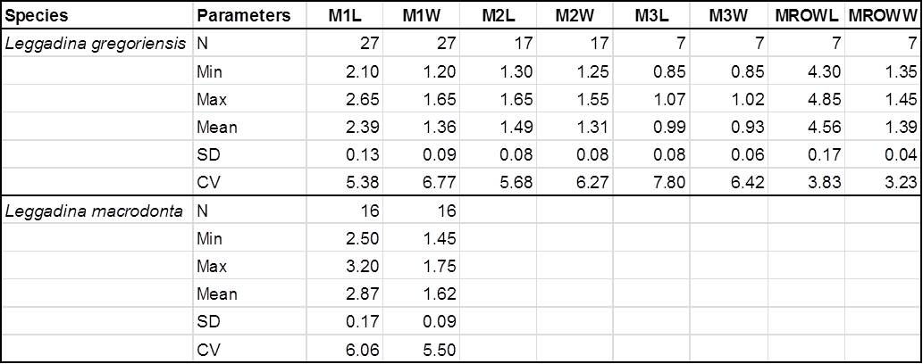
Table S2.1: Univariate statistics for fossil murid specimens. Measurements to 2 decimal places

