PeerJ

Schuster, R. and Arcese, P. Efficient routes to land conservation given risk of covenant failure.

Supplementary Information
This supplementary material includes two Appendices. In Appendix S1 we include a figure of the Georgia Basin of British Columbia, Canada, highlighting the study region. In Appendix S2 we provide the R script that we used for our analysis and simulations.

Appendix S1: Coastal Douglas Fir (CDF) ecological zone showing the study area in red.
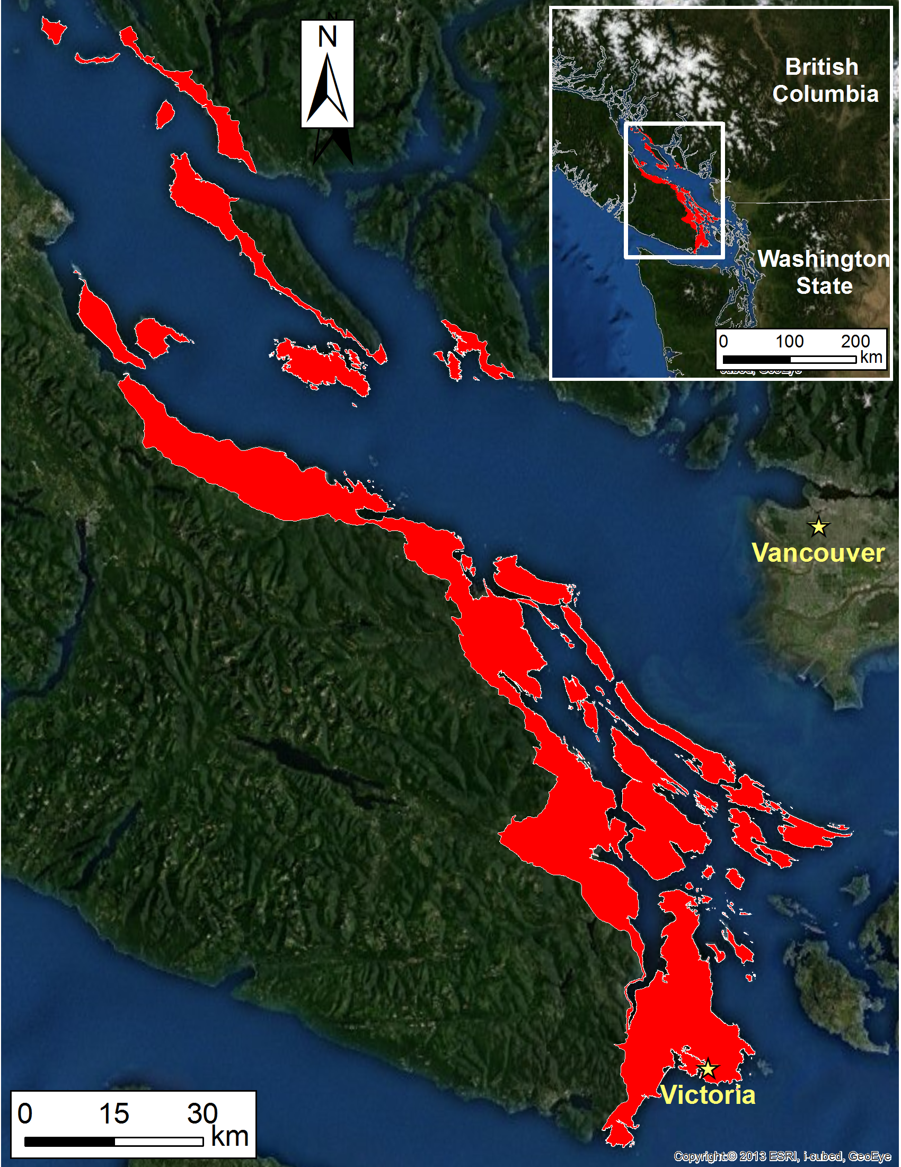

Appendix S2 Simulation and Analysis R code.
In this appendix, we provide the R code for conducting our simulations and analysis used in the paper. R v.3.0.2 (R Core Team 2013) was used and custom distributions were parameterized using package distr v.2.5.2 (Ruckdeschel et al. 2006).
R Core Team. 2013. R: A Language and Environment for Statistical Computing.
Ruckdeschel, P., M. Kohl, T. Stabla, and F. Camphausen. 2006. S4 Classes for Distributions. R News 6:2–6.

##############################################################################
### Setup Covenant analysis (run the Marxan scenario)
### Richard Schuster (mail@richard-schuster.com
### 2013, Sept 25
##############################################################################

library(Rmarxan2)
setwd("D:\\R_files\\13_09_25_Ch3_analytical_framework_setup")
cad <- read.csv("Single_Poly_post_cov_top_Land_value_IDW_10_groups_R.csv")

# area adjustment to have it in acres
cov.cst <- data.frame(ID=cad$ID, AREA=cad$AREA, ACR=cad$AREA * 0.000247105, COST=cad$CALC_TOTAL)

# fixed costs
#Land owner
LO.legal <- 300
LO.finadv <- 300
LO.registr <- 200
LO.endow <- 10000
#Covenant Holder
CH.legal <- 4000

fixed.all <- LO.legal + LO.finadv + LO.registr + LO.endow + CH.legal

# cost vary with property area
# area unit used is acre
LO.bas.b0 <- -2185.30978
LO.bas.b1 <- 1957.45823
LO.bas.min <- 1000
LO.app.b0 <- 0
LO.app.b1 <- 1957.45823
LO.app.min <- 1500
LO.surv.b0 <- 300
LO.surv.b1 <- 1957.45823
LO.surv.min <- 1000

cov.cst$COV.fix <- fixed.all
cov.cst$COV.bas <- ifelse((LO.bas.b0 + LO.bas.b1 * log(cov.cst$ACR)) > LO.bas.min,
(LO.bas.b0 + LO.bas.b1 * log(cov.cst$ACR)),LO.bas.min)
cov.cst$COV.app <- ifelse((LO.app.b0 + LO.app.b1 * log(cov.cst$ACR)) > LO.app.min,
(LO.app.b0 + LO.app.b1 * log(cov.cst$ACR)),LO.app.min)
cov.cst$COV.surv <- ifelse((LO.surv.b0 + LO.surv.b1 * log(cov.cst$ACR)) > LO.surv.min,
(LO.surv.b0 + LO.surv.b1 * log(cov.cst$ACR)),LO.surv.min)
cov.cst$COV.comb <- rowSums(cov.cst[,4:7], na.rm=T)

##############################################################################
# standard repeat costs
# Monitoring (to see if covenant is intact)
# repeat rate: 1/1 year
# rate used: NCC charge (from Management cost workshop)
mon <- 758
# Staff cost (work done to reply to Land owner request)
# repeat rate: 1/5 years
# rate used: NCC charge (from Management cost workshop)
# presented in yearly portion:
staff <- mon/5

tt <- cov.cst$COV.comb + 50*(mon+staff)

marxan.covenant.pu <- data.frame(id=cov.cst$ID, cost=cov.cst$COV.comb, status=0)
write.csv(marxan.covenant.pu, "input/Cadaster_pu_cost_Covenant.csv", row.names = FALSE)

indir=getwd()
spf <- 3
nitns <- 10000000
# Covenant Marxan costs
puC="Cadaster_pu_cost_Covenant.csv"
# Acquisition Marxan costs
puA="Cadaster_pu_cost_IDW_new.csv"

puvsp="Cadaster_puvsp_no_C_IDW_new_beta_score.csv"
spec="Cadaster_spec_BETA.csv"
#bound="Cadaster_bound_100m_buff.csv"

spffr <- read.csv((file=sprintf("input/%s",spec)))
spffr[spffr$name=="BETA",]$prop <- 0.2 #Set target
write.csv(spffr, sprintf("input/%s",spec), row.names = FALSE)

################################################################################
# Acquisition Marxan run
setwd("./Marxan_Acquisition")
outdir=getwd()

marx.acqu <- marxan(pu=puA,
puvsp=puvsp,
spec=spec,
# bound=bound,
spf=spf, nreps=1000, nitns=nitns, scenname="Acqu.T0.2",
indir=indir,outdir=outdir)
setwd("..")
################################################################################

save.image("Covenants_Acqu_1000_runs.RData")

#pre-emptive enforcement, and damage enforcement
spd <- function (years, cov.frame, dispute, rD1, pu, mon, staff,PE=T,DE=T, rand=F){

for (ii in 2:years){
for (pu in 1:length(cov.frame[,1])){
if (runif(1) > dispute) {
#cost of dispute
dis.cst <- rD1(1) #disp.cost$cost[which.min(disp.cost$prb < runif(1))]
#dis.cst <- 100000*rexp(1,rate=0.5)

if (rand == TRUE) {
alter <- runif(1,-1,1)
} else {
alter <- 0
}
if (DE == TRUE && alter <= 0){
#metric where bd.loss is losely dependent on dis.cst
init.bd.loss2 <- dis.cst / 400000
bd.loss2 <- init.bd.loss2 + rnorm(1,0,0.05)
bd.loss2 <- ifelse(bd.loss2 < 0, 0, ifelse(bd.loss2 > 1, 1, bd.loss2))
cov.frame[pu,4+years+ii] <- cov.frame[pu,4+years+ii-1] * (1 - bd.loss2)
}
else {
cov.frame[pu,4+years+ii] <- cov.frame[pu,4+years+ii-1]
}

if (PE == TRUE && alter >= 0){
# add dispute cost to covenant cost + set minimum cost to $1000
min.cst <- 1000
dis.cst <- ifelse(dis.cst<min.cst,min.cst,dis.cst)
cov.frame[pu,4+ii] <- cov.frame[pu,4+ii-1] + dis.cst
}
else {
cov.frame[pu,4+ii] <- cov.frame[pu,4+ii-1] + (mon + staff)
}
}
else {
# if there is no dispute carry costs forward but add yearly costs
cov.frame[pu,4+ii] <- cov.frame[pu,4+ii-1] + (mon + staff)
# if there is no dispute carry biodiversity values forward
cov.frame[pu,4+years+ii] <- cov.frame[pu,4+years+ii-1]

}
}
}
return(as.data.frame(cov.frame))
}

# setup and Marxan runs in folder:
# 13_09_25_Ch3_analytical_framework_setup
library(distr)

setwd("D:\\R_files\\15_05_08_Ch3_PeerJ")

load("Covenants_Acqu_1000_runs_red.RData")
rm(list=setdiff(ls(), c("marx.acqu","spd")))

#marx.acqu slots
# ssoln
# best
# run
# sums
# mv

# data frame including
# ID
# AREA
# CALC_TOTAL
# Carbon metrics (StC_AWS, SeqC_AWS)
# Biodiv metrics (both AWM and AWS for OF, SAV, BETA)
cad <- read.csv("Polygon_level_Area_Carbon_Biodiv_values.csv")

# area adjustment to have it in acres
cov.cst <- data.frame(ID=cad$ID, AREA=cad$AREA, ACR=cad$AREA * 0.000247105, COST=cad$CALC_TOTAL)

# fixed costs
#Land owner
LO.legal <- 300
LO.finadv <- 300
LO.registr <- 200
LO.endow <- 10000
#Covenant Holder
CH.legal <- 4000

fixed.all <- LO.legal + LO.finadv + LO.registr + LO.endow + CH.legal

# cost vary with property area
# area unit used is acre
LO.bas.b0 <- -2185.30978
LO.bas.b1 <- 1957.45823
LO.bas.min <- 1000
LO.app.b0 <- 0
LO.app.b1 <- 1957.45823
LO.app.min <- 1500
LO.surv.b0 <- 300
LO.surv.b1 <- 1957.45823
LO.surv.min <- 1000

cov.cst$COV.fix <- fixed.all
cov.cst$COV.bas <- ifelse((LO.bas.b0 + LO.bas.b1 * log(cov.cst$ACR)) > LO.bas.min,
(LO.bas.b0 + LO.bas.b1 * log(cov.cst$ACR)),LO.bas.min)
cov.cst$COV.app <- ifelse((LO.app.b0 + LO.app.b1 * log(cov.cst$ACR)) > LO.app.min,
(LO.app.b0 + LO.app.b1 * log(cov.cst$ACR)),LO.app.min)
cov.cst$COV.surv <- ifelse((LO.surv.b0 + LO.surv.b1 * log(cov.cst$ACR)) > LO.surv.min,
(LO.surv.b0 + LO.surv.b1 * log(cov.cst$ACR)),LO.surv.min)

# combined initial covenant cost of each parcel in the CDF
# does not include any reoccurring costs (they are calculated below
cov.cst$COV.comb <- rowSums(cov.cst[,5:8], na.rm=T)

##############################################################################
# standard repeat costs
# Monitoring (to see if covenant is intact)
# repeat rate: 1/1 year
# rate used: NCC charge (from Management cost workshop)
mon <- 758
# Staff cost (work done to reply to Land owner request)
# repeat rate: 1/5 years
# rate used: NCC charge (from Management cost workshop)
# presented in yearly portion:
staff <- mon/5

################################################################################
################################################################################
## MARXAN RUNS COMPLETE
## START COVENANT UNCERTAINTY ANALYSIS
################################################################################
################################################################################

################################################################################
#Setup from Rissman
#Data from Rissman 2010 Fig. 1
inc.rate <- data.frame(year=c(seq(1989,2007,1)),
issues=c(1,1,NA,1,NA,NA,2,1,NA,3,2,2,5,1,3,3,4,8,5))
fm2 <- glm(issues~year, data=inc.rate, family=quasi(link="log",variance="constant"))
fm2.lin <- lm(issues~year, data=inc.rate)

# for logistic growth
# Formula: N(t) = CC * N0 * exp(rr*t) / (CC + N0 * (exp(rr*t) - 1))
# growth rate rr
rr <- coef(fm2.lin)[[2]]
# Carrying Capacity CC
CC <- 50
# "Population" at year 2013
N0 <- predict(fm2.lin,newdata=data.frame(year=c(2013)))

#Data from Rissman 2010 Fig. 2
costs <- data.frame(value=c(5000,seq(10000,100000,10000),300000,400000),
incidents=c(12,7,9,4,1,1,2,2,1,1,1,1,1))

fm1 <- nls(incidents ~ a*value^b, data=costs,start = list(a = 2555, b = -0.655))
sc <- coef(fm1)[[1]]
pw <- coef(fm1)[[2]]

f <- function(x) {
return(sc*x^pw)
}

#dispute cost range
bins <- seq(1000,400000,500)
pred <- f(bins)

# length of segments
pred.1 <- pred/sum(pred)

#put pred.1 lengths on a vector between 0 and 1
pred.2 <- vector()
pred.2[1]<- pred.1[1]
for (ii in 2:length(pred.1)){
pred.2[ii] <- pred.2[ii-1] + pred.1[ii]
}

#create lookup data.frame for pred.2 vector values that correspond to bins
disp.cost <- data.frame(prb=pred.2,cost=bins)

D1 <- DiscreteDistribution (supp = bins , prob = pred.1)
dD1 <- d(D1) ## D1ensity function
pD1 <- p(D1) ## D1istribution function
qD1 <- q(D1) ## Quantile function
rD1 <- r(D1) ## Random number generation

### End setup from Rissman 2010
################################################################################

# check if all nreps runs met their target
summary(marx.acqu$sums[[2]]$MPM)
summary(marx.acqu$sums[[2]]$Shortfall)

# check acquisition reserve system cost
hist(marx.acqu$sums[[2]]$Cost)
summary(marx.acqu$sums[[2]]$Cost)
mean(marx.acqu$sums[[2]]$Cost)
sd(marx.acqu$sums[[2]]$Cost)

# assume all purchases are cost + 15%, and that all the
# proceeds of the 15% put into trust are spent in land management to
# maintain the value of the property
marx.acqu$sums[[2]]$Cost <- marx.acqu$sums[[2]]$Cost * 1.15

total.beta <- sum(cad$BETA_AWS)

runs <- marx.acqu$run
mv <- marx.acqu$mv
sums <- marx.acqu$sums

#!!!!!!!!!!!!!!!!!!!!!!!!!!!!
# NEEDS CHANGE FOR FINAL RUNS
years <- 100
nruns <- 100
#dispute rate: 2.8/1000 per year
# 2.8 is the average dispute rate from Rissman 2010
dispute <- 1 - (0.28/1000)

run.sum <- data.frame(ID=0,Init.cost=0,Cost.no.disp=0,Init.Beta=0)
run.sum[sprintf("cost.y%02d",seq(1,years,1))] <- 0
run.sum[sprintf("Beta.y%02d",seq(1,years,1))] <- 0

run.sum.PE <- run.sum.DE <- run.sum.PE.DE.alter <- run.sum

for (rn in 2: (nruns + 1)){

#extract polygon ID's that were selected by Marxan run
#cad$ID[ex==1]
#extract covenant costs that were selected by Marxan run
#cov.cst$COV.comb[ex==1]
#extract BETA values that were selected by Marxan run
#cad$BETA_AWS[ex==1]

#extract run to work with
ex <- runs[rn]
# cost framework for the covenants per run
cov.frame <- data.frame(ID=cad$ID[ex==1], Init.cost=cov.cst$COV.comb[ex==1],
Cost.no.disp=cov.cst$COV.comb[ex==1] + years * (mon + staff), Init.Beta=cad$BETA_AWS[ex==1])
cov.frame[sprintf("cost.y%02d",seq(1,years,1))] <- NA
cov.frame[sprintf("Beta.y%02d",seq(1,years,1))] <- NA

#setup cost and beta for year 1
cov.frame[,5] <- cov.frame[,2]
cov.frame[,5+years] <- cov.frame[,4]

dum <- as.matrix(cov.frame)
cov.frame <- spd (years, dum, dispute, rD1, pu, mon, staff,PE=T,DE=T)
cov.frame.PE <- spd (years, dum, dispute, rD1, pu, mon, staff,PE=T,DE=F)
cov.frame.DE <- spd (years, dum, dispute, rD1, pu, mon, staff,PE=F,DE=T)
cov.frame.PE.DE.alter <- spd (years, dum, dispute, rD1, pu, mon, staff,PE=T,DE=T, rand=T)
#summarize cov.frame rows
#tempR <- sapply(cov.frame,sum)
run.sum[rn-1,] <- sapply(cov.frame,sum)
run.sum.PE[rn-1,] <- sapply(cov.frame.PE,sum)
run.sum.DE[rn-1,] <- sapply(cov.frame.DE,sum)
run.sum.PE.DE.alter[rn-1,] <- sapply(cov.frame.PE.DE.alter,sum)
#run ID into run.sum data frame
run.sum[rn-1,1] <-run.sum.PE[rn-1,1] <-run.sum.DE[rn-1,1] <- run.sum.PE.DE.alter[rn-1,1] <- sprintf("run_%04d",rn-1)
#tempR[1] <- sprintf("run_%04d",rn-1)
#run.sum <- rbind(run.sum, tempR)
}

