Supplementary information
Table S1 a-h) Regression Models THES Ranking
Table S1 a) (plot figure 1a)
 | Estimate | 2.5% | 97.5% | Std. Error | t value | P
(Intercept) | -6.75246 |  | 1.93857 | -3.483 | 0.000628
Score2010 | 1.06831 | 1.008 | 1.13 | 0.03074 | 34.754 | P < 0.0001
R-squared: | 0.8746
172 degrees of freedom
Table S1 b) (plot figure 1b)
 | Estimate | 2.5% | 97.5% | Std. Error | t value | P
(Intercept) | 9.51167 |  | 0.92447 | 10.29 | P < 0.0001
Score 2011 | 0.89906 | 0.087 | 0.929 | 0.01534 | 58.61 | P < 0.0001
R-squared: | 0.9478
188 degrees of freedom
Table S1 c) (plot figure 1c)
 | Estimate | 2.5% | 97.5% | Std. Error | t value | P
(Intercept) | -2.34962 |  | 0.89422 | -2.628 | 0.00931
Score2012 | 0.97488 | 0.95 | 1.003 | 0.01408 | 69.258 | P < 0.0001
R-squared: | 0.9619
189 degrees of freedom
Table S1 d) (plot figure 1d)
 | Estimate | 2.5% | 97.5% | Std. Error | t value | P
(Intercept) | 3.26961 |  | 0.56031 | 5.835 | P < 0.0001
Score2013 | 0.961868 | 0.94 | 0.98 | 0.009345 | 102.923 | P < 0.0001
R-squared: | 0.9827
185 degrees of freedom
Table S1 e) (plot figure 1e)
 | Estimate | 2.5% | 97.5% | Std. Error | t value | P
(Intercept) | 14.25097 |  | 4.398 | 3.24 | 0.00143
Rank2010 | 0.85529 | 0.77 | 0.93 | 0.04115 | 20.79 | P < 0.0001
Adjusted R-squared: | 0.7136
172 degrees of freedom
Table S1 f) (plot figure 1f)
 | Estimate | 2.5% | 97.5% | Std. Error | t value | P
(Intercept) | 7.11189 |  | 3.11633 | 2.282 | 0.0236
Rank2011 | 0.93003 | 0.875 | 0.99 | 0.02809 | 33.107 | P < 0.0001
R-squared: | 0.8528
189 degrees of freedom
Table S1 g) (plot figure 1g)
 | Estimate | 2.5% | 97.5% | Std. Error | t value | P
(Intercept) | 3.35139 |  | 2.18742 | 1.532 | 0.127
Rank2012 | 0.96595 | 0.93 | 1.005 | 0.01969 | 49.049 | P < 0.0001
R-squared: | 0.9268
185 degrees of freedom
Table S1 h) (plot figure 1h)
 | Estimate | 2.5% | 97.5% | Std. Error | t value | P
(Intercept) | 1.36263 |  | 1.91355 | 0.712 | 0.477
Rank2013 | 1.00949 | 0.974 | 1.044 | 0.01755 | 57.507 | P < 0.0001
R-squared: | 0.9467
172 degrees of freedom

Table S2 a-h) Regression Models ARWU Ranking

Table S2 a) (plot figure 3a)
 | Estimate | 2.5% | 97.5% | Std. Error | t value | P
(Intercept) | 0.058263 |  | 0.216634 | 0.269 | 0.789
score2010 | 1.000911 | 0.99|1.012 | 0.005528 | 181.075 | P < 0.0001
AdjustedR-squared: | 0.9971
95 degrees of freedom
Table S2 b) (plot figure 3b)
 | Estimate | 2.5% | 97.5% | Std. Error | t value | P
(Intercept) | -0.214665 |  | 0.172703 | -1.243 | 0.217
score2011 | 1.000339 | 0.99 | 1.009 | 0.004375 | 228.671 | P < 0.0001
AdjustedR-squared: | 0.9982
94 degrees of freedom
Table S2 c) (plot figure 3c)
 | Estimate | 2.5% | 97.5% | Std. Error | t value | P
(Intercept) | 0.20383 |  | 0.166838 | 1.222 | 0.225
score2012 | 0.992015 | 0.98 | 1.000 | 0.004271 | 232.272 | P < 0.0001
AdjustedR-squared: | 0.9982
96 degrees of freedom
Table S2 d) (plot figure 3d)
 | Estimate | 2.5% | 97.5% | Std. Error | t value | P
(Intercept) | 0.47687 |  | 0.333487 | 1.43 | 0.156
score2013 | 0.984078 | 0.97 | 1.000 | 0.008458 | 116.35 | P < 0.0001
AdjustedR-squared: | 0.9937
85 degrees of freedom
Table S2 e) (plot figure 3e)
 | Estimate | 2.5% | 97.5% | Std. Error | t value | P
(Intercept) | 0.1128 |  | 0.87078 | 0.13 | 0.897
rank2010 | 1.00441 | 0.97 | 1.034 | 0.01531 | 65.59 | P < 0.0001
R-squared: | 0.9782
95 degrees of freedom
Table S2 f) (plot figure 3f)
 | Estimate | 2.5% | 97.5% | Std. Error | t value | P
(Intercept) | 0.190909 |  | 0.553378 | 0.345 | 0.731
rank2011 | 0.997138 | 0.98 | 1.016 | 0.009892 | 100.798 | P < 0.0001
R-squared: | 0.9907
94 degrees of freedom
Table S2 g) (plot figure 3g)
 | Estimate | 2.5% | 97.5% | Std. Error | t value | P
(Intercept) | 0.314811 |  | 0.475385 | 0.662 | 0.509
rank2012 | 0.991143 | 0.97 | 1.007 | 0.008358 | 118.585 | P < 0.0001
R-squared: | 0.9931
96 degrees of freedom
Table S2 h) (plot figure 3h)
 | Estimate | 2.5% | 97.5% | Std. Error | t value | P
(Intercept) | 1.28349 |  | 1.06017 | 1.211 | 0.229
rank2013 | 0.96857 | 0.929 | 1.007 | 0.01953 | 49.586 | P < 0.0001
R-squared: | 0.9662
85 degrees of freedom

Table S3) (plot figure 7).

 | Estimate | 2.5% | 97.5% | Std. Error | t value | P
(Intercept) | 12.3458 |  | 4.2609 | 2.897 | 0.00506
THES | 0.7265 | 0.56 | 0.89 | 0.0841 | 8.638 | 1.52E-12
R-squared | 0.5232

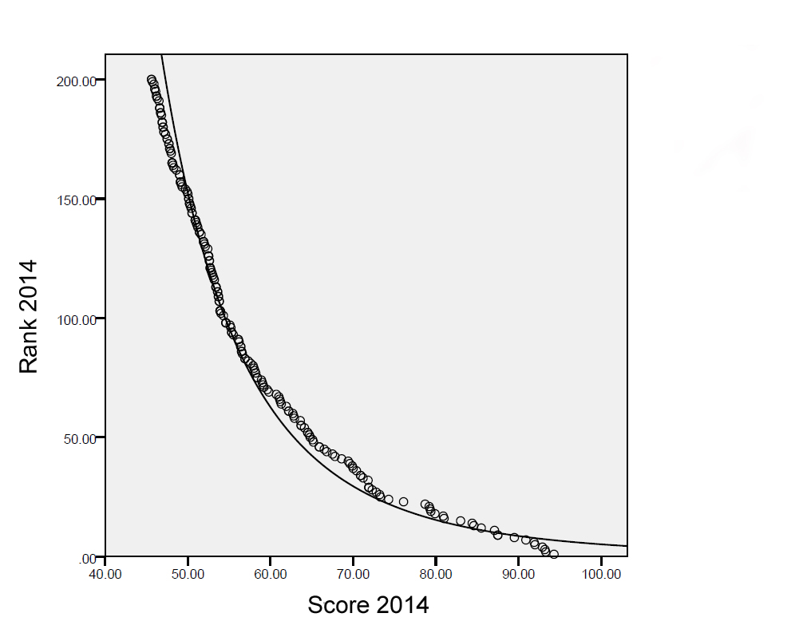
Figure S1) Scores vs ranks including power fit for the ranking 2014.

Table S3)
The 20 universities that are showing the total highest fluctuation in the THES rankings, from 2010 to 2014 (sum of changed ranks from 2010 to 2014).

University | Sum of Rank Changes from 2010 to 2014
Technical University of Denmark | 121
Albert-Ludwigs-Universität Freiburg | 121
Yeshiva University | 118
University of Massachusetts | 117
Universität Basel | 116
Stony Brook University | 110
University of Groningen | 109
University of Glasgow | 108
University of Zürich | 107
National Tsing Hua University | 107
George Washington University | 105
University of Virginia | 104
Boston College | 103
Seoul National University | 101
Uppsala University | 97
University of California, Santa Cruz | 95
Arizona State University | 93
Pennsylvania State University | 89
Erasmus University Rotterdam | 89
Georgetown University | 89

Table S4)
The 10 universities that are showing the total highest fluctuation in the ARWU rankings, from 2010 to 2014 (sum of changed ranks from 2010 to 2014).

University | Sum of Rank Changes from 2010 to 2014
Hebrew University Jerusalem | 36
Australische National University | 27
University Aarhus | 24
Technische Universität München | 21
Ludwig-Maximilians-Universität München | 21
University Uppsala | 20
Universityt Gent | 20
Rice University | 19
Carnegie Mellon University | 18

