SUPPLEMENTARY MATERIALS
Intrinsically disordered caldesmon binds calmodulin via the “buttons on a string” mechanism
Sergei E. Permyakov, † Eugene A. Permyakov, † and Vladimir N. Uversky†,‡,*

†Institute for Biological Instrumentation, Russian Academy of Sciences, 142290 Pushchino, Moscow Region, Russia;
‡Department of Molecular Medicine and USF Health Byrd Alzheimer's Research Institute, Morsani College of Medicine, University of South Florida, Tampa, Florida 33612, USA;

*To whom correspondence should be addressed: Vladimir N. Uversky, Department of Molecular Medicine, College of Medicine, University of South Florida, 12901 Bruce B. Downs Blvd, MDC3540, Tampa, FL 33612, USA; E-mail: vuversky@health.usf.edu

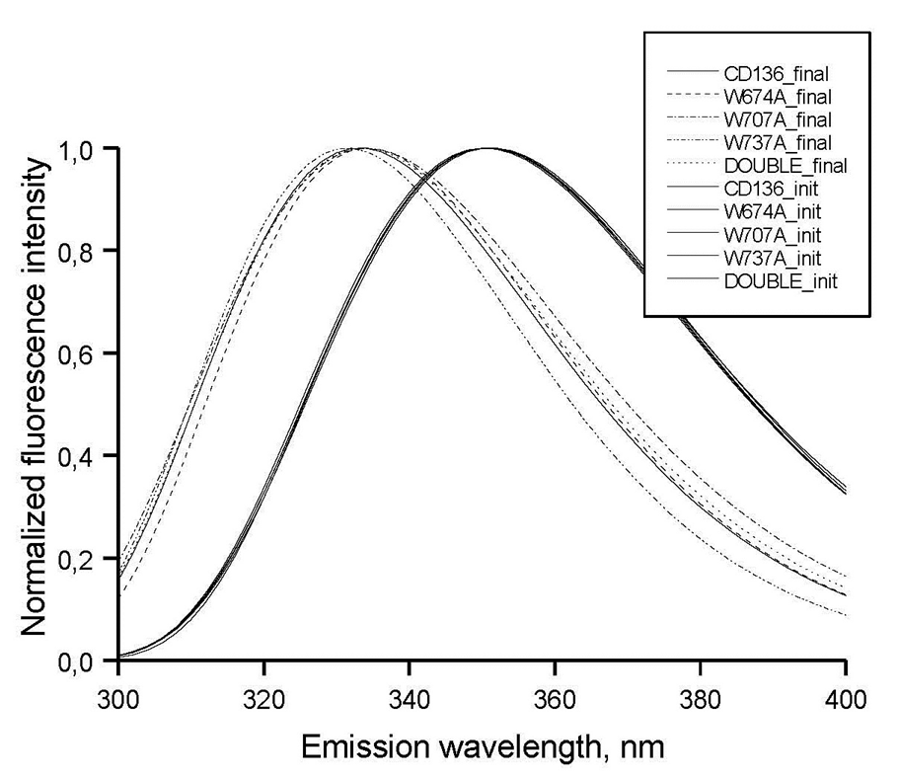
Figure S1. Normalized intrinsic tryptophan fluorescence spectra of wild type CaD₁₃₆ and its mutants in the free and CaM-bound states. Proteins are characterized by almost indistinguishable fluorescence in their unbound forms, whereas binding to CaM differently affects intrinsic fluorescence spectra.

Figure S2. Difference spectra determined by the subtraction from the far-UV CD spectrum of the wild type CaD₁₃₆ the far-UV CD spectrum of: W674A (2), W707A (3), W737A (4) and W674A/W707A (5). All measurements were carried out at a protein concentration of 0.6-0.8 mg/ml, cell pathlength 0.1 mm, 15ºC.

Figure S3. Difference spectra determined by the subtraction from the near-UV CD spectrum of the CaD₁₃₆ the near-UV CD spectrum of: W674A (2), W707A (3), W737A (4) and W674A/W707A (5). All measurements were carried out at a protein concentration of 0.6-0.8 mg/ml, cell pathlength 10 mm, 15ºC.

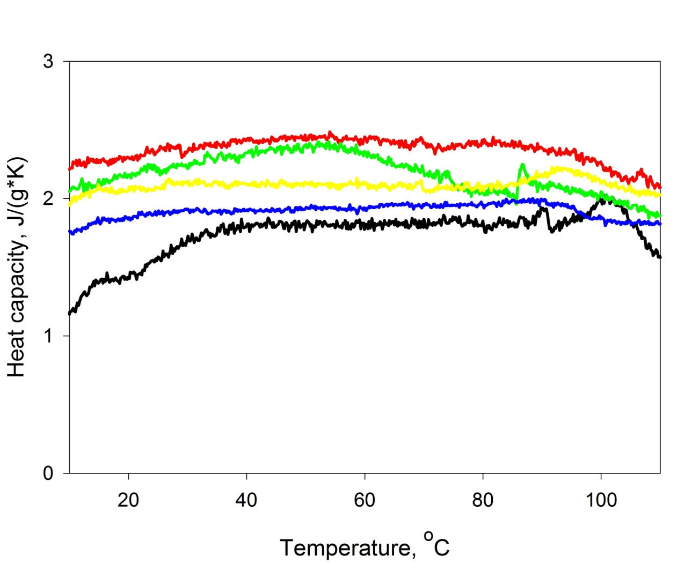
Figure S4. Calorimetric scans for wild type CaD₁₃₆ and its mutants in solution. Experiments were performed in 50 mM H₃BO₃ buffer, pH 8.0. Protein concentrations were 0.97 mg/ml, 1.38 mg/ml, 1.21 mg/ml, 1.56 mg/ml and 1.96 mg/ml for the wild type (black curve), W674A (red curve), W707A (green curve), W737A (yellow curve), and W674A/W707A (blue curve), respectively.

