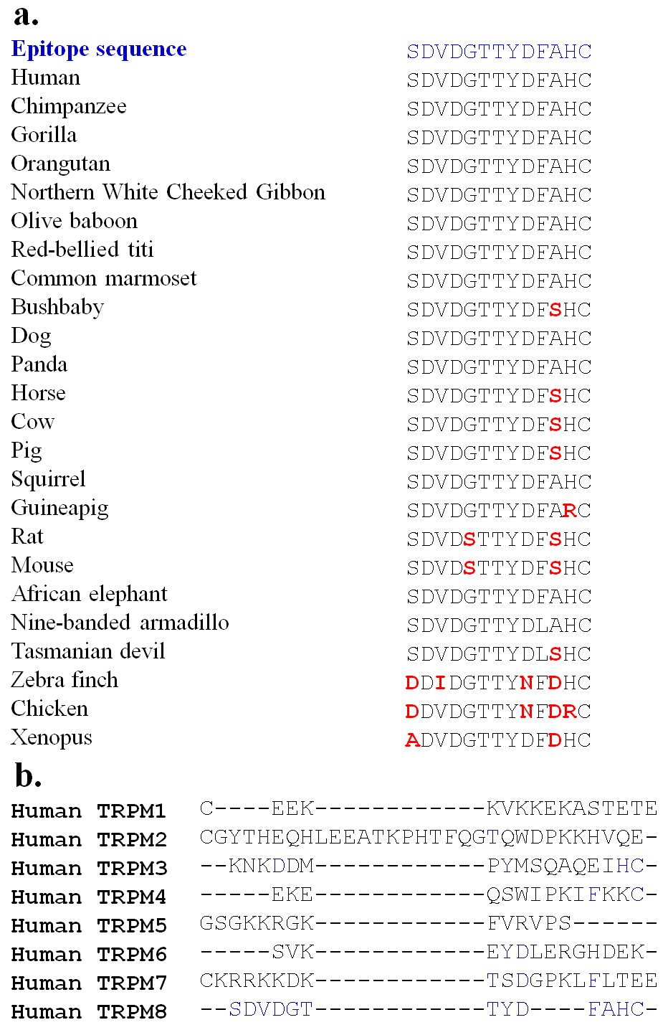

Supplementary figure S2. Conservation of the epitope of the TRPM8-specific antibody. a. The epitome sequence of the anti-TRPM8 antibody used in this work is highly conserved in all species for which TRPM8 sequences are available. b. The TRPM8 epitope sequence is missing in all other TRPM channels.

