Supplementary information
Appendix 1. Detailed description of the Bayesian occupancy model used to estimate trends in species’ occurrence

The Bayesian occupancy model approach was used to estimates true occupancy per site per year given imperfect detection. Occupancy models require detection/non-detection data during replicated visits within a closure period. In our model, the closure period spans a single year. Non-detection was inferred for each species not recorded on a visit where at least one other species was recorded. The model is run for each species separately but uses data from other species to infer non-detection and inform detection probability (described below).

The occupancy model consists of two hierarchically coupled sub-models, one, the state model, governs the true presence/absence of a species at a site in a given year, the second, the observation model, governs the probably of detecting that species given its presence or absence, and is therefore conditional on the state model (Appendix 1.1). For each site year combination the model estimates presence or absence for the species in question (z_{it}), which is linked to the observed data (y_{itv}), given variation in detection probability (p_{itv}). These z_{it} values were then combined to create an annual estimate of the proportion of occupied sites, which was in turn regressed against year to estimate a temporal trend in species’ occurrence.

The detection probability is estimated following capture-recapture theory (MacKenzie, 2006; van Strien et al., 2013) and is informed by the number of species recorded on a given visit (L_{itv}), a proxy for sampling effort. The full model equation can be seen in Appendix 1.1 and the model structure is illustrated in Appendix 1.2. Non-informative priors are used throughout these models

MacKenzie, D.I. (2006) Occupancy Estimation and Modeling: Inferring Patterns and Dynamics of Species Occurrence, Academic Press, Burlington, Massachusetts, USA.
Van Strien, A.J., van Swaay, C.A.M. & Termaat, T. (2013) Opportunistic citizen science data of animal species produce reliable estimates of distribution trends if analysed with occupancy models. Journal of Applied Ecology, 50, 1450–1458.

Appendix 1.1: The Bayesian occupancy model used to estimate annual site occupancy.
State model - z_{it} ~ Bernoulli(ψ_{it}); logit(ψ_{it}) = b_{t} + u_{i}
Observation model - y_{itv}|z_{it} ~ Bernoulli(z_{it} * p_{itv}); logit (p_{itv}) = a_{t} + c.log(L_{itv})

z_{it} = True occupancy of site (i) in year (t). Can be a 1 or 0, present or absent.
ψ_{it} = The probability that site (i) is occupied in year (t)
b_{t} = Year effect (categorical)
u_{i} = Site effect (categorical)
y_{itv} = Observed presence/absence at site (i) at year (t) on visit (v)
p_{itv} = The probability of detection at site (i) at year (t) on visit (v), conditional on Z_{it} that is the species true presence or absence.
a_{t} = Year level random effect (categorical)
L_{itv} = List length at site (i) in year (t) on visit (v)
c = Change in the log-odds of detectability associated with an increasing list length by a factor of e.

Appendix 1.2 Directed acyclic graph illustrating the occupancy model structure. Orange shading represents the state model, blue shading represents the observation model, and the green box represents the observed data.
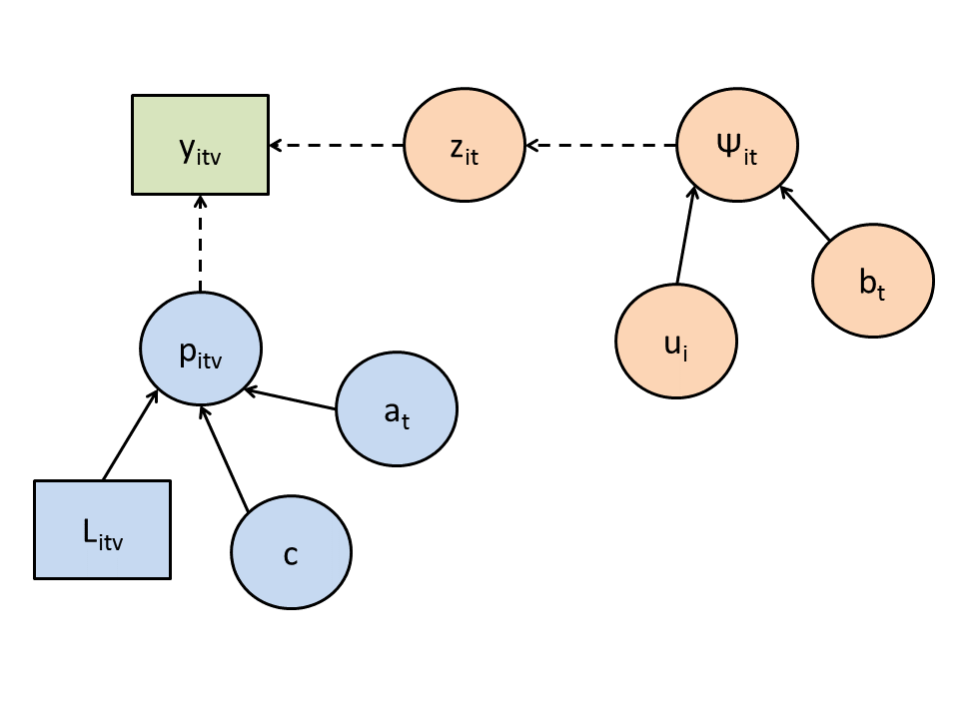

Appendix 2 The posterior distribution of the trend estimates for each species are summarised here as the mean, standard deviation and the lower 2.5 and upper 97.5 percentile. All values were rounded to 4 decimal places.
Species | Trend | Trend sd | Trend 2.5 | Trend 97.5
Aeshna caerulea | -0.0008 | 0.0015 | -0.0060 | 0.0000
Aeshna cyanea | 0.0021 | 0.0007 | 0.0007 | 0.0035
Aeshna grandis | 0.0049 | 0.0005 | 0.0038 | 0.0060
Aeshna juncea | -0.0033 | 0.0005 | -0.0044 | -0.0023
Aeshna mixta | 0.0112 | 0.0007 | 0.0097 | 0.0126
Anax imperator | 0.0147 | 0.0008 | 0.0131 | 0.0163
Brachytron pratense | 0.0047 | 0.0004 | 0.0039 | 0.0054
Calopteryx splendens | 0.0058 | 0.0004 | 0.0051 | 0.0066
Calopteryx virgo | 0.0011 | 0.0003 | 0.0004 | 0.0018
Ceriagrion tenellum | -0.0003 | 0.0002 | -0.0007 | 0.0001
Coenagrion hastulatum | -0.0001 | 0.0000 | -0.0002 | 0.0000
Coenagrion mercuriale | 0.0001 | 0.0000 | 0.0000 | 0.0001
Coenagrion puella | 0.0002 | 0.0006 | -0.0010 | 0.0014
Coenagrion pulchellum | -0.0001 | 0.0003 | -0.0007 | 0.0004
Cordulegaster boltonii | -0.0009 | 0.0004 | -0.0017 | -0.0001
Cordulia aenea | 0.0008 | 0.0002 | 0.0004 | 0.0012
Enallagma cyathigerum | 0.0013 | 0.0004 | 0.0004 | 0.0021
Erythromma najas | 0.0082 | 0.0004 | 0.0074 | 0.0090
Gomphus vulgatissimus | -0.0004 | 0.0001 | -0.0007 | -0.0002
Ischnura elegans | 0.0017 | 0.0003 | 0.0011 | 0.0023
Ischnura pumilio | -0.0020 | 0.0003 | -0.0025 | -0.0015
Lestes dryas | -0.0002 | 0.0009 | -0.0041 | 0.0002
Lestes sponsa | -0.0028 | 0.0007 | -0.0041 | -0.0014
Leucorrhinia dubia | -0.0002 | 0.0001 | -0.0003 | -0.0001
Libellula depressa | 0.0056 | 0.0008 | 0.0041 | 0.0072
Libellula fulva | 0.0014 | 0.0001 | 0.0011 | 0.0016
Libellula quadrimaculata | 0.0048 | 0.0007 | 0.0035 | 0.0062
Orthetrum cancellatum | 0.0099 | 0.0007 | 0.0084 | 0.0112
Orthetrum coerulescens | 0.0004 | 0.0002 | -0.0001 | 0.0008
Platycnemis pennipes | 0.0026 | 0.0002 | 0.0021 | 0.0030
Pyrrhosoma nymphula | 0.0057 | 0.0005 | 0.0046 | 0.0067
Somatochlora arctica | 0.0004 | 0.0007 | -0.0002 | 0.0016
Somatochlora metallica | -0.0002 | 0.0002 | -0.0007 | 0.0001
Sympetrum danae | -0.0029 | 0.0004 | -0.0036 | -0.0021
Sympetrum sanguineum | 0.0105 | 0.0008 | 0.0089 | 0.0121
Sympetrum striolatum | 0.0000 | 0.0008 | -0.0017 | 0.0014

