Table.S1
The raw data for Standard curves in Fig.2：
GlcNAC-1-P

C（mg/ml） | S（nC*min）
0.1 | 7.7087
0.05 | 4.0582
0.01 | 0.9238
0.005 | 0.4418
0.001 | 0.0936
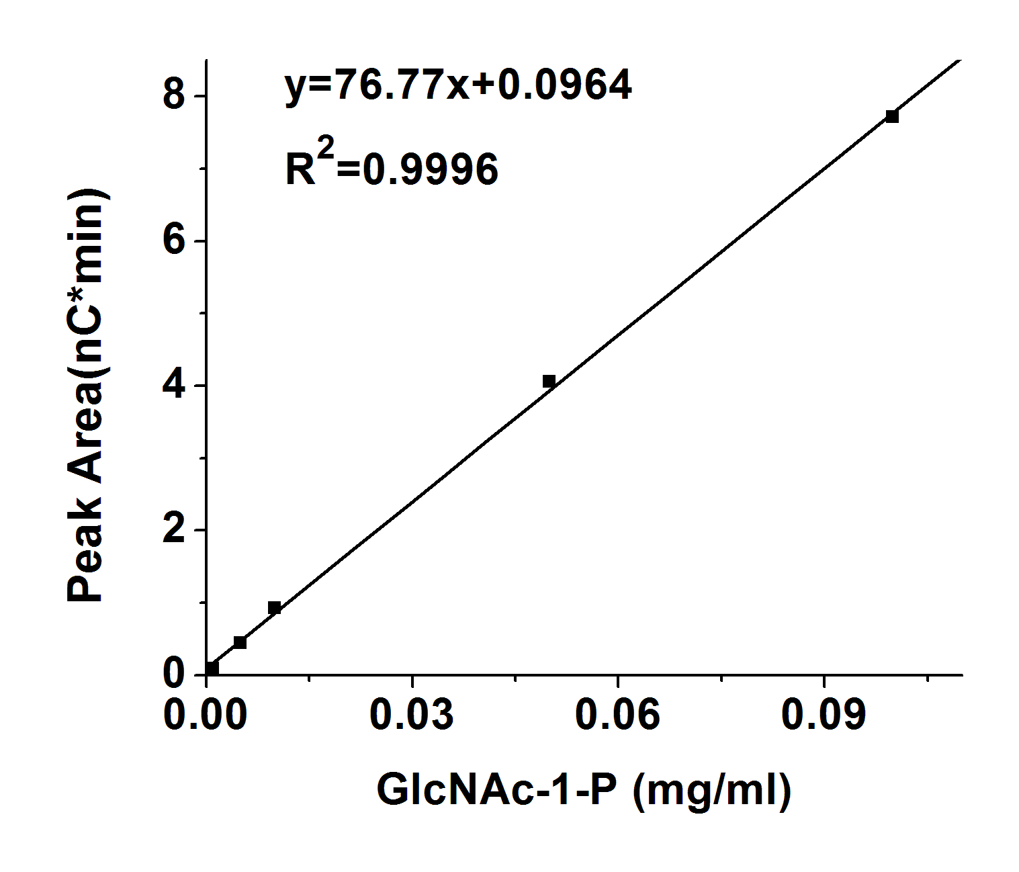
GlcNAC-6-P

C（mg/ml） | S（nc*min）
0.1 | 12.6313
0.05 | 6.4562
0.01 | 1.7417
0.005 | 0.8425
0.001 | 0.1668
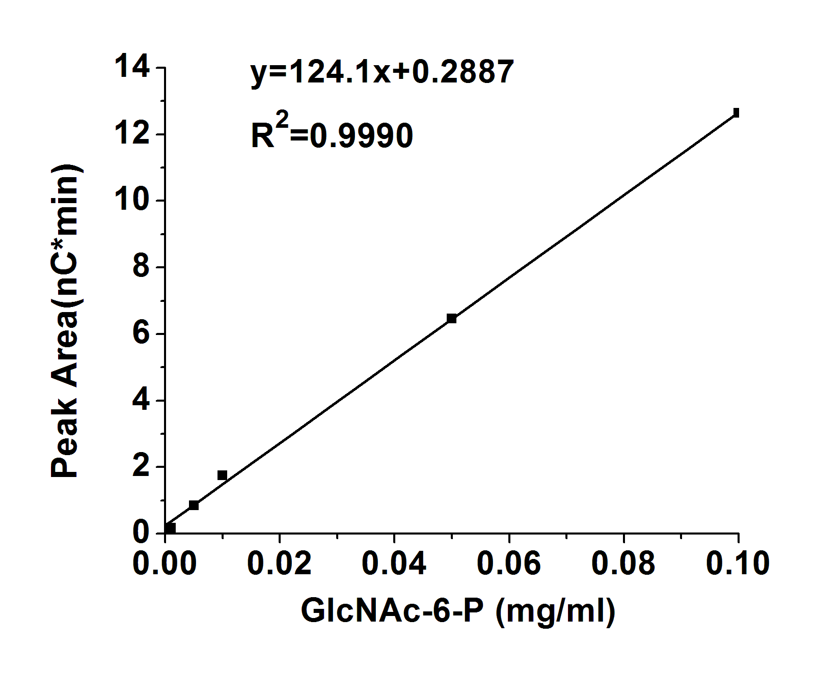
GlcN-1-P

C（mg/ml） | S（nc*min）
0.1 | 28.7228
0.01 | 4.2066
0.001 | 0.4835
0.05 | 14.3743
0.005 | 2.0035
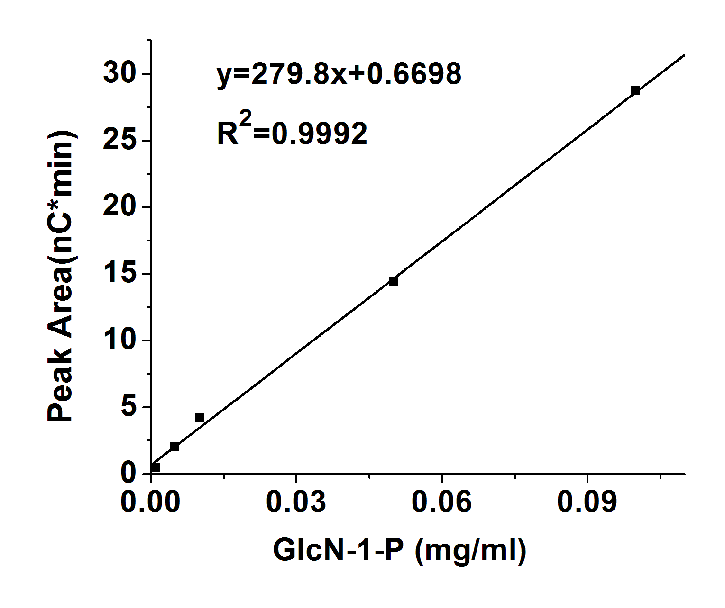
GlcN-6-P

C（mg/ml） | S（nc*min）
0.1 | 45.1897
0.01 | 5.2229
1.00E-03 | 0.5416
0.05 | 22.3842
0.005 | 2.4164
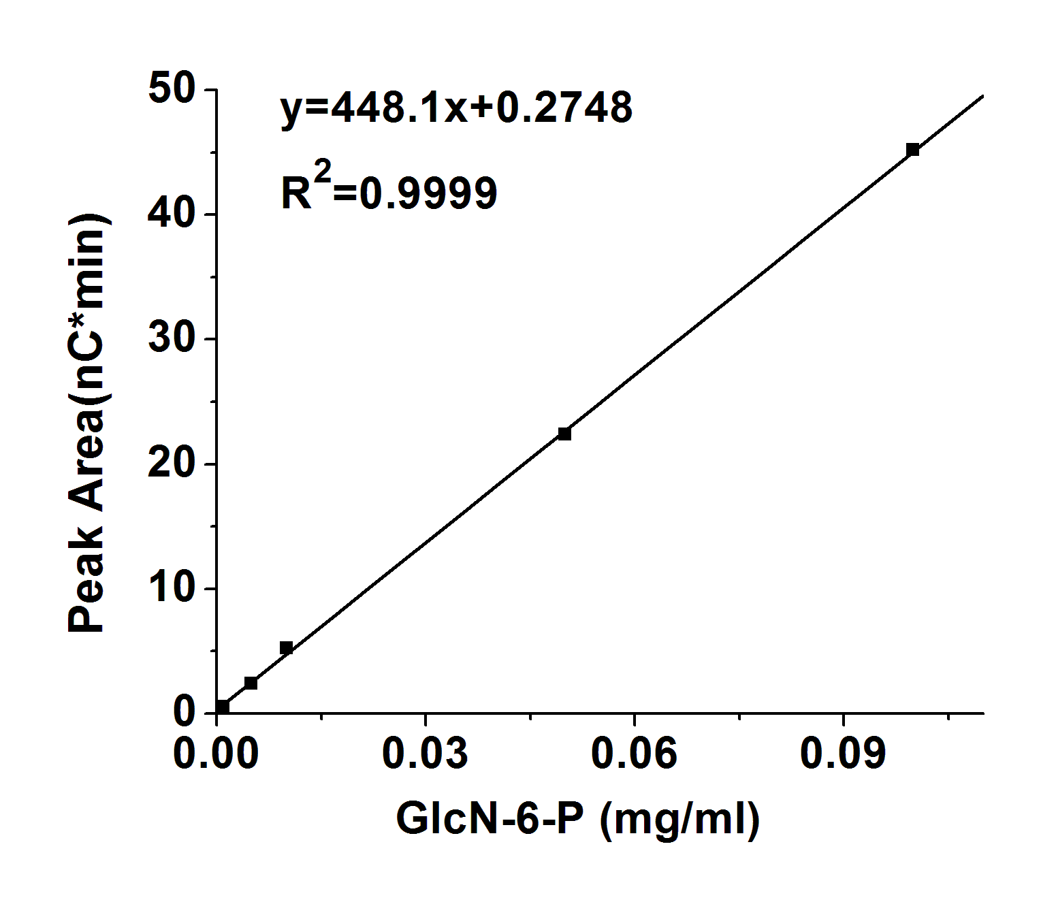

Glc-1-P

C（mg/ml） | S（nc*min）
0.1 | 11.5466
0.01 | 1.259
0.001 | 0.1436
0.05 | 5.555
0.005 | 0.5924
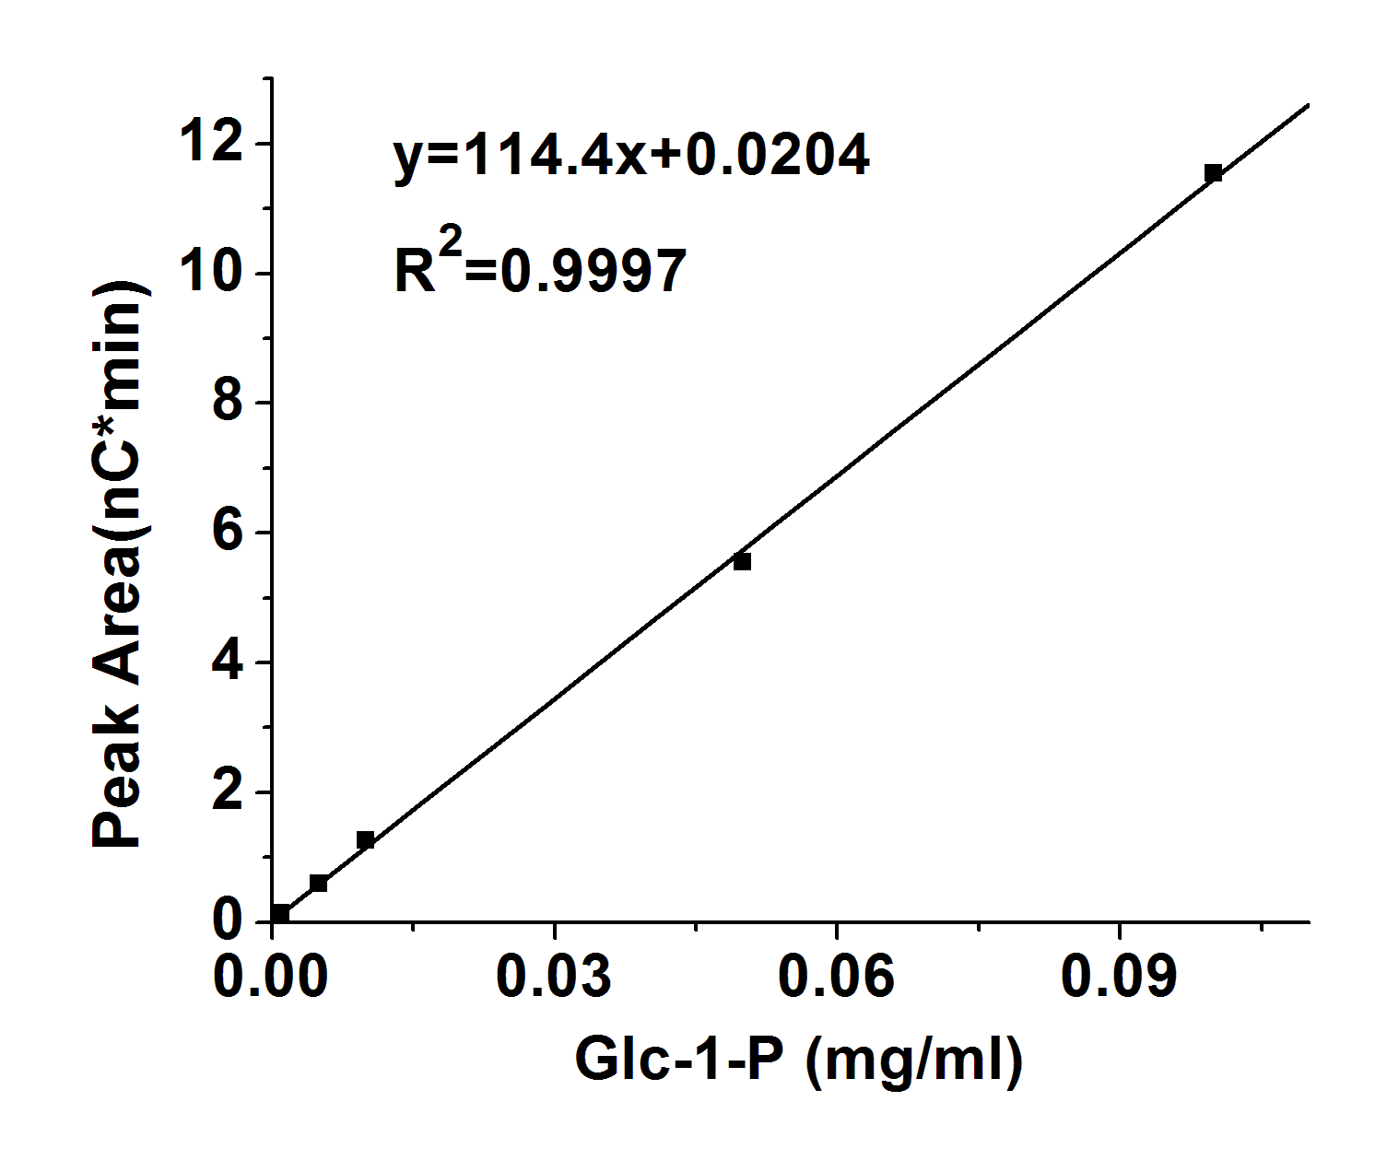
Glc-6-P

C（mg/ml） | S（nc*min）
0.1 | 18.2927
0.01 | 1.9931
0.001 | 0.219
0.05 | 8.5294
0.005 | 0.912
