The raw data for Fig.4 and table.1
The steady-state kinetics of AtAGM was detected by two methods (using Glc-1-P as substrates). When using the low concentration Glc-1-P as substrates (60μM), the Glc-1-P consuming (HPAEC-PAD method, 3.66 μg AtAGM) and NADH increasing (Traditional coupled assay, 3.66 μg AtAGM) were shown in Supplement Fig. 1(A, B). We chose 10min as reaction time because the reaction was still in initial rate stage.
Supplement Fig. 1
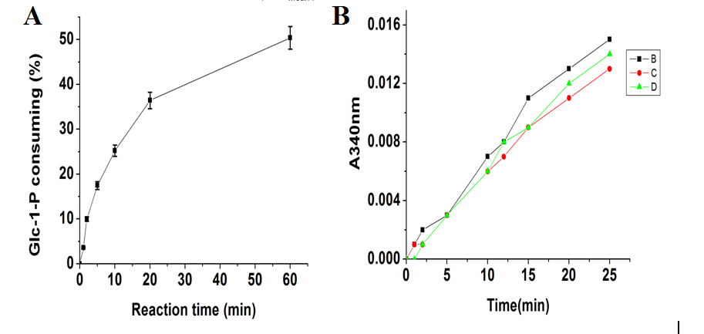

About three μg AtAGM protein or boiled enzymes (3.66 μg for HPAEC-PAD method, 3.15 μg for traditional coupled assay), were incubated for 10 min at 30 ℃ in a substrate buffer as described in the article, with varying concentrations of Glc-1-P (60-8000 μM). The results are the mean ± S.D. for three determinations.
Supplement table.1
HPAEC-PAD method

C(uM) | V(nmol/s)-1 | V-2 | V-3
8023.67642 | 2.700334128 | 1.319841 | 2.217628
6017.75732 | 2.52298617 | 1.301063 | 2.57834
4011.83821 | 2.345148511 | 1.431038 | 2.538697
2005.91911 | 1.823549285 | 0.932758 | 1.667311
802.36764 | 0.979258511 | 1.032893 | 1.534254
401.18382 | 0.813657574 | 0.869624 | 1.039853
80.23676 | 0.401136 | 0.398396 | 0.400314
60.17757 | 0.300852 | 0.295372 | 0.298934

Using the data shown above, we could match with michaelis-menten equation by using Oringin 7.5. The relative Steady-state kinetics data was shown in Table.1.
Supplement table.2
C(uM) | V(nmol/s)-1 | V-2 | V-3
6889.181 | 1.557054 | 1.938726 | 2.186885
4814.206 | 1.850766 | 1.817522 | 2.056786
1805.327 | 1.993174 | 2.020397 | 1.626686
481.4206 | 0.932975 | 0.869363 | 0.890567
300.8879 | 0.594915 | 0.571303 | 0.551303
180.5327 | 0.33806 | 0.360468 | 0.319264
60.17757 | 0.148428 | 0.127224 | 0.127224
Using the data shown above, we could match with michaelis-menten equation by using Oringin 7.5. The relative Steady-state kinetics data was shown in Table.1.

