Supplement S6 Partial dependence plots of each variable
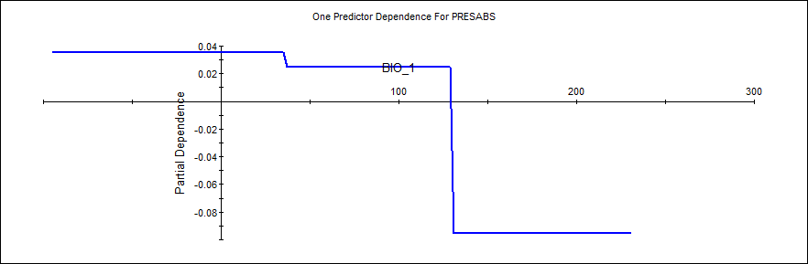
Bio_1

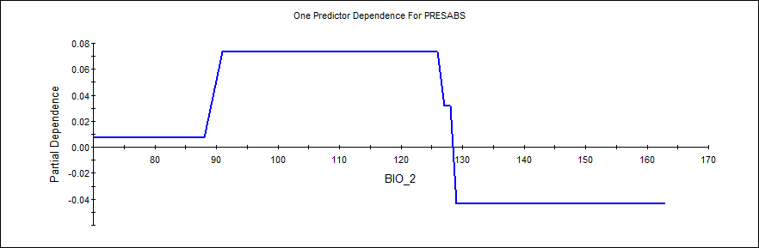
Bio_2

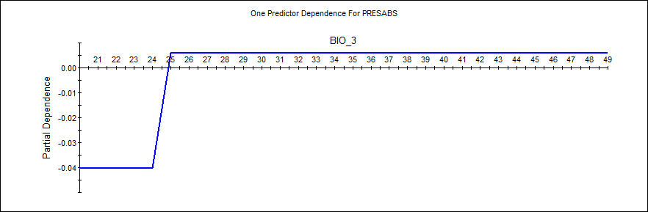
Bio_3

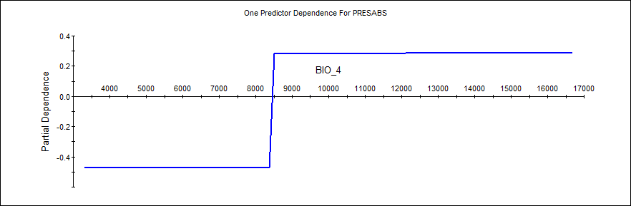
Bio_4
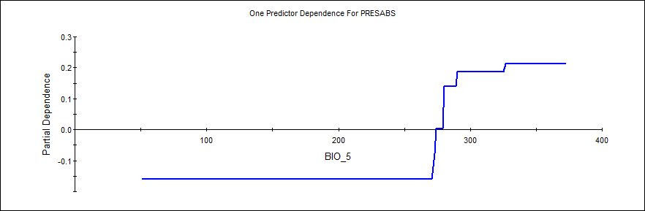
Bio_5

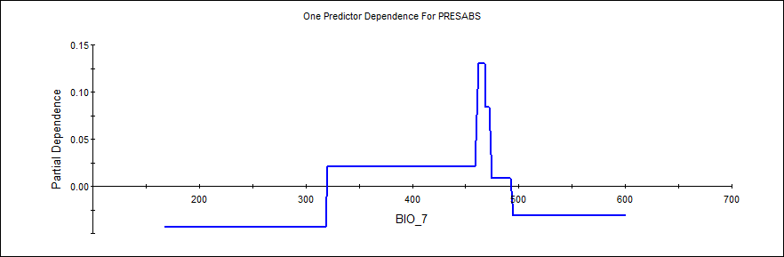
Bio_7

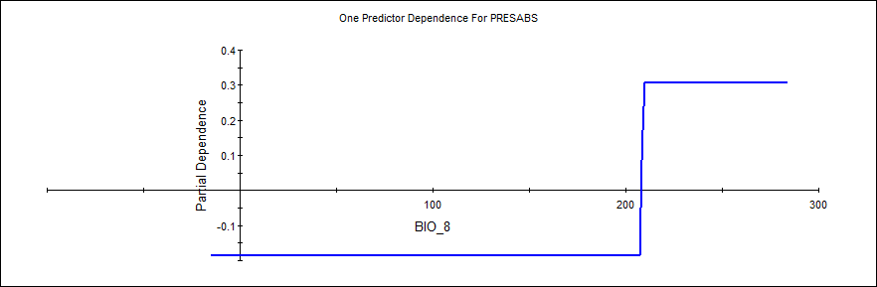
Bio_8

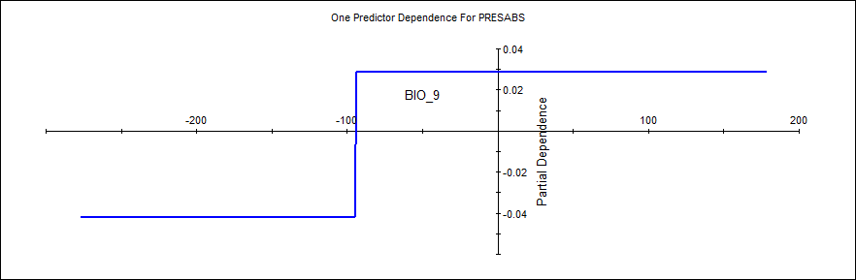Bio_9
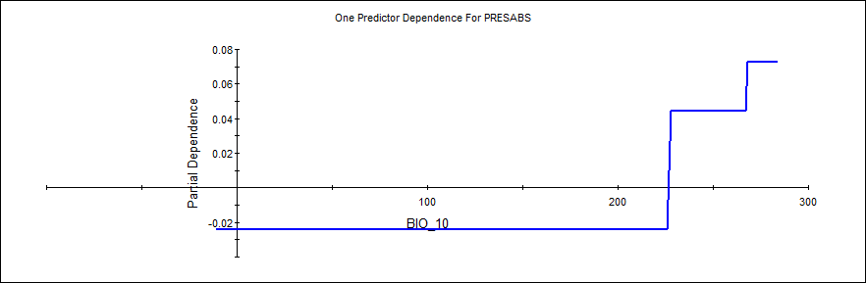
Bio_10

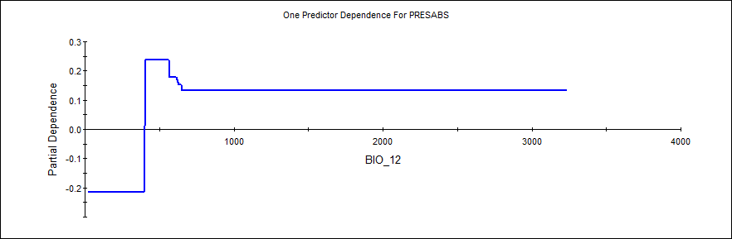
Bio_12

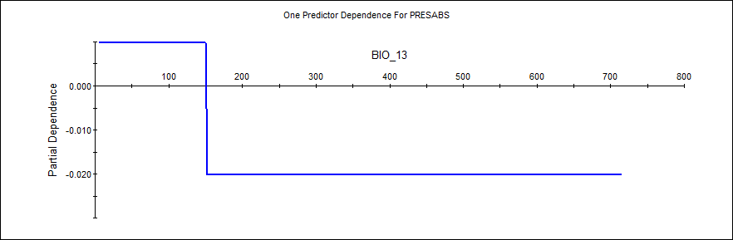
Bio_13

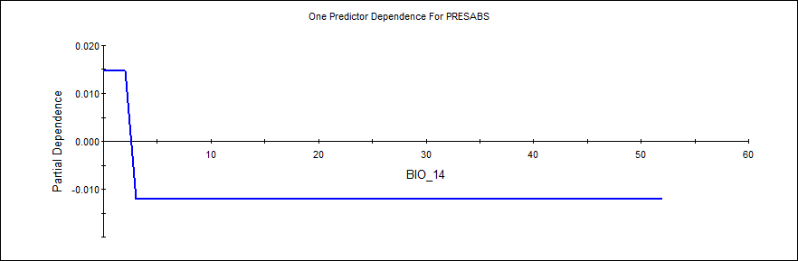Bio_14
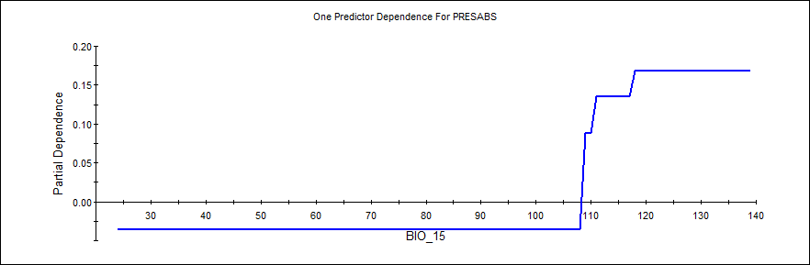
Bio_15

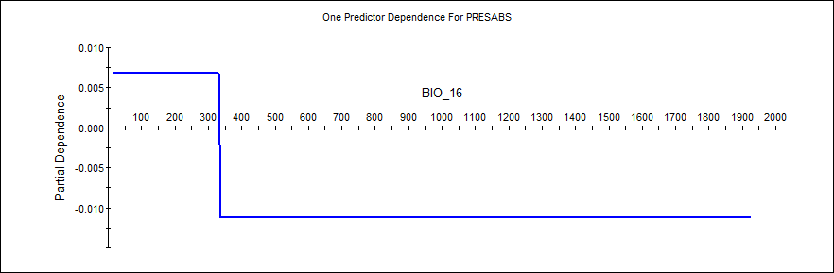
Bio_16

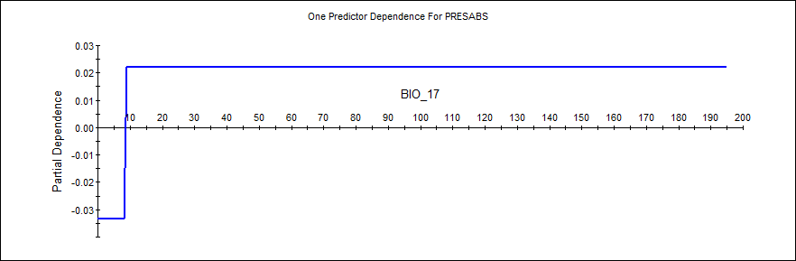
Bio_17

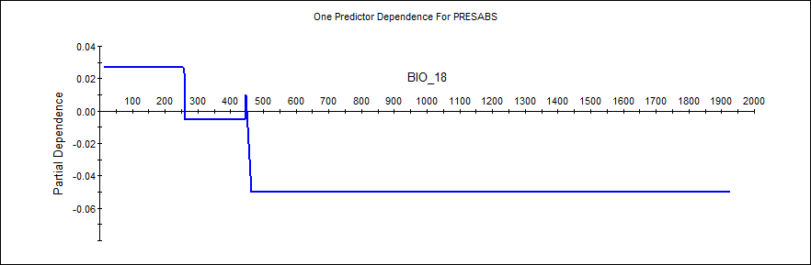
Bio_18
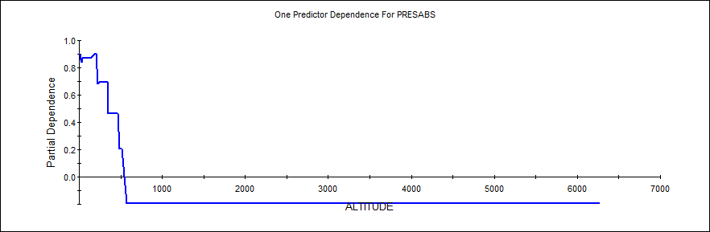
Altitude

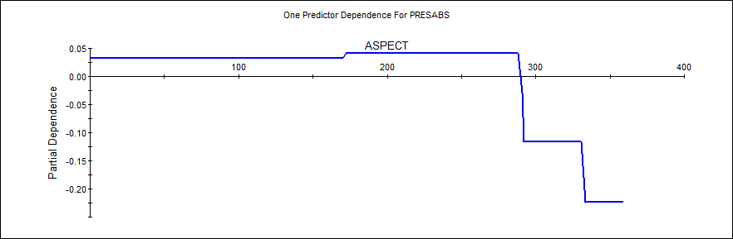
Aspect

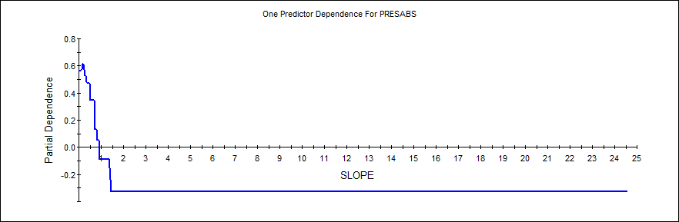
Slope
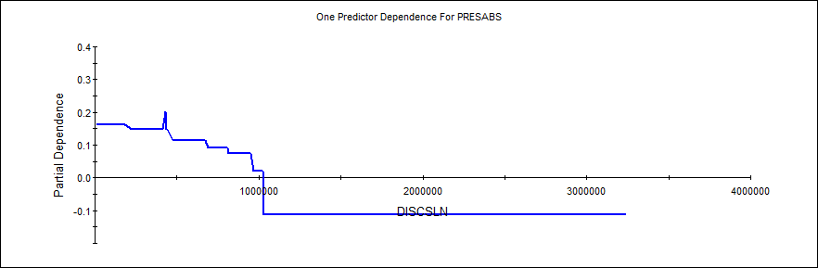
Distance to coastline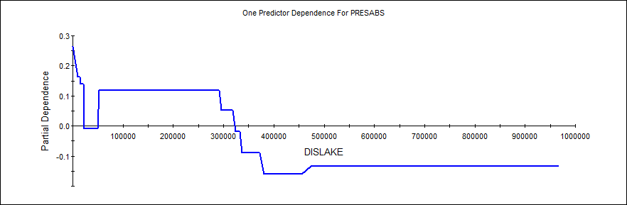
Distance to lake

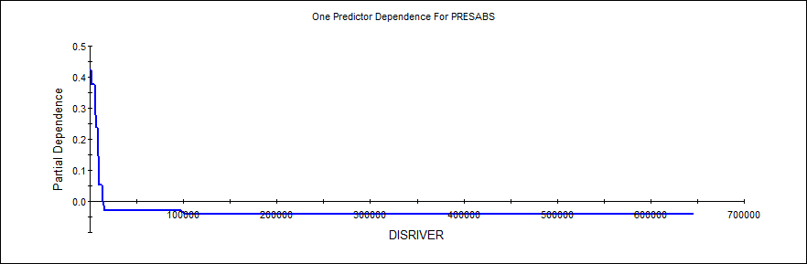
Distance to river

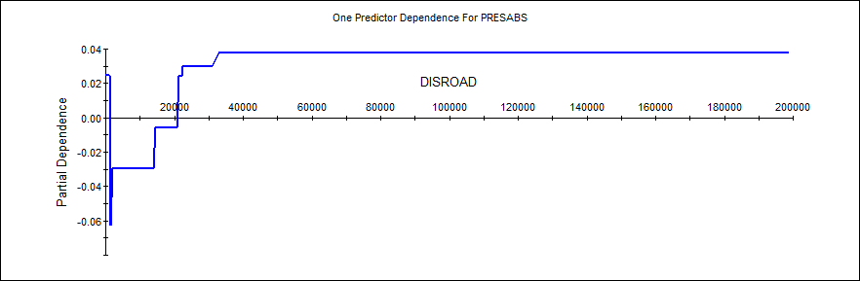
Distance to road

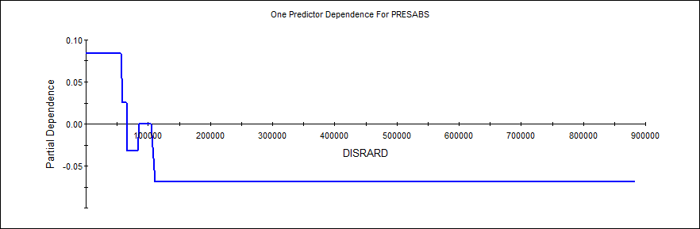
Distance to rail road
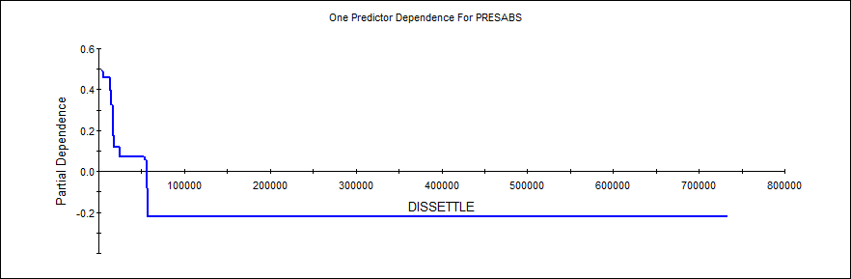
Distance to settlement

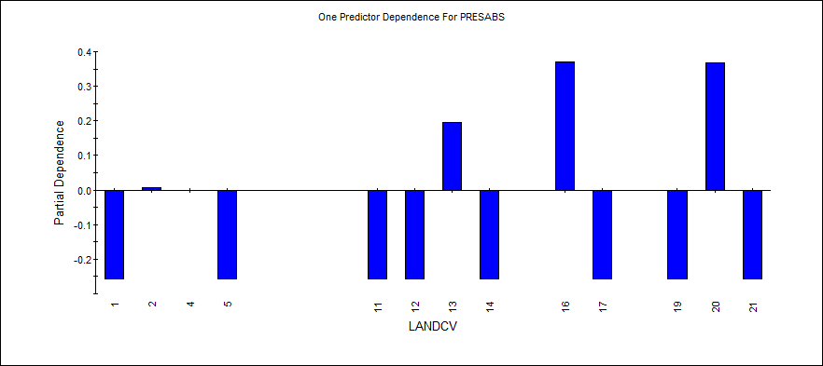
Land cover

The legend of land cover layer
GLC Global Class (according to LCCS terminology)
Tree Cover, broadleaved, evergreen
LCCS >15% tree cover, tree height >3m
(Examples of sub-classes at regional level* :
closed > 40% tree cove; open 15-40% tree cover)
Tree Cover, broadleaved, deciduous, closed
Tree Cover, broadleaved, deciduous, open
(open 15-40% tree cover)
Tree Cover, needle-leaved, evergreen
Tree Cover, needle-leaved, deciduous
Tree Cover, mixed leaf type
Tree Cover, regularly flooded, fresh water (& brackish)
Tree Cover, regularly flooded, saline water,
(daily variation of water level)
Mosaic:
Tree cover / Other natural vegetation
Tree Cover, burnt
Shrub Cover, closed-open, evergreen
(Examples of sub-classes at reg. level *: (i) sparse tree layer)
Shrub Cover, closed-open, deciduous
(Examples of sub-classes at reg. level *: (i) sparse tree layer)
Herbaceous Cover, closed-open
(Examples of sub-classes at regional level *:
(i) natural, (ii) pasture, (iii) sparse trees or shrubs)
Sparse Herbaceous or sparse Shrub Cover
Regularly flooded Shrub and/or Herbaceous Cover
Cultivated and managed areas
(Examples of sub-classes at reg. level *:
(i) terrestrial; (ii) aquatic (=flooded during cultivation), and under terrestrial: (iii) tree crop & shrubs (perennial), (iv) herbaceous crops (annual), non-irrigated, (v) herbaceous crops (annual), irrigated)
Mosaic:
Cropland / Tree Cover / Other natural vegetation
Mosaic:
Cropland / Shrub or Grass Cover
Bare Areas
Water Bodies (natural & artificial)
Snow and Ice (natural & artificial)
Artificial surfaces and associated areas

