**Supplemental Fig. S1** Dissociation curves for six candidate reference genes and two target genes,showing single peaks. A-H in different colours of each figure represents performances of eight different rows in a 96-well plate.

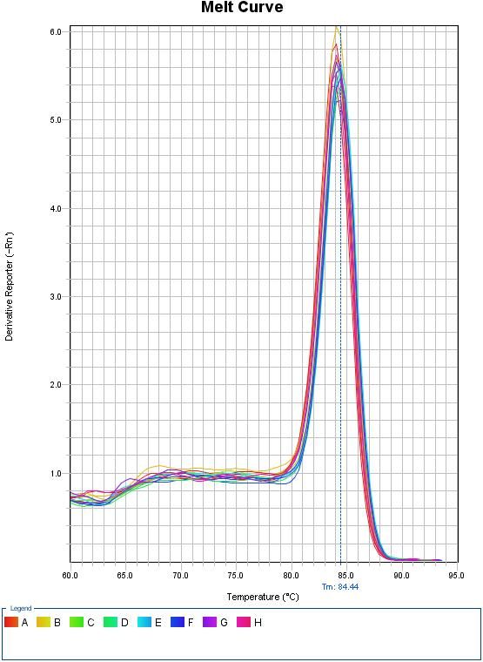

***18S***

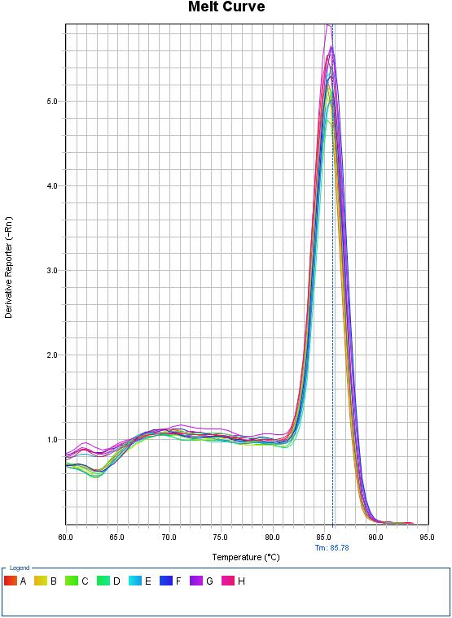

***28S***

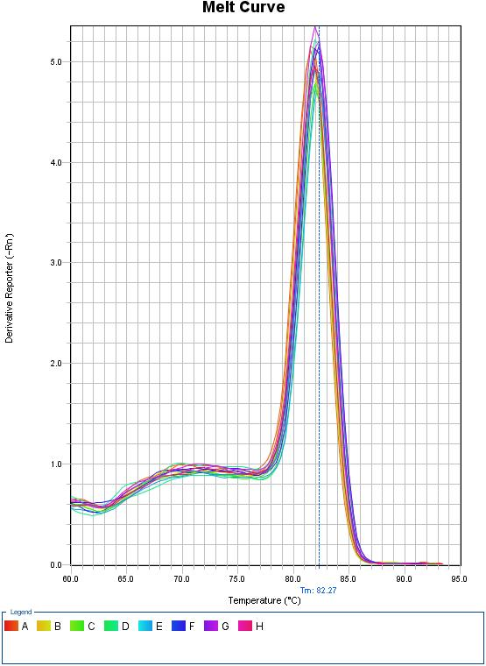

***ACTIN***

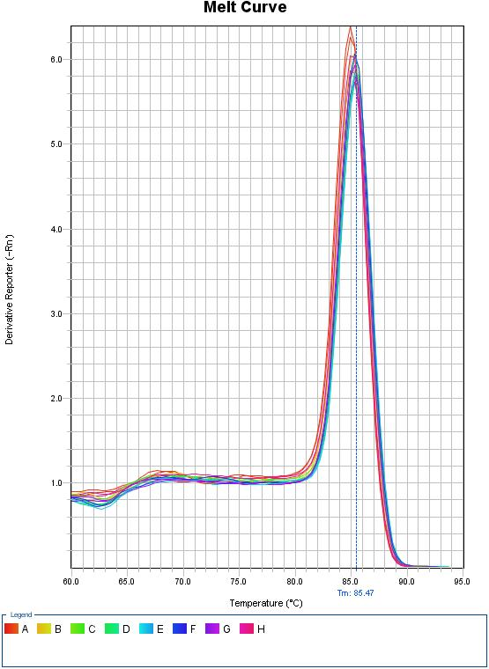

***β-TUB***

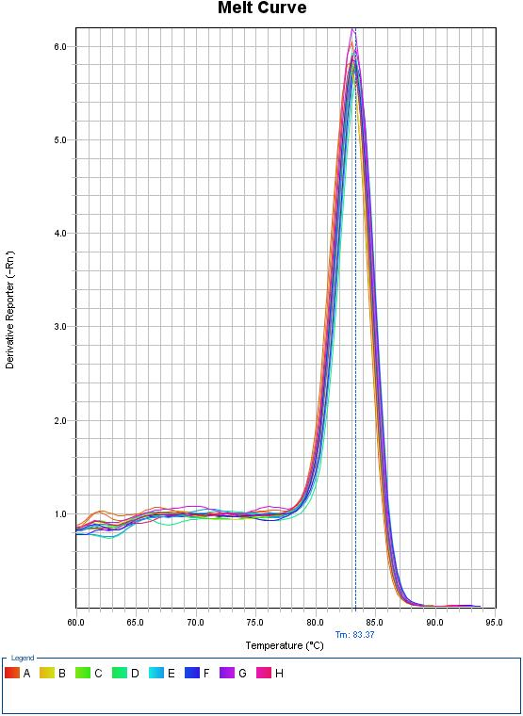

***GAPDH***

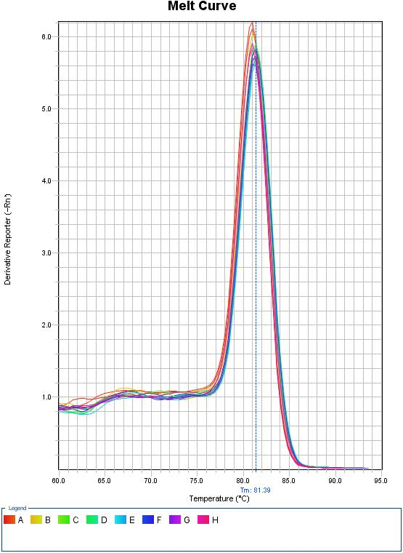

***UBQ***

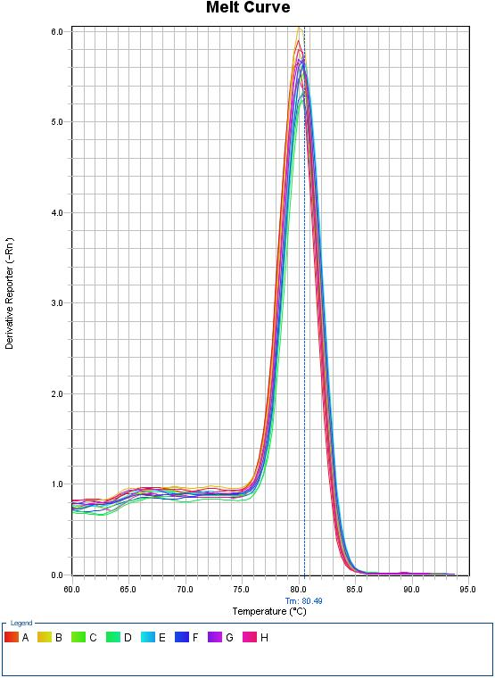

***PPDK***

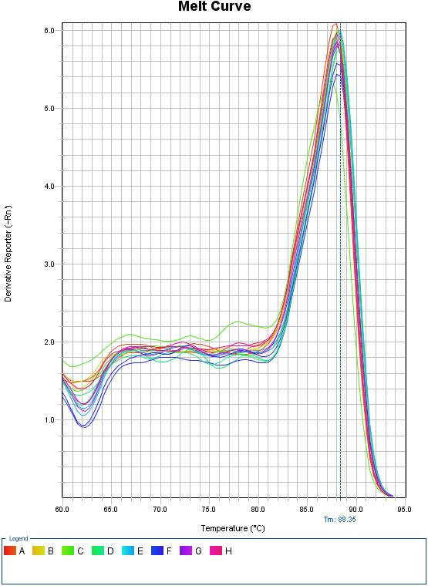

***SAT***

**Supplemental Fig. S1**