Figure S2.1: the dynamics are simulated with the same parameter values as in figure 1 in the main text, with the exception of the discount rate, which is taken as $d^{'}=0.01$.
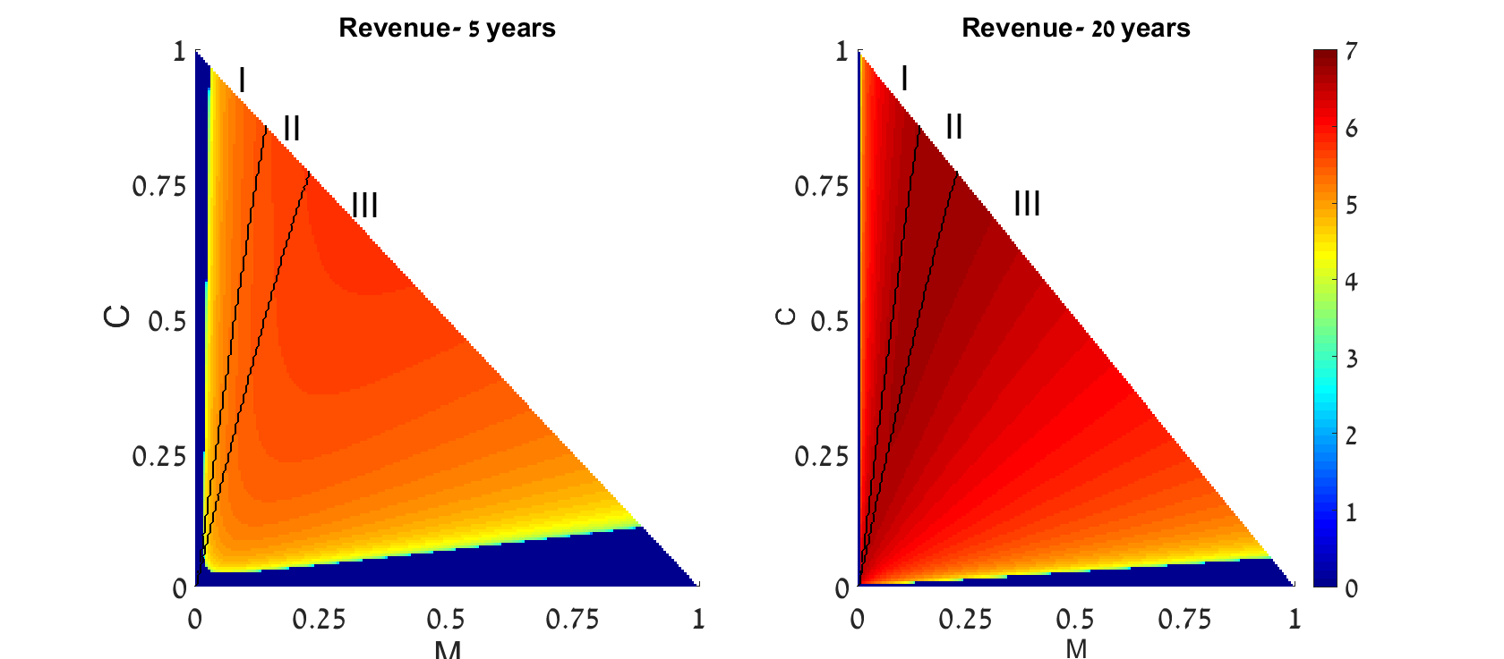

Figure S2.2: the dynamics are simulated with the same parameter values as in figure 1 in the main text, with the exception of the discount rate, which is taken as $d^{'}=0.07$.

