Mussel biofiltration effects on attached bacteria and unicellular eukaryotes in fish rearing seawater

E. Voudanta, K. A. Kormas, S. Monchy, A. Delegrange, D. Vincent, S. Genitsaris, U. Christaki

Supplementary material
Table S1. Description of environmental parameters. Mean (± SD) and range are presented for all of the sampling dates for Control (C) and Test (T) tanks (data from Delegrange et al. 2015).

 | T  (°C) | Salinity  (PSU) | Dissolved O₂  (mg L⁻¹) | Turbidity (NTU) | Chl-a  (µg L⁻¹)
CONTROL | 20.98±1.94  (18.12-23.7) | 33.85±0.43  (32.94-34.26) | 8.15±4.14  (4.7-20) | 4.09±1.04  (2.58-5.97) | 4.97±3.80  (0.80-10.36)
TEST | 20.82±1.71  (18.22-22.94) | 33.58±0.40  (32.81-33.97) | 9.71±4.85  (3.4-18.3) | 1.37±0.73  (0.64-2.91) | 0.79±0.62  (0.16-2.28)

Figure S1. Rarefaction curves of the eukaryotic and bacterial operational taxonomic units (OTUs) in the control (C) and mussels tanks (T) at all sampling dates.

Figure S2. Changes in the relative abundance of rare, common and abundant operational taxonomic units (OTUs) in the control (C) and mussels tanks (T) at all sampling dates.

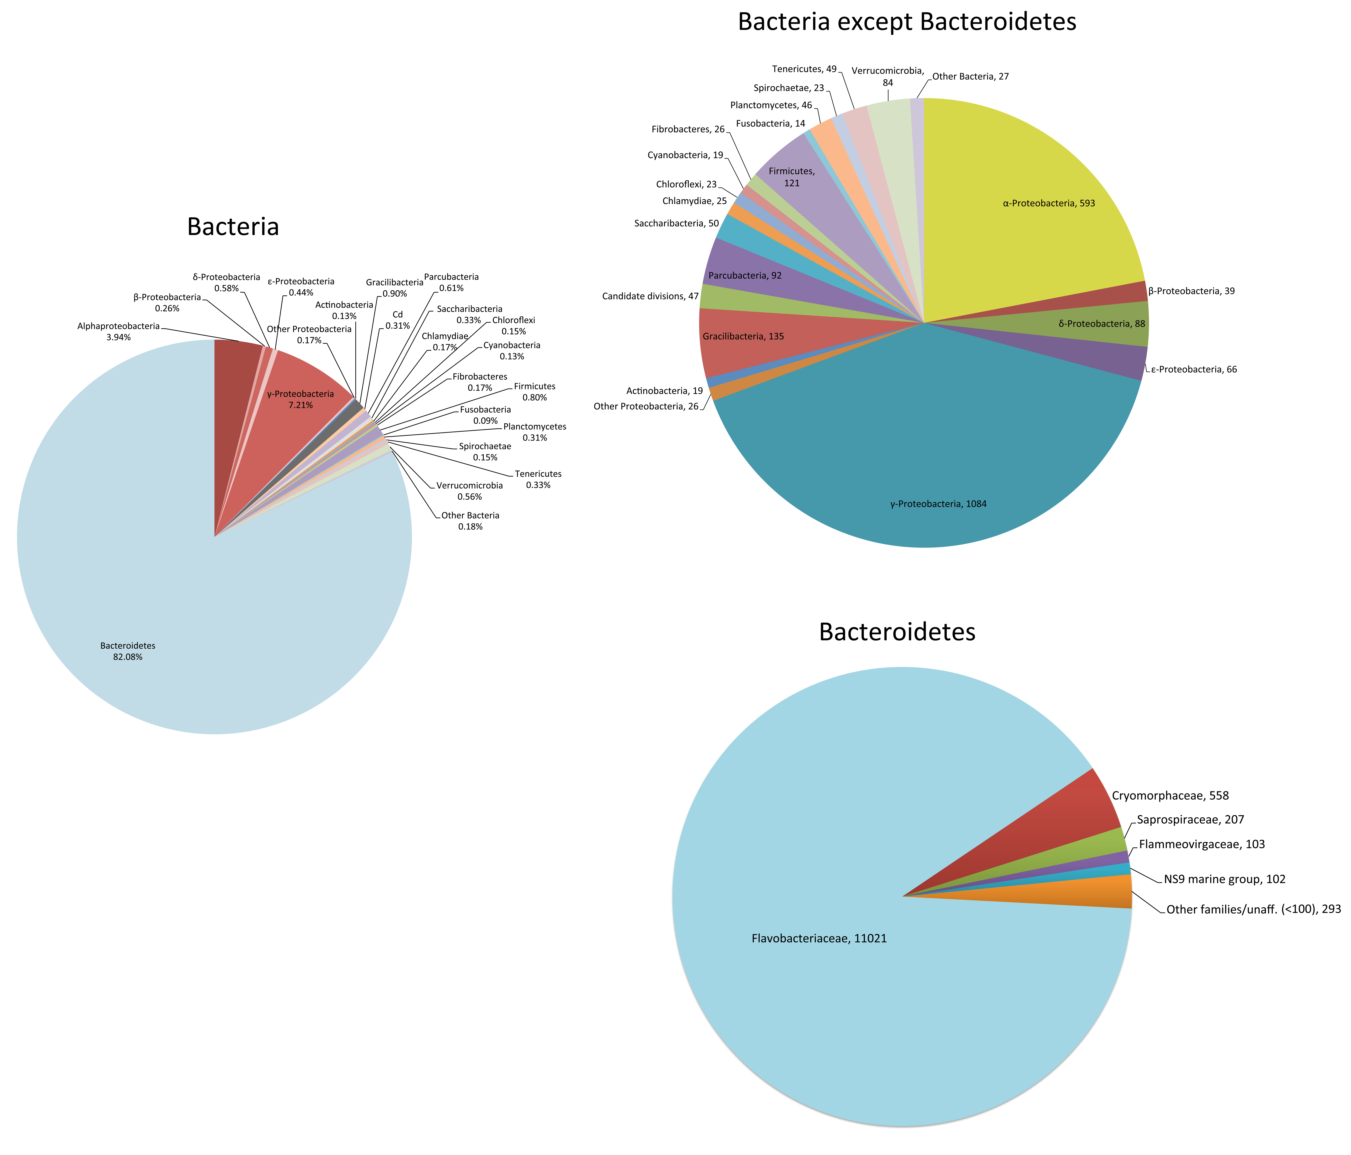
Figure S3. Relative abundance of the bacterial operational taxonomic units in the control (C) and mussels tanks (T) at all sampling dates.
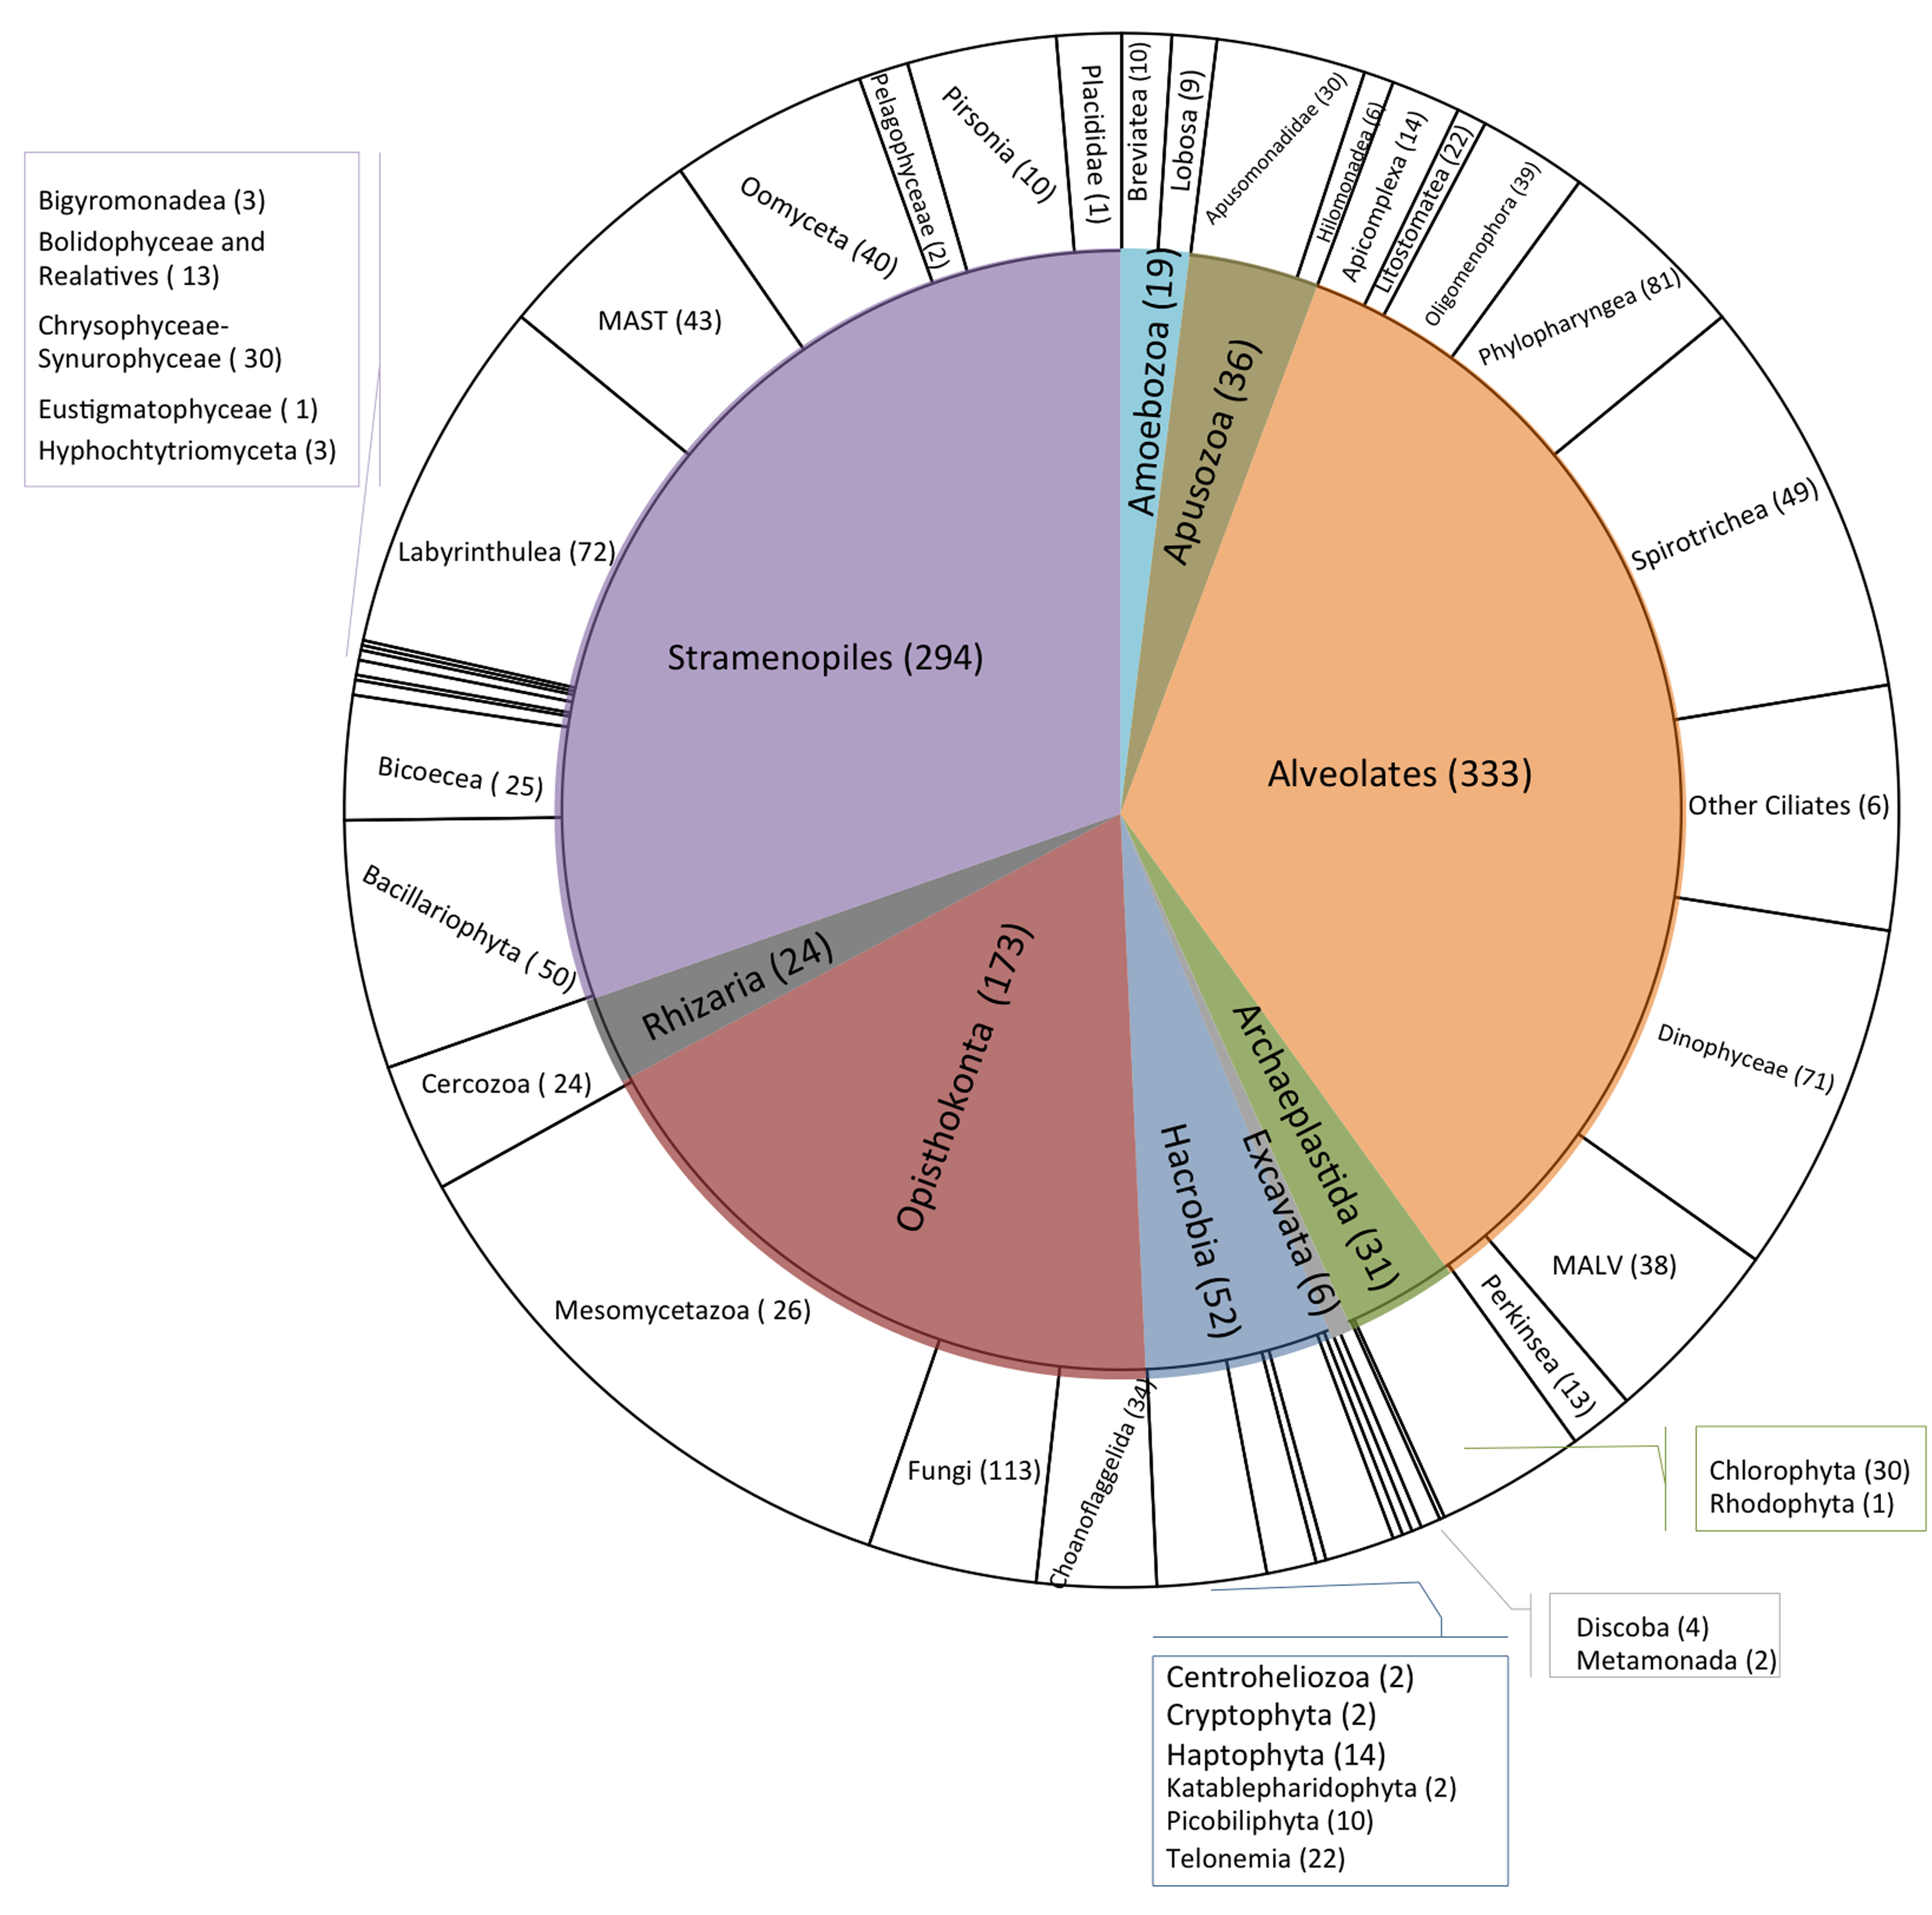

Figure S4. Relative abundance distribution of the unicellular eukaryotic operational taxonomic units (OTUs) in the control (C) and mussels tanks (T) at all sampling dates.

