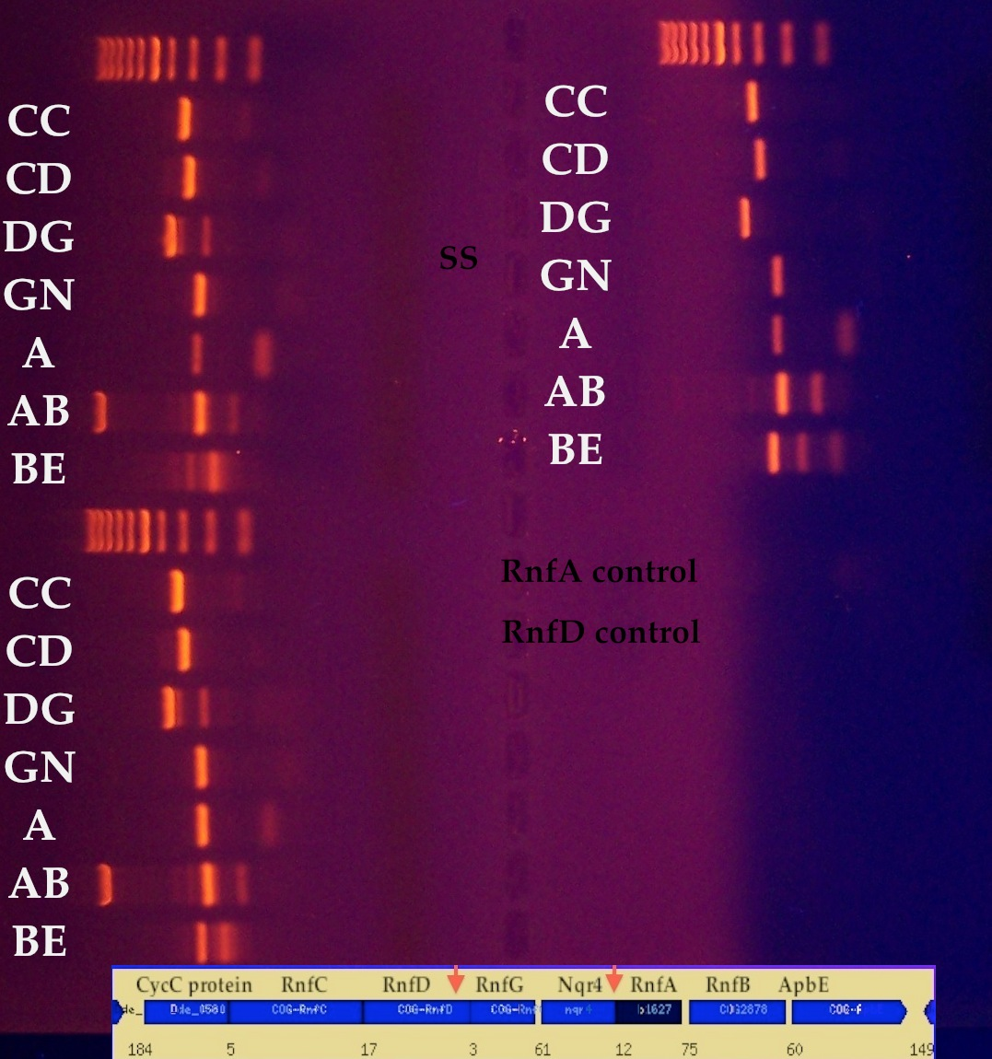

Figure S1. Results from PCR analysis showing the amplification of gene intervening regions on the transcripts. On the left of the gel, results from the rnfA mutant on on top and the rnfD mutant are underneath. The results from the parent strain are on the right side of the gel. GN corresponds to the rnfG-rnfE gap and A corresponds to the rnfE-rnfA gap represented by primers in Table 1.

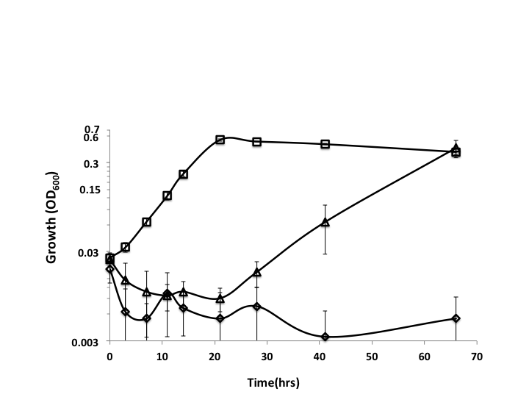
Figure. S2. Growth curve on H₂/SO₄²⁻ for D. alaskensis G20 parent strain (), the rnfA () and the rnfD () mutant. Standard deviation is shown.
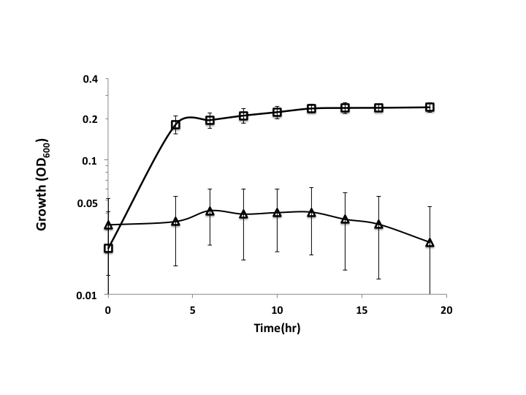
Figure. S3. Growth curve on Ethanol (25mM)/SO₄²⁻ (10 mM) for D. alaskensis G20 parent strain () and the rnfA () mutant. Standard deviation is shown.
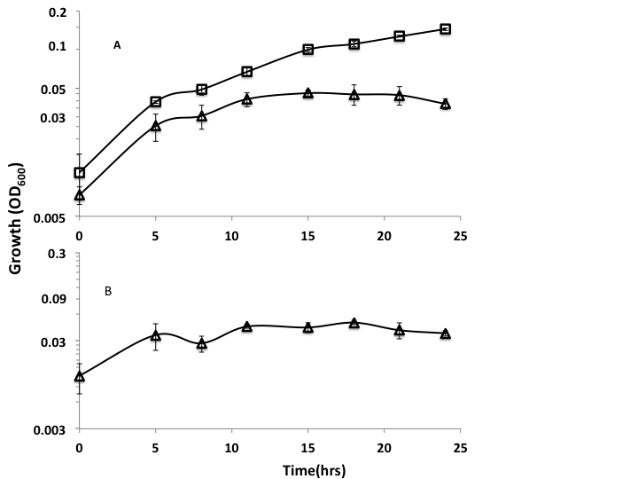
Figure S4. First day of growth curves on H₂/SO₄²⁻ for D. alaskensis G20 parent strain () and rnfD mutant (). (A) One set of cultures was incubated in the basal media described in methods (B) and the other set had 0.05% casamino acids added. Standard deviation is shown.

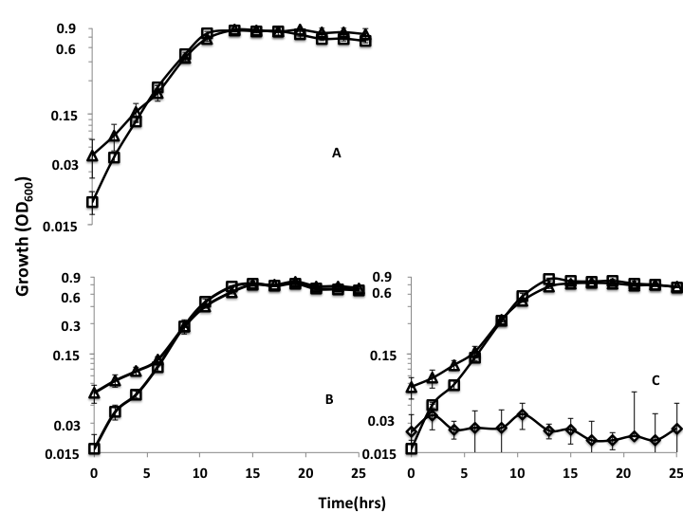
Figure S5. Growth curves on Lactate/SO₄²⁻ for D. alaskensis G20 parent strain (A), the rnfA (B) and the rnfD (C) mutant. One set of cultures was incubated with ETH 2120 (20 µM) () and the other without () . In plot C, the lack of growth of the rnfD mutant with 5uM TCS is shown (). Standard deviation is shown.

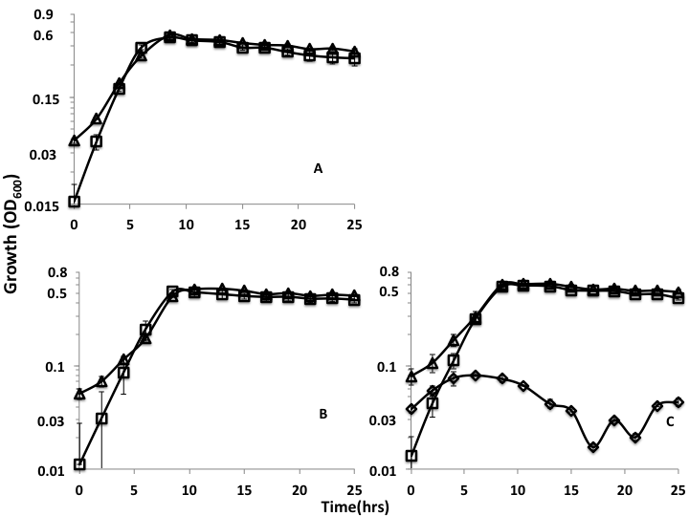
Figure S6. Growth curves on Lactate/SO₃²⁻ for D. alaskensis G20 parent strain (A), the rnfA (B) and the rnfD (C) mutant. One set of cultures was incubated with ETH 2120 (20 µM) () and the other without (). In plot C, the lack of growth of the rnfD mutant with 5uM TCS is shown (). Standard deviation is shown.
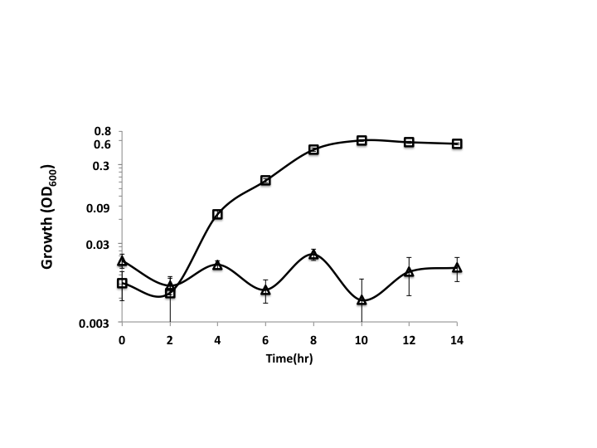
Figure S7. Growth curves on Lactate/SO₃²⁻ for D. alaskensis G20 rnfA mutant. One set of cultures was incubated with TCS (20 µM) () and the other without (). Standard deviation is shown.

