Supplementary materials

Table S1. Primer sequences designed for verifying the IR-SC boundary and accD locus region.
Table S2. Accession numbers of samples downloaded from GenBank involved in phylogenetic analysis.
Table S3. Number of each chloroplast SSR types in two Primula species.
Table S4 Detailed information of SSR loci in Primula sinensis plastid genome.
Table S5 Detailed information of SSR loci in Primula poissonii plastid genome.
Table S6 Detailed results of sequence variation in two Primula plastomes.
Figure S1. Reads remapping shows Coverage of Primula sinensis chloroplast genome.
Figure S2. This diagram shows the level of divergence between Primula sinensis and Primula poissonii.
Figure S3. Alignment of pt-accD loci of four species from Primulaceae and comparing with the coverage of Primula sinensis.
Figure S4. Multiple Alignment of Primula sinensis accD sequence shows the presence of a deletion to induce the ORF to terminate prematurely.

Table S1. Primer sequences designed for verifying the IR-SC boundary and accD locus region.
Region | primer | sequence | Product length
IRa-LSC | IRa-LSC_1F | TTATGAACCCTGTAGACCATCC | 420bp
 | IRa-LSC_1R | GATGTAGCCAAGTGGATTAAGG
IRb-SSC | IRb-SSC_1F | GAATACCGTCACCCATTCTTAC | 1157bp
 | IRb-SSC_1R | GCATTAATAGCTTGGTCCAC
LSC-IRb | LSC-IRb_1F | CATAAGTGTTTCCTCATAGG | 647bp
 | LSC-IRb_1R | GTAAGCGTCCTGTAGTAAGAG
SSC-IRa | SSC-IRa_1F | GAAAGGATCATATATTTGGCGC | 606bp
 | SSC-IRa_1R | CTAAACAGGAACAAGAGGGATC
accD | accD_1F | GGAGTTAGAGTTAGAACACAGG | 1352bp
 | accD_1R | CTTCTTCGTTTGTTCTTGTC

Table S2. Accession numbers of samples downloaded from GenBank involved in phylogenetic analysis.
Species | Family | Accession number
Primula poissonii | Primulaceae | NC_024543
Androsace bulleyana | Primulaceae | KU513438
Lysimachia coreana | Primulaceae | NC_026197
Ardisia polysticta | Primulaceae | KC465962
Actinidia chinensis | Actinidiaceae | KP297243
Camellia yunnanensis | Theaceae | KF156838
Vaccinium macrocarpon | Ericaceae | JQ757046
Arbutus unedo | Ericaceae | JQ067650
Agrostemma githago | Caryophyllaceae | KF527884

Table S3. Number of each chloroplast SSR types in two Primula species.
 | Motif | Primula sinensis | Primula poissonii
Mononucleotide | T | 75 | 73
 | A | 65 | 52
 | C | 2 | 3
 | G | 6 | 1
Dinucleotide | TA | 16 | 16
 | AT | 8 | 11
 | TC | 7 | 7
 | GA | 5 | 6
 | AG | 5 | 4
 | CT | 3 | 2
Trinucleotide | ATT | 0 | 1
 | TAT | 0 | 1
 | TAA | 1 | 0

Table S4 Detailed information of SSR loci in Primula sinensis plastid genome.
SSR type | Numbers of SSR | Distributions
(A)₈ | 18 | 4355-4362, 4526-4533, 13492-13499, 27544-27551, 31620-31627, 35852-35859, 41450-41457, 42091-42098, 68041-68048, 68659-68666, 73573-73580, 79746-79753, 80808-80815, 86258-86265, 111685-111692, 112633-112640, 125192-125199, 150700-150707
(A)₉ | 29 | 4315-4323, 5365-5373, 13594-13602, 15908-15916, 18262-18270, 20024-20032, 28672-28680, 35023-35031, 35525-35533, 46488-46496, 46528-46536, 54099-54107, 56154-56162, 56295-56303, 61630-61638, 64576-64584, 68383-68391, 68400-68408, 73263-73271, 87433-87441, 107500-107508, 107611-107619, 110114-110122, 110713-110721, 111322-111330, 115687-115695, 118263-118271, 132459-132467, 141300-141308
(A)₁₀ | 8 | 3663-3672, 23236-23245, 30069-30078, 42199-42208, 45639-45648, 58290-58299, 69306-69315, 75191-75200
(A)₁₁ | 3 | 1534-1544, 6708-6718, 46821-46831
(A)₁₂ | 4 | 8096-8107, 12426-12437, 46144-46155, 110986-110997
(A)₁₃ | 2 | 11562-11574, 13157-13169
(A)₁₄ | 1 | 79210-79223
(T)₈ | 30 | 2121-2128, 5344-5351, 5712-5719, 13669-13676, 14194-14201, 30702-30709, 36381-36388, 41816-41823, 50535-50542, 50671-50678, 53959-53966, 58778-58785, 59449-59456, 61891-61898, 69947-69954, 77169-77176, 80746-80753, 82217-82224, 110537-110544, 112023-112030, 120535-120542, 121400-121407, 121686-121693, 122072-122079, 122578-122585, 122881-122888, 123185-123192, 123440-123447, 124715-124722, 146659-146666
(T)₉ | 18 | 4922-4930, 7382-7390, 7705-7713, 8620-8628, 9911-9919, 18014-18022, 31382-31390, 47331-47339, 80629-80637, 91616-91624, 100457-100465, 110425-110433, 117664-117672, 120228-120236, 123227-123235, 124955-124963, 125416-125424, 145483-145491
(T)₁₀ | 8 | 6252-6261, 25830-25839, 53519-53528, 66562-66571, 68825-68834, 76313-76322, 123504-123513, 124730-124739
(T)₁₁ | 11 | 18120-18130, 31047-31057, 43322-43332, 67559-67569, 67619-67629, 73682-73692, 78108-78118, 121911-121921, 123156-123166, 124044-124054, 125162-125172
(T)₁₂ | 4 | 3625-3636, 56206-56217, 72134-72145, 78626-78637
(T)₁₃ | 2 | 9779-9791, 117560-117572
(T)₁₅ | 2 | 8443-8457, 50466-50480
(G)₈ | 3 | 46497-46504, 46537-46544, 69869-69876
(G)₉ | 1 | 45649-45657
(G)₁₀ | 1 | 101485-101494
(G)₁₃ | 1 | 35506-35518
(C)₉ | 1 | 120442-120450
(C)₁₀ | 1 | 131430-131439
(AT)₄ | 5 | 24053-24060, 35594-35601, 44586-44593, 54123-54130, 60676-60683
(AT)₅ | 2 | 19505-19514, 110473-110482
(AT)₇ | 1 | 79780-79793
(AG)₄ | 5 | 30160-30167, 74488-74495, 92768-92775, 99922-99929, 129304-129311
(TA)₄ | 14 | 2160-2167, 6678-6685, 12296-12303, 12943-12950, 41306-41313, 46358-46365, 46367-46374, 57903-57910, 76017-76024, 76232-76239, 90819-90826, 94943-94950, 137974-137981, 142098-142105
(TA)₆ | 1 | 7029-7040
(TA)₇ | 1 | 64594-64607
(TC)₄ | 7 | 48597-48604, 69225-69232, 121370-121377, 132994-133001, 147471-147478, 148458-148465, 148470-148477
(CT)₄ | 3 | 18963-18970, 103613-103620, 140149-140156
(GA)₄ | 5 | 34762-34769, 84447-84454, 84459-84466, 85446-85453, 114653-114660
(TAA)₄ | 1 | 44144-44155

Table S5 Detailed information of SSR loci in Primula poissonii plastid genome.
SSR type | Numbers of SSR | Distributions
(A)8 | 30 | 139-146, 1480-1487, 2698-2705, 3585-3592, 7652-7659, 12943-12950, 13238-13245, 17993-18000, 21681-21688, 27174-27181, 30002-30009, 35846-35853, 36106-36113, 41717-41724, 46450-46457, 54083-54090, 54588-54595, 56645-56652, 65032-65039, 69829-69836, 71372-71379, 75066-75073, 87643-87650, 108634-108641, 112374-112381, 112736-112743, 113938-113945, 126215-126222, 142012-142019, 151580-151587
(A)9 | 13 | 5291-5299, 11315-11323, 28326-28334, 45866-45874, 47106-47114, 54127-54135, 82112-82120, 87756-87764, 88932-88940, 110162-110170, 111779-111787, 112136-112144, 116766-116774
(A)10 | 6 | 7824-7833, 62535-62544, 68721-68730, 74749-74758, 112022-112031, 133409-133418
(A)11 | 1 | 81291-81301
(A)12 | 1 | 6581-6592
(A)13 | 1 | 80712-80724
(T)8 | 32 | 2063-2070, 3847-3854, 5488-5495, 8493-8500, 13610-13617, 13943-13950, 27122-27129, 36678-36685, 41501-41508, 42085-42092, 50530-50537, 54451-54458, 58419-58426, 59776-59783, 70865-70872, 81928-81935, 83522-83529, 93090-93097, 111598-111605, 113083-113090, 113577-113584, 113643-113650, 115284-115291, 118628-118635, 118881-118888, 122835-122842, 123721-123728, 124015-124022, 124307-124314, 125735-125742, 126468-126475, 147459-147466
(T)9 | 23 | 4883-4891, 6167-6175, 7272-7280, 17744-17752, 28924-28932, 30566-30574, 41367-41375, 50923-50931, 56709-56717, 78711-78719, 80142-80150, 82055-82063, 118707-118715, 121336-121344, 123221-123229, 124349-124357, 124550-124558, 125071-125079, 125560-125568, 125750-125758, 125978-125986, 146169-146177, 147345-147353
(T)10 | 11 | 15953-15962, 26765-26774, 43580-43589, 54012-54021, 58488-58497, 59188-59197, 69069-69078, 77857-77866, 79613-79622, 101691-101700, 124529-124538
(T)11 | 4 | 17850-17860, 42575-42585, 123060-123070, 126185-126195
(T)12 | 2 | 25549-25560, 34957-34968
(T)13 | 1 | 48362-48374
(C)8 | 2 | 36098-36105, 71952-71959
(C)9 | 1 | 108720-108728
(G)9 | 1 | 76593-76601
(AG)4 | 4 | 30746-30753, 94175-94182, 101156-101163, 130255-130262
(AT)4 | 8 | 6472-6479, 19148-19155, 23772-23779, 35912-35919, 44817-44824, 54611-54618, 61580-61587, 111535-111542
(AT)5 | 2 | 29605-29614, 46509-46518
(AT)7 | 1 | 123286-123299
(TA)4 | 13 | 2102-2109, 6912-6919, 12058-12065, 58827-58834, 67474-67481, 77562-77569, 77776-77783, 92303-92310, 96329-96336, 119278-119285, 124119-124126, 138773-138780, 142799-142806
(TA)5 | 1 | 47071-47080
(TA)6 | 1 | 46626-46637
(TA)7 | 1 | 45747-45760
(TC)4 | 7 | 48962-48969, 70651-70658, 129935-129942, 133945-133952, 148352-148359, 149339-149346, 149351-149358
(GA)4 | 6 | 35093-35100, 85751-85758, 85763-85770, 86750-86757, 105167-105174, 115695-115702
(CT)4 | 2 | 104847-104854, 140927-140934
(TAT)4 | 1 | 76796-76807
(ATT)4 | 1 | 80164-80175

Table S6 Detailed results of sequence variation in two Primula plastomes.
No. | Region | Aligned position | Aligned length | NSs | Indels | PIC | Pi
1 | trnH-psbA | 76-289 | 213 | 39 | 3 | 42 | 0.24375
2 | psbA-matK | 1351-1878 | 527 | 36 | 4 | 40 | 0.071429
3 | matK | 1879-3416 | 1539 | 88 | 1 | 89 | 0.057743
4 | trnK-rps16 | 4175-5016 | 841 | 71 | 11 | 82 | 0.095816
5 | rps16-trnQ | 6139-6963 | 825 | 216 | 18 | 234 | 0.305516
6 | psbK-psbI | 7573-7929 | 356 | 26 | 5 | 31 | 0.078078
7 | trnS-trnG | 8243-8951 | 708 | 70 | 8 | 78 | 0.110063
8 | trnG intron | 8974-9705 | 731 | 39 | 2 | 41 | 0.056034
9 | atpH-atpI | 13739-14486 | 747 | 57 | 6 | 63 | 0.078082
10 | rps2-rpoC2 | 16161-16395 | 234 | 17 | 2 | 19 | 0.082927
11 | rpoB-trnC | 26786-27978 | 1192 | 74 | 12 | 86 | 0.074522
12 | trnC-petN | 28059-28518 | 459 | 44 | 3 | 47 | 0.101852
13 | petN-psbM | 28608-29617 | 1009 | 66 | 13 | 79 | 0.078853
14 | psbM-trnD | 29743-30984 | 1241 | 64 | 12 | 76 | 0.078431
15 | trnT-psbD | 32116-33414 | 1298 | 67 | 13 | 80 | 0.06381
16 | psbZ-rps14 | 36721-37429 | 708 | 48 | 9 | 57 | 0.07218
17 | psaA-pafI | 42345-42941 | 596 | 40 | 10 | 50 | 0.074212
18 | pafI-trnS | 44900-45777 | 877 | 63 | 9 | 72 | 0.07563
19 | trnT-trnL | 47203-48073 | 870 | 62 | 8 | 70 | 0.097946
20 | trnL-trnF | 48110-49072 | 962 | 55 | 12 | 67 | 0.066345
21 | trnF-ndhJ | 49145-49823 | 678 | 45 | 9 | 54 | 0.078125
22 | ndhC-trnV | 51503-52454 | 952 | 146 | 18 | 164 | 0.192612
23 | pafII-cemA | 61660-62187 | 527 | 48 | 9 | 57 | 0.108352
24 | petA-psbJ | 64077-65108 | 1031 | 70 | 13 | 83 | 0.116086
25 | psbE-petL | 65889-67008 | 1119 | 81 | 8 | 89 | 0.084025
26 | petL-trnP | 67104-67770 | 666 | 41 | 8 | 49 | 0.064669
27 | trnP-psaJ | 67844-68251 | 406 | 28 | 6 | 34 | 0.075676
28 | psaJ-rpl33 | 68386-68888 | 502 | 32 | 5 | 37 | 0.06823
29 | rpl20-clpP | 70196-71229 | 1033 | 61 | 6 | 67 | 0.05957
30 | clpP-psbB | 72404-73836 | 1434 | 69 | 11 | 80 | 0.053118
31 | rpl36-rps8 | 81186-81542 | 356 | 102 | 6 | 108 | 0.331169
32 | ndhF_partial | 111520-111963 | 445 | 29 | 1 | 30 | 0.066514
33 | ndhF-rpl32 | 113483-114384 | 901 | 78 | 15 | 93 | 0.09319
34 | rpl32-trnL | 114546-114981 | 435 | 59 | 7 | 66 | 0.154047
35 | ccsA-ndhD | 116152-116362 | 210 | 33 | 5 | 38 | 0.168367
36 | psaC-ndhG | 118266-119088 | 823 | 52 | 4 | 56 | 0.066667
37 | ndhG-ndhI | 119619-119969 | 350 | 27 | 4 | 31 | 0.083077
38 | ndhA_intron | 121117-122273 | 1156 | 66 | 13 | 79 | 0.066398
39 | rps15-ycf1 | 124360-124746 | 387 | 38 | 5 | 43 | 0.111765
40 | ycf1_partial1 | 125548-126529 | 982 | 68 | 3 | 71 | 0.072805
41 | ycf1_partial2 | 126671-128233 | 1562 | 107 | 4 | 111 | 0.075299
42 | rbcL+matK+ITS | n.a. | 3594 | 225 | 7 | 232 | 0.06299

Figure S1. Reads remapping shows Coverage of Primula sinensis chloroplast genome. Vertical axis represents the common logarithm (log10) of each position coverage value. Horizontal axis represents each position of corrected complete chloroplast genome.
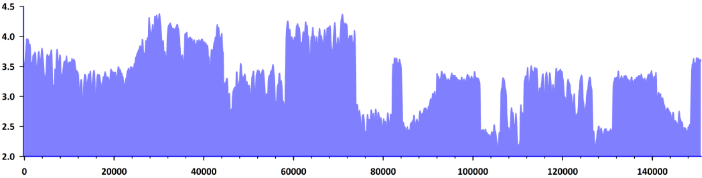

Figure S2. This diagram shows the level of divergence between Primula sinensis and Primula poissonii. The horizontal axis represents coordinate position of each sliding window within the plastome alignment of two Primula species. The vertical scale indicates the Pi value of each window region for illustrating divergence levels. Red dashed line shows the criterion of divergence value corresponding to the concatenated sequence of three barcode regions (rbcL+matK+ITS). Above peak graph, black arrows represent the annotations of coding genes indicating the position and direction of each gene in this alignment.
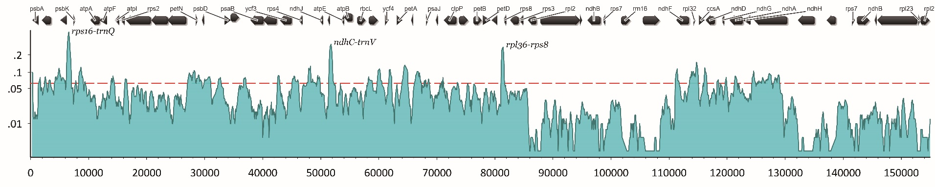

Figure S3. Alignment of pt-accD loci of four species from Primulaceae and comparing with the coverage of Primula sinensis.
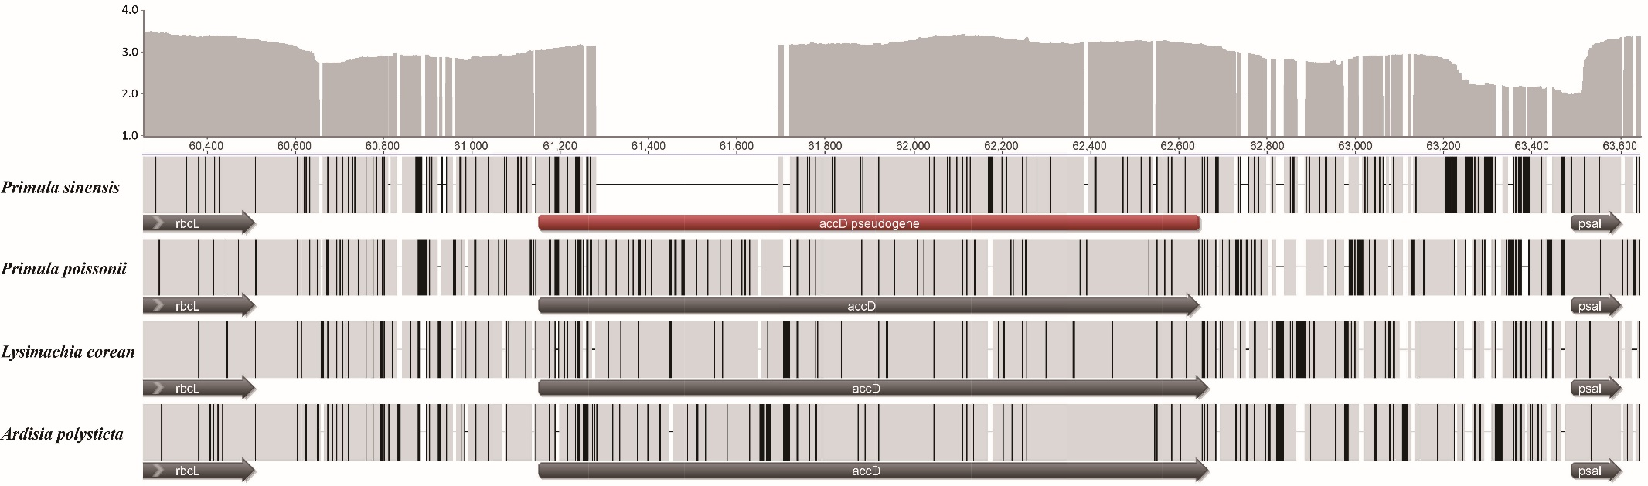

Figure S4. Multiple alignment of Primula sinensis accD sequence shows the presence of a deletion to induce the ORF to terminate prematurely. Red color indicates the reduced ORF without C-terminal functional structure sequence.
