Table S1 The 21 accessions of colored calla lily used in present study for transcriptome sequencing and EST-SSR markers development.
Cultivars/hybrids | Origins | Spathe Color | Type | Photographs
Rehmannii | Netherlands | Pink | Pot-flower | 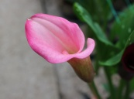
Elmaro | New Zealand | Yellow | Pot-/Cut- flower | 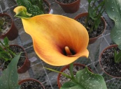
Parfait | American | Pink | Pot-flower | 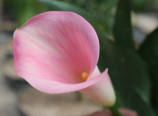
Pink Diamond | New Zealand | Pink | Cut-flower | 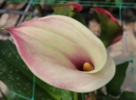
Super Gem | American | Pink | Pot-flower | 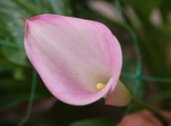
Rose Gem | American | Pink | Pot-flower | 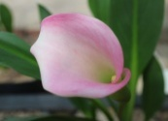
Butter Gold | New Zealand | Yellow | Cut-flower | 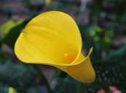
Odessa | Netherlands | Purple | Pot-flower | 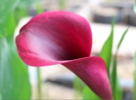
Black Magic | New Zealand | Yellow | Cut-flower | 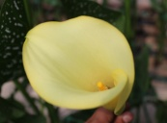
Jingcai Yangguang | China | Yellow | Cut-flower | 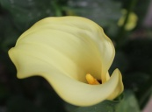
Majestic Red | New Zealand | Red | Pot-flower | 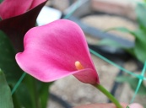
Xiangyuan Red | China | Red | Pot-flower | 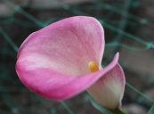
Sunny Baby | New Zealand | Yellow | Pot-/Cut- flower | 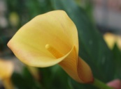
Captain Reno | Netherlands | Purple | Pot-/Cut- flower | 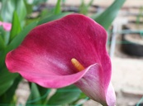
Allure | Netherlands | Red | Pot-flower | 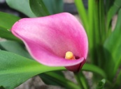
Greta | New Zealand | Purple | Pot-flower | 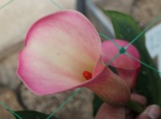
Goldilocks | New Zealand | Yellow | Pot-flower | 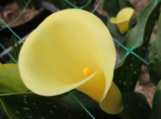
Captain Romance | Netherlands | Pink | Pot-/Cut- flower | 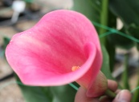
Captain Murano | Netherlands | Orange | Pot-/Cut- flower | 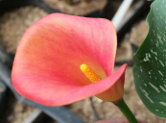
Gold affair | New Zealand | Yellow | Pot-/Cut- flower | 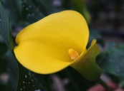
ZH | China | Yellow | Cut-flower | 