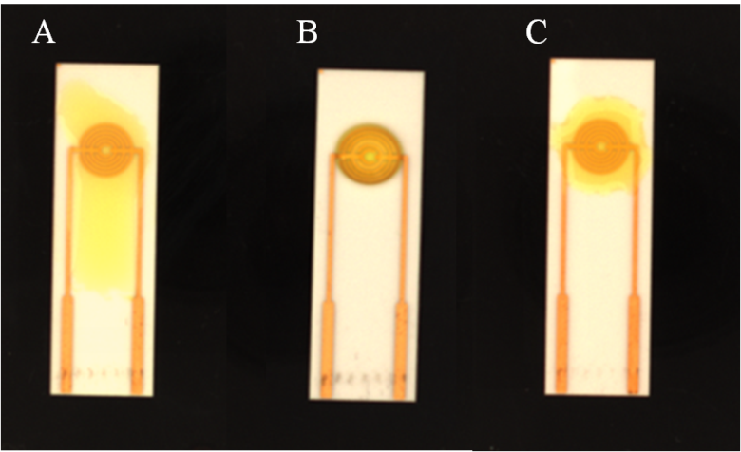
Figure S2. Droplets coverage of the different SPIMs. (A) bare clean SPIM, (B) modified by protein and C) incubation for 2h after the protein immobilization. Yellow solution (K₃Fe(CN)₆/K₄Fe(CN)₆) was used to show the different coverage.

