Colony | Tributyrin  agar | Rhodamine agar | Victoria blue agar
1 | + | + | +
2 | + | + | +
3 | + | - | -

Table 1: Qualitative determination of recombinant E.coli harbouring putative lipase gene. Major lipid component in the Rhodamine B and Victoria blue agar plates contain olive oil and triolein, respectively

Purification table:
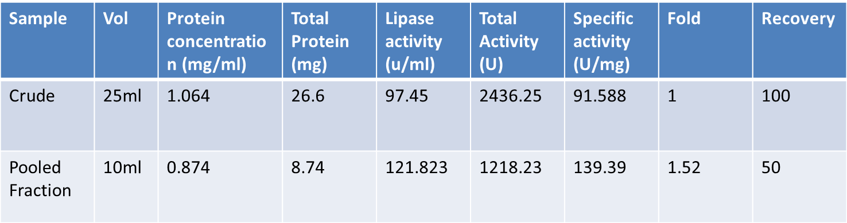

Effect of temperature on lipase activity
Temperature | U/mg | Error (+-)
5 °C | 6.22 | 0.093
10 °C | 8.29 | 0.082
20 °C | 17.73 | 0.16
30 °C | 34.48 | 0.52
40 °C | 66.20 | 1.3
50 °C | 75.41 | 1.5
60 °C | 70.81 | 1.34
70 °C | 11.98 | 0.131

Effect of temperature on stability
Temperature | Relative activity %
5 °C | 88 +-0.2
10 °C | 85 +-0.5
20 °C | 91 +-0.9
30 °C | 100 +-0.95
40 °C | 98 +-1
50 °C | 85 +-1.1
60 °C | 65 +-0.2
70 °C | 18 +-0.2

Effect of pH on activity.
pH | U/mg | Error (+-)
SA 4 | 2.88 | 0.026
SA 5 | 41.37 | 0.39
SA 6 | 39.93 | 1.1
PB 6 | 44.50 | 2.45
PB 7 | 48.20 | 2.5
PB 8 | 50.37 | 2.53
TH 8 | 49.08 | 2.44
TH 9 | 32.73 | 1.3
GN 9 | 32.38 | 1.46
GN10 | 24.36 | 0.51
GN11 | 11.14 | 0.12
GN12 | 3.95 | 0.03

Effect of pH stability
pH | Relative activity %
SA 4 | 2.66+-2.1
SA 5 | 72.11+-1.7
SA 6 | 83.32+-3.2
PB 6 | 89.45+-4
PB 7 | 100+-4
PB 8 | 95.01+-3.7
TH 8 | 95.69+-2.9
TH 9 | 85.03+-3.9
GN 9 | 94.48+-2.1
GN10 | 56.3+-2.3
GN11 | 12.4+-2.1
GN12 | 4.98+-1.7

Effect of metal ion
 | 1 mM | Error(+-) | 5 mM | Error(+-)
Control | 100 | 2.9 | 100 | 2.5
Li⁺ | 161 | 3.2 | 28.3 | 0.75
Na⁺ | 104.6 | 3.0 | 98 | 3.8
K⁺ | 83.4 | 2.1 | 122.4 | 4.1
Rb⁺ | 161.9 | 3.0 | 83.6 | 3.2
Mg²⁺ | 89.1 | 2.9 | 61.2 | 2.9
Ca²⁺ | 72.3 | 2.1 | 55.7 | 3.7
Mn²⁺ | 70.5 | 0.9 | 55.5 | 2.5
Fe²⁺ | 88.7 | 1.2 | 44.4 | 2.4
Co²⁺ | 88.9 | 1.7 | 100 | 4
Ni²⁺ | 61 | 0.9 | 33.4 | 0.9
Zn²⁺ | 150 | 3.2 | 72.3 | 1.2

Effect of Organic solvent:
Organic solvent | Relative activity %
Control | 100+-2.1
DMSO | 73.78+-3.7
Methanol (-0.76) | 88.91+-3.1
Acetonitril (-0.33) | 7.96+-4.5
Ethanol (-0.24) | 36.22+-4.1
Acetone (-0.24) | 25.9+-3.9
1-propanol (0.28) | 6.58+-4.8
Chloroform (2.0) | 20.74+-6.1
Benzene (2.0) | 42.12+-5.5
Toulene (2.5) | 30.22+-5.2
Xylene (3.1) | 40.17+-3.9
n-hexane (3.5) | 116.58+-4.7

