Supplementary 1
List of strains used in the preliminary study
All strains are B. pseudomallei unless stated (S- susceptible, R- resistant)
 |  |  | Published | Published | Study | Magainin 2 | Sushi 1 | Sushi 2 | Ornithine | V2D | 1037 | 1018 | DJK 5
Type of strains | Source | Label | LL-37 | PG1 | TP1
Clinical |  | UMC002 | S | S | S | R | R | R | R | R | R | R | R
Clinical |  | UMC006 | S | S | S | R | R | R | R | R | R | R | R
Clinical |  | UMC007 | S | S | S | R | R | R | R | R | R | R | R
Clinical |  | UMC009 | S | S | S | R | R | R | R | R | R | R | R
Clinical |  | UMC010 | S | S | S | R | R | R | R | R | R | R | R
Clinical |  | UMC011 | S | S | R | R | R | R | R | R | R | R | R
Clinical |  | UMC012 | S | S | S | R | R | R | R | R | R | R | R
Clinical |  | UMC013 | S | S | S | R | R | R | R | R | R | R | R
Clinical |  | UMC014 | S | S | S | R | R | R | R | R | R | R | R
Clinical |  | UMC015 | S | S | S | R | R | R | R | R | R | R | R
Clinical |  | UMC016 | S | S | S | R | R | R | R | R | R | R | R
Clinical |  | UMC019 | S | S | S | R | R | R | R | R | R | R | R
Clinical |  | UMC020 | S | S | R | R | R | R | R | R | R | R | R
Clinical |  | UMC021 | S | S | S | R | R | R | R | R | R | R | R
Clinical |  | UMC022 | S | S | S | R | R | R | R | R | R | R | R
Clinical |  | UMC023 | S | S | S | R | R | R | R | R | R | R | R
Clinical |  | UMC024 | S | S | S | R | R | R | R | R | R | R | R
Clinical |  | UMC025 | S | S | S | R | R | R | R | R | R | R | R
Clinical |  | UMC026 | S | S | S | R | R | R | R | R | R | R | R
Clinical |  | UMC027 | S | S | S | R | R | R | R | R | R | R | R
Clinical |  | UMC028 | S | S | R | R | R | R | R | R | R | R | R
Clinical |  | UMC029 | S | S | S | R | R | R | R | R | R | R | R
Clinical |  | UMC030 | S | S | S | R | R | R | R | R | R | R | R
Clinical |  | UMC031 | S | S | S | R | R | R | R | R | R | R | R
Clinical |  | UMC032 (K96243) | S | S | S | R | R | R | R | R | R | R | R
Clinical |  | UMC033 | S | S | S | R | R | R | R | R | R | R | R
Clinical |  | UMC034 | S | S | R | R | R | R | R | R | R | R | R
Clinical |  | UMC035 | S | S | S | R | R | R | R | R | R | R | R
Clinical |  | UMC036 | S | S | S | R | R | R | R | R | R | R | R
Clinical |  | UMC038 | S | S | R | R | R | R | R | R | R | R | R
Clinical |  | UMC039 | S | S | S | R | R | R | R | R | R | R | R
Clinical |  | UMC040 | S | S | S | R | R | R | R | R | R | R | R
Clinical |  | UMC042 | S | S | S | R | R | R | R | R | R | R | R
Clinical |  | UMC043 | S | S | S | R | R | R | R | R | R | R | R
Clinical |  | UMC044 | S | S | S | R | R | R | R | R | R | R | R
Clinical |  | UMC045 | S | S | S | R | R | R | R | R | R | R | R
Clinical |  | UMC046 | S | S | S | R | R | R | R | R | R | R | R
Clinical |  | UMC047 | S | S | S | R | R | R | R | R | R | R | R
Clinical |  | UMC048 | S | S | R | R | R | R | R | R | R | R | R
Clinical |  | UMC049 | S | S | S | R | R | R | R | R | R | R | R
Clinical |  | UMC049L | S | S | S | R | R | R | R | R | R | R | R
Clinical |  | UMC049S | S | S | R | R | R | R | R | R | R | R | R
Clinical |  | UMC050 | S | S | S | R | R | R | R | R | R | R | R
Clinical |  | UMC051 | S | S | S | R | R | R | R | R | R | R | R
Clinical |  | UMC052 | S | S | S | R | R | R | R | R | R | R | R
Clinical |  | UMC053 | S | S | R | R | R | R | R | R | R | R | R
Clinical |  | UMC054A | S | S | S | R | R | R | R | R | R | R | R
Clinical |  | UMC054B | S | S | S | R | R | R | R | R | R | R | R
Clinical |  | UMC055 | S | S | S | R | R | R | R | R | R | R | R
Clinical |  | UMC056 | S | S | R | R | R | R | R | R | R | R | R
Clinical |  | UMC057 | S | S | S | R | R | R | R | R | R | R | R
Clinical |  | UMC058 | S | S | S | R | R | R | R | R | R | R | R
Clinical |  | UMC059 | S | S | S | R | R | R | R | R | R | R | R
Clinical |  | UMC061 | S | S | R | R | R | R | R | R | R | R | R
Clinical |  | UMC061A | S | S | S | R | R | R | R | R | R | R | R
Clinical |  | UMC061B | S | S | S | R | R | R | R | R | R | R | R
Clinical |  | UMC062 | S | S | R | R | R | R | R | R | R | R | R
Clinical |  | UMC063 | S | S | S | R | R | R | R | R | R | R | R
Clinical |  | UMC064 | S | S | S | R | R | R | R | R | R | R | R
Clinical |  | UMC065 | S | S | S | R | R | R | R | R | R | R | R
Clinical |  | UMC066 | S | S | S | R | R | R | R | R | R | R | R
Clinical |  | UMC067 | S | S | S | R | R | R | R | R | R | R | R
Clinical |  | UMC068 | S | S | S | R | R | R | R | R | R | R | R
Clinical |  | UMC069 | S | S | R | R | R | R | R | R | R | R | R
Clinical |  | UMC070 | S | S | S | R | R | R | R | R | R | R | R
Clinical |  | UMC071 | S | S | S | R | R | R | R | R | R | R | R
Clinical |  | UMC072 | S | S | S | R | R | R | R | R | R | R | R
Clinical |  | UMC073 | S | S | R | R | R | R | R | R | R | R | R
Clinical |  | UMC074 | S | S | S | R | R | R | R | R | R | R | R
Clinical |  | UMC074L | S | S | S | R | R | R | R | R | R | R | R
Clinical |  | UMC074S | S | S | S | R | R | R | R | R | R | R | R
Clinical |  | UMC076 | S | S | S | R | R | R | R | R | R | R | R
Clinical |  | UMC077 | S | S | R | R | R | R | R | R | R | R | R
Clinical |  | UMC078 | S | S | S | R | R | R | R | R | R | R | R
Clinical |  | UMC079 | S | S | S | R | R | R | R | R | R | R | R
Clinical |  | UMC080 | S | S | S | R | R | R | R | R | R | R | R
Clinical |  | UMC081 | S | S | S | R | R | R | R | R | R | R | R
Clinical |  | UMC082 | S | S | S | R | R | R | R | R | R | R | R
Clinical |  | UMC084 | S | S | R | R | R | R | R | R | R | R | R
Clinical |  | UMC085 | S | S | S | R | R | R | R | R | R | R | R
Clinical |  | UMC086 | S | S | S | R | R | R | R | R | R | R | R
Clinical |  | UMC087 | S | S | S | R | R | R | R | R | R | R | R
Clinical |  | UMC088 | S | S | R | R | R | R | R | R | R | R | R
Clinical |  | UMC089 | S | S | S | R | R | R | R | R | R | R | R
Clinical |  | UMC105 | S | S | R | R | R | R | R | R | R | R | R
Clinical |  | UMC106 | S | S | S | R | R | R | R | R | R | R | R
Clinical |  | UMC107 | S | S | S | R | R | R | R | R | R | R | R
Clinical |  | UMC108 | S | S | S | R | R | R | R | R | R | R | R
Clinical |  | UMC109 | S | S | S | R | R | R | R | R | R | R | R
Animal |  | UMA001 | S | S | S | R | R | R | R | R | R | R | R
Animal |  | UMA002 | S | S | S | R | R | R | R | R | R | R | R
Animal |  | UMA003 | S | S | S | R | R | R | R | R | R | R | R
Animal |  | UMA004 | S | S | S | R | R | R | R | R | R | R | R
Animal |  | UMA005 | S | S | S | R | R | R | R | R | R | R | R
Animal |  | UMA006 | S | S | S | R | R | R | R | R | R | R | R
Animal |  | UMA007 | S | S | S | R | R | R | R | R | R | R | R
Animal |  | UMA008 | S | S | S | R | R | R | R | R | R | R | R
Animal |  | UMA009 | S | S | S | R | R | R | R | R | R | R | R
Environmental |  | UME001 | S | S | S | R | R | R | R | R | R | R | R
 |  | E. coli ATCC 25922 | S | S | S | S | S | S | S | S | S | R | R

Supplementary 2
Antibiotic susceptibility of strains used in the preliminary study (S- susceptible, R- resistant)
All strains are B. pseudomallei unless stated
 | Antibiotic susceptibility (µg/ml) by disk diffusion
Type of strains |  | CIP 5 | C 10 | DXT 30 | IMI 10 | MRP 10 | TGC 15 | SXT | CAZ 30 | AUG--30
Clinical | UMC002 | I | S | S | S | S | R | R | S | I
Clinical | UMC006 | I | R | S | S | S | R | R | S | I
Clinical | UMC007 |  |  |  |  |  |  |  |  |  | Not available
Clinical | UMC009 |  |  |  |  |  |  |  |  |  | Not available
Clinical | UMC010 | S | S | S | S | S | R | R | S | R
Clinical | UMC011 | I | S | S | S | S | R | R | S | S
Clinical | UMC012 |  |  |  |  |  |  |  |  |  | Not available
Clinical | UMC013 |  |  |  |  |  |  |  |  |  | Not available
Clinical | UMC014 | I | I | S | S | S | R | R | S | S
Clinical | UMC015 | I | I | S | S | S | R | R | S | I
Clinical | UMC016 | S | I | S | S | S | R | R | S | R
Clinical | UMC019 | S | S | S | S | S | R | R | S | R
Clinical | UMC020 | I | S | S | S | S | R | R | S | R
Clinical | UMC021 | S | S | S | S | S | R | R | S | I
Clinical | UMC022 | S | S | S | S | S | I | R | S | S
Clinical | UMC023 | R | R | S | S | S | R | R | S | R
Clinical | UMC024 | S | S | S | S | S | R | R | S | R
Clinical | UMC025 | S | S | S | S | S | R | R | S | R
Clinical | UMC026 | I | S | S | S | S | R | R | S | I
Clinical | UMC027 |  |  |  |  |  |  |  |  |  | Not available
Clinical | UMC028 |  |  |  |  |  |  |  |  |  | Not available
Clinical | UMC029 |  |  |  |  |  |  |  |  |  | Not available
Clinical | UMC030 |  |  |  |  |  |  |  |  |  | Not available
Clinical | UMC031 |  |  |  |  |  |  |  |  |  | Not available
Clinical | UMC032 (K96243) | S | I | S | S | S | R | R | S | I
Clinical | UMC033 | S | S | S | S | S | R | R | S | I
Clinical | UMC034 | S | S | S | S | S | R | R | S | S
Clinical | UMC035 | S | I | S | S | S | R | R | S | R
Clinical | UMC036 | I | I | S | S | S | R | R | S | I
Clinical | UMC038 |  |  |  |  |  |  |  |  |  | Not available
Clinical | UMC039 |  |  |  |  |  |  |  |  |  | Not available
Clinical | UMC040 | I | S | S | S | S | R | R | S | I
Clinical | UMC042 |  |  |  |  |  |  |  |  |  | Not available
Clinical | UMC043 |  |  |  |  |  |  |  |  |  | Not available
Clinical | UMC044 |  |  |  |  |  |  |  |  |  | Not available
Clinical | UMC045 |  |  |  |  |  |  |  |  |  | Not available
Clinical | UMC046 |  |  |  |  |  |  |  |  |  | Not available
Clinical | UMC047 | I | I | S | S | S | R | R | S | I
Clinical | UMC048 |  |  |  |  |  |  |  |  |  | Not available
Clinical | UMC049 | S | I | S | S | S | R | R | S | I
Clinical | UMC049L | S | I | S | S | S | R | R | S | I
Clinical | UMC049S | S | I | S | S | S | R | R | S | I
Clinical | UMC050 | I | S | S | S | S | R | R | S | R
Clinical | UMC051 |  |  |  |  |  |  |  |  |  | Not available
Clinical | UMC052 | S | S | S | S | S | R | R | S | S
Clinical | UMC053 | S | S | S | - | - | - | R | R | R
Clinical | UMC054A | I | I | S | S | S | R | I | S | I
Clinical | UMC054B | S | S | S | S | S | R | I | S | I
Clinical | UMC055 |  |  |  |  |  |  |  |  |  | Not available
Clinical | UMC056 | S | S | S | S | S | R | R | S | I
Clinical | UMC057 | I | S | S | S | S | R | R | I | R
Clinical | UMC058 | S | S | S | S | S | R | R | S | I
Clinical | UMC059 | S | I | S | S | S | R | I | S | I
Clinical | UMC061 | I | S | S | S | S | R | R | S | I
Clinical | UMC061A | I | S | S | S | S | R | R | S | I
Clinical | UMC061B | I | S | S | S | S | R | R | S | I
Clinical | UMC062 | I | S | S | S | S | R | R | S | I
Clinical | UMC063 | S | S | S | S | S | R | R | S | I
Clinical | UMC064 | I | I | S | S | S | R | I | S | R
Clinical | UMC065 | I | I | S | S | S | R | R | S | I
Clinical | UMC066 | S | I | S | S | S | R | I | S | S
Clinical | UMC067 | S | S | S | S | S | R | S | I | S
Clinical | UMC068 | S | S | S | S | S | R | R | S | S
Clinical | UMC069 | S | I | S | S | S | R | S | R | I
Clinical | UMC070 | I | I | S | S | S | R | I | S | S
Clinical | UMC071 | S | S | S | S | S | R | R | S | S
Clinical | UMC072 | S | S | S | S | S | R | R | S | S
Clinical | UMC073 | I | S | S | S | S | R | R | S | R
Clinical | UMC074 | I | I | S | S | S | R | I | S | I
Clinical | UMC074L | I | I | S | S | S | R | I | S | I
Clinical | UMC074S | I | I | S | S | S | R | I | S | I
Clinical | UMC076 |  |  |  |  |  |  |  |  |  | Not available
Clinical | UMC077 | I | I | S | S | S | R | S | S | I
Clinical | UMC078 |  |  |  |  |  |  |  |  |  | Not available
Clinical | UMC079 |  |  |  |  |  |  |  |  |  | Not available
Clinical | UMC080 |  |  |  |  |  |  |  |  |  | Not available
Clinical | UMC081 |  |  |  |  |  |  |  |  |  | Not available
Clinical | UMC082 |  |  |  |  |  |  |  |  |  | Not available
Clinical | UMC084 |  |  |  |  |  |  |  |  |  | Not available
Clinical | UMC085 |  |  |  |  |  |  |  |  |  | Not available
Clinical | UMC086 |  |  |  |  |  |  |  |  |  | Not available
Clinical | UMC087 |  |  |  |  |  |  |  |  |  | Not available
Clinical | UMC088 |  |  |  |  |  |  |  |  |  | Not available
Clinical | UMC089 |  |  |  |  |  |  |  |  |  | Not available
Clinical | UMC105 |  |  |  |  |  |  |  |  |  | Not available
Clinical | UMC106 |  |  |  |  |  |  |  |  |  | Not available
Clinical | UMC107 |  |  |  |  |  |  |  |  |  | Not available
Clinical | UMC108 |  |  |  |  |  |  |  |  |  | Not available
Clinical | UMC109 |  |  |  |  |  |  |  |  |  | Not available
Animal | UMA001 | S | I | S | S | S | S | I | S | S
Animal | UMA002 | I | S | S | S | S | I | I | S | R
Animal | UMA003 | S | S | S | S | S | S | I | S | R
Animal | UMA004 | S | S | S | S | S | S | S | S | S
Animal | UMA005 | I | S | S | S | S | I | S | S | S
Animal | UMA006 | S | S | S | S | S | S | S | S | I
Animal | UMA007 | I | S | S | S | S | R | R | R | R
Animal | UMA008 | I | S | S | S | S | S | S | S | S
Animal | UMA009 | I | S | S | S | S | I | S | S | S
Environmental | UME001 |  |  |  |  |  |  |  |  |  | Not available
 | E.coli ATCC 25922 | S | S | S | S | S | I | S | S | S

Supplementary 3
Molar concentrations of antimicrobial agents used in this study
 | Concentration in µM
Concentration of AMP (µg/ml) | TP1 | LL37 | Protegrin 1 | Magainin 2 | Sushi 1 | Sushi 3 | 1037 | 1018 | DJK5 | V2D | Ornithine
1000 | 441.74 | 222.55 | 463.89 | 405.37 | 266.1 | 257.07 | Molecular weight was not revealed by collaborators  As such, molar concentration could not be calculated
500 | 220.87 | 111.28 | 231.94 | - | - | -
250 | 110.43 | 55.64 | 115.97 | - | - | -
100 | 48.59 | 22.26 | 46.39 | - | - | -
50 | 22.35 | 11.13 | 23.19 | - | - | -
25 | 11.04 | 5.56 | 11.6 | - | - | -
12.5 | 5.52 | 2.78 | 5.8 | - | - | -
6.25 | 2.76 | 1.39 | 2.9 | - | - | -
3.13 | 1.38 | 0.7 | 1.45 | - | - | -
1.06 | 0.47 | 0.24 | 0.49 | - | - | -
0 | 0 | 0 | 0 | - | - | -

Relative Molecular Mass
Antimicrobial agents |  | Molecular mass (g/mol)
TP1 | : | 2263.78
LL37 | : | 4493.30
PG1 | : | 2155.70
Magainin 2 | : | 2466.90
Sushi 1 | : | 3758.00
Sushi 3 | : | 3890.00
Ceftazidime | : | 546.58
Meropenem | : | 383.46

Formula
$Concentration in µM=(Concentration in (µg/mL) × 10^3)/(Relative Molecular Mass)$

Supplementary 4
Abbreviations from E. coli LPS (PDB ID: 1QFG) (Adapted from Ferguson et al. (2000) )
No | Residue abbreviation | Name/ Formula/ InChl Key | 2D diagram
1. | DAO | LAURIC ACID  C₁₂ H₂₄ O₂  POULHZVOKOAJMA-UHFFFAOYSA-N
2. | DDQ | DECYLAMINE-N,N-DIMETHYL-N-OXIDE  C₁₂ H₂₇ N O  ZRKZFNZPJKEWPC-UHFFFAOYSA-N
3. | DPO | DIPHOSPHATE  O₇ P₂  XPPKVPWEQAFLFU-UHFFFAOYSA-J | 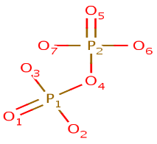
4. | FTT | 3-HYDROXY-TETRADECANOIC ACID  3-HYDROXY-MYRISTIC ACID (Synonym)  C₁₄ H₂₈ O₃  ATRNZOYKSNPPBF-CYBMUJFWSA-N
5. | GCN | 3-DEOXY-D-GLUCOSAMINE  C₆ H₁₃ N O₄  SNDZDGQLFKEBLF-MOJAZDJTSA-N | 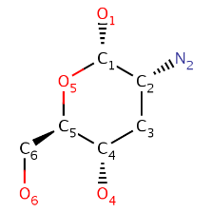
6. | GLA | ALPHA D-GALACTOSE  C₆ H₁₂ O₆  WQZGKKKJIJFFOK-PHYPRBDBSA-N | 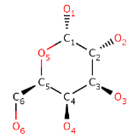
7. | GLC | ALPHA-D-GLUCOSE  C₆ H₁₂ O₆  WQZGKKKJIJFFOK-DVKNGEFBSA-N | 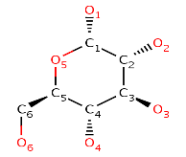
8. | GMH | L-GLYCERO-D-MANNO-HEPTOPYRANOSE  C₇ H₁₄ O₇  BGWQRWREUZVRGI-QQABCQGCSA-N | 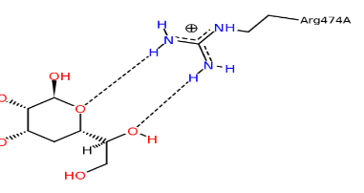
9. | GOL | GLYCEROL  GLYCERIN; PROPANE-1,2,3-TRIOL (Synonym)  C₃ H₈ O₃  PEDCQBHIVMGVHV-UHFFFAOYSA-N | 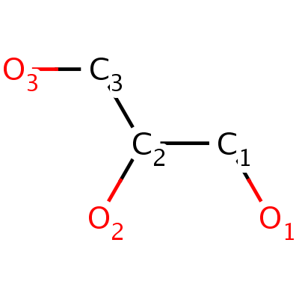
10. | KDO | 3-DEOXY-D-MANNO-OCT-2-ULOSONIC ACID  C₈ H₁₄ O₈  NNLZBVFSCVTSLA-HXUQBWEZSA-N | 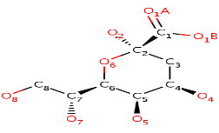
11. | MYR | MYRISTIC ACID  C₁₄ H₂₈ O₂  TUNFSRHWOTWDNC-UHFFFAOYSA-N
12. | PA1 | 2-amino-2-deoxy-alpha-D-glucopyranose  C₆ H₁₃ N O₅  MSWZFWKMSRAUBD-UKFBFLRUSA-N | 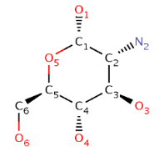
13. | PO4 | PHOSPHATE ION  O₄ P  NBIIXXVUZAFLBC-UHFFFAOYSA-K | 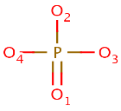
14. | NI | NICKEL (II) ION  Ni  VEQPNABPJHWNSG-UHFFFAOYSA-N

Supplementary 5
B. pseudomallei homology model verification
4.1 PROCHECK report
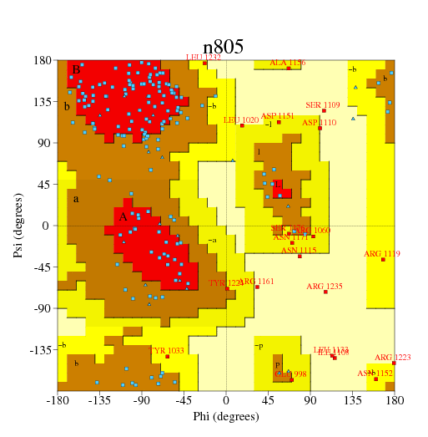

4.1.1 Ramachandran Plot statistics

No. of
residues %-tage
------ ------
Most favoured regions [A, B, L] 87 53.7%**
Additional allowed regions [a,b,l,p] 55 34.0%
Generously allowed regions [~a,~b,~l,~p] 12 7.4%
Disallowed regions [XX] 8 4.9%*
---- ------
Non-glycine and non-proline residues 162 100.0%

End-residues (excl. Gly and Pro) 2

Glycine residues 19
Proline residues 12
----
Total number of residues 195

Based on an analysis of 118 structures of resolution of at least 2.0 Angstroms and R-factor no greater than 20.0 a good quality model would be expected to have over 90% in the most favoured regions [A,B,L].

4.1.2 G-Factors
Average
Parameter Score Score
--------- ----- -----
Dihedral angles: -
Phi-psi distribution -1.63**
Chi1-chi2 distribution -0.91*
Chi1 only -0.49
Chi3 & chi4 0.58
Omega -1.62**
-1.25**
=====
Main-chain covalent forces: -
Main-chain bond lengths -0.06
Main-chain bond angles -1.62**
-0.96*
=====

OVERALL AVERAGE -1.08**
=====

G-factors provide a measure of how unusual, or out-of-the-ordinary, a property is.
Values below -0.5* - unusual
Values below -1.0** - highly unusual
Important note: The main-chain bond-lengths and bond angles are compared with the Engh & Huber (1991) ideal values derived from small-molecule data. Therefore, structures refined using different restraints may show apparently large deviations from normality.

4.2 ERRAT report
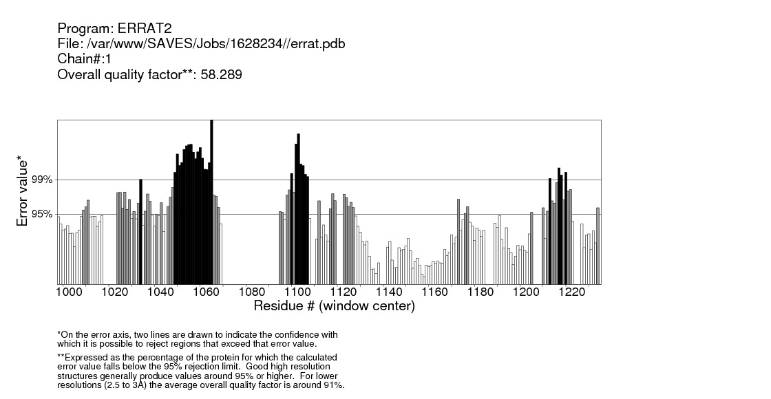

4.3 Verify 3D Results plot
76.41% of the residues had an averaged 3D-1D score >= 0.2
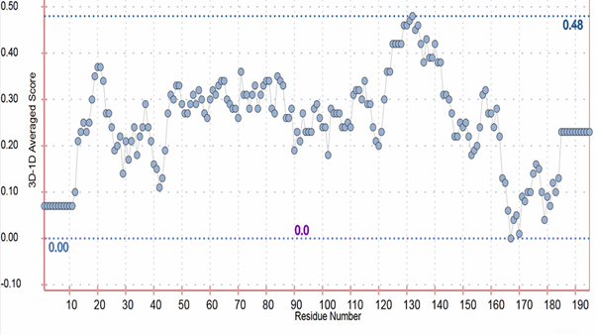

Supplementary 6
List of B. pseudomallei PDB protein molecules for molecular docking.
PDB ID | Burkholderia pseudomallei Molecules
2G0U | Solution structure of monomeric BSAL, the type III secretion needle protein
2IXR | BipD
2JOK | NMR structure of the catalytic domain of guanine nucleotide exchange factor BopE
2MPE | Solution NMR structure for strain BPSl1050
2WLL | Potassium channel
2X3Y | Crystal structure of GMHA
2XBL | Crystal structure of GMHA in complex with product
2Y78 | Crystal structure of BPSS1823, a Mip-like chaperone
3E5Y | Crystal structure of Trmh family RNA methyltransferase
3GQM | Crystal structure of cycle inhibiting factor
3LAA | Crystal structure of the trimeric autotransporteradhesin head domain BpaA
3LR3 | Periplasmic domain of the Riss sensor protein, low pH native structure
3RQI | Crystal structure of a response regulator protein with a phosphorylated aspartic acid, calcium ion and citrate
3S6O | Crystal structure of a polysaccharide deacetylase family protein
3SLG | Crystal structure of Pbgp3 protein
3TU8 | Crystal structure of the lethal factor 1
3UAM | Crystal structure of a chitin binding domain
3ZS6 | The structural characterization of OppA
4B5C | Crystal structure of the peptidoglycan-associated lipoprotein
4C26 | NMR structure of the HicA toxin
4CFI | 3D structure of FliC
4F3P | Crystal structure of a glutamine-binding periplasmic protein in complex with glutamine
4HCN | Crystal structure of protein CHBP in complex with ubiquitin
4HCP | Crystal structure of effector protein CHBP in complex with nedd8
4UT1 | The structure of the flagellar hook junction protein FlgK
4WNY | Crystal structure of a protein from the universal stress protein family

Supplementary 7
Data of residue interactions of TP1 in binding with amino acid acids of potential target proteins (interaction within 3Å of peptide are highlighted in bold number, interaction energy values less than -20 kcal/mol are shaded)
TP1 Amino Acid residue | 2G0U  (1) | 2IXR  (2) | 2JOK  (3) | 2MPE  (4) | 2WLL  (5) | 2X3Y  (6) | 2XBL  (7) | 2Y78  (8) | 3E5Y  (9) | 3GQM  (10) | 3LAA  (11) | 3LR3  (12) | 3QRI  (13) | 3S6O  (14)
LYS1 | -68.29 | -36.13 | 44.37 | -21.72 | 25.25 | 25.08 | -60.30 | -2.48 | -27.26 | 13.23 | -13.89 | -24.45 | -56.20 | -23.51
TRP2 | 4.23 | -10.00 | 9.71 | 1.89 | -16.72 | 9.16 | 2.48 | -7.32 | 15.44 | -7.48 | -20.29 | 5.39 | 22.84 | -9.28
CYS3 | 11.32 | 2.86 | -12.24 | 0.26 | 40.14 | -14.31 | -6.77 | 5.47 | -6.96 | 9.72 | -5.36 | 2.99 | -28.23 | 23.05
PHE4 | -0.04 | -8.11 | -0.27 | -4.10 | -2.82 | 2.63 | -16.43 | 9.58 | 0.12 | 5.18 | 923.08 | -2.05 | 4.13 | 10.37
ARG5 | -5.70 | -41.03 | -4.29 | -33.24 | -12.42 | 67.03 | -8.91 | -40.74 | 17.93 | 2.89 | -38.40 | 17.99 | 26.39 | 11.69
VAL6 | -3.33 | 29.30 | 5.07 | 14.97 | 4.29 | 15.73 | -8.42 | 11.73 | 15.16 | 4.21 | -10.01 | 13.07 | 17.84 | -2.48
CYS7 | 9.78 | -5.10 | 1.10 | -7.72 | -6.64 | -14.68 | -20.90 | -16.32 | -2.50 | 2.33 | 1.12 | 6.94 | -2.97 | 4.96
TYR8 | 7.45 | -8.96 | 4.91 | -2.83 | -12.85 | -10.14 | -6.95 | 7.19 | -3.04 | -6.23 | -4.33 | 15.31 | -7.03 | -24.14
ARG9 | 39.84 | -2.38 | -9.17 | 8.94 | 22.54 | -68.17 | 23.19 | -30.70 | -0.97 | 0.06 | 3.77 | -0.96 | 59.13 | -53.29
GLY10 | -0.97 | 14.76 | 15.47 | 2.78 | -3.46 | -1.36 | -4.58 | -5.23 | -6.65 | 2.43 | -6.73 | 6.56 | 5.30 | 5.98
ILE11 | 3.83 | -21.77 | -18.72 | 0.80 | 2.74 | -4.89 | 0.49 | -2.00 | 1.79 | -3.90 | -10.98 | -20.55 | -22.33 | -0.33
CYS12 | 9.62 | -1.14 | -1.98 | -4.37 | 4.62 | 7.01 | -4.03 | -2.42 | 4.20 | 5.50 | -7.62 | -5.95 | -1.56 | -6.65
TYR13 | 11.89 | 10.27 | 143.93 | -1.37 | 0.24 | -12.60 | 3.84 | 1.22 | 5.72 | -17.86 | 0.92 | -11.12 | -0.02 | -8.56
ARG14 | -37.34 | -59.79 | -16.96 | -3.76 | 47.98 | -34.51 | 47.86 | -15.68 | 6.44 | -53.42 | 17.68 | 21.53 | 2.97 | 0.10
ARG15 | -22.23 | 4.22 | 52.26 | -1.23 | 7.21 | 115.94 | -1.97 | 0.95 | -9.52 | -19.86 | 8.19 | -35.44 | 3.75 | 13.99
CYS16 | 5.68 | -2.28 | -11.42 | 1.02 | -13.90 | -10.11 | 0.75 | -3.22 | -3.94 | -12.98 | 7.43 | 3.76 | 13.43 | -13.08
ARG17 | -28.05 | 8.71 | 34.94 | -35.76 | 6.58 | -0.65 | -40.77 | 6.67 | 192.41 | -154.58 | -23.86 | -82.36 | 13.38 | -20.52

Data of residue interactions of TP1 in binding with amino acid acids of potential target proteins (interaction within 3Å of peptide are highlighted in bold number, interaction energy values less than -20 kcal/mol are shaded) (continued)
TP1 Amino Acid residue | 3SLG  (15) | 3TU8  (16) | 3UAM  (17) | 3ZS6  (18) | 4B5C  (19) | 4C26  (20) | 4CFI  (21) | 4F3P  (22) | 4HCN  (23) | 4HCP  (24) | 4UT1  (25) | 4WNY  (26) | Sum of interaction energy | Number of values less than -20 kcal/mol
LYS1 | 10.69 | -47.92 | 6.63 | 25.88 | 36.49 | 30.62 | -36.28 | -6.77 | -48.51 | -57.26 | -1.81 | -22.03 | -256.93 | 12
TRP2 | 8.65 | -5.91 | 154.18 | -16.06 | -2.21 | 6.28 | -5.04 | -15.98 | -13.46 | -6.69 | 8.50 | -15.21 | 156.98 | 1
CYS3 | 0.38 | -8.18 | 0.68 | 4.73 | -1.29 | -0.80 | -5.10 | -4.24 | 5.50 | 3.74 | -9.60 | 2.15 | 14.82 | 1
PHE4 | 0.32 | -18.24 | -16.22 | 5.42 | 8.20 | -0.92 | -17.04 | -0.87 | 18.75 | -2.52 | 5.10 | 2.94 | 887.13 | 0
ARG5 | -11.43 | -51.39 | -23.43 | -36.16 | -28.65 | 10.35 | 1.94 | -51.95 | -4.57 | 8.69 | -8.53 | 0.54 | -127.08 | 9
VAL6 | 0.35 | 1.33 | 9.37 | 10.85 | -7.56 | 19.99 | 73.41 | -3.68 | -6.40 | -13.11 | -2.16 | -2.57 | 118.19 | 0
CYS7 | -11.21 | -11.42 | -0.77 | 3.64 | -1.66 | -1.58 | -18.51 | 11.17 | 1.02 | 5.05 | -3.25 | 1.63 | -74.01 | 1
TYR8 | -23.41 | 3.33 | -19.08 | -2.34 | -8.31 | -0.99 | 3.53 | -2.59 | -5.24 | -18.17 | 6.25 | -13.38 | -90.81 | 2
ARG9 | -22.07 | -34.99 | -84.18 | -12.21 | 0.93 | 44.53 | -49.09 | 44.68 | -70.60 | -0.10 | 4.28 | 6.35 | -149.41 | 8
GLY10 | 4.32 | 1.03 | -16.58 | 24.51 | -13.88 | 9.69 | -5.24 | -7.29 | -1.25 | -9.00 | -7.13 | -2.26 | 13.07 | 0
ILE11 | 3.60 | -4.90 | 11.57 | 4.27 | 10.14 | 8.54 | 5.24 | -6.91 | 2.73 | -2.63 | 8.14 | -6.43 | -85.53 | 3
CYS12 | 14.73 | 7.23 | 36.93 | 21.17 | -13.55 | -2.28 | 7.32 | 2.41 | 11.79 | -2.67 | -2.09 | -6.51 | 54.13 | 0
TYR13 | 3.05 | -3.98 | -13.30 | -17.08 | 4.59 | -9.16 | -12.18 | 8.89 | 12.68 | 149.59 | 7.52 | 13.22 | 112.27 | 0
ARG14 | -69.12 | 72.58 | -0.73 | -26.31 | 9.30 | 9.63 | -39.23 | -12.04 | 40.77 | 23.38 | -12.18 | -10.11 | -74.19 | 7
ARG15 | 5.66 | -5.17 | 34.42 | 52.77 | -9.15 | 70.09 | -1.12 | -19.68 | -45.00 | -21.45 | 2.05 | -63.41 | 151.18 | 5
CYS16 | -7.42 | 5.08 | -10.10 | -27.34 | 3.15 | -2.34 | -7.20 | 17.29 | -2.02 | -6.25 | 5.10 | -7.00 | -51.27 | 1
ARG17 | -34.90 | -6.43 | 5.78 | -45.50 | -30.79 | 57.99 | 17.72 | 23.32 | -5.52 | -11.23 | -18.29 | 17.26 | -159.42 | 10

Supplementary 8
Seven TP1-B. pseudomallei protein complexes based on interaction energy from peptide less than -100 kcal/mol with the detail for hydrogen bonding and the Pi interactions.
PDB ID | Total  Interaction Energy  (kcal/mol)  (A+B) | VDW Energy  (kcal/mol)  (A) | Electrostatic energy  (kcal/mol)  (B) | Binding Affinity  (kcal/mol) | Hydrogen Bonds | Hydrogen bond details | Intermolecular Pi Interactions  (C-π) Cation-Pi Interactions  (π-π) Pi- Pi Interaction  (π-σ) Pi-Sigma Interactions
3GQM  (Cycle inhibiting factor) | -230.75 | -8.10 | -222.65 | -8.5(-8.0) | 5 | TP1:TYR13:HH - 3GQM:SER243:O  TP1:ARG15:HH21 - 3GQM:SER112:OG  TP1:ARG17:HE - 3GQM:GLU114:OE1  TP1:ARG17:HE - 3GQM:GLU114:OE2  TP1:ARG17:HH12 - 3GQM:GLU114:OE1 | (C-π) TP1:TYR8 - 3GQM:LYS132:NZ  TP1:TRP2 - 3GQM:LYS201:NZ  TP1:TRP2 - 3GQM:LYS201:NZ
3SLG  (Pbgp 3 protein) | -127.80 | -53.17 | -74.63 | -10.9(-9.9) | 5 | TP1:LYS1:HZ2 - 3SLG:SER107:OG  TP1:LYS1:HZ3 - 3SLG:PRO103:O  TP1:ARG9:HH22 - 3SLG:LYS110:O  TP1:ARG14:HE - 3SLG:GLU99:OE2  3SLG:LYS110:HZ1 - TP1:ARG17:O | (C-π) TP1:TYR8 - 3SLG:LYS110:NZ  TP1:TYR13 - 3SLG:LYS61:NZ  TP1:PHE4 - 3SLG:LYS61:NZ
2IXR  (Bip D) | -126.57 | -48.63 | -77.94 | -8.0(-7.4) | 3 | TP1:ARG5:HE-2IXR:SER280:OG  TP1:CYS7:HN-2IXR:GLU277:HO  TP1:ARG9:HH11-2IXR:LYS214:O | (C-π) TP1:TRP2 - 2IXR:ARG48:NE  TP1:TRP2 - 2IXR:ARG48:NE  (π-σ)2IXR:HIS281 - TP1:TYR8:HB1
4HCN  (Effector protein) | -109.35 | -9.28 | -100.07 | -7.8(-6.8) | 4 | TP1:LYS1:HZ3 - 4HCN:ASP118:OD1  TP1:LYS1:HZ3 - 4HCN:ASP118:OD2  TP1:CYS12:HN - 4HCN:THR12:O  4HCN:THR14:HN - TP1:GLY10:O | (C-π) TP1:TYR13 - 4HCN:ARG109:NE  TP1:TYR13 - 4HCN:LYS11:NZ
3TU8  (Lethal factor 1) | -107.93 | 23.84 | -131.77 | -6.7(-5.8) | 2 | TP1:ARG5:HH22 - 3TU8:SER185:OG  TP1:ARG17:HH21 - 3TU8:ALA198:O | (C-π) TP1:TRP2 - 3TU8:LYS14:NZ  TP1:TRP2 - 3TU8:LYS14:NZ
4WNY  (Universal stress protein) | -104.83 | -41.73 | -63.10 | -7.4 (-6.4) | 4 | TP1:LYS1:HT2 - 4WNY:SER12:OG  TP1:TRP2:HE1 - 4WNY:TYR37:OH  TP1:ARG15:HH11 - 4WNY:ASP40:OD2  TP1:NH218:HN2 - 4WNY:ASP10:OD2 | -
2XBL  (GMHA) | -101.42 | -51.48 | -49.94 | -8.2(-7.6) | 6 | TP1:LYS1:HT1-2XBL:GLU115:OE1  TP1:LYS1:HT2-2XBL:GLU115:OE2  TP1:LYS1:HT3-2XBL:ALA140:O  TP1:TRP2:HN-2XBL:ALA140:O  TP1:ARG5:HH22-2XBL:ALA111:O  TP1:NH218:HN1-2XBL:GLU137:OE1 | -

