Supplemental Information - Appendix 1
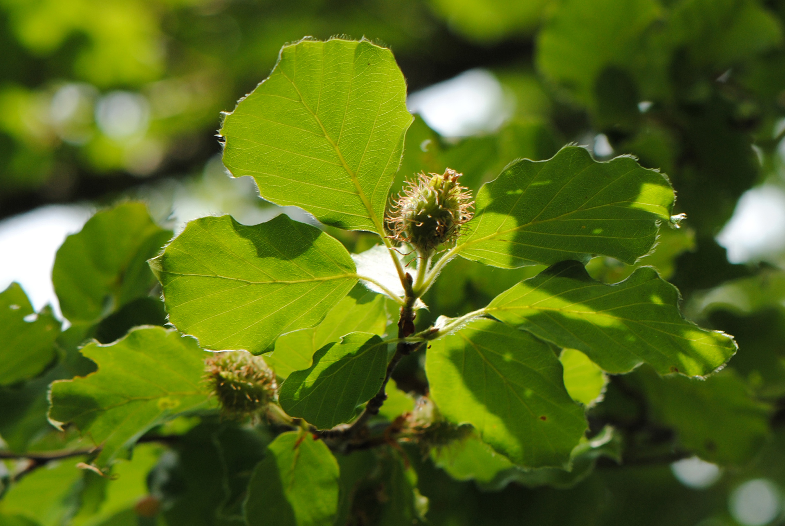
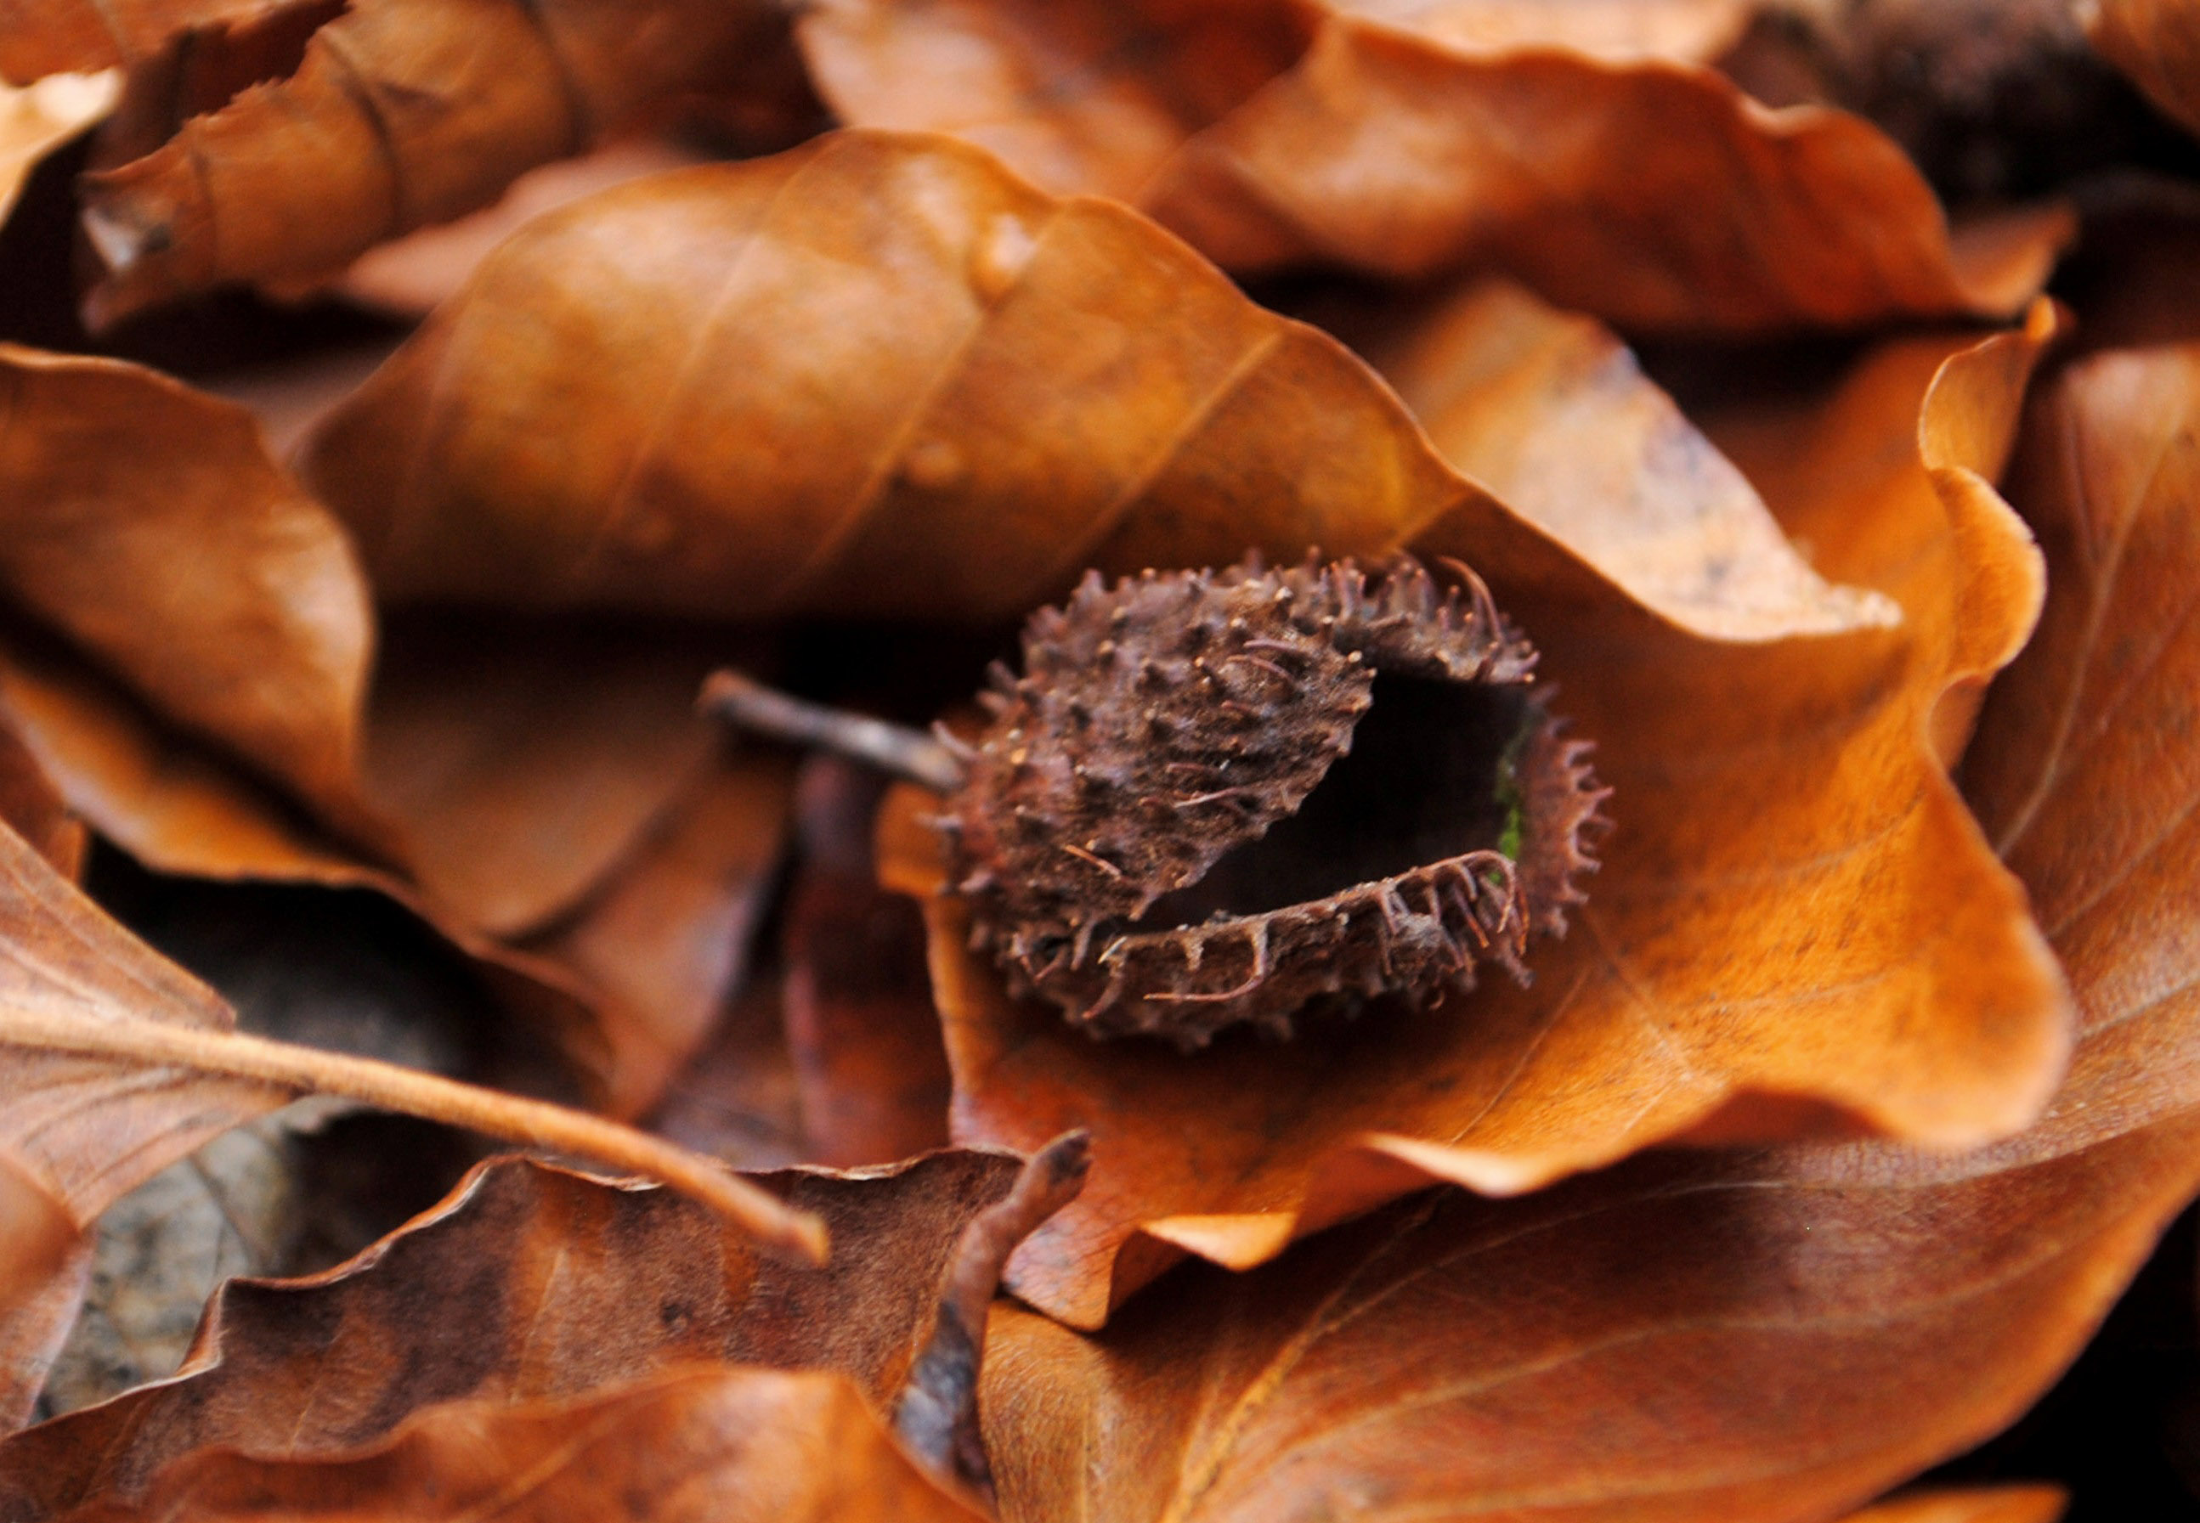
Figure S1. Beech cupules before ripening in late spring (left) and dropped on the forest floor after ripening (right). Photo credit: Nereida Melguizo-Ruiz.

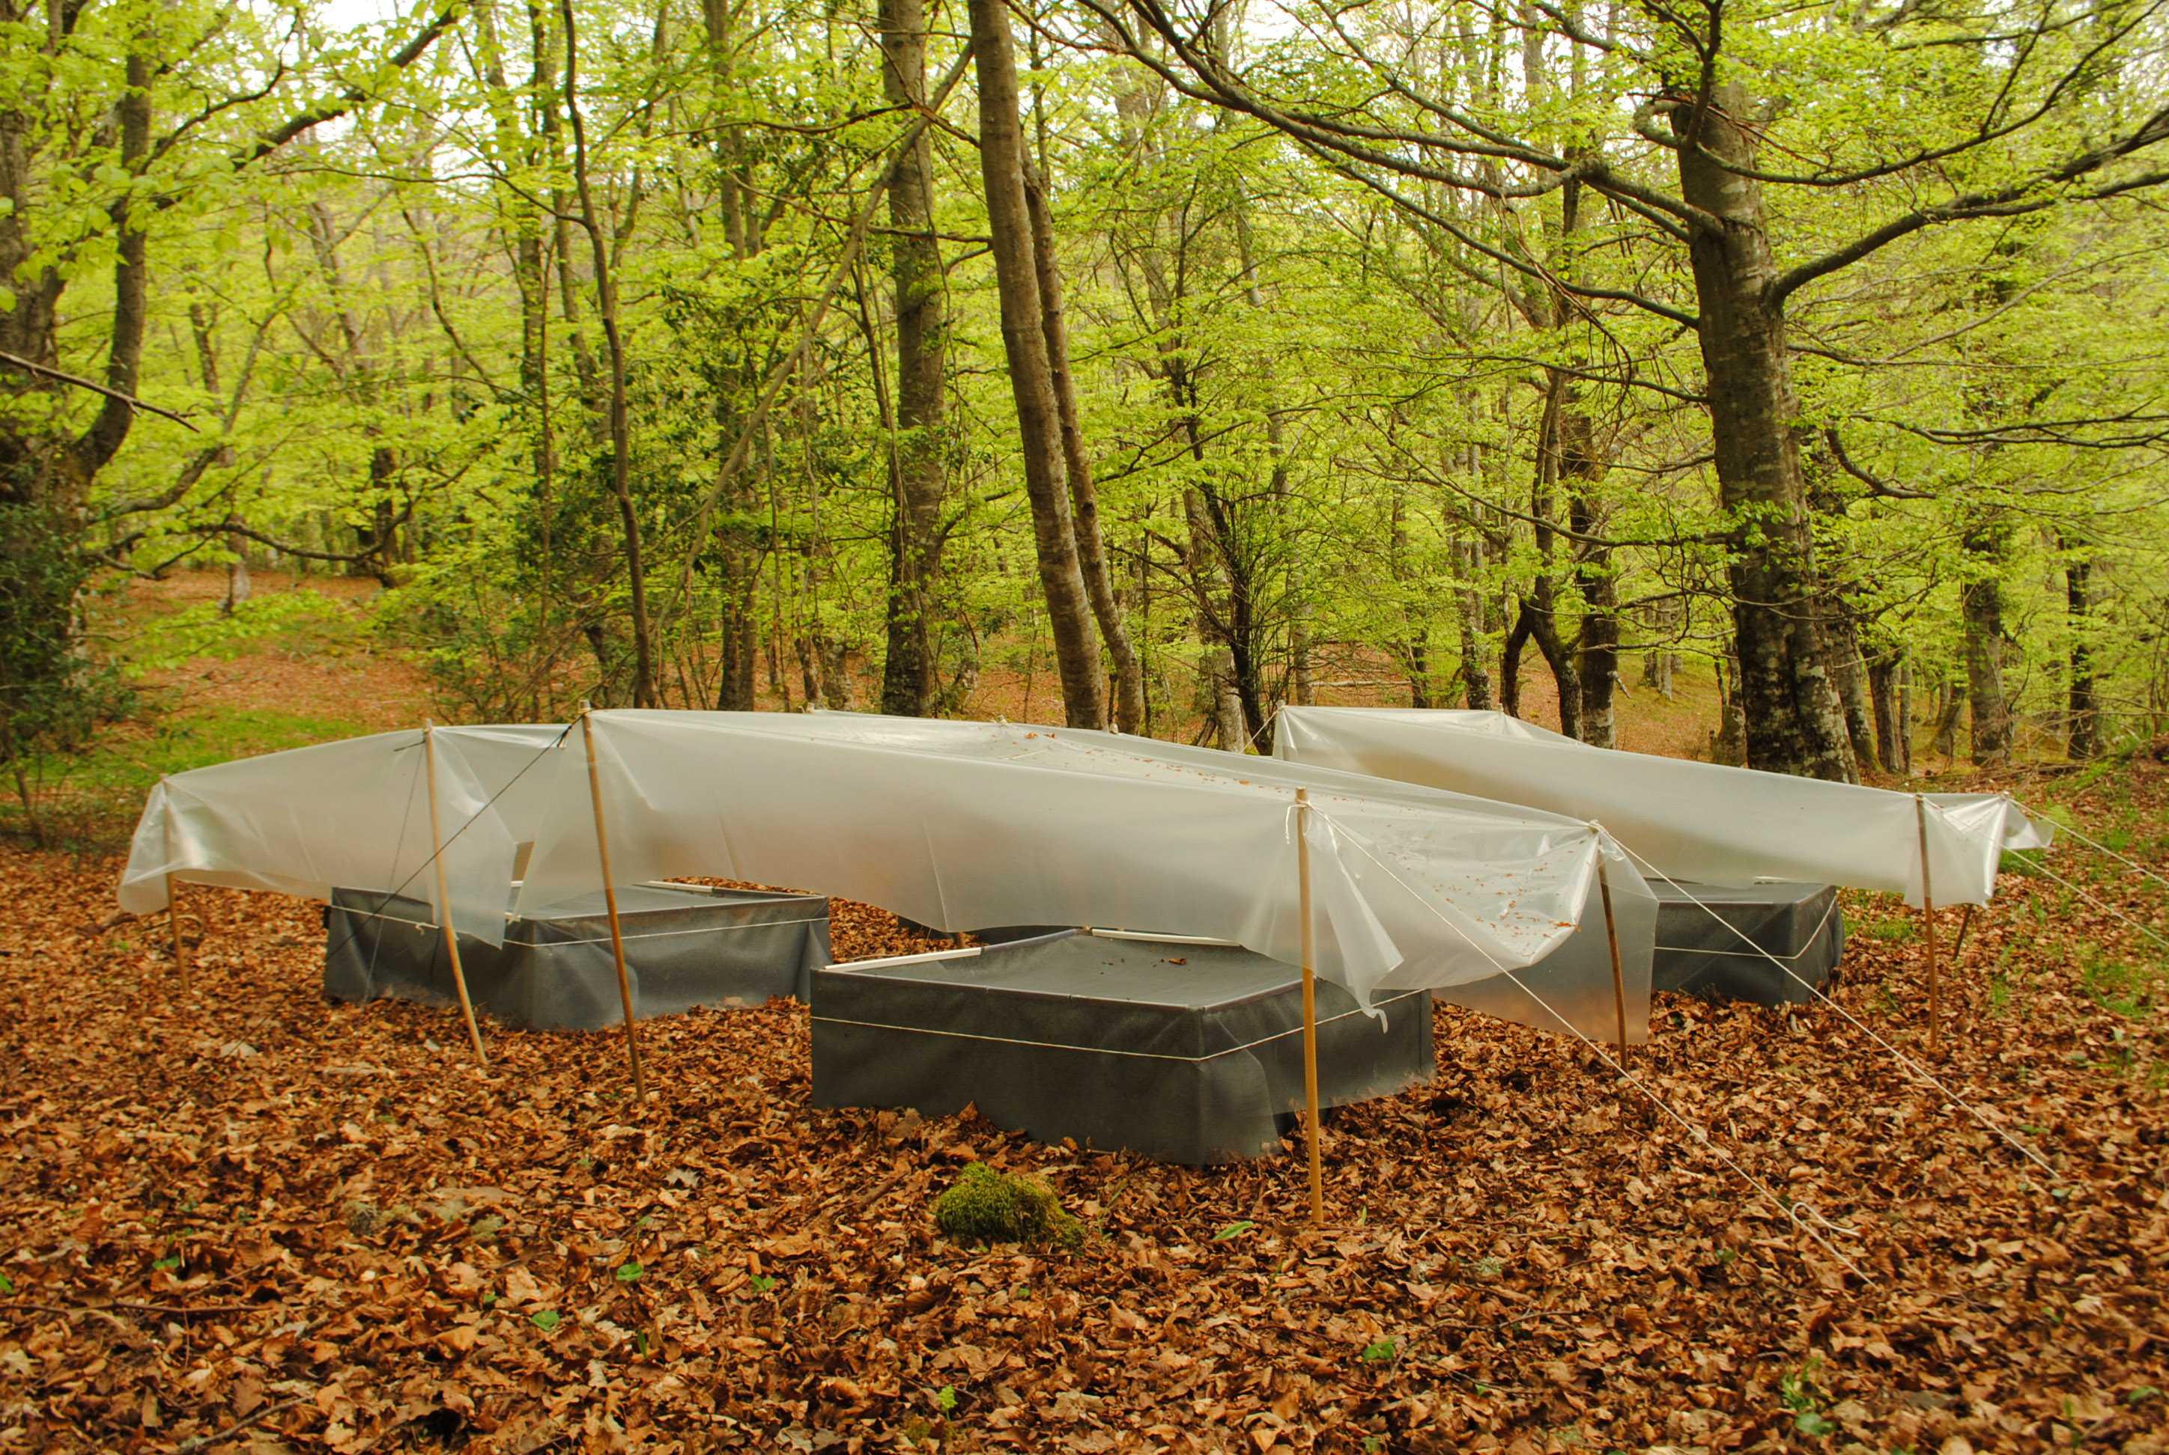
Figure S2. Short-term field experiment, showing the 1 m² plots covered with plastic roofs used for rainfall exclusion. Photo credit: Nereida Melguizo-Ruiz.

Supplemental Information - Appendix 2
Multiplicative effects of treatments on total abundances in the leaf litter (inside and outside the cupules)

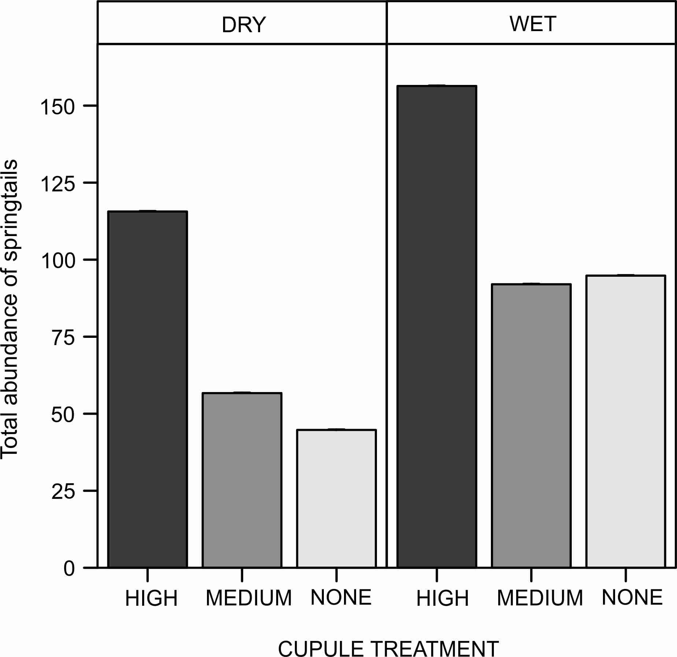

Figure S3. Total abundance of springtails in the leaf litter (inside and outside the cupules). Abbreviations: DRY: 'Dry' treatment, WET: 'Wet' treatment. HIGH: 'High density of cupules', MEDIUM: 'Intermediate density of cupules' and NONE: 'None' (i.e. no single cupule) treatment. Effects are model predicted effects ± SE (library "effects" – Fox 2003).
Additive effects of treatments on the abundances inside relative to outside the cupules

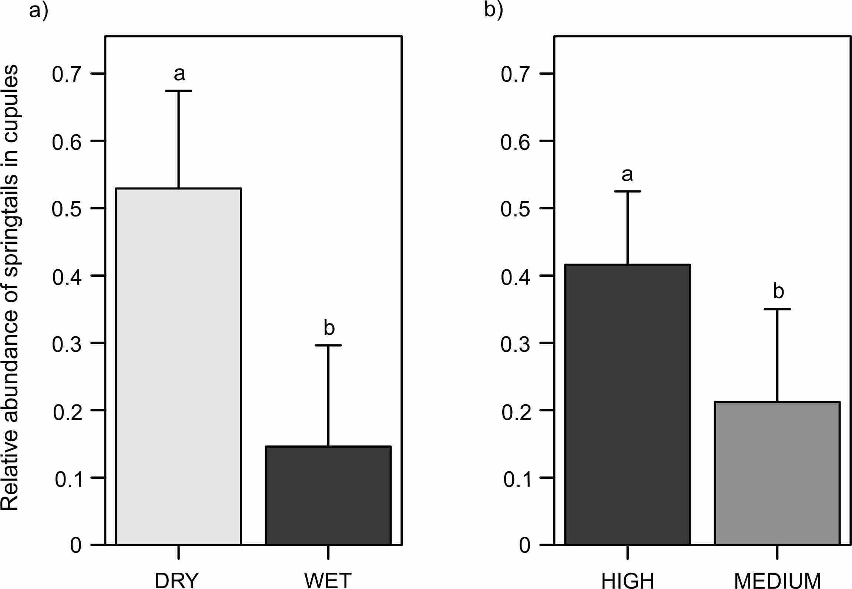

Figure S4. Abundance of springtails inside the cupules relative to outside, for a) water and b) cupule treatments. Abbreviations: DRY: 'Dry' treatment, WET: 'Wet' treatment. HIGH: 'High density of cupules' and MEDIUM: 'Intermediate density of cupules' treatment. Effects are model predicted effects ± SE (library "effects" – Fox 2003). Letters denote significant differences between treatments.

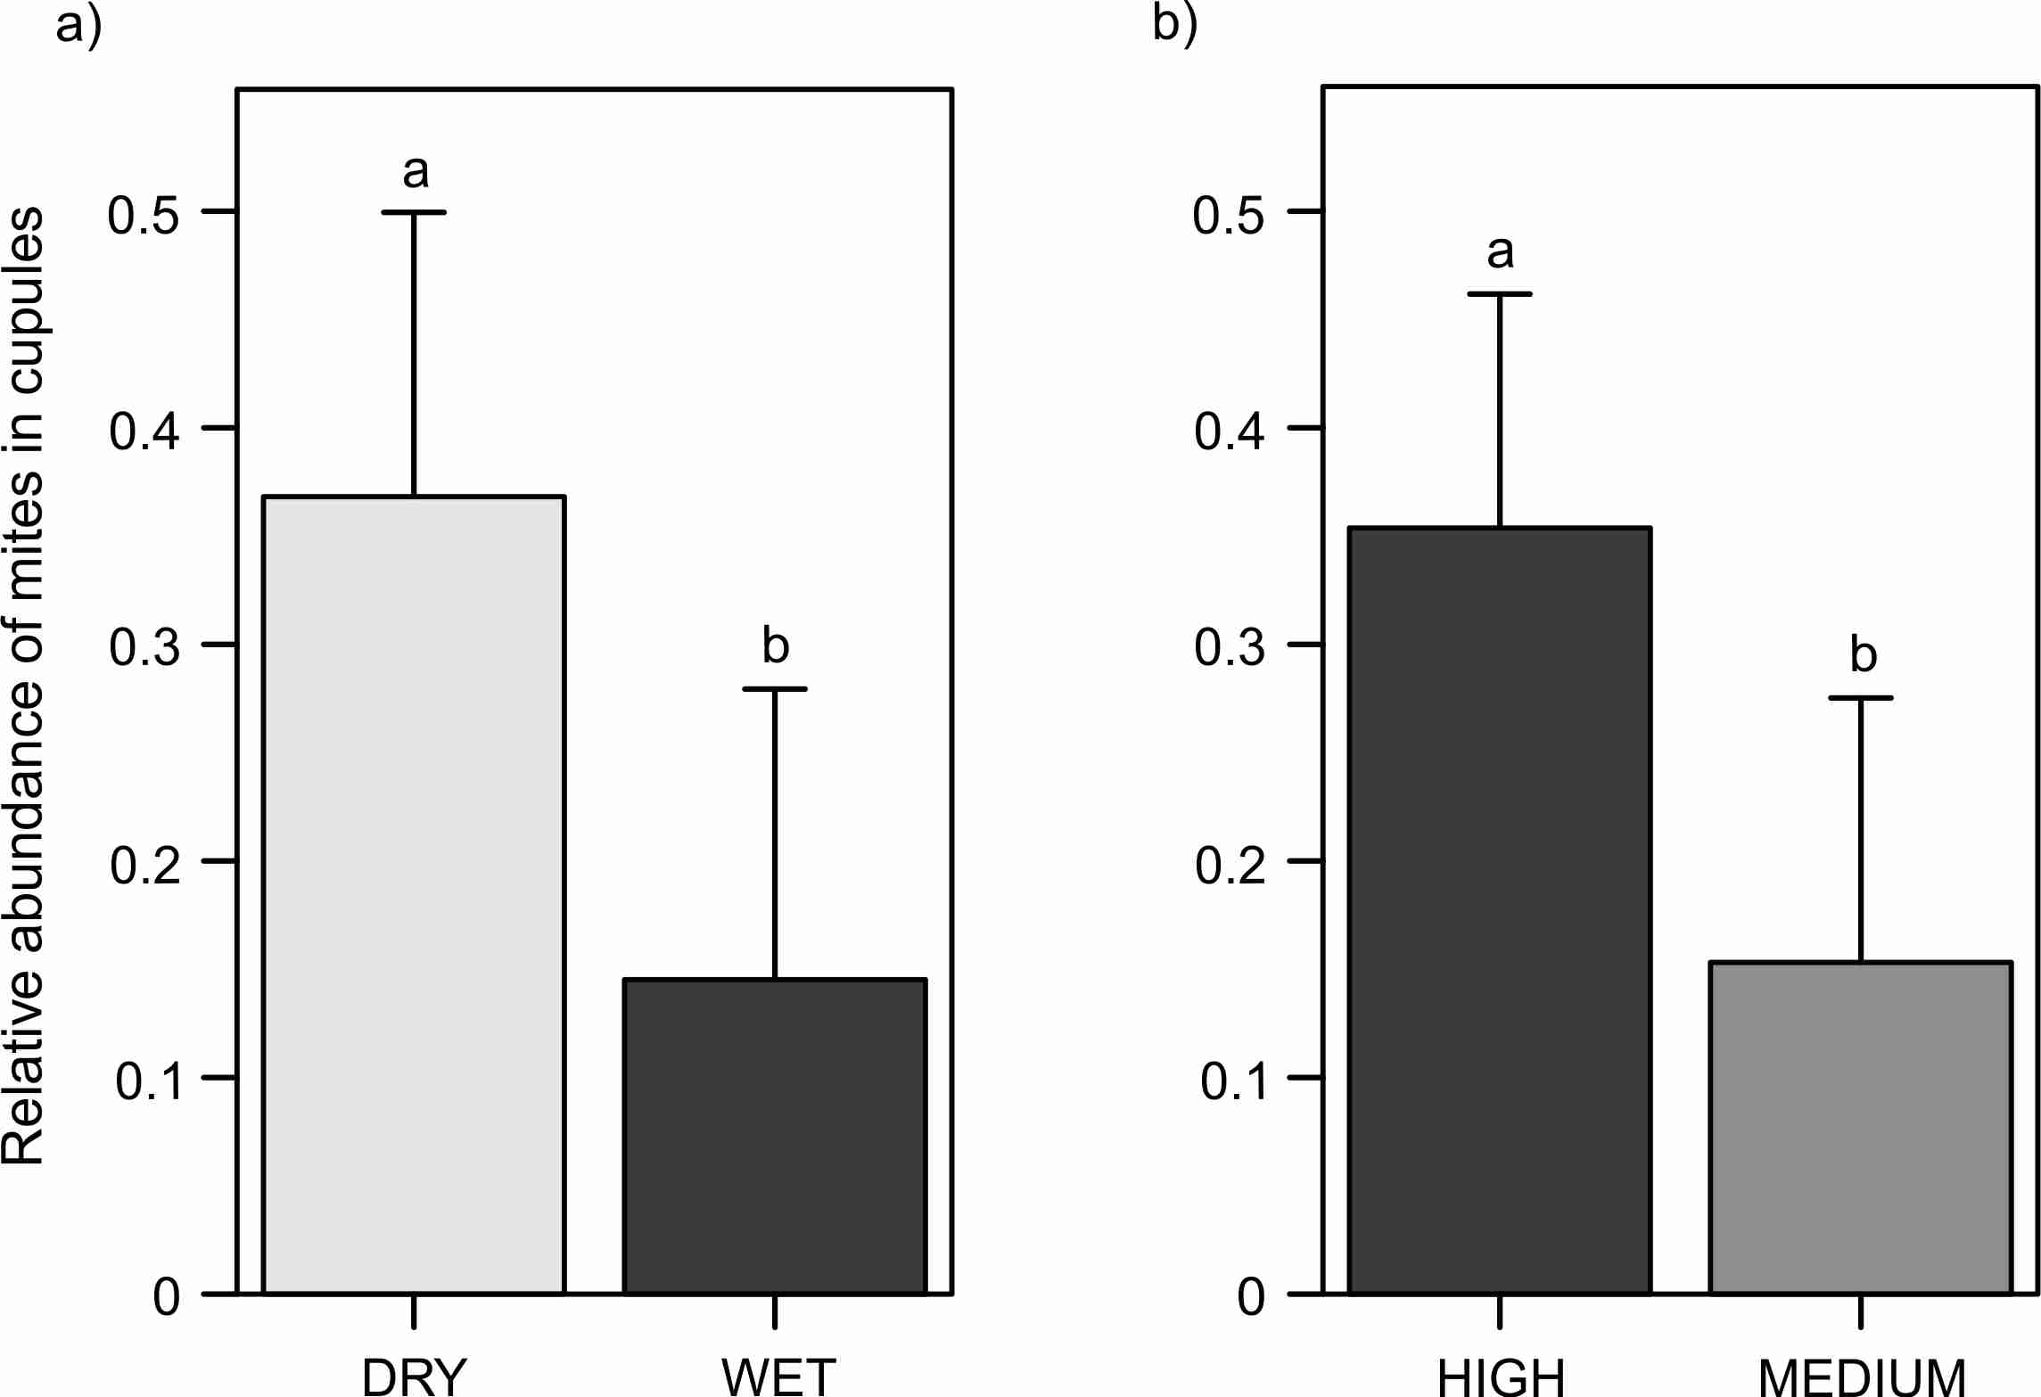

Figure S5. Abundance of mites inside the cupules relative to outside, for a) water and b) cupule treatments. Abbreviations: DRY: 'Dry' treatment, WET: 'Wet' treatment. HIGH: 'High density of cupules' and MEDIUM: 'Intermediate density of cupules' treatment. Effects are model predicted effects ± SE (library "effects" – Fox 2003). Letters denote significant differences between treatments.
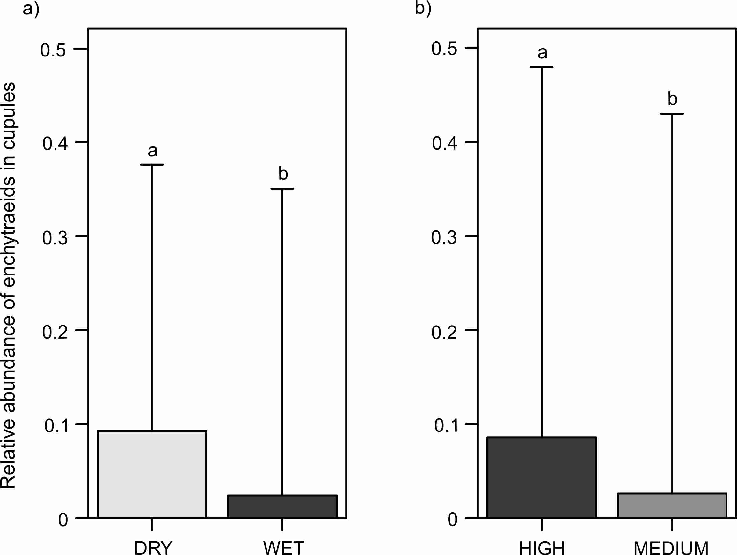

Figure S6. Abundance of enchytraeids inside the cupules relative to outside, for a) water and b) cupule treatments. Abbreviations: DRY: 'Dry' treatment, WET: 'Wet' treatment. HIGH: 'High density of cupules' and MEDIUM: 'Intermediate density of cupules' treatment. Effects are model predicted effects ± SE (library "effects" – Fox 2003). Letters denote significant differences between treatments.

Additive effects of treatments on total abundances in the leaf litter (inside and outside the cupules)
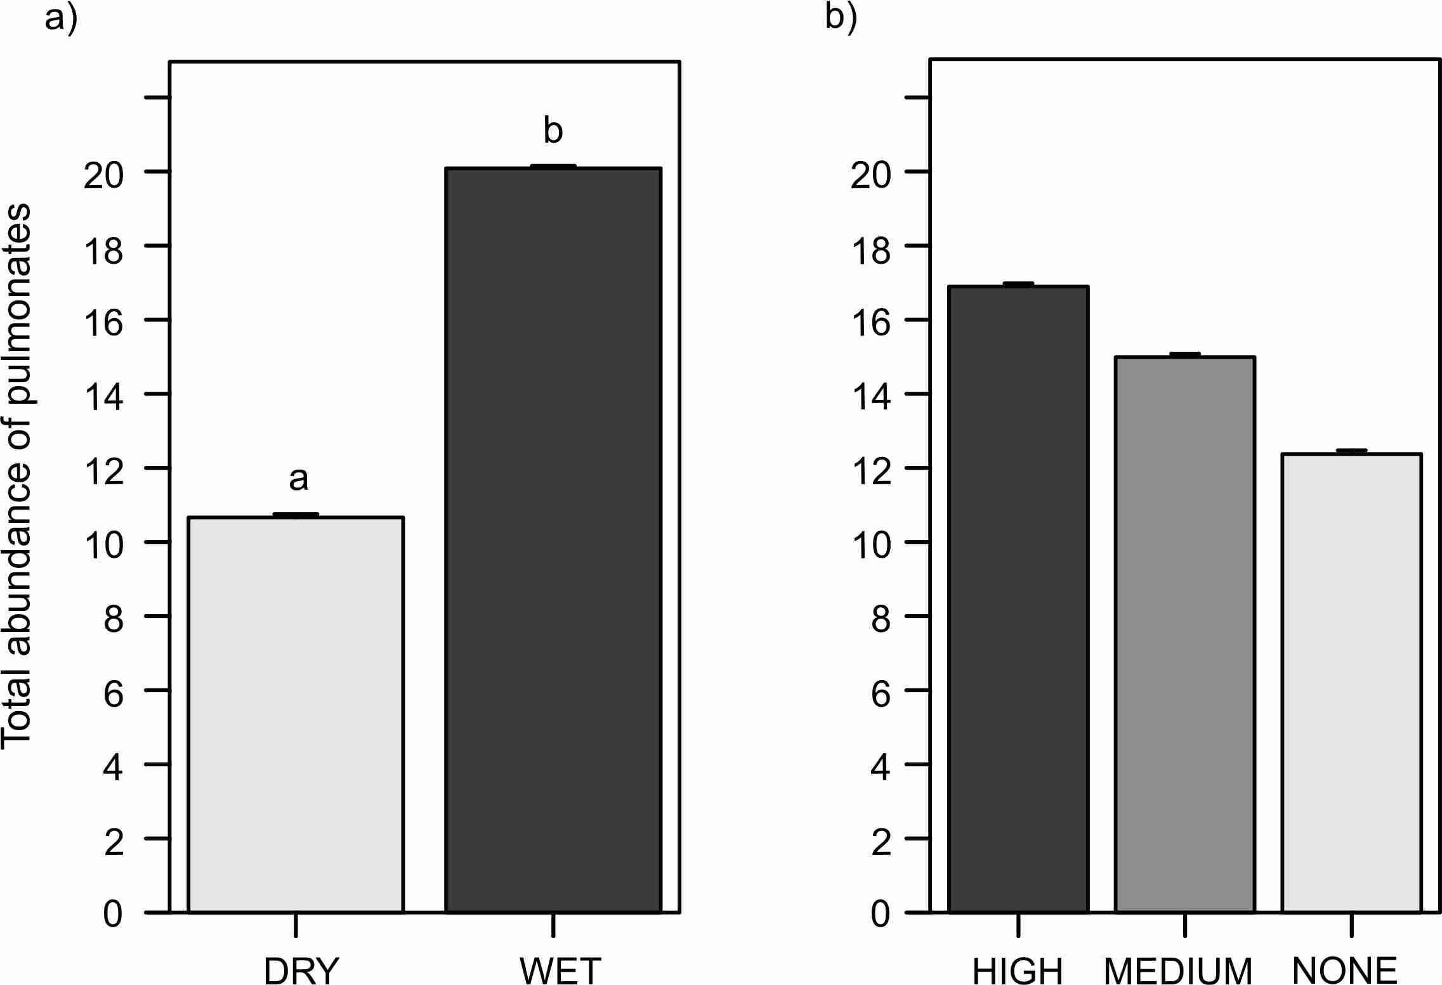

Figure S7. Total abundance of pulmonates in the leaf litter (inside and outside the cupules), across a) water and b) cupule treatments. Abbreviations: DRY: 'Dry' treatment, WET: 'Wet' treatment. HIGH: 'High density of cupules', MEDIUM: 'Intermediate density of cupules' and NONE: 'None' (i.e. no single cupule) treatment. Effects are model predicted effects ± SE (library "effects" – Fox 2003). Letters denote significant differences between treatments after post-hoc contrasts.

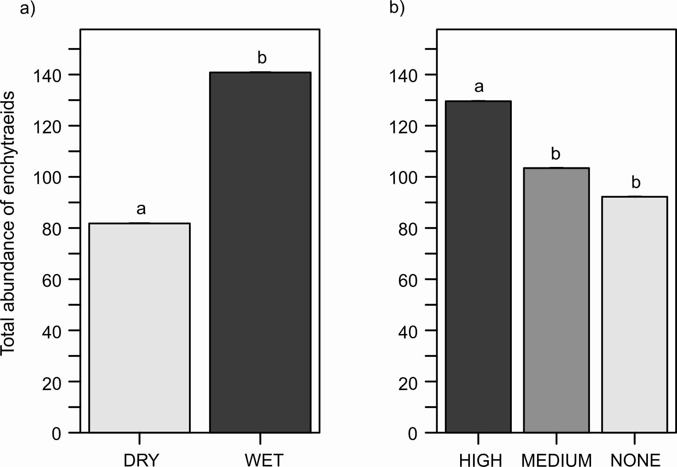

Figure S8. Total abundance of enchytraeids in the leaf litter (inside and outside the cupules), across a) water and b) cupule treatments. Abbreviations: DRY: 'Dry' treatment, WET: 'Wet' treatment. HIGH: 'High density of cupules', MEDIUM: 'Intermediate density of cupules' and NONE: 'None' (i.e. no single cupule) treatment. Effects are model predicted effects ± SE (library "effects" – Fox 2003). Letters denote significant differences between treatments after post-hoc contrasts.

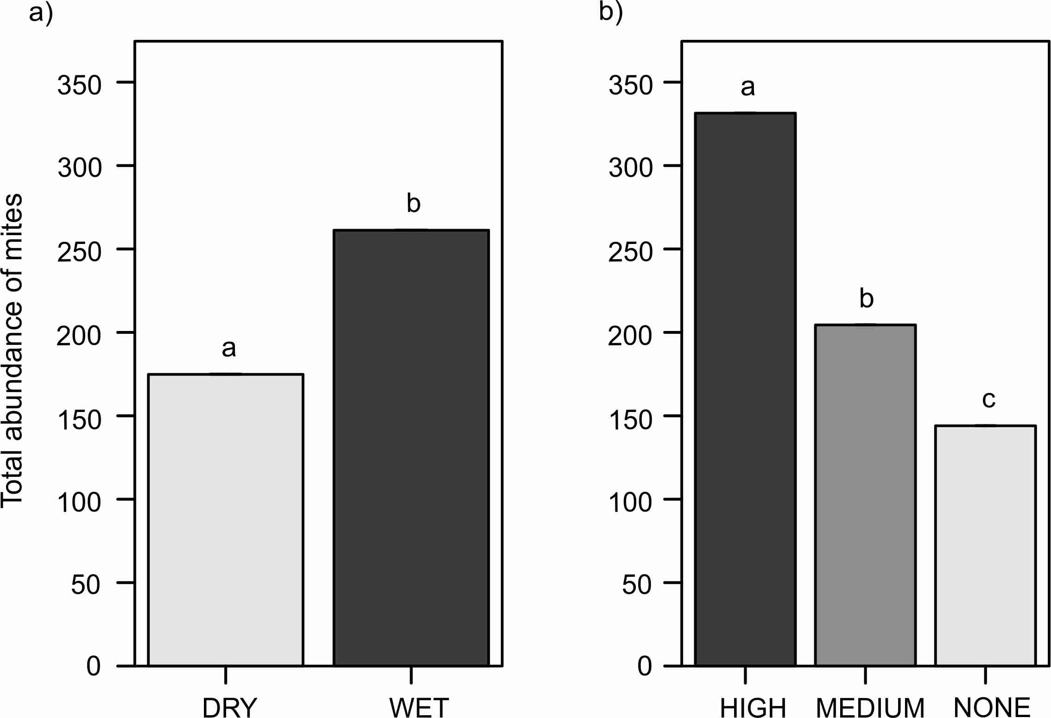

Figure S9. Total abundance of mites in the leaf litter (inside and outside the cupules), across a) water and b) cupule treatments. Abbreviations: DRY: 'Dry' treatment, WET: 'Wet' treatment. HIGH: 'High density of cupules', MEDIUM: 'Intermediate density of cupules' and NONE: 'None' (i.e. no single cupule) treatment. Effects are model predicted effects ± SE (library "effects" – Fox 2003). Letters denote significant differences between treatments after post-hoc contrasts.
Supplemental Information - Appendix 3

Table S1. Total abundances of fauna in the leaf litter, inside and outside the cupules (Mean ± sd).

 | WATER TREATMENT |  | CUPULE TREATMENT
TAXONOMIC GROUPS | WET | DRY | HIGH | INTERMEDIATE | NO CUPULES
TAXONOMIC GROUPS | WET | DRY | DENSITY | DENSITY | NO CUPULES
 | Mean ± SD | Mean ± SD | Mean ± SD | Mean ± SD | Mean ± SD
ARACHNIDA
ARANEAE | 4.1 ± 2.6 | 3.4 ± 2.3 | 3.3 ± 2.2 | 3.5 ± 2.6 | 4.5 ±2.7
ACARINA (TOTAL) | 282.2 ± 116.3 | 189.8 ± 84.7 | 344.5 ± 100.9 | 212.3 ± 61.6 | 151.1 ± 59.7
ORIBATIDA | 177.1 ± 75.4 | 104.8 ± 44.7 | 206.0 ± 69.9 | 129.1 ± 42.5 | 87.8 ± 40.4
MESOSTIGMATA | 95.2 ± 41.1 | 76.9 ± 42.8 | 126.9 ± 42.4 | 73.6 ±22.6 | 57.6 ± 22.3
PROSTIGMATA | 9.6 ± 3.7 | 7.9 ± 4.4 | 11.4 ± 4.1 | 9.3 ± 1.9 | 5.6 ± 3.9
PSEUDOSCORPIONIDA | 9.8 ± 4.4 | 8.0 ± 4.4 | 11.0 ± 4.1 | 7.9 ± 4.4 | 7.8 ± 4.3
OPILIONES | 1.2 ± 1.3 | 0.3 ± 0.5 | 0.9 ± 1.4 | 0.8 ± 1.0 | 0.5 ± 0.8
MYRIAPODA
LITHOBIOMORPHA | 5.1 ± 2.8 | 3.3 ± 2.9 | 5.4 ± 3.7 | 2.3 ± 0.9 | 4.9 ± 2.9
GEOPHILOMORPHA | 4.9 ± 3.5 | 3.2 ± 2.0 | 4.5 ± 3.3 | 3.5 ± 3.3 | 4.1 ± 2.4
JULIDA | 1.3 ± 1.1 | 0.8 ± 1.2 | 1.1 ± 1.4 | 1.1 ± 1.1 | 0.9 ± 1.0
GLOMERIDA | NA | NA | NA | NA | NA
POLYXENIDA | 1.3 ± 1.5 | 0.7 ± 0.8 | 0.8 ± 0.7 | 1.3 ± 1.8 | 0.9 ± 1.1
SYMPHYLA | 1.1 ± 1.0 | 0.8 ± 1.2 | 0.9 ± 1.1 | 0.5 ± 0.8 | 1.4 ± 1.3
HEXAPODA
COLLEMBOLA (TOTAL) | 117.0 ± 42.3 | 74.4 ± 40.7 | 139.1 ± 38.9 | 75.6 ± 23.7 | 72.4 ± 40.6
ENTOMOBRYOMORPHA | 87.4 ± 28.7 | 62.1 ± 38.5 | 109.9 ± 27.0 | 60.5 ± 20.0 | 53.9 ± 30.0
PODUROMORPHA | 28.8 ± 18.1 | 11.5 ± 5.7 | 28.5 ± 22.7 | 14.4 ± 4.0 | 17.6 ± 13.0
CAMPODEIDAE | 7.8 ± 3.4 | 5.0 ± 3.4 | 4.9 ± 2.7 | 5.4 ± 2.8 | 9.0 ± 4.0
STAPHYLINIDAE | NA | NA | NA | NA | NA
CARABIDAE | NA | NA | NA | NA | NA
LARVAE | 12.5 ± 6.1 | 9.8 ± 2.9 | 15.5 ± 4.5 | 9.9 ± 2.6 | 8.1 ± 4.1
CRUSTACEA
ISOPODA | 0.5 ± 0.7 | 0.6 ± 0.8 | 0.3 ± 0.5 | 0.8 ± 0.7 | 0.6 ± 0.9
ANNELIDA
ENCHYTRAEIDAE | 146.5 ± 46.0 | 83.3 ± 16.0 | 137.6 ± 53.8 | 108.1 ± 32.8 | 98.9 ± 47.4
LUMBRICIDAE | 2.9 ± 2.2 | 1.0 ± 1.3 | 2.8 ± 2.7 | 1.4 ± 1.2 | 1.8 ± 1.7
MOLLUSCA
PULMONATA | 20.3 ± 5.2 | 10.8 ± 4.4 | 17.8 ± 8.8 | 15.8 ± 5.2 | 13.0 ± 5.7

Table S2. Statistical results of the a) multiplicative and b) additive GLMMs explaining total abundances of fauna in the leaf litter (inside and outside the cupules).

a)
 | TAXONOMIC GROUPS |  |  | χ² | df | p value
 | COLLEMBOLA (TOTAL) | WATER TREATMENT |  | 2.9 | 1 | 0.0887
 |  | CUPULE TREATMENT |  | 77.4 | 2 | <0.0001
 |  | WATER*CUPULE |  | 8.4 | 2 | 0.0152
 | ENTOMOBRYOMORPHA | WATER TREATMENT |  | 0.4 | 1 | 0.5419
 |  | CUPULE TREATMENT |  | 108.3 | 2 | <0.0001
 |  | WATER*CUPULE |  | 16.8 | 2 | 0.0002

b) |  | WATER TREATMENT |  |  |  |  | CUPULE TREATMENT
 | TAXONOMIC GROUPS | WET | DRY |  |  |  | HIGH | INTERMEDIATE | NO CUPULES
 |  |  |  |  |  |  | DENSITY | DENSITY
 |  | Estimate ± SE | Estimate ± SE | χ² | df | p value | Estimate ± SE | Estimate ± SE | Estimate ± SE | χ² | df | p value
 | ARACHNIDA
 | ARANEAE | 4.0 ± 0.1 | 3.4 ± 0.2 | 0.7 | 1 | 0.3997 | 3.2 ± 0.2 | 3.5 ± 0.2 | 4.5 ± 0.2 | 1.9 | 2 | 0.3959
 | ACARINA (TOTAL) | 261.2 ± 0.1 | 174.8 ± 0.1 | 8.4 | 1 | 0.0039 | 331.4 ± 0.1 | 204.5 ± 0.1 | 144.0 ± 0.1 | 250.4 | 2 | <0.0001
 | ORIBATIDA | 162.9 ± 0.1 | 96.7 ± 0.1 | 14 | 1 | 0.0002 | 195.4 ± 0.1 | 122.8 ± 0.1 | 82.4 ± 0.1 | 169.2 | 2 | <0.0001
 | MESOSTIGMATA | 88.0 ± 0.1 | 68.6 ± 0.1 | 1.8 | 1 | 0.1809 | 121.1 ± 0.1 | 70.8 ± 0.1 | 54.8 ± 0.1 | 72.8 | 2 | <0.0001
 | PROSTIGMATA | 9.1 ± 0.1 | 7.5 ± 0.1 | 1.4 | 1 | 0.2451 | 11.2 ± 0.1 | 9.1 ± 0.1 | 5.6 ± 0.2 | 15 | 2 | 0.0006
 | PSEUDOSCORPIONIDA | 9.2 ± 0.2 | 7.5 ± 0.2 | 0.7 | 1 | 0.3993 | 10.5 ± 0.2 | 7.5 ± 0.2 | 7.3 ± 0.2 | 5 | 2 | 0.0808
 | OPILIONES | 0.9 ± 0.5 | 0.2 ± 0.7 | 3.5 | 1 | 0.0611 | 0.5 ± 0.5 | 0.5 ± 0.5 | 0.3 ± 0.6 | 0.8 | 2 | 0.6681
 | MYRIAPODA
 | LITHOBIOMORPHA | 4.7 ± 0.2 | 3.0 ± 0.2 | 2.8 | 1 | 0.0953 | 5.2 ± 0.2 | 2.2 ± 0.3 | 4.7 ± 0.2 | 10.3 | 2 | 0.0059
 | GEOPHILOMORPHA | 4.4 ± 0.2 | 2.9 ± 0.2 | 2.1 | 1 | 0.1437 | 4.0 ± 0.2 | 3.1 ± 0.3 | 3.7 ± 0.2 | 0.5 | 2 | 0.7655
 | JULIDA | 1.2 ± 0.9 | 0.8 ± 0.6 | 0.7 | 1 | 0.4168 | 1.0 ± 0.4 | 1.0 ± 0.4 | 0.8 ± 0.4 | 0.3 | 2 | 0.8508
 | GLOMERIDA | NA | NA | NA | NA | NA | NA | NA | NA | NA | NA | NA
 | POLYXENIDA | 1.0 ± 0.5 | 0.6 ± 0.6 | 0.5 | 1 | 0.4724 | 0.6 ± 0.5 | 1.0 ± 0.5 | 0.7 ± 0.5 | 1.1 | 2 | 0.5628
 | SYMPHYLA | 0.8 ± 0.5 | 0.4 ± 0.7 | 0.8 | 1 | 0.377 | 0.6 ± 0.6 | 0.3 ± 0.6 | 0.9 ± 0.5 | 3.2 | 2 | 0.2059

 | WATER TREATMENT |  |  |  |  | CUPULE TREATMENT
TAXONOMIC GROUPS | WET | DRY |  |  |  | HIGH | INTERMEDIATE | NO CUPULES
 |  |  |  |  |  | DENSITY | DENSITY
 | Estimate ± SE | Estimate ± SE | χ² | df | p value | Estimate ± SE | Estimate ± SE | Estimate ± SE | χ² | df | p value
HEXAPODA
COLLEMBOLA (TOTAL) | 110.1 ± 0.1 | 67.2 ± 0.1 | 9.9 | 1 | 0.0016 | 133.8 ± 0.1 | 72.2 ± 0.1 | 65.9 ± 0.1 | 68.6 | 2 | <0.0001
ENTOMOBRYOMORPHA | NA significant interaction (see above) |  |  |  |  | NA significant interaction (see above)
PODUROMORPHA | 25.3 ± 0.2 | 10.6 ± 0.2 | 8.4 | 1 | 0.0038 | 22.7 ± 0.2 | 13.3 ± 0.2 | 14.6 ± 0.2 | 9.6 | 2 | 0.0082
CAMPODEIDAE | 7.4 ± 0.2 | 4.6 ± 0.2 | 2.8 | 1 | 0.0971 | 4.6 ± 0.2 | 5.1 ± 0.2 | 8.5 ± 0.2 | 12.4 | 2 | 0.002
STAPHYLINIDAE | NA | NA | NA | NA | NA | NA | NA | NA | NA | NA | NA
CARABIDAE | NA | NA | NA | NA | NA | NA | NA | NA | NA | NA | NA
LARVAE | 12.0 ± 0.1 | 9.4 ± 0.1 | 2.7 | 1 | 0.0991 | 15.3 ± 0.1 | 9.8 ± 0.1 | 8.0 ± 0.1 | 20.7 | 2 | <0.0001
CRUSTACEA
ISOPODA | 0.5 ± 0.4 | 0.5 ± 0.4 | 0.1 | 1 | 0.7817 | 0.2 ± 0.7 | 0.7 ± 0.4 | 0.6 ± 0.5 | 1.8 | 2 | 0.3992
ANNELIDA
ENCHYTRAEIDAE | 140.8 ± 0.1 | 81.8 ± 0.1 | 17.4 | 1 | <0.0001 | 129.6 ± 0.1 | 103.4 ± 0.1 | 92.2 ± 0.1 | 23.4 | 2 | <0.0001
LUMBRICIDAE | 2.6 ± 0.3 | 0.9 ± 0.4 | 5.8 | 1 | 0.0157 | 2.3 ± 0.3 | 1.1 ± 0.3 | 1.4 ± 0.3 | 4.1 | 2 | 0.1312
MOLLUSCA
PULMONATA | 20.1 ± 0.1 | 10.7 ± 0.1 | 33.8 | 1 | <0.0001 | 16.9 ± 0.1 | 15.0 ± 0.1 | 12.4 ± 0.1 | 5.8 | 2 | 0.0541
* Significant p-values after applying the False Discovery Rate procedure are shown in bold
Estimates (±SE) are the predicted means of each factor extracted from the GLMM models (library "effects")
NA - Insoluble models -likely due to the small number of individuals present-

