Discovery of novel inhibitors disrupting HIF-1α/von Hippel−Lindau interaction through shape-based screening and cascade docking

Xin Xue, ª Ning-Yi Zhao, ^{b} Hai-Tao Yu, ª Yuan Sun, ^{c} Chen Kang, ^{d} Qiong-Bin Huang,ª Hao-Peng Sun, ^{e} Xiao-Long Wang ^{a,*} Nian-Guang Li, ^{a,*}

- The information about 18 crystal complex and their native ligands for virtual screening.
Supporting Table 1 The crystal complex and their native ligands for virtual screening.
PDB ID | Resolution | Sequence | MW of native ligands | K_{d} of native ligand(μM)
3ZRC | 2.9Å | LEU63-GLU204 | 410 | 5.3
3ZTC | 2.65 Å | LEU63-GLU204 | 419 | 27.7
3ZTD | 2.79 Å | LEU63-GLU204 | 401 | 96.2
3ZUN | 2.5 Å | VAL62-GLU204 | 390 | To Be Published
4B9K | 2.0 Å | VAL62-THR202 | 451 | 0.7
4B95 | 2.8 Å | VAL62-GLN203 | 393 | 52(IC₅₀)
4BKS | 2.2 Å | VAL62-THR202 | 329 | 150
4BKT | 2.35 Å | VAL62-LEU201 | 267 | 240
4W9C | 2.2 Å | VAL62-THR202 | 385 | 22.2
4W9D | 2.2 Å | VAL62-THR202 | 399 | 10.2
4W9E | 2.6 Å | VAL62-THR202 | 402 | 7.1
4W9F | 2.1 Å | VAL62-GLN203 | 416 | 3.3
4W9G | 2.7 Å | VAL62-THR202 | 416 | 6.5
4W9H | 2.1 Å | VAL62-THR202 | 473 | 0.2
4W9I | 2.4 Å | VAL62-THR202 | 473 | 1.1
4W9J | 2.2 Å | VAL62-THR202 | 586 | 0.6
4W9K | 2.1 Å | VAL62-THR202 | 620 | 0.3
4W9L | 2.2 Å | VAL62-THR202 | 586 | 9.5
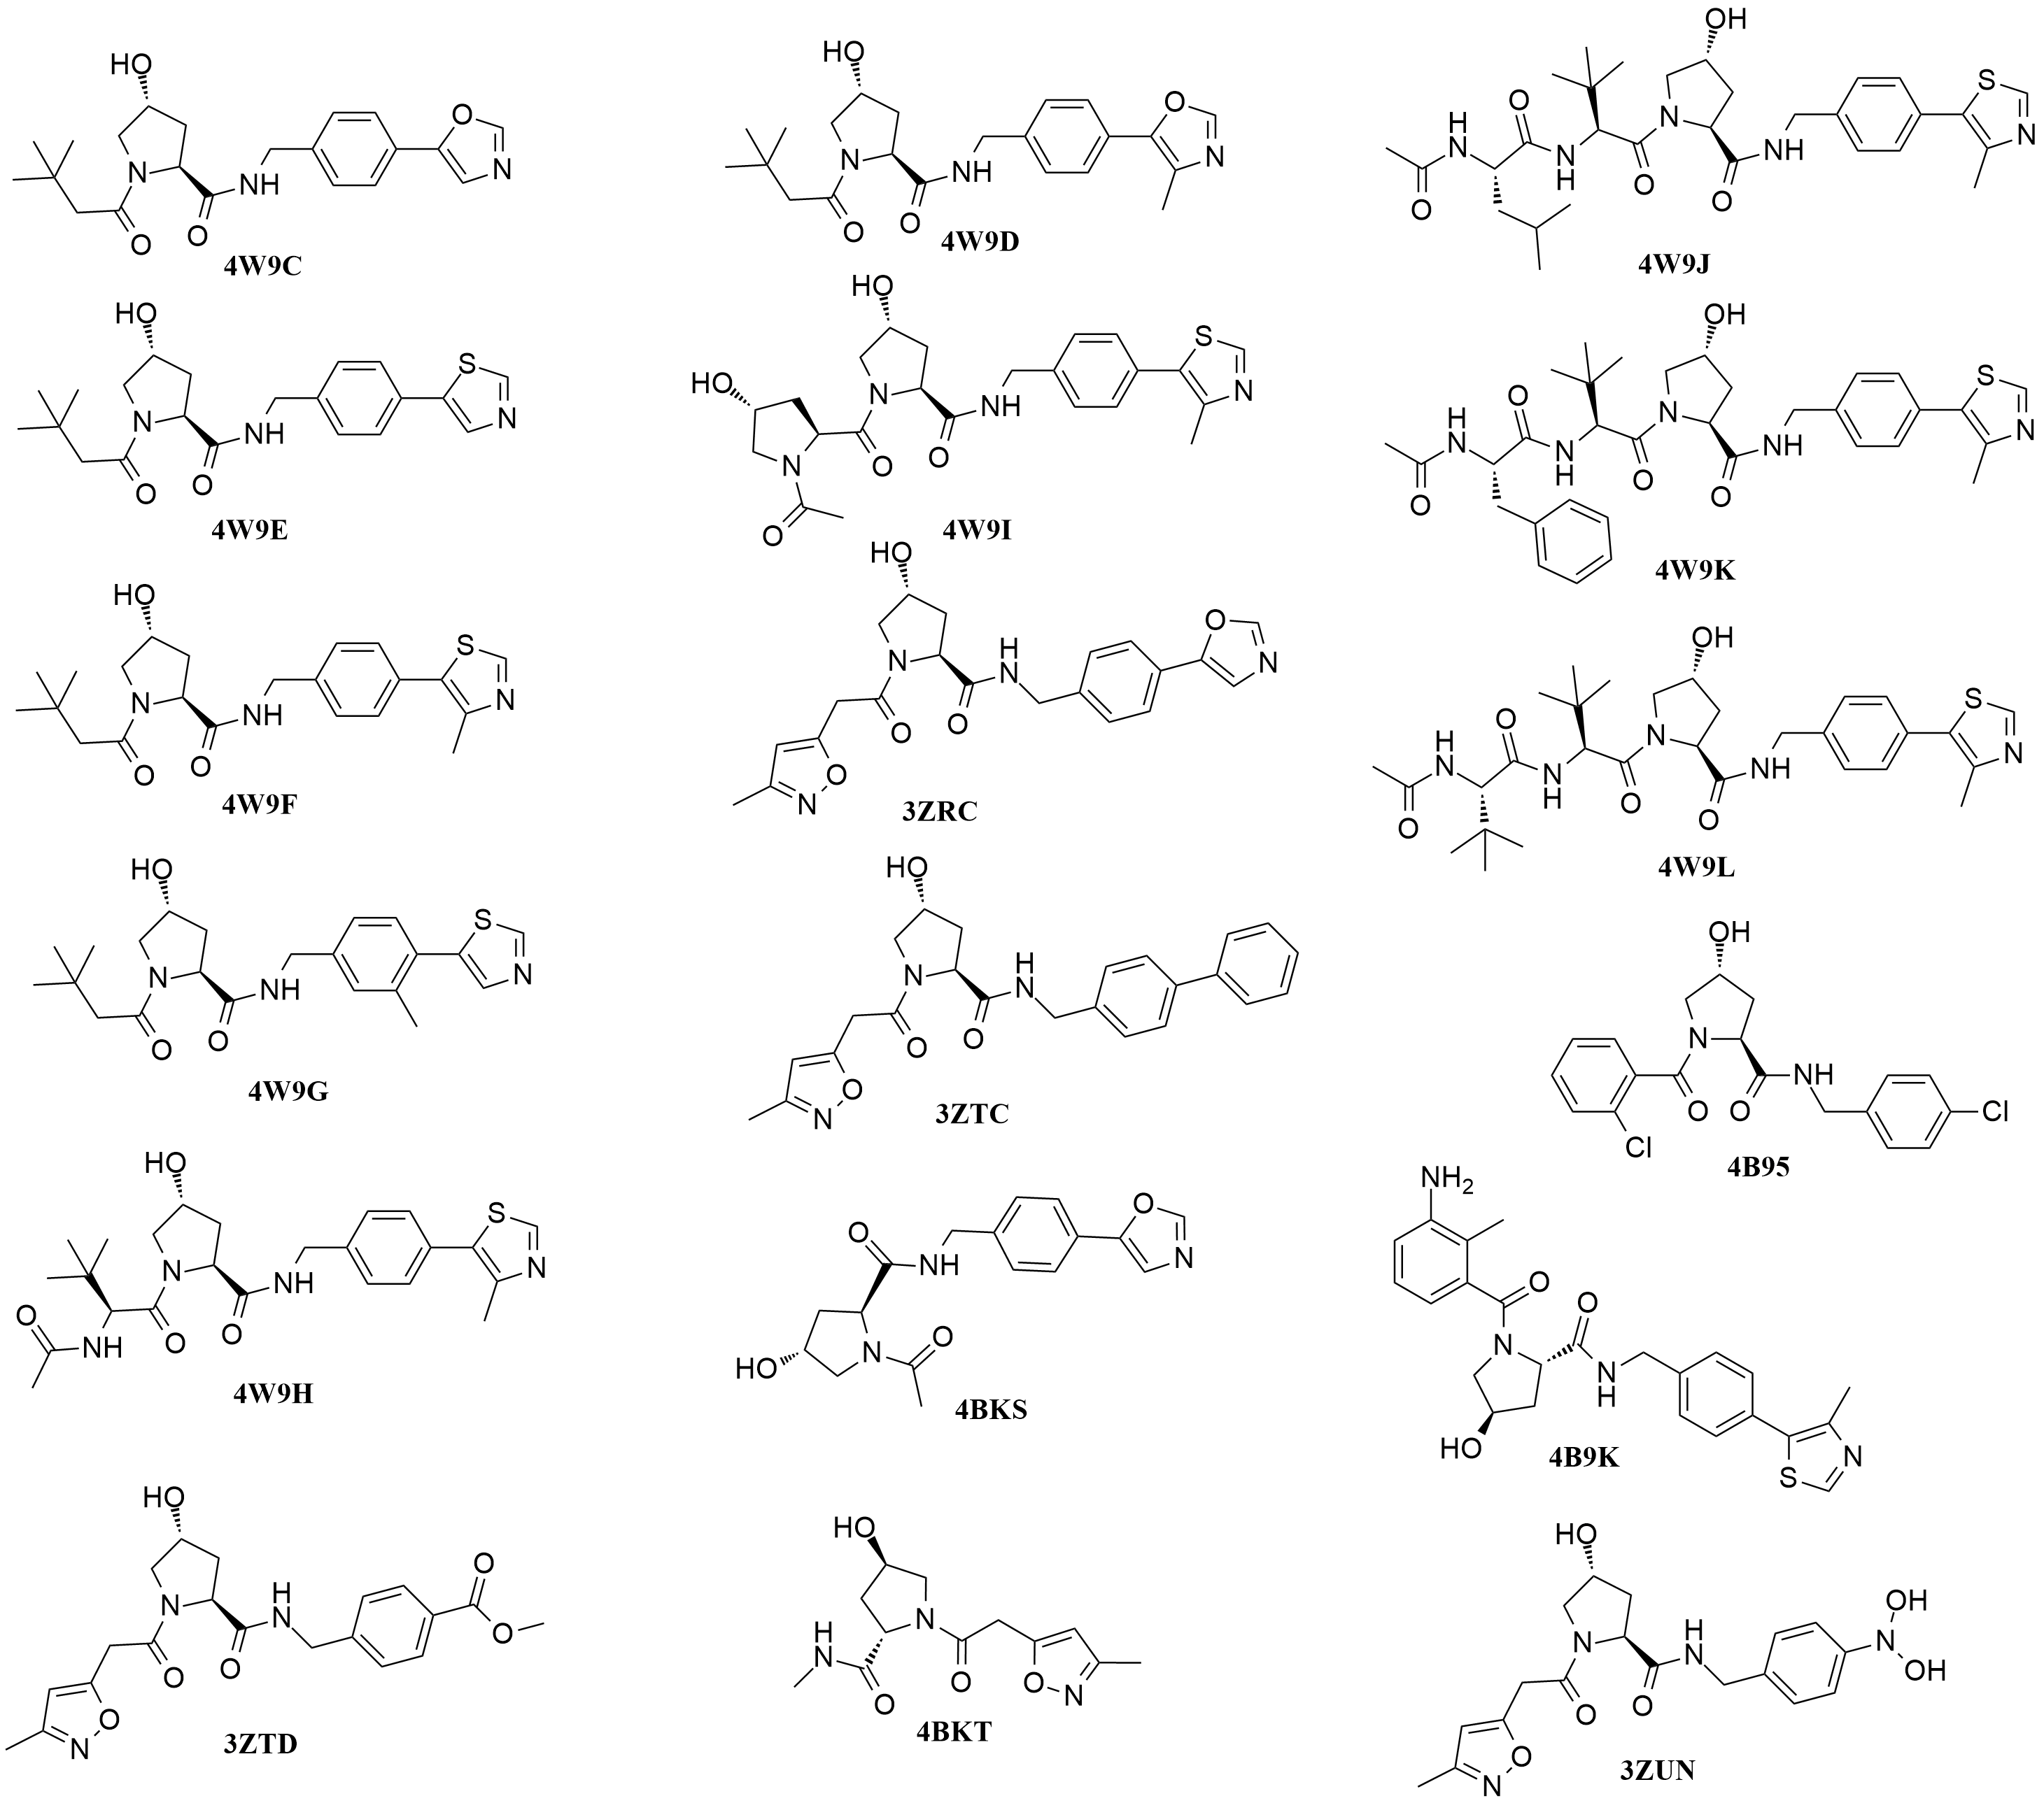
Supporting Figure 1 The structure of the eighteen native ligands.
- Shape-based modeling
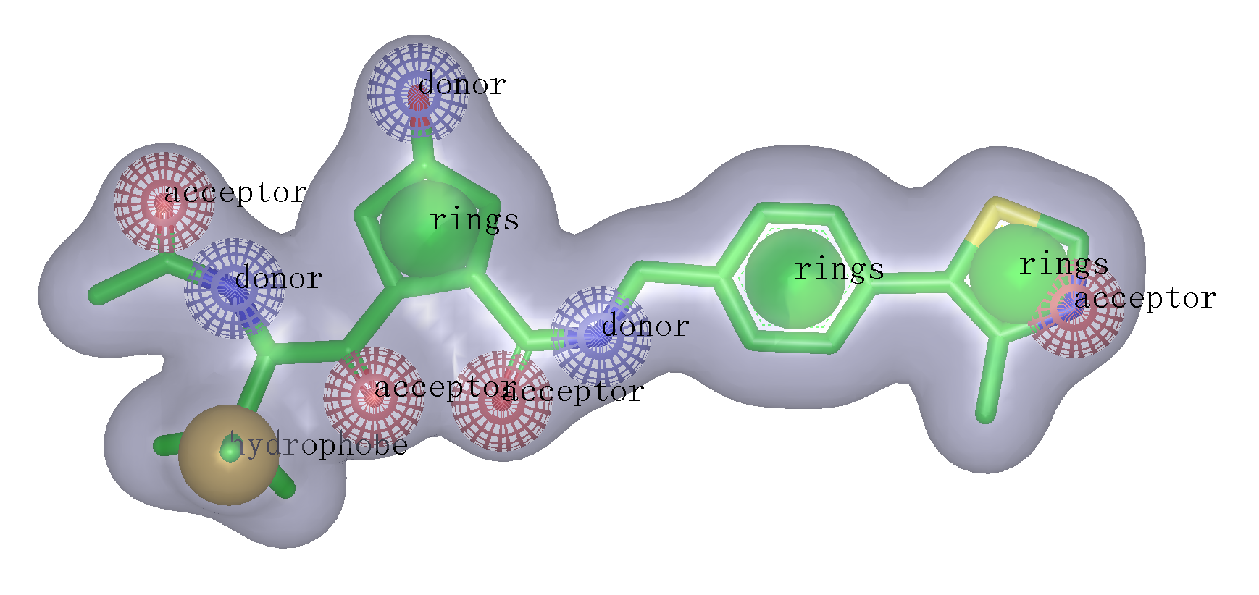
Supporting Figure 2 The shape-based model constructed from the native ligand of 3ZRC, in which red, blue and green ball represent hydrogen-bond acceptor, donor and ring feature.
- Native-Docking
The pVHL-ligand complexes (PDB Code：3ZRC, 3ZTC, 3ZTD, 3ZUN, 4B9K, 4B95, 4BKS, 4BKT, 4W9C, 4W9D, 4W9E, 4W9F, 4W9G, 4W9H, 4W9I, 4W9J, 4W9K, 4W9L) were used to conduct Native-Docking. These ligands were docked back into their corresponding protein structures using GOLD, Libdock and CDOCKER (DS4.0). The docking results were evaluated through comparison of the best docked ligands binding modes with the experimental ones. The root-mean-square deviation (RMSD) was used to compare differences between the atomic distances of the docked poses and the real co-crystallized pose to measure docking reliability. The docking software with the smallest RMSD would be selected to perform Cross-Docking.
Supporting Table2 The native ligand from virtual screening.
Docking software
PDB Code | Libdock | CDOCKER | GOLD
3ZRC | 0.3979 | 1.5859 | 0.2413
3ZTC | 1.1709 | 2.0197 | 0.2296
3ZTD | 2.9709 | 0.9629 | 1.4900
3ZUN | 8.6443 | 0.7471 | 0.2741
4B9K | 1.8186 | 0.2671 | 0.1600
4B95 | 1.0947 | 1.1892 | 0.2580
4BKS | 6.3324 | 1.5518 | 0.4290
4BKT | 2.3457 | 0.5720 | 0.2156
4W9C | 1.6034 | 0.9084 | 0.1562
4W9D | 1.7468 | 0.3214 | 0.2032
4W9E | 1.7304 | 0.3466 | 0.1851
4W9F | 1.9646 | 1.4870 | 0.2004
4W9G | 1.1303 | 1.2045 | 0.1547
4W9H | 1.4795 | 0.3736 | 0.6202
4W9I | 2.0986 | 0.4459 | 0.2173
4W9J | 2.3550 | 0.4582 | 0.9678
4W9K | 6.7849 | 1.6250 | 1.0809
4W9L | 2.0833 | 1.8496 | 0.4970
Av ª | 2.6529 | 0.9953 | 0.4211
ªAverage RMSD values of native ligand poses referring to their native poses.
- Cross-Docking
Eighteen complexes used in Native-Docking were used to perform Cross-Docking evaluation. The native ligands were docked into all complex structures using the docking software confirmed by Native-Docking. The docking reliability was evaluated by calculating the RMSD difference of each ligand between the reference positions of the ligand in the experimental pVHL-ligand complex and positions predicted by the docking software. Finally the working protein structure was selected which had the smallest RMSD.
Supporting Table 3 The eighteen native ligands for Cross-Docking.
PDB Code | 3ZRC Ligand | 3ZTC Ligand | 3ZTD Ligand | 3ZUN Ligand | 4B9K Ligand | 4B95 Ligand | 4BKS Ligand | 4BKT Ligand | 4W9C Ligand | 4W9D Ligand | 4W9E Ligand | 4W9F Ligand | 4W9G Ligand | 4W9H Ligand | 4W9I Ligand | 4W9J Ligand | 4W9K Ligand | 4W9L Ligand | Avª
3ZRC | 0.2413 | 0.6629 | 0.3528 | 0.0953 | 1.8848 | 1.4381 | 1.2900 | 7.3605 | 0.1601 | 0.0951 | 0.2809 | 0.1022 | 1.1659 | 0.4628 | 0.5922 | 0.8218 | 1.2110 | 0.3208 | 1.0299
3ZTC | 0.1524 | 0.2296 | 0.3528 | 0.8763 | 0.1923 | 0.2781 | 3.7962 | 0.4329 | 0.3766 | 1.2640 | 0.0614 | 0.1333 | 1.0627 | 0.2834 | 1.1700 | 0.4568 | 0.4438 | 0.5697 | 0.6740
3ZTD | 0.1460 | 0.9008 | 1.4900 | 0.8186 | 0.2906 | 0.3322 | 2.6000 | 0.8369 | 0.9430 | 1.1583 | 1.3389 | 0.3888 | 1.3653 | 0.8936 | 0.1672 | 3.4068 | 0.9258 | 0.8335 | 1.0465
3ZUN | 1.3827 | 0.7243 | 1.5601 | 0.2741 | 1.4231 | 0.9821 | 2.5961 | 0.1947 | 0.4197 | 3.2000 | 0.3509 | 3.1894 | 1.1986 | 3.6205 | 0.6334 | 1.0909 | 1.9519 | 1.0642 | 1.4365
4B9K | 0.1654 | 1.0368 | 0.3903 | 1.0723 | 0.1600 | 0.2157 | 2.6715 | 3.2135 | 0.1463 | 0.2634 | 1.0777 | 0.3241 | 0.0773 | 0.1497 | 0.8828 | 1.1266 | 1.6818 | 0.5881 | 0.8469
4B95 | 1.0423 | 0.4173 | 0.5831 | 0.9207 | 0.1657 | 0.2580 | 2.5636 | 0.1497 | 0.3443 | 2.3122 | 1.1585 | 1.0484 | 1.1954 | 0.5835 | 1.2166 | 10.2217 | 1.1246 | 1.4183 | 1.4847
4BKS | 0.2843 | 0.9713 | 0.1870 | 0.8611 | 0.0927 | 1.9351 | 0.4290 | 3.0368 | 0.2102 | 1.1663 | 0.2762 | 0.9860 | 0.2529 | 0.4533 | 0.2249 | 1.1480 | 0.2484 | 2.2006 | 0.8313
4BKT | 0.4975 | 0.3182 | 0.9019 | 0.4010 | 0.4516 | 1.1074 | 3.9295 | 0.2116 | 8.4752 | 5.0226 | 0.3510 | 1.8536 | 9.3330 | 3.7268 | 3.9823 | 3.6449 | 10.6145 | 3.4946 | 3.2398
4W9C | 0.3517 | 0.8259 | 0.1638 | 0.3112 | 0.5411 | 0.5072 | 3.6609 | 0.2939 | 0.1562 | 0.4467 | 0.2106 | 1.0513 | 0.1216 | 0.3488 | 0.2330 | 1.1845 | 2.5355 | 0.5376 | 0.7490
4W9D | 0.2120 | 0.7185 | 1.0039 | 0.9646 | 0.1601 | 1.5671 | 0.9231 | 7.8430 | 0.9726 | 0.2032 | 0.1323 | 1.0780 | 0.2786 | 0.2286 | 0.1078 | 2.0448 | 10.8870 | 2.1018 | 1.7459
4W9E | 1.0114 | 0.9638 | 0.9406 | 0.8512 | 2.4250 | 0.0853 | 3.3523 | 0.2147 | 0.3139 | 0.3445 | 0.1851 | 1.0888 | 0.2021 | 0.2114 | 1.2239 | 0.5723 | 0.4309 | 0.8755 | 0.8496
4W9F | 0.0525 | 0.7593 | 0.8455 | 0.2683 | 0.3225 | 0.2017 | 0.5939 | 0.0719 | 1.1400 | 1.2636 | 0.1505 | 0.2004 | 0.2207 | 0.2014 | 1.0649 | 2.0494 | 0.7959 | 0.4098 | 0.5896
4W9G | 0.9974 | 0.2159 | 0.2958 | 0.1477 | 0.4107 | 0.5607 | 7.6049 | 2.8800 | 0.1600 | 0.6113 | 1.1643 | 0.1656 | 0.1547 | 0.6994 | 1.1672 | 1.2568 | 0.8910 | 1.4204 | 1.1558
4W9H | 0.2586 | 0.3438 | 1.0958 | 0.2245 | 0.1396 | 0.1576 | 1.3445 | 0.1112 | 0.3592 | 0.1971 | 0.1883 | 0.3398 | 0.2652 | 0.6202 | 0.0874 | 0.6032 | 0.6526 | 0.2308 | 0.4011
4W9I | 0.4169 | 0.3868 | 0.7519 | 0.2553 | 0.1778 | 0.2369 | 1.5265 | 0.1604 | 0.3003 | 0.1427 | 0.1542 | 1.2118 | 1.2611 | 0.5984 | 0.2174 | 0.7570 | 0.4422 | 0.6941 | 0.5384
4W9J | 0.1155 | 0.9300 | 0.1433 | 0.9026 | 1.5389 | 1.5758 | 0.9230 | 0.2056 | 0.2900 | 1.0983 | 0.1714 | 0.4252 | 0.2660 | 0.4048 | 0.6151 | 0.9678 | 0.5977 | 0.6376 | 0.6560
4W9K | 1.0762 | 0.9006 | 1.1827 | 1.4786 | 2.7473 | 0.2844 | 0.7888 | 0.2360 | 1.0097 | 0.2428 | 0.8734 | 1.0709 | 0.3842 | 0.2697 | 0.3158 | 0.5433 | 1.0809 | 0.3991 | 0.8269
4W9L | 1.0869 | 0.1656 | 0.5050 | 0.2124 | 0.1564 | 1.4958 | 1.0601 | 0.0939 | 0.2535 | 1.0471 | 0.8460 | 1.1323 | 0.1707 | 0.1668 | 0.0479 | 0.7258 | 1.5493 | 0.4970 | 0.6229
ªAverage RMSD values of native ligand poses referring to their native poses.

- The ZINC numbers, the shape scores generated by ROCS and the docking scores of the 22 hits screened by GOLD.
Supporting Table 4 The screening scores of the 22 hits retained after GOLD docking.
NAME | MW | COMBO SCORE | shape Tanimoto | -CDocker interaction ENERGY | LibDock Score | GOLD Score Fitness
ZINC72320666 | 408.53 | 1.063 | 0.687 | 33.534 | 132.79 | 38.3046
ZINC01034728 | 418.491 | 1.033 | 0.67 | 34.2441 | 122.031 | 69.7957
ZINC02141023 | 347.409 | 0.977 | 0.757 | 30.6748 | 115.831 | 53.0827
ZINC30879352 | 377.498 | 1.076 | 0.584 | 29.1872 | 137.681 | 51.3743
ZINC13466751 | 363.413 | 1.026 | 0.695 | 37.7583 | 129.798 | 45.0739
ZINC22936870 | 463.595 | 1.039 | 0.762 | 41.583 | 139.936 | 30.2952
ZINC08879609 | 445.421 | 1.096 | 0.659 | 41.5329 | 145.91 | 54.779
ZINC30879372 | 378.463 | 1.243 | 0.726 | 32.9687 | 135.286 | 55.2002
ZINC12504094 | 452.574 | 1.045 | 0.76 | 42.3023 | 124.139 | 34.8237
ZINC00150576 | 332.313 | 0.975 | 0.766 | 29.3417 | 118.105 | 49.3516
ZINC30879611 | 425.521 | 1.042 | 0.739 | 37.8785 | 126.458 | 18.419
ZINC03125768 | 487.363 | 1.066 | 0.685 | 26.11 | 114.014 | 50.7593
ZINC04335475 | 334.395 | 1.02 | 0.693 | 27.9074 | 106.228 | 50.1269
ZINC49169623 | 346.383 | 0.968 | 0.663 | 35.5026 | 130.224 | 62.7553
ZINC09660015 | 365.422 | 0.949 | 0.679 | 37.4662 | 117.407 | 41.0432
ZINC04394452 | 406.382 | 0.92 | 0.619 | 33.6854 | 124.592 | 42.0553
ZINC02413444 | 457.303 | 0.892 | 0.71 | 43.9495 | 133.06 | 59.9172
ZINC30879401 | 392.512 | 1.053 | 0.562 | 36.5012 | 139.876 | 45.12
ZINC02151712 | 398.45 | 0.908 | 0.68 | 36.4656 | 134.639 | 48.8735
ZINC20224030 | 402.415 | 0.901 | 0.67 | 32.3553 | 114.18 | 41.6924
ZINC09659909 | 385.412 | 0.995 | 0.72 | 34.9939 | 123.223 | 42.7912
ZINC05433596 | 388.423 | 1.002 | 0.667 | 40.1133 | 129.01 | 46.6692

- The chemical structures, the curve of inhibitory and the binding modes of the nine hits and 4W9H.
Supporting Figure 3 the structure of 4W9H
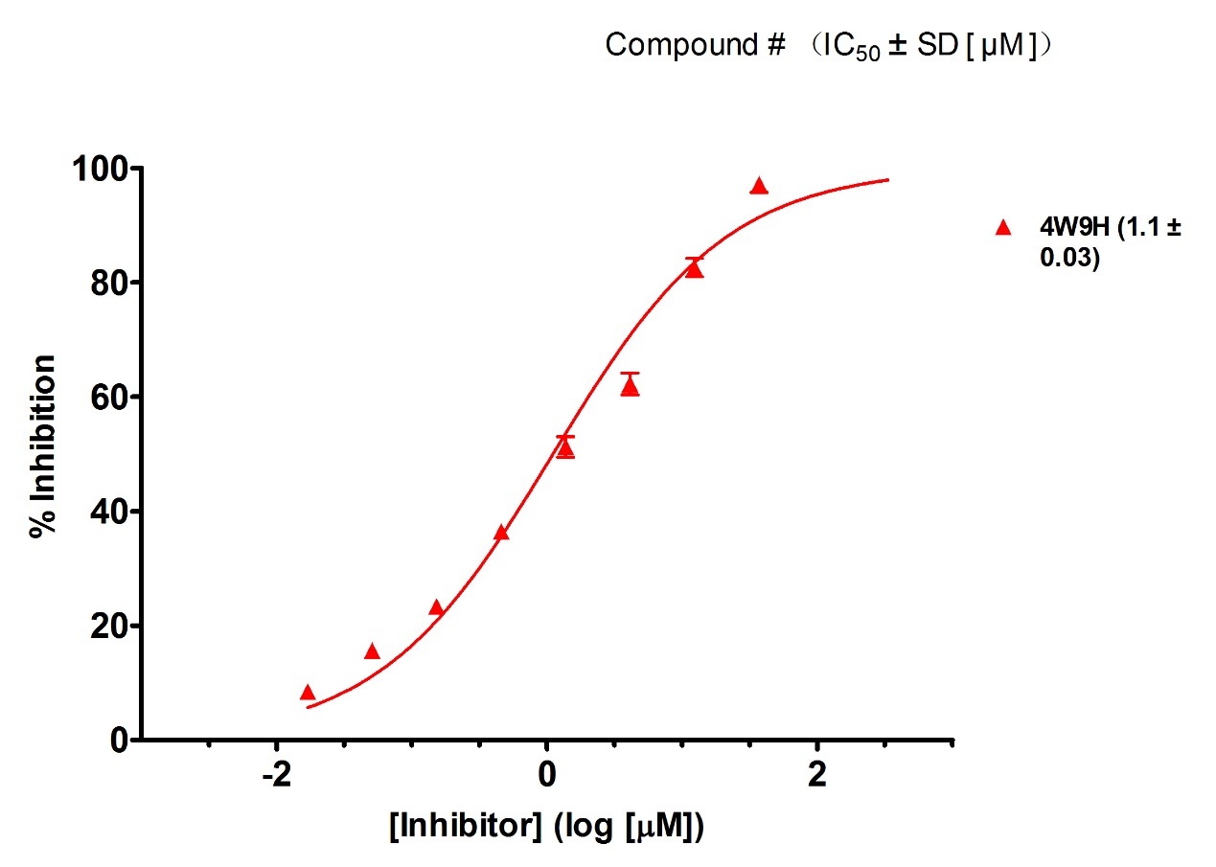
Supporting Figure 4 the curve of inhibitory of 4W9H
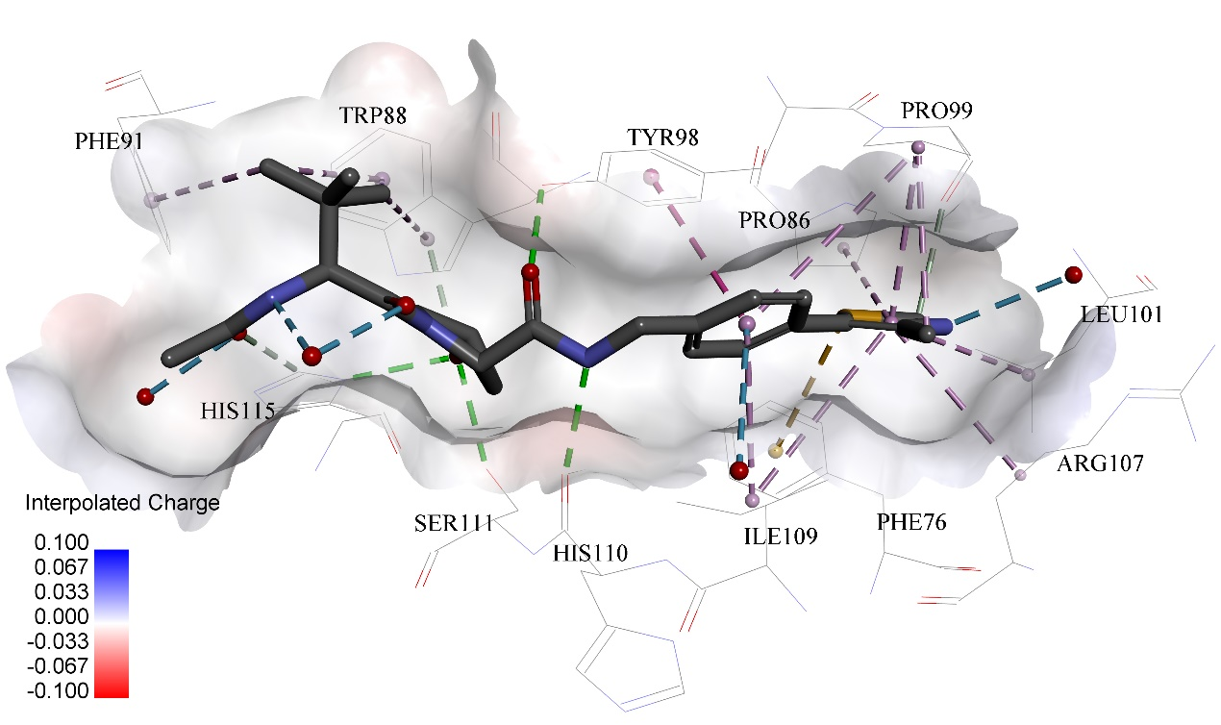
Supporting Figure 5 Predicted binding modes of compound 4W9H to pVHL. The protein displayed as a gray surface and its key residues were shown with labels. All compounds are shown with only backbone atoms.
Supporting Figure 6 the structure of 1
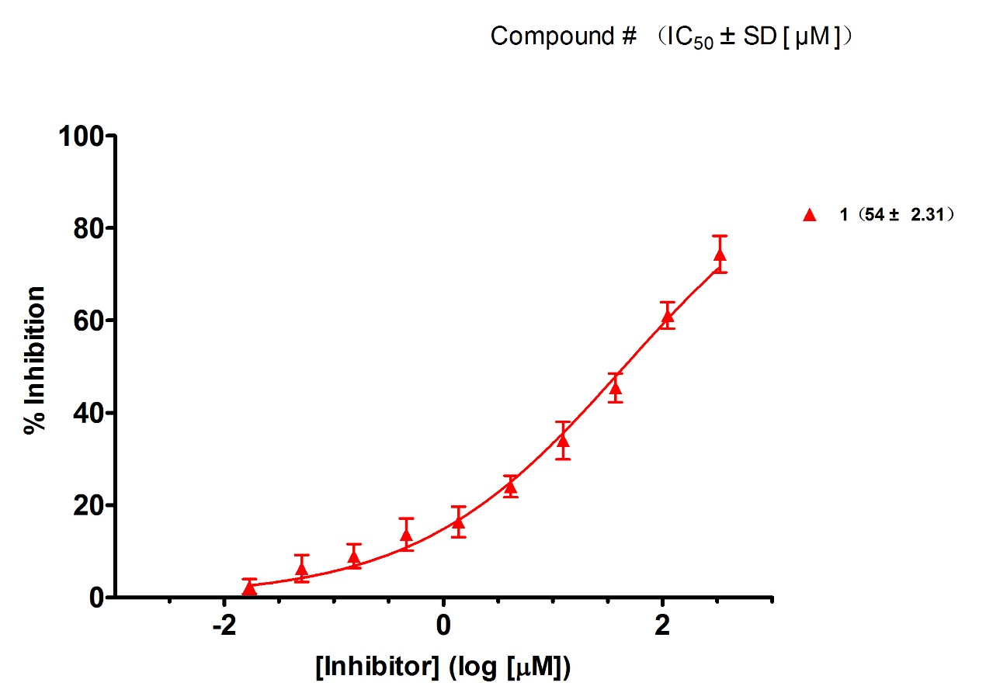
Supporting Figure 7 the curve of inhibitory of 1
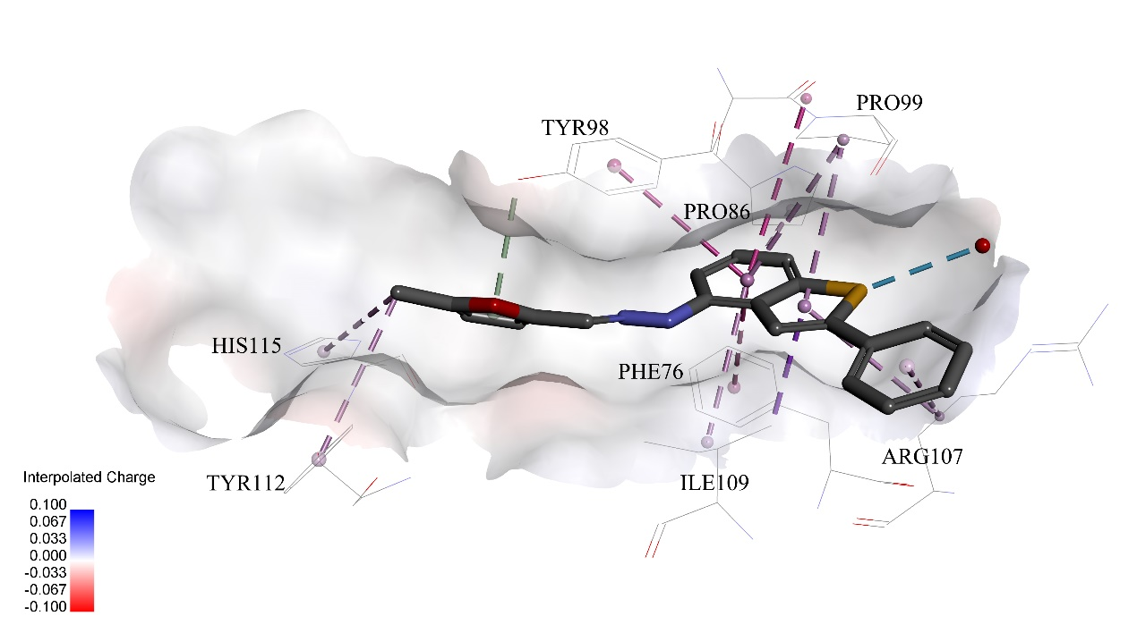
Supporting Figure 8 Predicted binding modes of compound 1 to pVHL. The protein displayed as a gray surface and its key residues were shown with labels. All compounds are shown with only backbone atoms.
Supporting Figure 9 the structure of 2
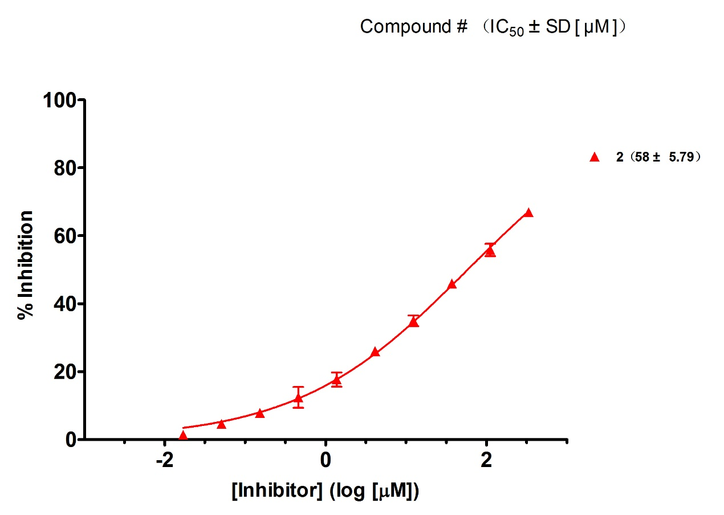
Supporting Figure 10 the curve of inhibitory of 2
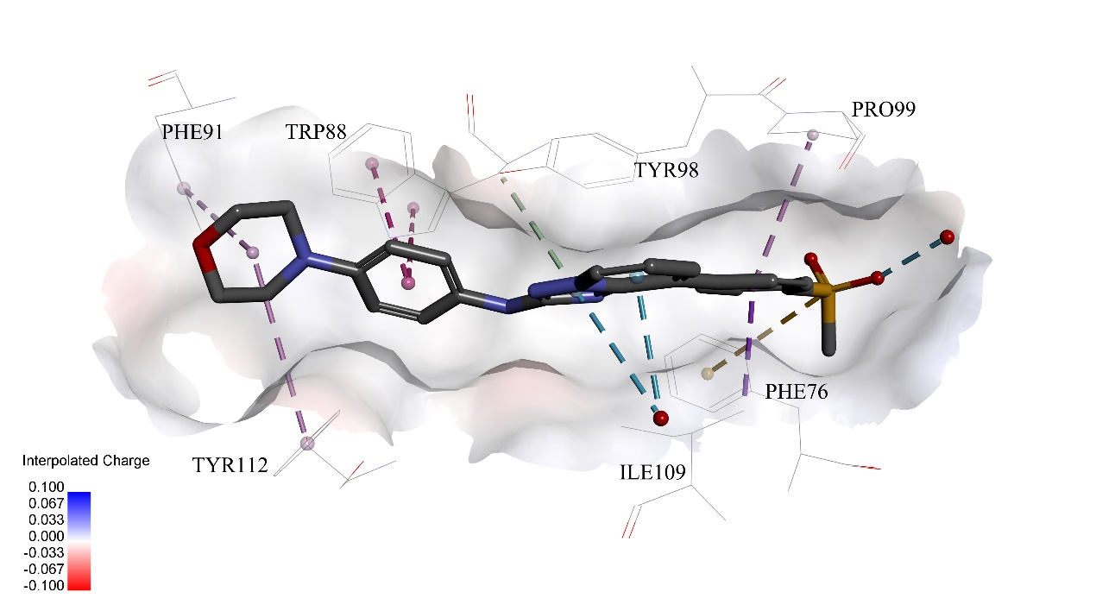
Supporting Figure 11 Predicted binding modes of compound 2 to pVHL. The protein displayed as a gray surface and its key residues were shown with labels. All compounds are shown with only backbone atoms.
Supporting Figure 12 the structure of 3
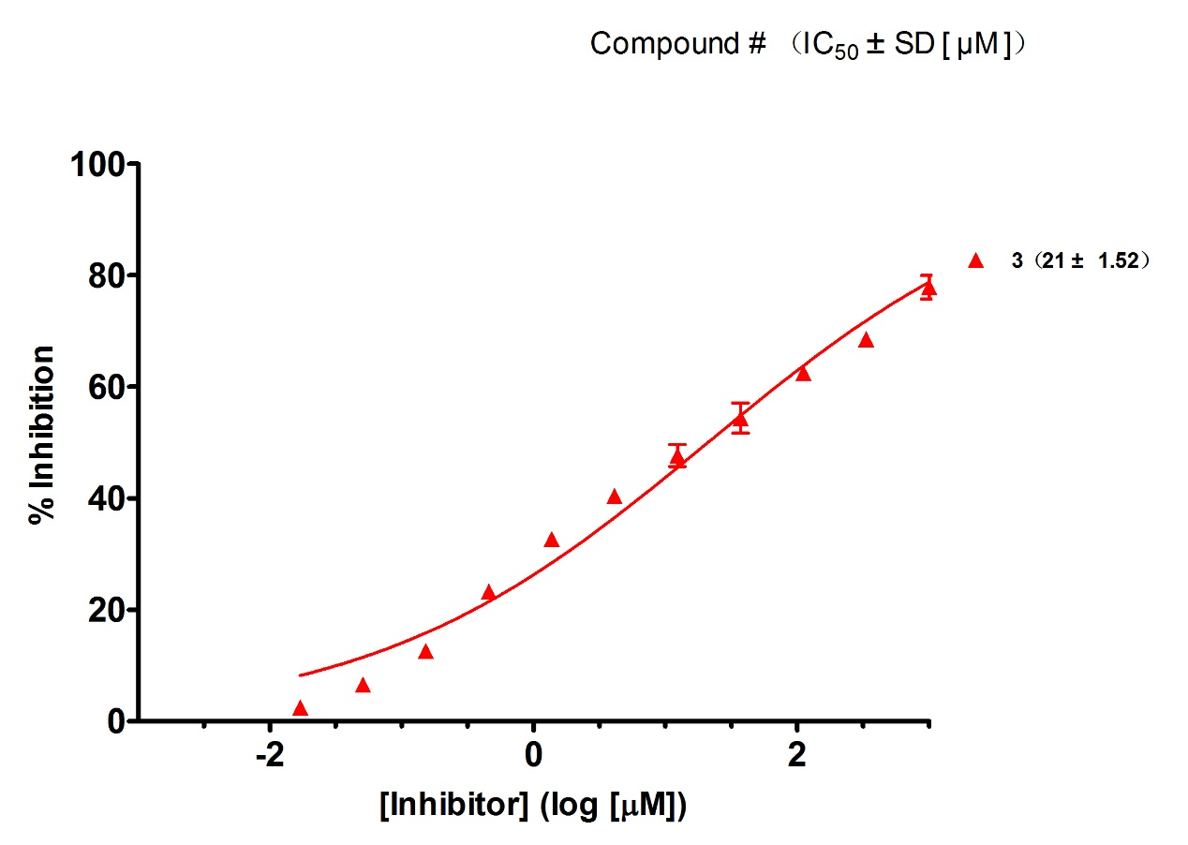
Supporting Figure 13 the curve of inhibitory of 3
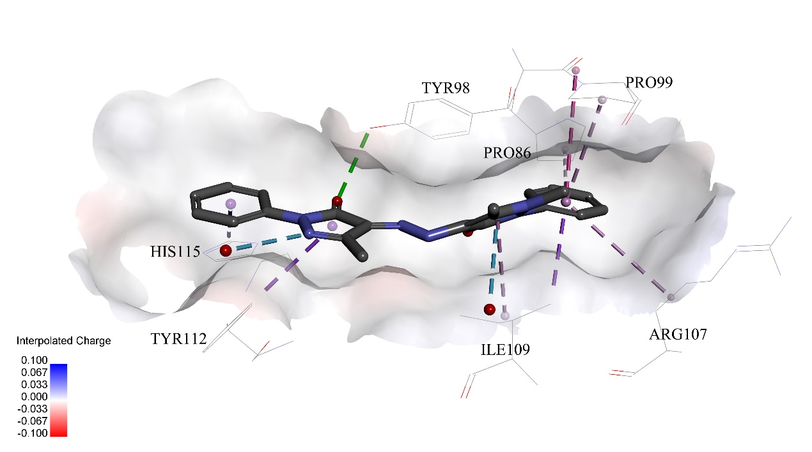
Supporting Figure 14 Predicted binding modes of compound 3 to pVHL. The protein displayed as a gray surface and its key residues were shown with labels. All compounds are shown with only backbone atoms.
Supporting Figure 15 the structure of 4
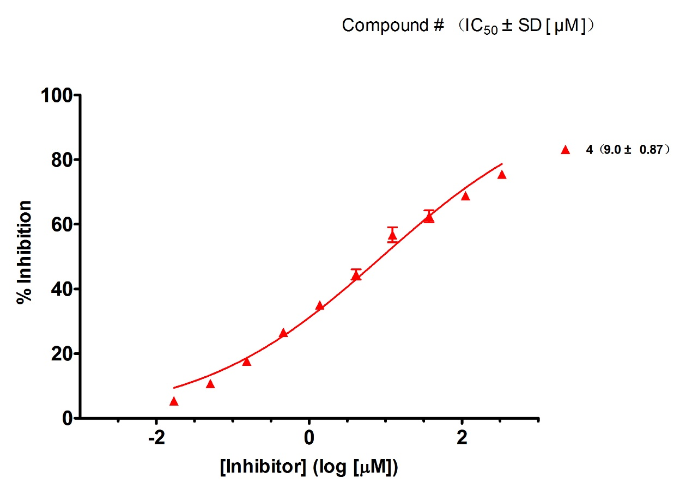
Supporting Figure 16 the curve of inhibitory of 4
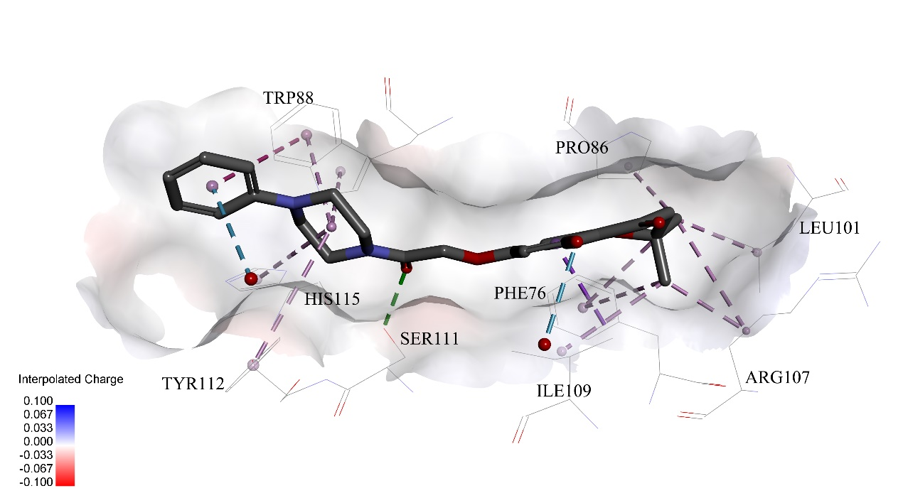
Supporting Figure 17 Predicted binding modes of compound 4 to pVHL. The protein displayed as a gray surface and its key residues were shown with labels. All compounds are shown with only backbone atoms.
Supporting Figure 18 the structure of 5

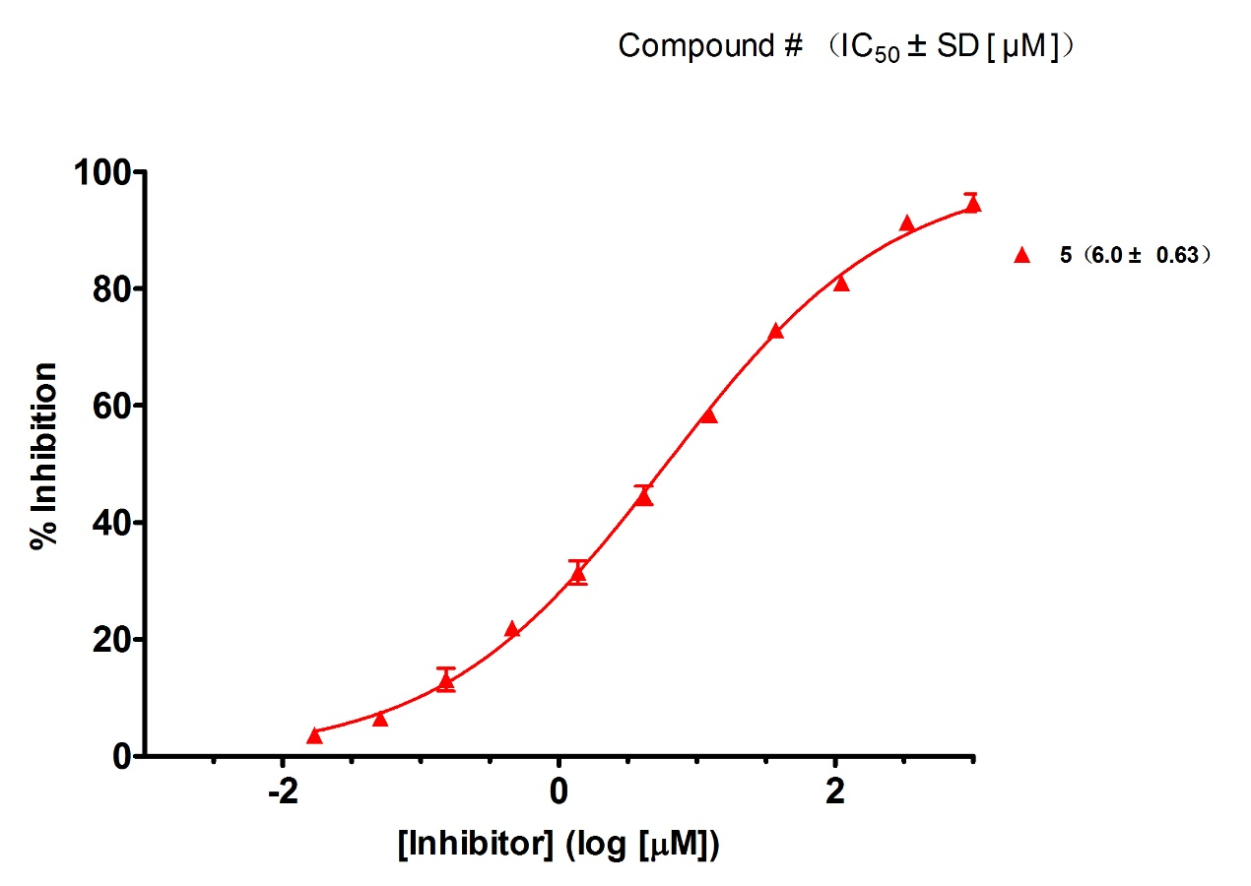
Supporting Figure 19 the curve of inhibitory of 5
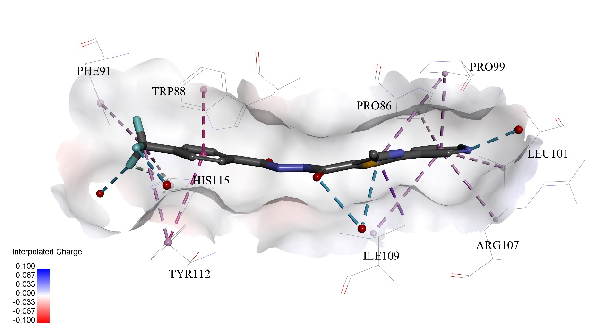
Supporting Figure 20 Predicted binding modes of compound 5 to pVHL. The protein displayed as a gray surface and its key residues were shown with labels. All compounds are shown with only backbone atoms.
Supporting Figure 21 the structure of 6
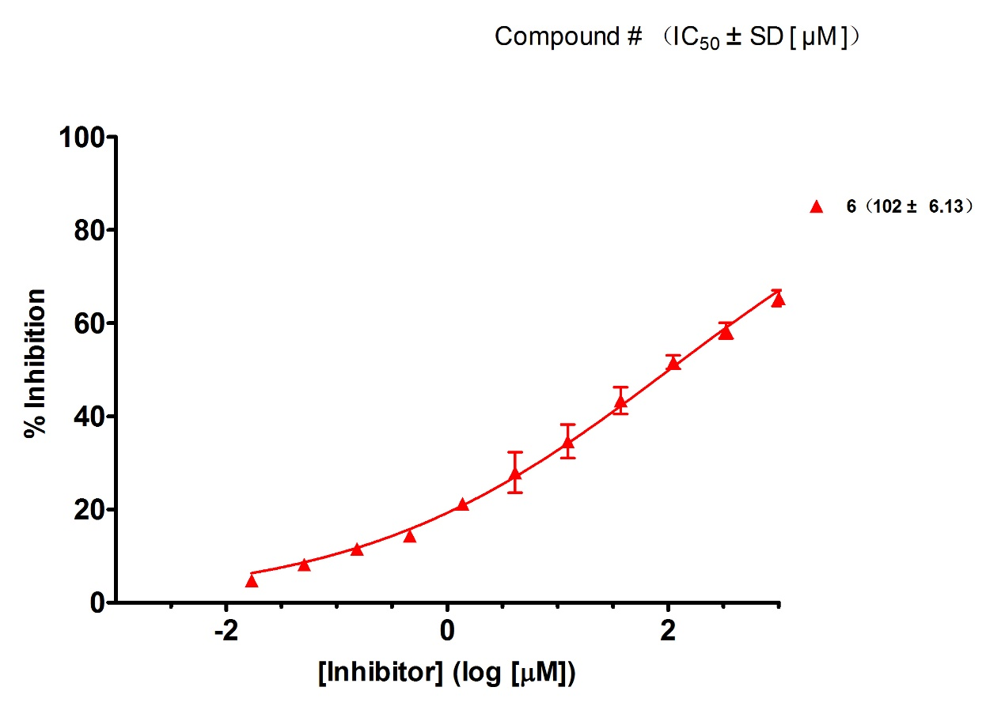
Supporting Figure 22 the curve of inhibitory of 6
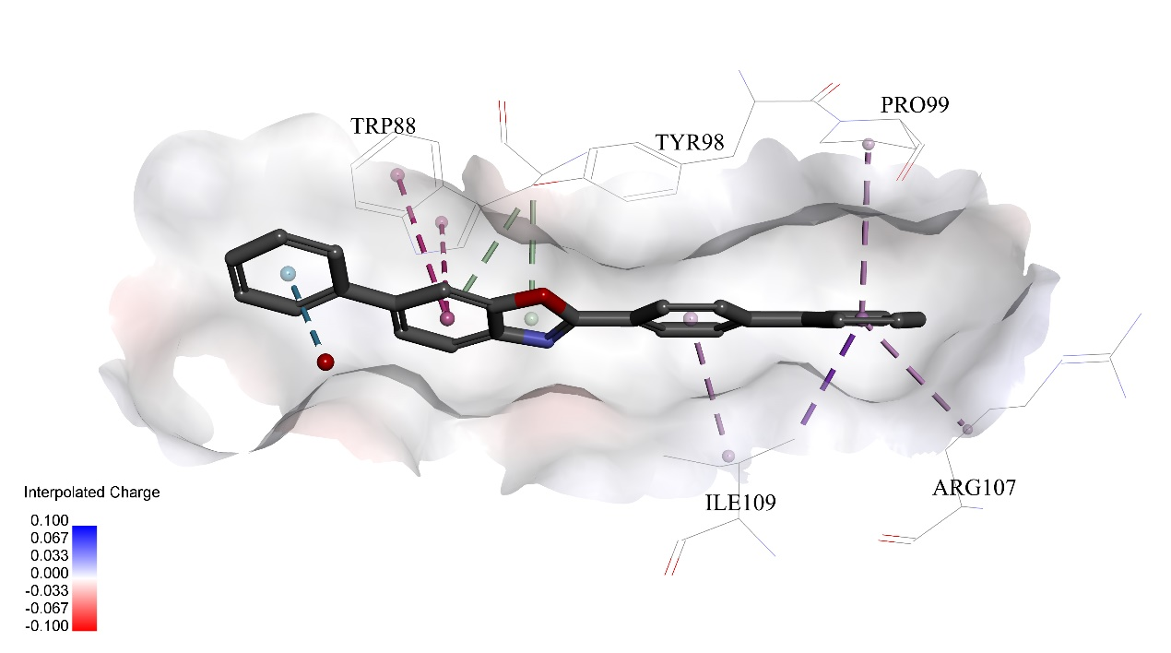
Supporting Figure 23 Predicted binding modes of compound 6 to pVHL. The protein displayed as a gray surface and its key residues were shown with labels. All compounds are shown with only backbone atoms.
Supporting Figure 24 the structure of 7
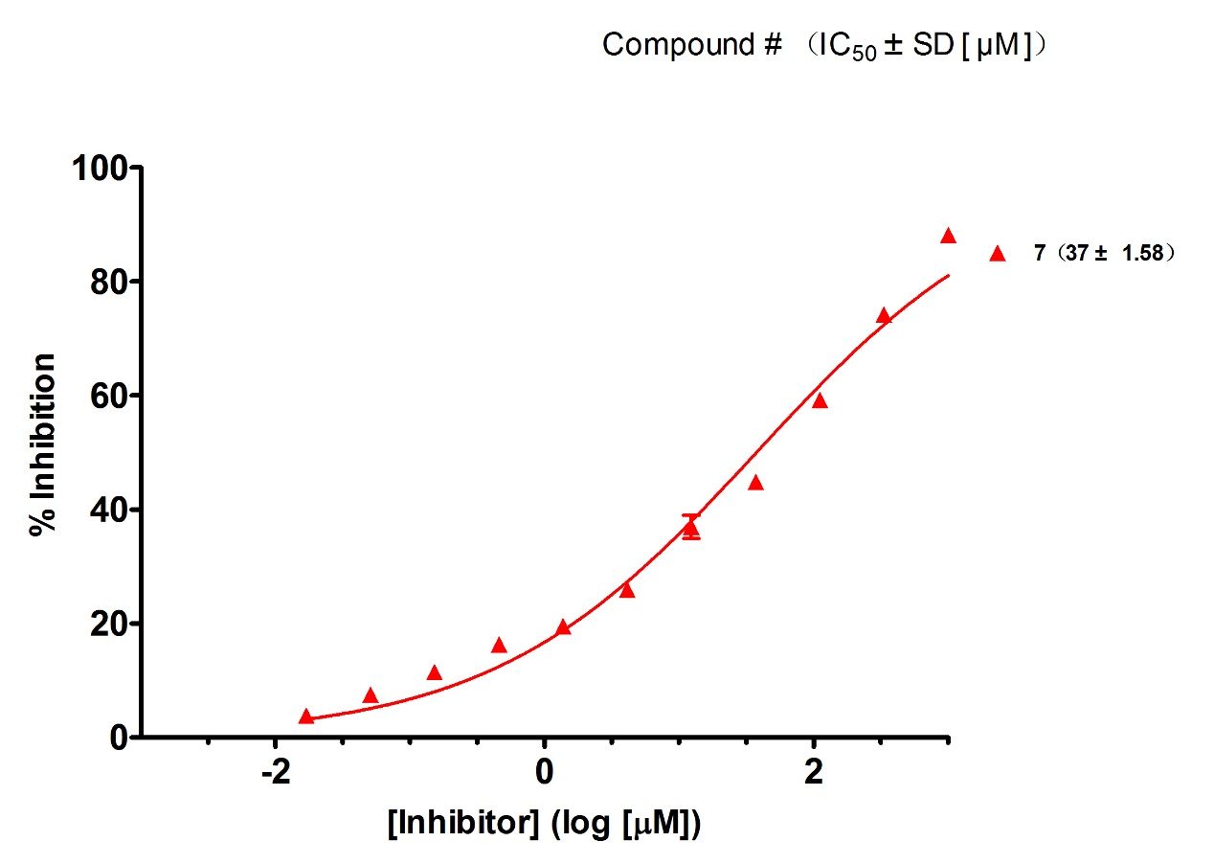
Supporting Figure 25 the curve of inhibitory of 7
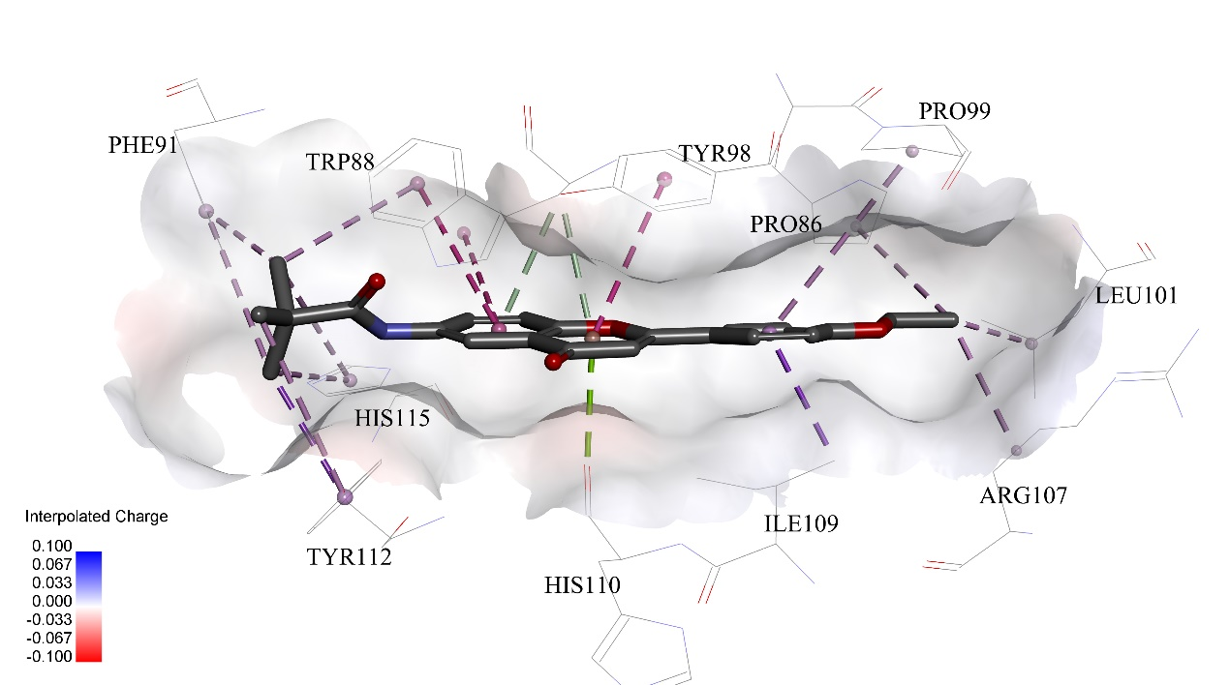
Supporting Figure 26 Predicted binding modes of compound 7 to pVHL. The protein displayed as a gray surface and its key residues were shown with labels. All compounds are shown with only backbone atoms.
Supporting Figure 27 the structure of 8

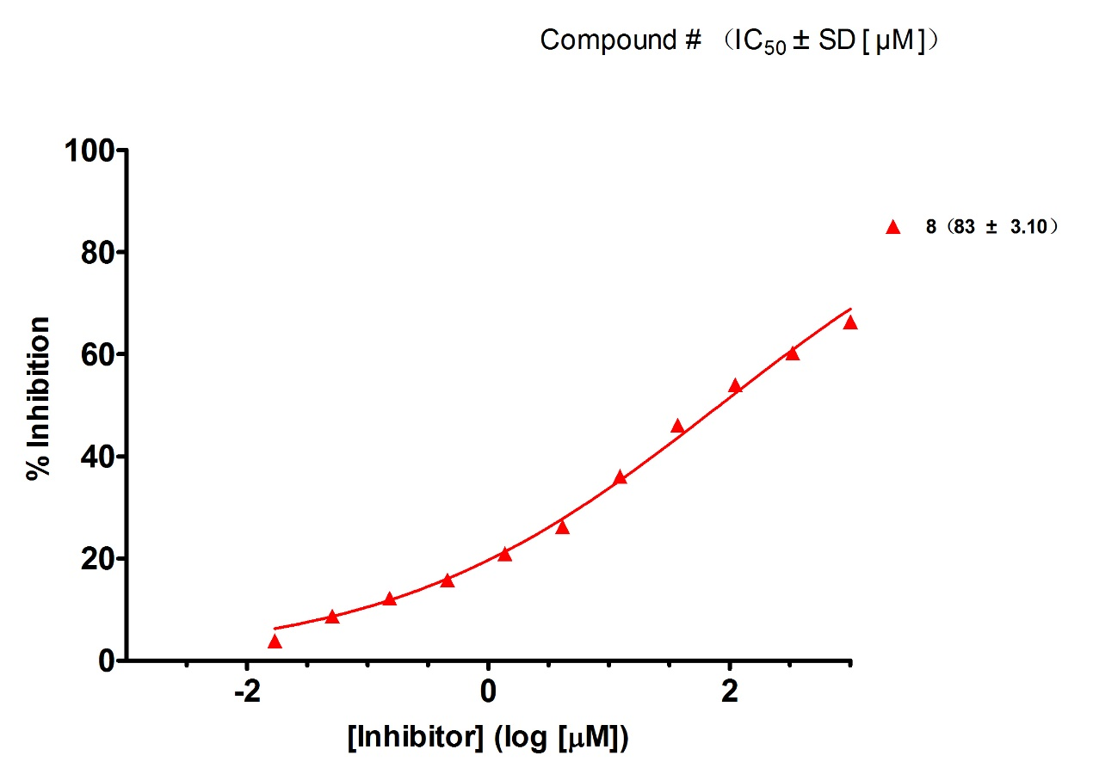
Supporting Figure 28 the curve of inhibitory of 8
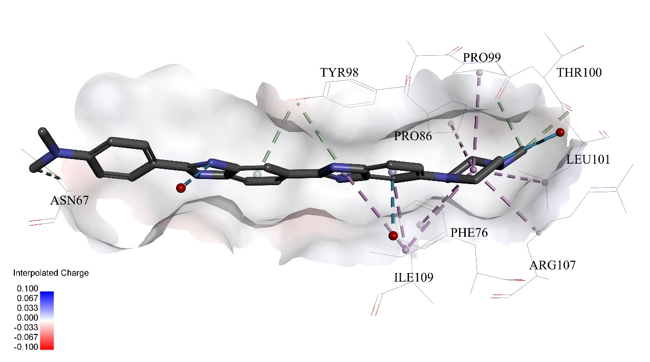
Supporting Figure 29 Predicted binding modes of compound 8 to pVHL. The protein displayed as a gray surface and its key residues were shown with labels. All compounds are shown with only backbone atoms.
Supporting Figure 30 the structure of 9
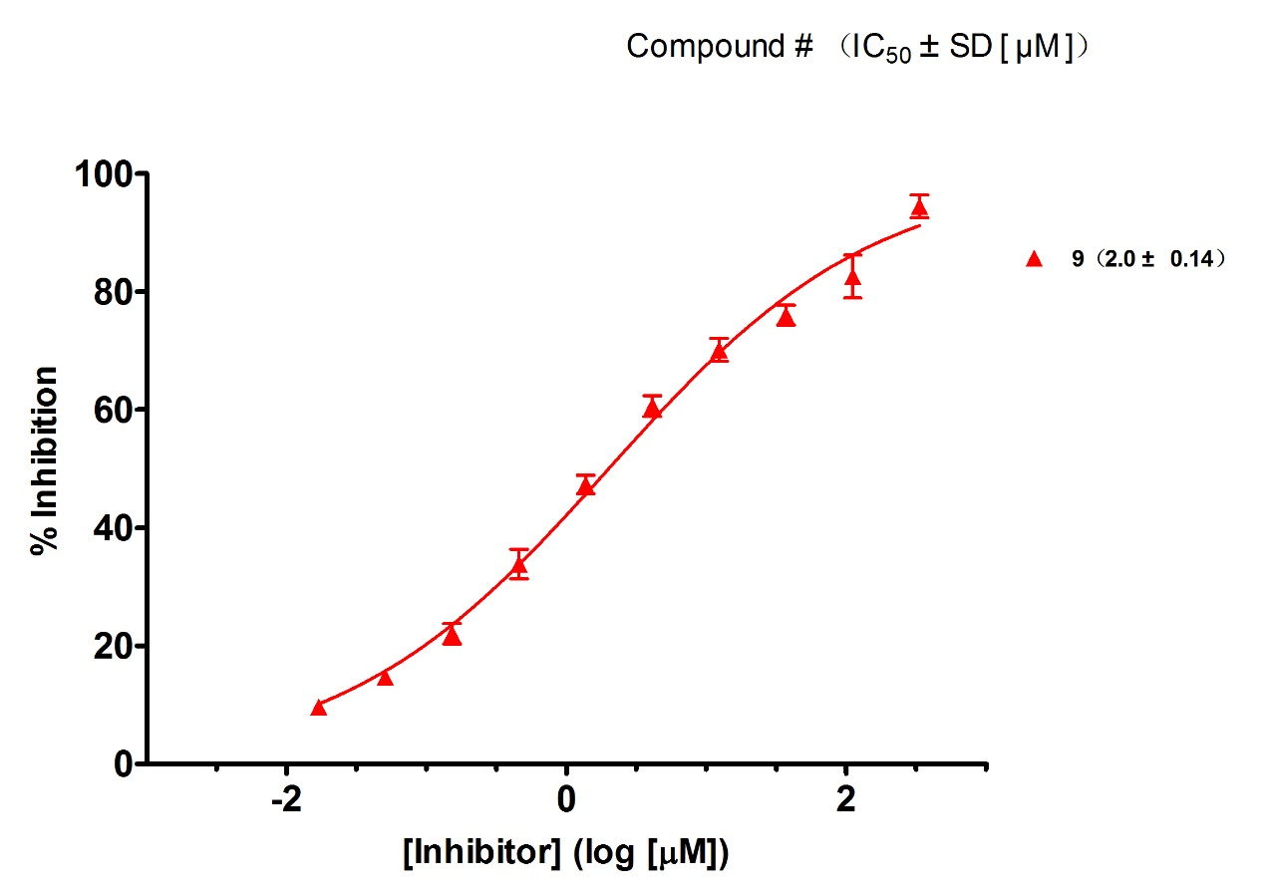
Supporting Figure 31 the curve of inhibitory of 9
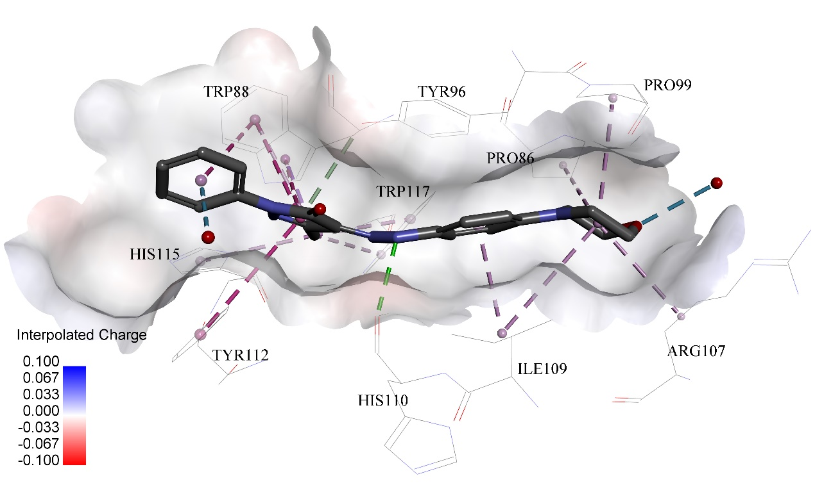
Supporting Figure 32 Predicted binding modes of compound 9 to pVHL. The protein displayed as a gray surface and its key residues were shown with labels. All compounds are shown with only backbone atoms.

