Sukanlaya Leejae¹, Peter William Taylor², and Supayang Piyawan Voravuthikunchai¹
¹Department of Microbiology and Natural Products Research Center, Faculty of Science,
Prince of Songkla University, Songkhla 90112, Thailand
²School of Pharmacy, University College London, London WC1N 1AX, UK

Method
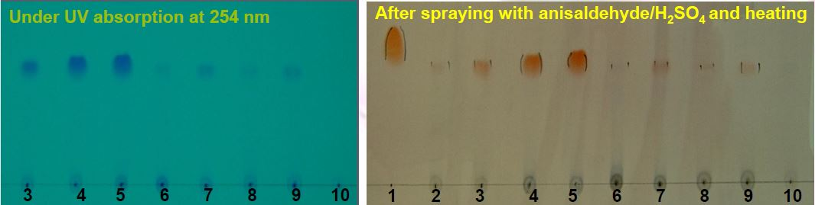
Thin-layer chromatography (Leejae et al., 2013).

Results

Figure: Localization of rhodomyrtone in S. aureus ATCC 29213 after treated with 8 μg/ml of the compound for 1-4 h. Lanes: 1, reference rhodomyrtone; 2 and 6, rhodomyrtone-treated S. aureus for 1 h; 3 and 7, rhodomyrtone-treated S. aureus for 2 h; 4 and 8, rhodomyrtone-treated S. aureus for 3 h; 5 and 9, rhodomyrtone-treated S. aureus for 4 h; 10: 1% DMSO-treated S. aureus for 4 h; 2-5, cell wall and cell membrane fractions; 6-9, cytoplasmic fraction.

Reference
Leejae S, Taylor PW, and Voravuthikunchai SP. 2013. Antibacterial mechanisms of rhodomyrtone against important hospital-acquired antibiotic-resistant pathogenic bacteria. Journal of Medical Microbiology 62(1):78-85. DOI 10.1099/jmm.0.049205-0.

