Map comparison results

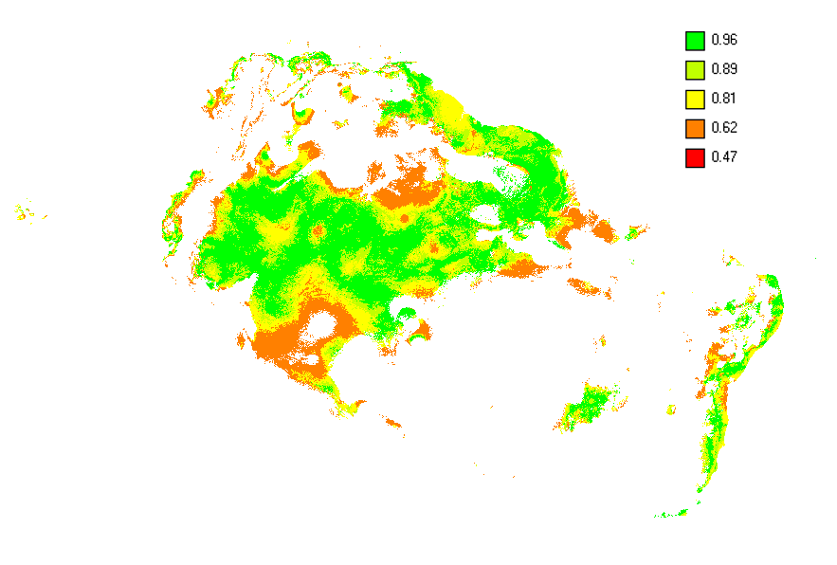

S4.1. Numerical fuzzy similarity map results for Aguilar et al. 2015. The fuzzy similarity map and corresponding Fuzzy Kappa statistic, using the ‘Numerical Fuzzy kappa algorithm’, a value of 1.0 (dark green) means total similarity and a value of 0.0 total dissimilarity. Values in orange (around 0.6) point to some similarity in both maps.

S4.2. Numerical fuzzy similarity map results for Alamgir et al. 2015. The fuzzy similarity map and corresponding Fuzzy Kappa statistic, using the ‘Numerical Fuzzy kappa algorithm’, a value of 1.0 (dark green) means total similarity and a value of 0.0 total dissimilarity. Values in orange (around 0.6) point to some similarity in both maps.

S4.3. Numerical fuzzy similarity map results for Alfaro-Saiz et al. 2015. The fuzzy similarity map and corresponding Fuzzy Kappa statistic, using the ‘Numerical Fuzzy kappa algorithm’, a value of 1.0 (dark green) means total similarity and a value of 0.0 total dissimilarity. Values in orange (around 0.6) point to some similarity in both maps.

S4.4. Numerical fuzzy similarity map results for Carvalho et al. 2015. The fuzzy similarity map and corresponding Fuzzy Kappa statistic, using the ‘Numerical Fuzzy kappa algorithm’, a value of 1.0 (dark green) means total similarity and a value of 0.0 total dissimilarity. Values in red (around 0.64) point to some similarity in both maps.

S4.5. Numerical fuzzy similarity map results for Chetan et al. 2014. The fuzzy similarity map and corresponding Fuzzy Kappa statistic, using the ‘Numerical Fuzzy kappa algorithm’, a value of 1.0 (dark green) means total similarity and a value of 0.0 total dissimilarity. Values in red (around 0.72) point to some similarity in both maps.

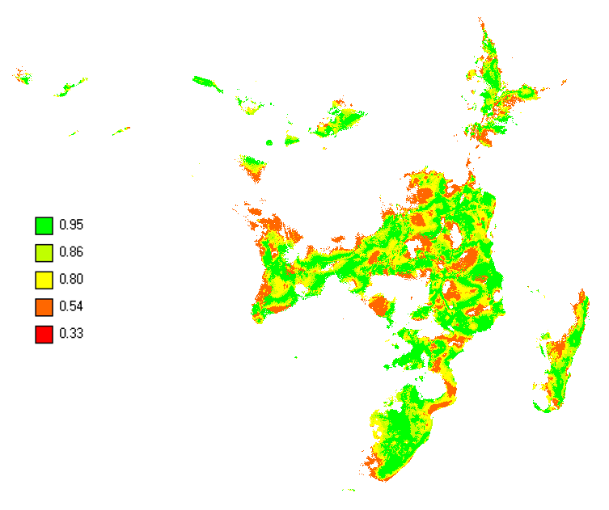

S4.6. Numerical fuzzy similarity map results for Chlond et al. 2015. The fuzzy similarity map and corresponding Fuzzy Kappa statistic, using the ‘Numerical Fuzzy kappa algorithm’, a value of 1.0 (dark green) means total similarity and a value of 0.0 total dissimilarity. Values in orange (around 0.54) point to some similarity in both maps.

S4.7. Numerical fuzzy similarity map results for Chunco et al. 2013. The fuzzy similarity map and corresponding Fuzzy Kappa statistic, using the ‘Numerical Fuzzy kappa algorithm’, a value of 1.0 (dark green) means total similarity and a value of 0.0 total dissimilarity. Values in red (around 0.51) point to some similarity in both maps.

S4.8. Numerical fuzzy similarity map results for Confliti et al. 2015. The fuzzy similarity map and corresponding Fuzzy Kappa statistic, using the ‘Numerical Fuzzy kappa algorithm’, a value of 1.0 (dark green) means total similarity and a value of 0.0 total dissimilarity. Values in orange (around 0.58) point to some similarity in both maps.

S4.9. Numerical fuzzy similarity map results for De Castro et al. 2014. The fuzzy similarity map and corresponding Fuzzy Kappa statistic, using the ‘Numerical Fuzzy kappa algorithm’, a value of 1.0 (dark green) means total similarity and a value of 0.0 total dissimilarity. Values in yellow (around 0.53) point to some similarity in both maps.

S4.10. Numerical fuzzy similarity map results for Fois et al. 2014. The fuzzy similarity map and corresponding Fuzzy Kappa statistic, using the ‘Numerical Fuzzy kappa algorithm’, a value of 1.0 (dark green) means total similarity and a value of 0.0 total dissimilarity. Values in red (around 0.65) point to some similarity in both maps.

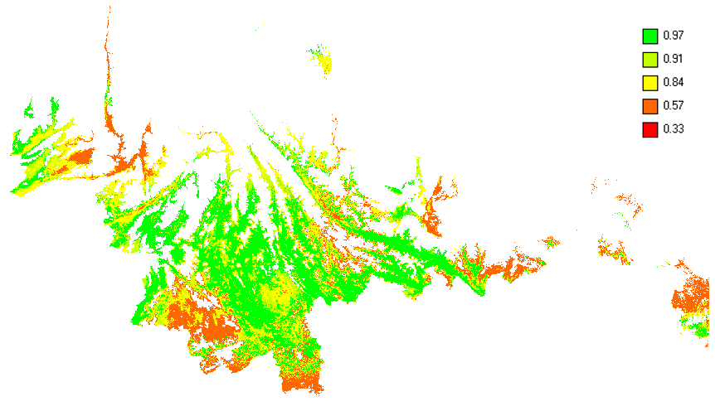

S4.11. Numerical fuzzy similarity map results for Hu et al. 2015. The fuzzy similarity map and corresponding Fuzzy Kappa statistic, using the ‘Numerical Fuzzy kappa algorithm’, a value of 1.0 (dark green) means total similarity and a value of 0.0 total dissimilarity. Values in red (around 0.65) point to some similarity in both maps.

S4.12. Numerical fuzzy similarity map results for Meyer et al. 2014. The fuzzy similarity map and corresponding Fuzzy Kappa statistic, using the ‘Numerical Fuzzy kappa algorithm’, a value of 1.0 (dark green) means total similarity and a value of 0.0 total dissimilarity. Values in red (around 0.69) point to some similarity in both maps.

S4.13. Numerical fuzzy similarity map results for Mweya et al. 2013. The fuzzy similarity map and corresponding Fuzzy Kappa statistic, using the ‘Numerical Fuzzy kappa algorithm’, a value of 1.0 (dark green) means total similarity and a value of 0.0 total dissimilarity. Values in red (around 0.85) point to moderate similarity in both maps.

S4.14. Numerical fuzzy similarity map results for Orr et al. 2014. The fuzzy similarity map and corresponding Fuzzy Kappa statistic, using the ‘Numerical Fuzzy kappa algorithm’, a value of 1.0 (dark green) means total similarity and a value of 0.0 total dissimilarity. Values in red (around 0.50) point to some similarity in both maps.

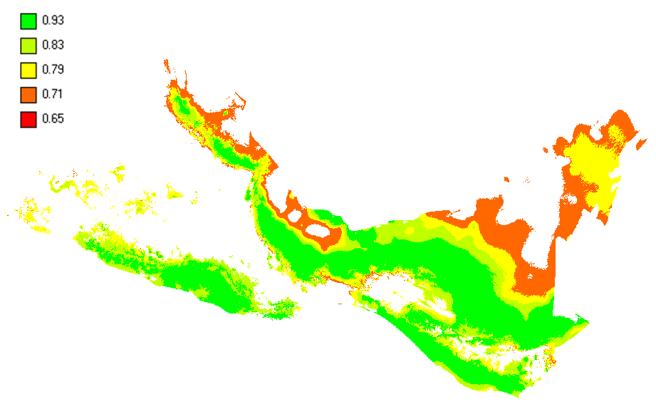

S4.15. Numerical fuzzy similarity map results for Palma-Perez et al. 2013. The fuzzy similarity map and corresponding Fuzzy Kappa statistic, using the ‘Numerical Fuzzy kappa algorithm’, a value of 1.0 (dark green) means total similarity and a value of 0.0 total dissimilarity. Values in red (around 0.65) point to moderate similarity in both maps.

S4.16. Numerical fuzzy similarity map results for Pedersen et al. 2014. The fuzzy similarity map and corresponding Fuzzy Kappa statistic, using the ‘Numerical Fuzzy kappa algorithm’, a value of 1.0 (dark green) means total similarity and a value of 0.0 total dissimilarity. Values in red (around 0.65) point to moderate similarity in both maps.

S4.17. Numerical fuzzy similarity map results for Simo et al. 2014. The fuzzy similarity map and corresponding Fuzzy Kappa statistic, using the ‘Numerical Fuzzy kappa algorithm’, a value of 1.0 (dark green) means total similarity and a value of 0.0 total dissimilarity. Values in red (around 0.20) point to low similarity in both maps.
S4.18. Numerical fuzzy similarity map results for Urbani et al. 2015. The fuzzy similarity map and corresponding Fuzzy Kappa statistic, using the ‘Numerical Fuzzy kappa algorithm’, a value of 1.0 (dark green) means total similarity and a value of 0.0 total dissimilarity. Values in red (around 0.65) point to moderate similarity in both maps.

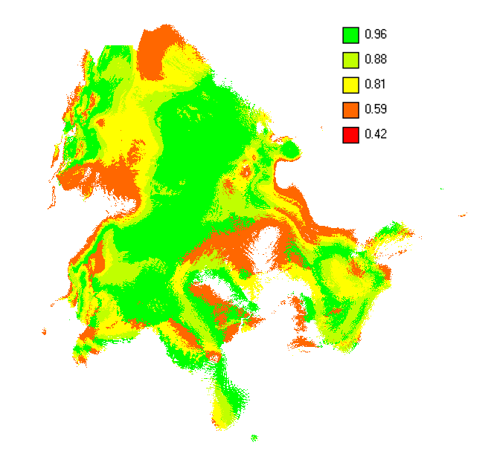

S4.19. Numerical fuzzy similarity map results for Vergara et al. 2015. The fuzzy similarity map and corresponding Fuzzy Kappa statistic, using the ‘Numerical Fuzzy kappa algorithm’, a value of 1.0 (dark green) means total similarity and a value of 0.0 total dissimilarity. Values in orange (around 0.59) point to moderate similarity in both maps.

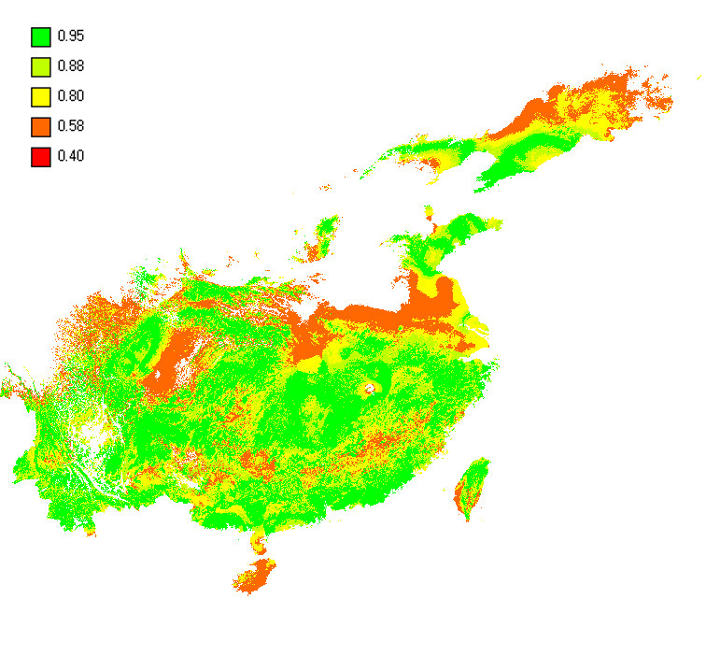

S4.20. Numerical fuzzy similarity map results for Yu et al. 2013. The fuzzy similarity map and corresponding Fuzzy Kappa statistic, using the ‘Numerical Fuzzy kappa algorithm’, a value of 1.0 (dark green) means total similarity and a value of 0.0 total dissimilarity. Values in orange (around 0.58) point to some similarity in both maps.

