INTERACTING EFFECTS OF EARLY DIETARY CONDITIONS AND REPRODUCTIVE EFFORT ON THE OXIDATIVE COSTS OF REPRODUCTION
Noguera, Jose C.

SUPPLEMENTAL INFORMATION (SI)
Figure S1. Chronogram of the experiment
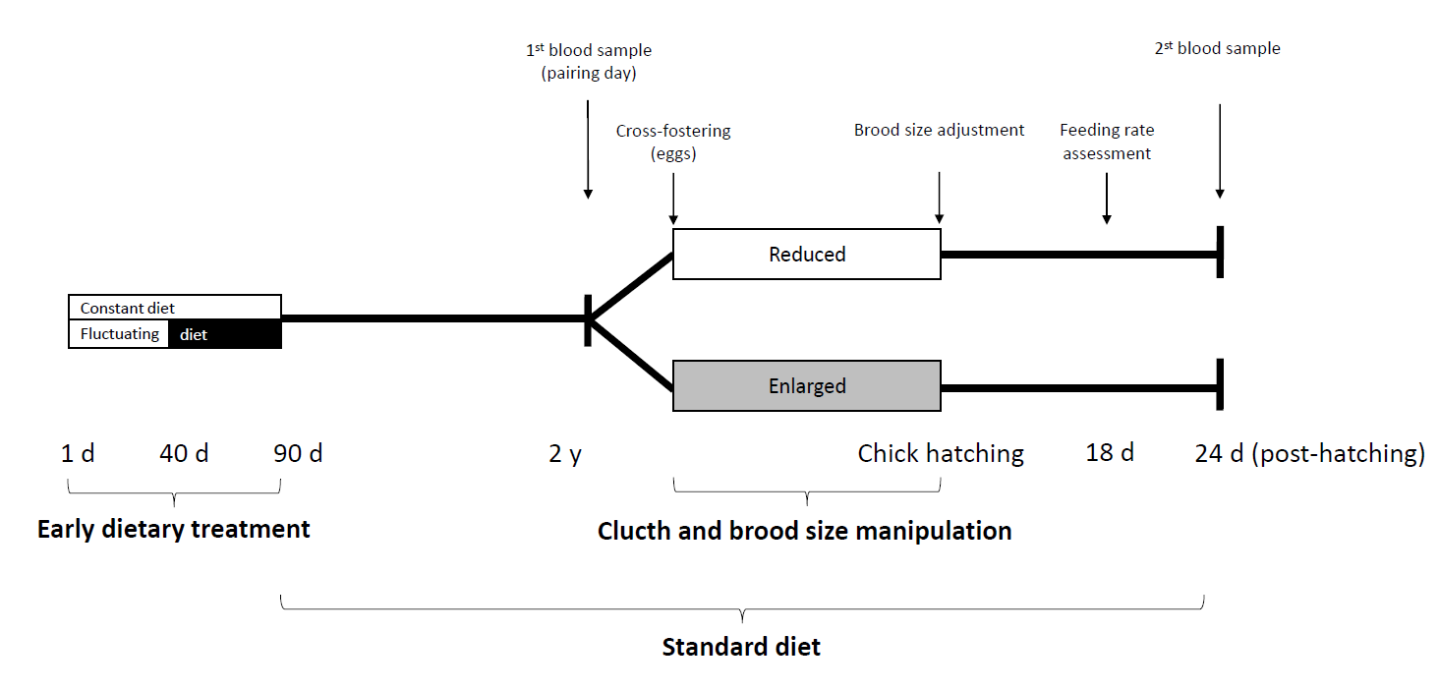

Table S1. Results of Full linear mixed models on the change (Δ) in adult body mass and bill colouration during reproduction.
 | Δ Body mass |  |  |  | Δ Bill colour
Source of variation | estimate | F | d.f._{n,d} | p | estimate | F | d.f._{n,d} | p
Intercept | -1.270 |  |  |  | -0.974
Nutritional treatment (C) | 0.212 | 0.578 | 1,30 | 0.453 | -0.071 | 6.171 | 1,30 | 0.019
Brood size (enlarged) | 0.200 | 0.149 | 1,30 | 0.703 | -1.271 | 2.902 | 1,30 | 0.099
Sex (female) | -1.425 | 0.957 | 1,30 | 0.336 | -1.105 | 7.974 | 1,30 | 0.008
Nutritional treatment x brood size | -0.490 | 1.330 | 1,30 | 0.258 | 1.535 | 4.895 | 1,30 | 0.035
Nutritional treatment x sex | 1.435 | 0.686 | 1,30 | 0.414 | 0.349 | 0.431 | 1,30 | 0.516
Brood size x sex | 1.095 | 0.229 | 1,30 | 0.636 | -0.443 | 0.146 | 1,30 | 0.705
Nutritional treatment x brood size x sex | -1.261 | 0.421 | 1,30 | 0.521 | 0.303 | 0.040 | 1,30 | 0.844

Table S2. Results of Full linear mixed models (LMM) on the change (Δ) in antioxidant defences (TAC and GPx), oxidative damage and telomere length over the period of reproduction.
 | ΔTAC |  |  |  | ΔGPx |  |  |  | ΔDNA damage |  |  |  | ΔTelomere length
Source of variation | estimate | F | d.f._{n,d} | p | estimate | F | d.f._{n,d} | p | estimate | F | d.f._{n,d} | p | estimate | F | d.f._{n,d} | p
Intercept | -0.081 |  |  |  | -453.631 |  |  |  | 1.456 |  |  |  | -0.132
Nutritional treatment (C) | 0.215 | 1.315 | 1,30 | 0.261 | -580.712 | 10.772 | 1,30 | 0.003 | -2.219 | 0.156 | 1,30 | 0.695 | 0.209 | 1.233 | 1,30 | 0.276
Brood size (enlarged) | 0.390 | 0.606 | 1,30 | 0.442 | -1120.267 | 0.442 | 1,30 | 0.511 | 1.053 | 10.148 | 1,30 | 0.003 | 0.082 | 0.538 | 1,30 | 0.469
Sex (female) | 0.032 | 0.524 | 1,30 | 0.475 | -847.179 | 0.226 | 1,30 | 0.638 | -0.639 | 0.173 | 1,30 | 0.680 | 0.086 | 0.090 | 1,30 | 0.767
Nutritional treatment x brood size | -0.571 | 0.320 | 1,30 | 0.576 | 1641.174 | 5.172 | 1,30 | 0.030 | 4.634 | 1.739 | 1,30 | 0.197 | -0.250 | 0.818 | 1,30 | 0.373
Nutritional treatment x sex | 0.127 | 2.490 | 1,30 | 0.125 | 1666.245 | 5.402 | 1,30 | 0.027 | 1.189 | 0.248 | 1,30 | 0.622 | -0.089 | 0.007 | 1,30 | 0.934
Brood size x sex | -0.343 | 0.018 | 1,30 | 0.894 | 768.326 | 0.283 | 1,30 | 0.599 | 1.433 | 0.136 | 1,30 | 0.715 | -0.137 | 0.046 | 1,30 | 0.831
Nutritional treatment x brood size x sex | 0.773 | 1.408 | 1,30 | 0.245 | -1003.761 | 1.004 | 1,30 | 0.324 | -4.267 | 1.266 | 1,30 | 0.269 | 0.205 | 0.396 | 1,30 | 0.534

Table S3. Mean ± standard error (ES) of the change (Δ) in body mass (g), bill colour (scale point), TAC (mmol Trolox equiv/l), GPx (nmol/min/mg protein), oxidative DNA damage (ng of 8-OHdG) and telomere length (T/S ratio) in all experimental groups.
 | Constant diet |  |  |  |  | Fluctuating diet
 | Enlarged brood |  | Reduced brood |  |  | Enlarged brood |  | Reduced brood
 | Mean | SE | Mean | SE |  | Mean | SE | Mean | SE
Δ Body mass | -1.426 | 0.314 | -1.053 | 0.299 |  | -1.235 | 0.191 | -1.983 | 0.953
Δ Bill colour | -1.230 | 0.460 | -1.424 | 0.363 |  | -3.020 | 0.418 | -1.527 | 0.335
Δ TAC | 0.248 | 0.219 | 0.213 | 0.121 |  | 0.153 | 0.114 | -0.066 | 0.183
Δ GPx | -221.621 | 111.650 | -624.811 | 284.458 |  | -1613.325 | 87.049 | -877.221 | 298.448
Δ DNA damage | 3.782 | 1.059 | -0.488 | 0.465 |  | 2.906 | 1.049 | 1.137 | 0.949
Δ Telomere length | -0.059 | 0.060 | 0.075 | 0.062 |  | -0.075 | 0.097 | -0.089 | 0.085

Table S4. Results of linear mixed models of the initial adult body mass, bill colouration, TAC level, GPx activity, and oxidative DNA damage level and telomere length. Variables retained in the final model are shown in bold. For removed terms, significance levels are those when terms were dropped from the model.
 | Body mass |  |  | Bill colour |  |  | TAC |  |  | GPx |  |  | DNA damage |  |  | Telomere length
Source of variation | F | d.f._{n,d} | p | F | d.f._{n,d} | p | F | d.f._{n,d} | P | F | d.f._{n,d} | p | F | d.f._{n,d} | p | F | d.f._{n,d} | p
Nutritional treatment | 0.02 | 1,34 | 0.900 | 6.65 | 1,35 | 0.014 | 0.29 | 1,36 | 0.590 | 0.51 | 1,36 | 0.480 | 0.01 | 1,34 | 0.908 | 1.20 | 1,36 | 0.280
Brood size | 0.07 | 1,35 | 0.795 | 1.58 | 1,34 | 0.217 | 0.31 | 1,35 | 0.582 | 0.13 | 1,35 | 0.717 | 1.10 | 1,36 | 0.301 | 1.06 | 1,35 | 0.311
Sex | 2.13 | 1,36 | 0.153 | 59.98 | 1,35 | <0.001 | 0.10 | 1,34 | 0.752 | 0.18 | 1,34 | 0.676 | 0.85 | 1,35 | 0.361 | 0.29 | 1,34 | 0.595
Nutritional treatment x brood size | 3.01 | 1,33 | 0.092 | 0.85 | 1,32 | 0.364 | 1.18 | 1,32 | 0.285 | 0.75 | 1,32 | 0.392 | 1.17 | 1,31 | 0.289 | 0.37 | 1,32 | 0.545
Nutritional treatment x sex | 0.54 | 1,31 | 0.468 | 2.18 | 1,33 | 0.150 | 1.99 | 1,33 | 0.168 | 0.78 | 1,33 | 0.382 | 4.06 | 1,33 | 0.052 | 0.00 | 1,31 | 0.958
Brood size x sex | 2.39 | 1,32 | 0.132 | 0.00 | 1,31 | 0.967 | 0.17 | 1,31 | 0.682 | 0.02 | 1,31 | 0.896 | 2.64 | 1,32 | 0.114 | 1.34 | 1,33 | 0.256
Nutritional treatment x brood size x sex | 0.94 | 1,30 | 0.341 | 1.46 | 1,30 | 0.236 | 0.29 | 1,30 | 0.596 | 1.45 | 1,30 | 0.238 | 3.21 | 1,30 | 0.083 | 0.20 | 1,30 | 0.654

