Systematic Drug Repositioning through Mining Adverse Event Data in ClinicalTrials.gov

Supplemental information

Supplementary information

- The YAML script of the I2E query in Figure 1:
To generate the query in Figure 1, copy and paste the YAML script below into the I2E Pro interface, remove query limits for hits, time, and rows, and add the “Same PTs” filter in the “Output editor” as shown in 2 below.

# Options: omitDefaults
# Written: Tue, 16 Aug 2016 21:10:33.898 GMT by I2E 4.4R31
---
version: 4.4
title: Extracting Serious Adverse Events
creationDate: '2015-07-30 11:31:14'
query:
document:
- region:
showInColumn: false
showInHitColumn: false
snid: ct.event_se
pt: Serious Event
where:
- region:
columnOptions: [Text]
id: region2
view: {height: 87, width: 165}
snid: ct.sub_title_se
pt: Serious Event Subtitle
where:
- class: {showInColumn: false, showInHitColumn: false, snid: nlm_plus.C04,
pt: Neoplasms}
- region:
columnOptions: [Text]
showInColumn: false
showInHitColumn: false
snid: ct.counts_se
pt: Serious Event Counts
where:
- region:
showInColumn: false
snid: ct.group_id
pt: Group IDs
where:
- class: {showInColumn: false, showInHitColumn: false, parameterisationEnabled: false,
id: class3, snid: /word}
- region:
columnOptions: [Text]
id: region4
view: {height: 42, width: 300}
snid: ct.subjects_affected_se
pt: Count of Participants Affected by Serious Event
- region:
columnOptions: [Text]
id: region5
view: {height: 44, width: 298}
snid: ct.subjects_at_risk_se
pt: Count of Participants At Risk of Serious Event
- region:
view: {height: 129, width: 289}
snid: ct.re_group
pt: Reported Adverse Events Reporting Group
where:
- region:
showInColumn: false
snid: ct.group_id
pt: Group IDs
where:
- class: {showInColumn: false, showInHitColumn: false, parameterisationEnabled: false,
id: class2, snid: /word}
- region:
columnOptions: [Text]
id: region3
snid: ct.title
pt: Title
- region:
identifiers:
- {snid: ct.study_design, pt: Study Design}
- {snid: ct.official_title, pt: Official Title}
view: {height: 96, width: 197}
where:
- word: {text: random*, id: word1, matchType: Wildcard, showInColumn: false}
- region:
snid: ct.condition
pt: Condition
where:
- class: {role: negated, showInColumn: false, showInHitColumn: false, parameterisationEnabled: false,
snid: nlm_plus.C04, pt: Neoplasms}
output:
columns:
- {id: region2}
- {title: Study Arm, id: region3}
- {id: class2}
- {title: Num. of Ptnts w SAE, id: region4}
- {title: Number of Patients, id: region5}
- {id: class3}
- {id: word1}
outputSettings:
allDocs: true
allResults: true
allRows: false
allTime: true
boundaries: Default
crossProduct: true
defaultColumnOptions: [Default]
documentsPerAssertion: -1
fileFormatValue: dhtml
globalDisambiguationValue: 12
hitsPerDoc: 10000
hitsPerDocPerAssertion: 10
language: mul
maxDocs: 10000
maxResults: 1000
maxRows: 110000
maxTime: 60
outputOrdering: frequency
outputType: cluster
overrideDisambiguation: false
resultType: standard
showQueryIDs: true
useOutputEditor: true
filters:
- of: PT
where: [class2, class3]
condition: equals
comments: "Please first double-click \"CTgov.i2x\" on the upper left window to open\
\ the index (database).\n\nTo select type of disease, go to Query editor and double-click\
\ the two disease folders (Neoplasms, do one at a time), click the upper level \n\
folder \"Disease\", then click \"More\" button and select \"Below selection\", type\
\ in your disease term next to \"Look for\" and enter\nor click \"Search\" (may\
\ take a minute, click \"Stop\" when a good hit is found), click the correct term\
\ in the results, click OK.\n\nTo run your query, click the green arrow on top right.\
\ When finished, click the refresh button in the new web browser\n(the two green\
\ arrows like a circle) to retrieve all the hits (may take a minute).\n\nTo view\
\ the results, click the triangles to see more, and then click a term under \"Hit\"\
\ to see the document with query terms highlighted.\n\nTo export to the Excel, change\
\ \"HTML\" in the result (browser) window upper right to \"Excel\", then click the\
\ green arrow, click \"Open\", \"Yes\"\n(If no dialog window for \"Yes\" shows up,\
\ minimize windows to see it behind them).\n\nPlease contact Eric Su (ewsu@lilly.com,\
\ 317-277-7706) for questions.\n\nÂ© 2016 Eli Lilly and Company\n"
creator: Eric Su
summary: This query extracts serious adverse events from clinicaltrials.com.
useInSmartQuery: true

- Output editor setting of the I2E query in Figure 1:
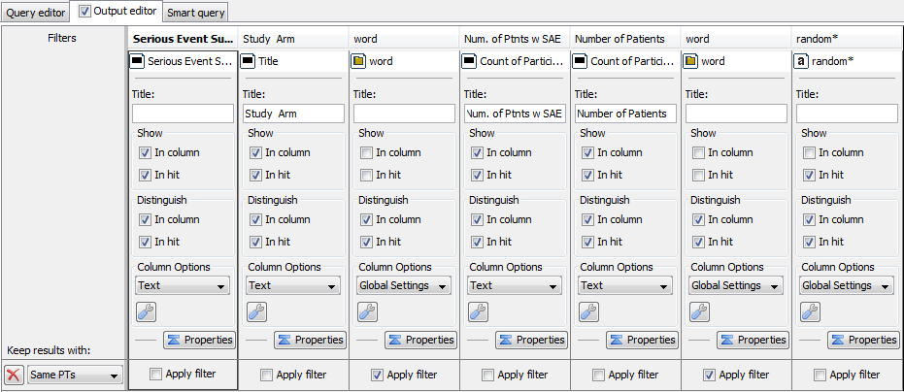
The “word” classes inside Group IDs in Figure 1 are matched with the “Same PTs” (the same preferred term) to match the data to the reporting groups (study arms).

- PolyAnalyst script will be also available upon request to EWS. However, the algorithm for calculating the statistics columns in Table 3 could also be implemented by SAS or one of the open-source packages such as KNIME, R or Python.

