Cell transfection
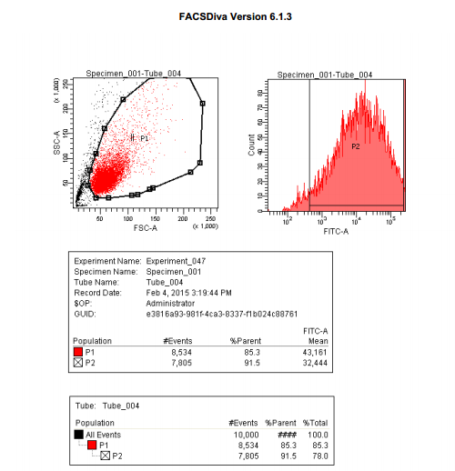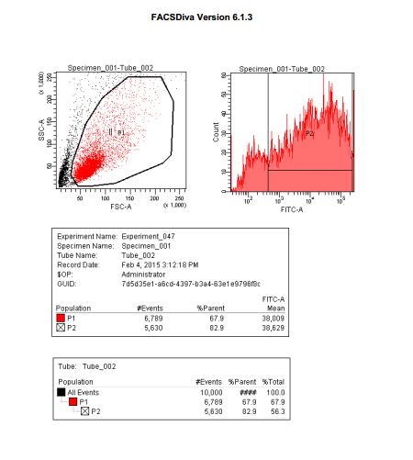

Cell Proliferation
 | 50nM-TR |  |  | 100nM-TR |  |  | 150nM-TR |  |  | 100nMN-CR |  |  | PBS-CR
0 h | 0.489 | 0.498 | 0.502 | 0.495 | 0.491 | 0.499 | 0.498 | 0.501 | 0.495 | 0.497 | 0.499 | 0.501 | 0.497 | 0.502 | 0.501
24 h | 0.689 | 0.698 | 0.910 | 0.687 | 0.679 | 0.683 | 0.681 | 0.683 | 0.691 | 0.751 | 0.785 | 0.723 | 0.752 | 0.735 | 0.739
48 h | 0.812 | 0.814 | 0.811 | 0.798 | 0.795 | 0.789 | 0.779 | 0.789 | 0.788 | 1.223 | 1.175 | 1.189 | 1.216 | 1.211 | 1.207
72 h | 1.123 | 1.111 | 1.219 | 1.102 | 1.099 | 1.121 | 1.106 | 1.171 | 1.195 | 1.198 | 1.121 | 1.219 | 1.211 | 1.232 | 1.229

Parameter
Table Analyzed | Data 1
Two-way RM ANOVA | Matching by rows
Source of Variation | % of total variation | P value
Interaction | 8.89 | < 0.0001
Row Factor | 84.47 | < 0.0001
Time | 5.47 | < 0.0001
Subjects (matching) | 0.2834 | 0.2937
Source of Variation | P value summary | Significant?
Interaction | *** | Yes
Row Factor | *** | Yes
Time | *** | Yes
Subjects (matching) | ns | No
Source of Variation | Df | Sum-of-squares | Mean square | F
Interaction | 12 | 0.3936 | 0.03280 | 26.54
Row Factor | 3 | 3.741 | 1.247 | 794.8
Time | 4 | 0.2422 | 0.06055 | 48.99
Subjects (matching) | 8 | 0.01255 | 0.001569 | 1.269
Residual | 32 | 0.03955 | 0.001236
Number of missing values | 0
Bonferroni posttests
100nMN-CR vs 50nM-TR
Row Factor | 100nMN-CR | 50nM-TR | Difference | 95% CI of diff.
0 h | 0.4990 | 0.4963 | -0.002667 | -0.09443 to 0.08909
24 h | 0.7530 | 0.7657 | 0.01267 | -0.07909 to 0.1044
48 h | 1.196 | 0.8123 | -0.3833 | -0.4751 to -0.2916
72 h | 1.179 | 1.151 | -0.02833 | -0.1201 to 0.06343
Row Factor | Difference | t | P value | Summary
0 h | -0.002667 | 0.09289 | P > 0.05 | ns
24 h | 0.01267 | 0.4412 | P > 0.05 | ns
48 h | -0.3833 | 13.35 | P<0.001 | ***
72 h | -0.02833 | 0.9870 | P > 0.05 | ns
100nMN-CR vs 100nM-TR
Row Factor | 100nMN-CR | 100nM-TR | Difference | 95% CI of diff.
0 h | 0.4990 | 0.4950 | -0.004000 | -0.09576 to 0.08776
24 h | 0.7530 | 0.6830 | -0.07000 | -0.1618 to 0.02176
48 h | 1.196 | 0.7940 | -0.4017 | -0.4934 to -0.3099
72 h | 1.179 | 1.107 | -0.07200 | -0.1638 to 0.01976
Row Factor | Difference | t | P value | Summary
0 h | -0.004000 | 0.1393 | P > 0.05 | ns
24 h | -0.07000 | 2.438 | P > 0.05 | ns
48 h | -0.4017 | 13.99 | P<0.001 | ***
72 h | -0.07200 | 2.508 | P > 0.05 | ns
100nMN-CR vs 150nM-TR
Row Factor | 100nMN-CR | 150nM-TR | Difference | 95% CI of diff.
0 h | 0.4990 | 0.4980 | -0.001000 | -0.09276 to 0.09076
24 h | 0.7530 | 0.6850 | -0.06800 | -0.1598 to 0.02376
48 h | 1.196 | 0.7853 | -0.4103 | -0.5021 to -0.3186
72 h | 1.179 | 1.157 | -0.02200 | -0.1138 to 0.06976
Row Factor | Difference | t | P value | Summary
0 h | -0.001000 | 0.03483 | P > 0.05 | ns
24 h | -0.06800 | 2.369 | P > 0.05 | ns
48 h | -0.4103 | 14.29 | P<0.001 | ***
72 h | -0.02200 | 0.7664 | P > 0.05 | ns
100nMN-CR vs PBS-CR
Row Factor | 100nMN-CR | PBS-CR | Difference | 95% CI of diff.
0 h | 0.4990 | 0.5000 | 0.001000 | -0.09076 to 0.09276
24 h | 0.7530 | 0.7420 | -0.01100 | -0.1028 to 0.08076
48 h | 1.196 | 1.211 | 0.01567 | -0.07609 to 0.1074
72 h | 1.179 | 1.224 | 0.04467 | -0.04709 to 0.1364
Row Factor | Difference | t | P value | Summary
0 h | 0.001000 | 0.03484 | P > 0.05 | ns
24 h | -0.01100 | 0.3832 | P > 0.05 | ns
48 h | 0.01567 | 0.5458 | P > 0.05 | ns
72 h | 0.04467 | 1.556 | P > 0.05 | ns

 | 100nM-T |  |  | 100nMN-C |  |  | PBS-C
0 h | 0.509 | 0.504 | 0.511 | 0.512 | 0.514 | 0.511 | 0.507 | 0.502 | 0.513
24 h | 0.801 | 0.798 | 0.804 | 0.814 | 0.807 | 0.812 | 0.816 | 0.809 | 0.821
48 h | 1.214 | 1.209 | 1.208 | 1.221 | 1.197 | 1.231 | 1.216 | 1.211 | 1.207
72 h | 1.387 | 1.384 | 1.386 | 1.388 | 1.391 | 1.394 | 1.391 | 1.389 | 1.395

Parameter
Table Analyzed | Data 1
Two-way RM ANOVA | Matching by rows
Source of Variation | % of total variation | P value
Interaction | 0.01 | 0.4189
Row Factor | 99.97 | < 0.0001
Time | 0.01 | 0.0364
Subjects (matching) | 0.0089 | 0.2676
Source of Variation | P value summary | Significant?
Interaction | ns | No
Row Factor | *** | Yes
Time | * | Yes
Subjects (matching) | ns | No
Source of Variation | Df | Sum-of-squares | Mean square | F
Interaction | 6 | 0.0002176 | 0.00003627 | 1.072
Row Factor | 3 | 4.254 | 1.418 | 29850
Time | 2 | 0.0002777 | 0.0001389 | 4.104
Subjects (matching) | 8 | 0.0003800 | 0.00004750 | 1.404
Residual | 16 | 0.0005413 | 0.00003383
Number of missing values | 0
Bonferroni posttests
100nMN-C vs 100nM-T
Row Factor | 100nMN-C | 100nM-T | Difference | 95% CI of diff.
0 h | 0.5123 | 0.5080 | -0.004333 | -0.01927 to 0.01061
24 h | 0.8110 | 0.8010 | -0.01000 | -0.02494 to 0.004940
48 h | 1.216 | 1.210 | -0.006000 | -0.02094 to 0.008940
72 h | 1.391 | 1.386 | -0.005333 | -0.02027 to 0.009607
Row Factor | Difference | t | P value | Summary
0 h | -0.004333 | 0.9124 | P > 0.05 | ns
24 h | -0.01000 | 2.106 | P > 0.05 | ns
48 h | -0.006000 | 1.263 | P > 0.05 | ns
72 h | -0.005333 | 1.123 | P > 0.05 | ns
100nMN-C vs PBS-C
Row Factor | 100nMN-C | PBS-C | Difference | 95% CI of diff.
0 h | 0.5123 | 0.5073 | -0.005000 | -0.01994 to 0.009940
24 h | 0.8110 | 0.8153 | 0.004333 | -0.01061 to 0.01927
48 h | 1.216 | 1.211 | -0.005000 | -0.01994 to 0.009940
72 h | 1.391 | 1.392 | 0.0006666 | -0.01427 to 0.01561
Row Factor | Difference | t | P value | Summary
0 h | -0.005000 | 1.053 | P > 0.05 | ns
24 h | 0.004333 | 0.9124 | P > 0.05 | ns
48 h | -0.005000 | 1.053 | P > 0.05 | ns
72 h | 0.0006666 | 0.1404 | P > 0.05 | ns

Cell Apoptosis
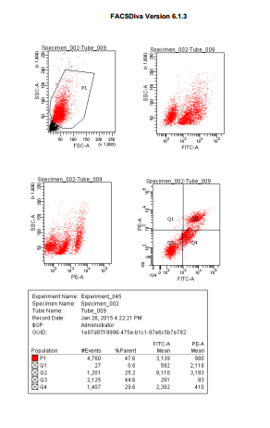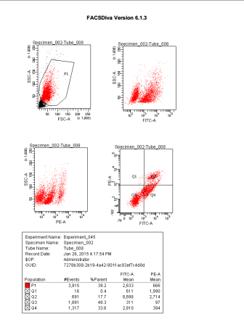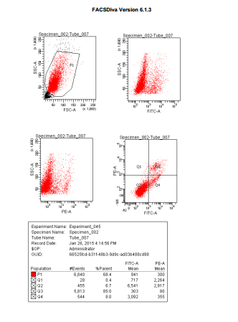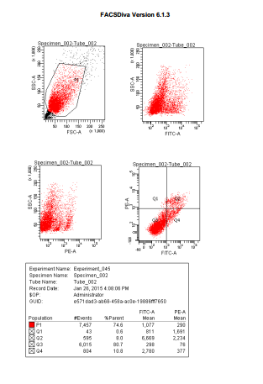
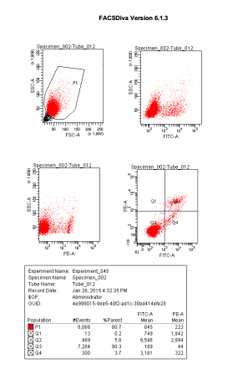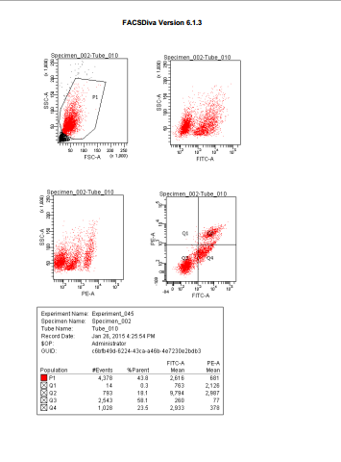

 | HEP-2/100nM-TR |  |  | HEP-2/100nMN-CR |  |  | M2E/100nM-TR |  |  | M2E/100nMN-CR |  |  | TU212/100nM-TR |  |  | TU212/100nMN-CR
Early Apoptosis | 1480. | 1432. | 1476. | 540. | 523. | 561. | 1680. | 1654. | 1678. | 400. | 412. | 381. | 1175. | 1156. | 1197. | 185. | 164. | 201.
Late Apoptosis | 1260. | 1278. | 1253. | 400. | 423. | 372. | 855. | 825. | 875. | 335. | 321. | 358. | 905. | 915. | 891. | 290. | 271. | 306.

Parameter
Table Analyzed | Data 1
Two-way RM ANOVA | Matching by rows
Source of Variation | % of total variation | P value
Interaction | 8.87 | < 0.0001
Row Factor | 5.70 | < 0.0001
Time | 85.33 | < 0.0001
Subjects (matching) | 0.0260 | 0.2159
Source of Variation | P value summary | Significant?
Interaction | *** | Yes
Row Factor | *** | Yes
Time | *** | Yes
Subjects (matching) | ns | No
Source of Variation | Df | Sum-of-squares | Mean square | F
Interaction | 5 | 748400 | 149700 | 434.1
Row Factor | 1 | 481200 | 481200 | 878.1
Time | 5 | 7202000 | 1440000 | 4178
Subjects (matching) | 4 | 2192 | 548.0 | 1.589
Residual | 20 | 6896 | 344.8
Number of missing values | 0
Bonferroni posttests
M2E/100nM-TR vs HEP-2/100nM-TR
Row Factor | M2E/100nM-TR | HEP-2/100nM-TR | Difference | 95% CI of diff.
Early Apoptosis | 1671 | 1463 | -208.0 | -255.8 to -160.2
Late Apoptosis | 851.7 | 1264 | 412.0 | 364.2 to 459.8
Row Factor | Difference | t | P value | Summary
Early Apoptosis | -208.0 | 13.72 | P<0.001 | ***
Late Apoptosis | 412.0 | 27.17 | P<0.001 | ***
M2E/100nM-TR vs HEP-2/100nMN-CR
Row Factor | M2E/100nM-TR | HEP-2/100nMN-CR | Difference | 95% CI of diff.
Early Apoptosis | 1671 | 541.3 | -1129 | -1177 to -1082
Late Apoptosis | 851.7 | 398.3 | -453.3 | -501.1 to -405.5
Row Factor | Difference | t | P value | Summary
Early Apoptosis | -1129 | 74.49 | P<0.001 | ***
Late Apoptosis | -453.3 | 29.90 | P<0.001 | ***
M2E/100nM-TR vs M2E/100nMN-CR
Row Factor | M2E/100nM-TR | M2E/100nMN-CR | Difference | 95% CI of diff.
Early Apoptosis | 1671 | 397.7 | -1273 | -1321 to -1225
Late Apoptosis | 851.7 | 338.0 | -513.7 | -561.5 to -465.9
Row Factor | Difference | t | P value | Summary
Early Apoptosis | -1273 | 83.96 | P<0.001 | ***
Late Apoptosis | -513.7 | 33.88 | P<0.001 | ***
M2E/100nM-TR vs TU212/100nM-TR
Row Factor | M2E/100nM-TR | TU212/100nM-TR | Difference | 95% CI of diff.
Early Apoptosis | 1671 | 1176 | -494.7 | -542.5 to -446.9
Late Apoptosis | 851.7 | 903.7 | 52.00 | 4.190 to 99.81
Row Factor | Difference | t | P value | Summary
Early Apoptosis | -494.7 | 32.63 | P<0.001 | ***
Late Apoptosis | 52.00 | 3.430 | P<0.01 | **
M2E/100nM-TR vs TU212/100nMN-CR
Row Factor | M2E/100nM-TR | TU212/100nMN-CR | Difference | 95% CI of diff.
Early Apoptosis | 1671 | 183.3 | -1487 | -1535 to -1440
Late Apoptosis | 851.7 | 289.0 | -562.7 | -610.5 to -514.9
Row Factor | Difference | t | P value | Summary
Early Apoptosis | -1487 | 98.10 | P<0.001 | ***
Late Apoptosis | -562.7 | 37.11 | P<0.001 | ***

Parameter
Table Analyzed | Data 1
Two-way RM ANOVA | Matching by rows
Source of Variation | % of total variation | P value
Interaction | 8.87 | < 0.0001
Row Factor | 5.70 | < 0.0001
Time | 85.33 | < 0.0001
Subjects (matching) | 0.0260 | 0.2159
Source of Variation | P value summary | Significant?
Interaction | *** | Yes
Row Factor | *** | Yes
Time | *** | Yes
Subjects (matching) | ns | No
Source of Variation | Df | Sum-of-squares | Mean square | F
Interaction | 5 | 748400 | 149700 | 434.1
Row Factor | 1 | 481200 | 481200 | 878.1
Time | 5 | 7202000 | 1440000 | 4178
Subjects (matching) | 4 | 2192 | 548.0 | 1.589
Residual | 20 | 6896 | 344.8
Number of missing values | 0
Bonferroni posttests
HEP-2/100nM-TR vs HEP-2/100nMN-CR
Row Factor | HEP-2/100nM-TR | HEP-2/100nMN-CR | Difference | 95% CI of diff.
Early Apoptosis | 1463 | 541.3 | -921.3 | -969.1 to -873.5
Late Apoptosis | 1264 | 398.3 | -865.3 | -913.1 to -817.5
Row Factor | Difference | t | P value | Summary
Early Apoptosis | -921.3 | 60.77 | P<0.001 | ***
Late Apoptosis | -865.3 | 57.07 | P<0.001 | ***
HEP-2/100nM-TR vs M2E/100nM-TR
Row Factor | HEP-2/100nM-TR | M2E/100nM-TR | Difference | 95% CI of diff.
Early Apoptosis | 1463 | 1671 | 208.0 | 160.2 to 255.8
Late Apoptosis | 1264 | 851.7 | -412.0 | -459.8 to -364.2
Row Factor | Difference | t | P value | Summary
Early Apoptosis | 208.0 | 13.72 | P<0.001 | ***
Late Apoptosis | -412.0 | 27.17 | P<0.001 | ***
HEP-2/100nM-TR vs M2E/100nMN-CR
Row Factor | HEP-2/100nM-TR | M2E/100nMN-CR | Difference | 95% CI of diff.
Early Apoptosis | 1463 | 397.7 | -1065 | -1113 to -1017
Late Apoptosis | 1264 | 338.0 | -925.7 | -973.5 to -877.9
Row Factor | Difference | t | P value | Summary
Early Apoptosis | -1065 | 70.24 | P<0.001 | ***
Late Apoptosis | -925.7 | 61.05 | P<0.001 | ***
HEP-2/100nM-TR vs TU212/100nM-TR
Row Factor | HEP-2/100nM-TR | TU212/100nM-TR | Difference | 95% CI of diff.
Early Apoptosis | 1463 | 1176 | -286.7 | -334.5 to -238.9
Late Apoptosis | 1264 | 903.7 | -360.0 | -407.8 to -312.2
Row Factor | Difference | t | P value | Summary
Early Apoptosis | -286.7 | 18.91 | P<0.001 | ***
Late Apoptosis | -360.0 | 23.74 | P<0.001 | ***
HEP-2/100nM-TR vs TU212/100nMN-CR
Row Factor | HEP-2/100nM-TR | TU212/100nMN-CR | Difference | 95% CI of diff.
Early Apoptosis | 1463 | 183.3 | -1279 | -1327 to -1232
Late Apoptosis | 1264 | 289.0 | -974.7 | -1022 to -926.9
Row Factor | Difference | t | P value | Summary
Early Apoptosis | -1279 | 84.38 | P<0.001 | ***
Late Apoptosis | -974.7 | 64.29 | P<0.001 | ***

Parameter
Table Analyzed | Data 1
Two-way RM ANOVA | Matching by rows
Source of Variation | % of total variation | P value
Interaction | 8.87 | < 0.0001
Row Factor | 5.70 | < 0.0001
Time | 85.33 | < 0.0001
Subjects (matching) | 0.0260 | 0.2159
Source of Variation | P value summary | Significant?
Interaction | *** | Yes
Row Factor | *** | Yes
Time | *** | Yes
Subjects (matching) | ns | No
Source of Variation | Df | Sum-of-squares | Mean square | F
Interaction | 5 | 748400 | 149700 | 434.1
Row Factor | 1 | 481200 | 481200 | 878.1
Time | 5 | 7202000 | 1440000 | 4178
Subjects (matching) | 4 | 2192 | 548.0 | 1.589
Residual | 20 | 6896 | 344.8
Number of missing values | 0
Bonferroni posttests
TU212/100nM-TR vs HEP-2/100nM-TR
Row Factor | TU212/100nM-TR | HEP-2/100nM-TR | Difference | 95% CI of diff.
Early Apoptosis | 1176 | 1463 | 286.7 | 238.9 to 334.5
Late Apoptosis | 903.7 | 1264 | 360.0 | 312.2 to 407.8
Row Factor | Difference | t | P value | Summary
Early Apoptosis | 286.7 | 18.91 | P<0.001 | ***
Late Apoptosis | 360.0 | 23.74 | P<0.001 | ***
TU212/100nM-TR vs HEP-2/100nMN-CR
Row Factor | TU212/100nM-TR | HEP-2/100nMN-CR | Difference | 95% CI of diff.
Early Apoptosis | 1176 | 541.3 | -634.7 | -682.5 to -586.9
Late Apoptosis | 903.7 | 398.3 | -505.3 | -553.1 to -457.5
Row Factor | Difference | t | P value | Summary
Early Apoptosis | -634.7 | 41.86 | P<0.001 | ***
Late Apoptosis | -505.3 | 33.33 | P<0.001 | ***
TU212/100nM-TR vs M2E/100nM-TR
Row Factor | TU212/100nM-TR | M2E/100nM-TR | Difference | 95% CI of diff.
Early Apoptosis | 1176 | 1671 | 494.7 | 446.9 to 542.5
Late Apoptosis | 903.7 | 851.7 | -52.00 | -99.81 to -4.190
Row Factor | Difference | t | P value | Summary
Early Apoptosis | 494.7 | 32.63 | P<0.001 | ***
Late Apoptosis | -52.00 | 3.430 | P<0.01 | **
TU212/100nM-TR vs M2E/100nMN-CR
Row Factor | TU212/100nM-TR | M2E/100nMN-CR | Difference | 95% CI of diff.
Early Apoptosis | 1176 | 397.7 | -778.3 | -826.1 to -730.5
Late Apoptosis | 903.7 | 338.0 | -565.7 | -613.5 to -517.9
Row Factor | Difference | t | P value | Summary
Early Apoptosis | -778.3 | 51.34 | P<0.001 | ***
Late Apoptosis | -565.7 | 37.31 | P<0.001 | ***
TU212/100nM-TR vs TU212/100nMN-CR
Row Factor | TU212/100nM-TR | TU212/100nMN-CR | Difference | 95% CI of diff.
Early Apoptosis | 1176 | 183.3 | -992.7 | -1040 to -944.9
Late Apoptosis | 903.7 | 289.0 | -614.7 | -662.5 to -566.9
Row Factor | Difference | t | P value | Summary
Early Apoptosis | -992.7 | 65.47 | P<0.001 | ***
Late Apoptosis | -614.7 | 40.54 | P<0.001 | ***

Cell Cycle
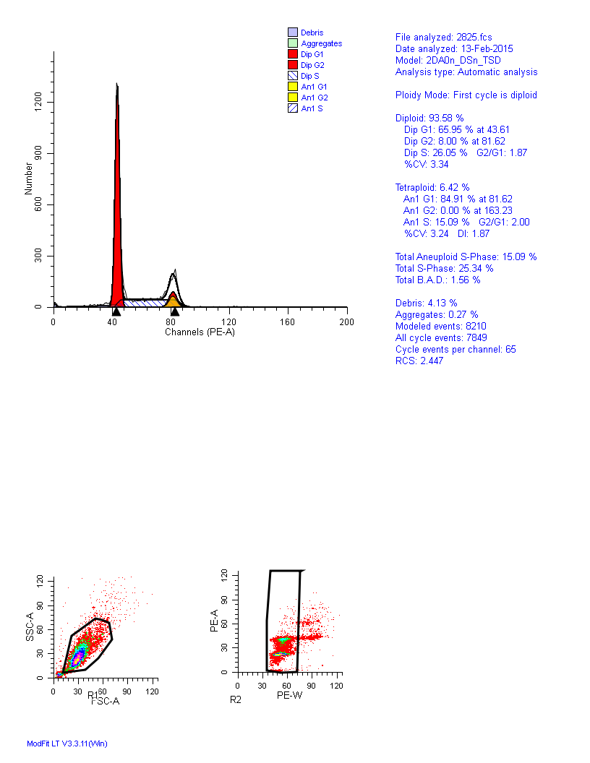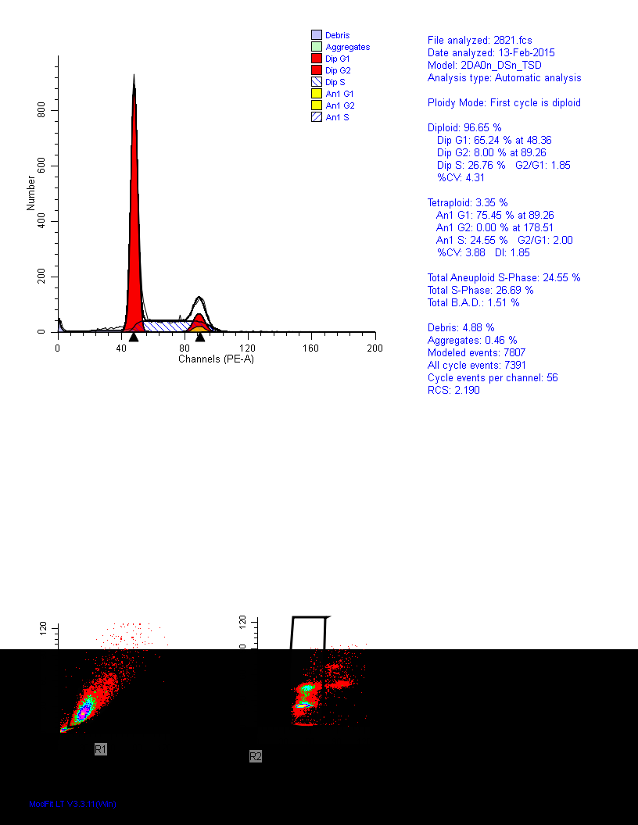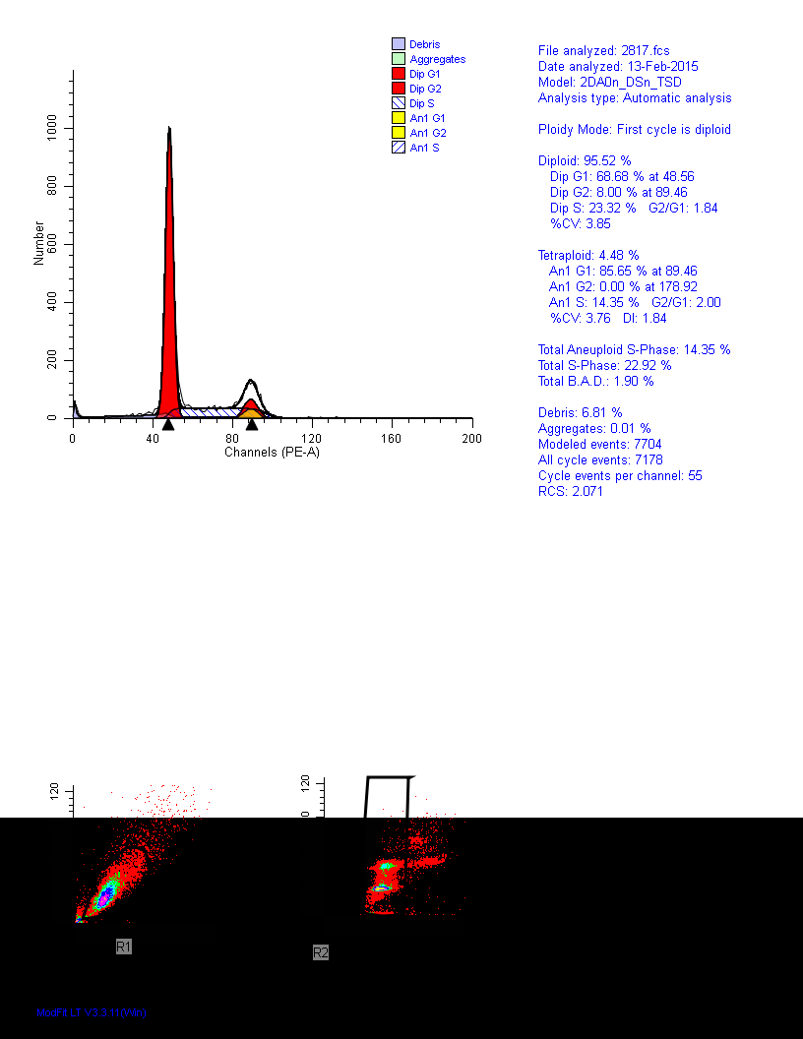

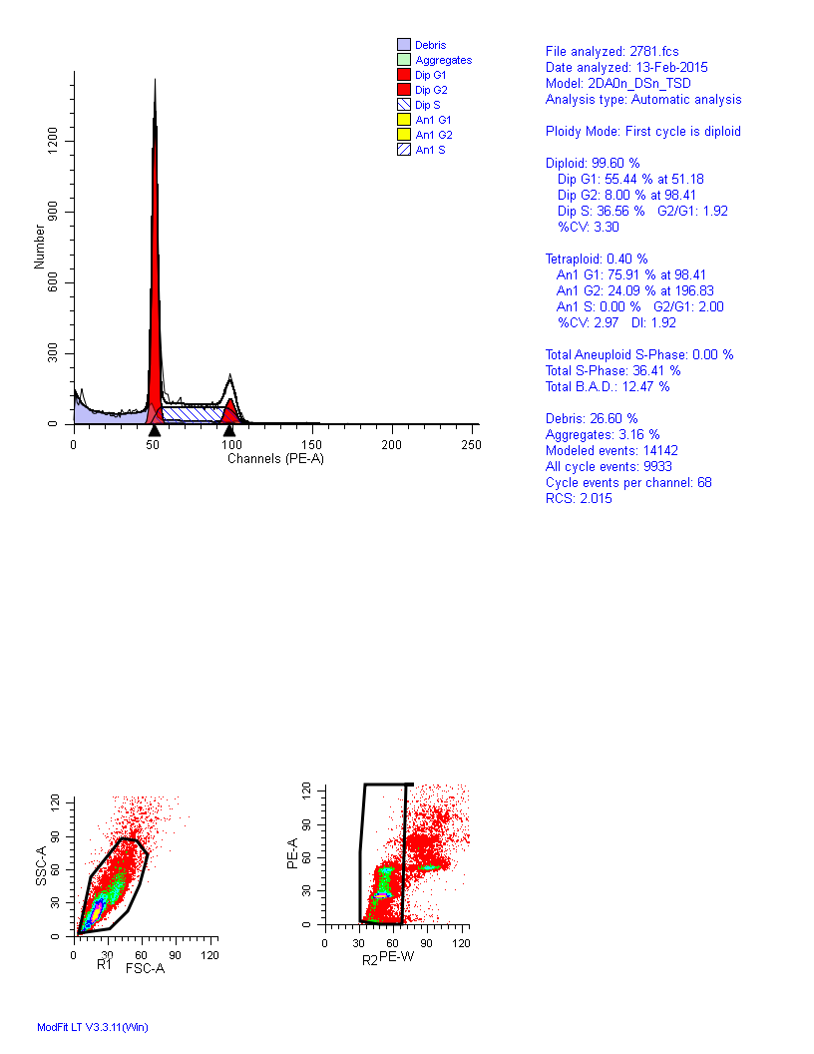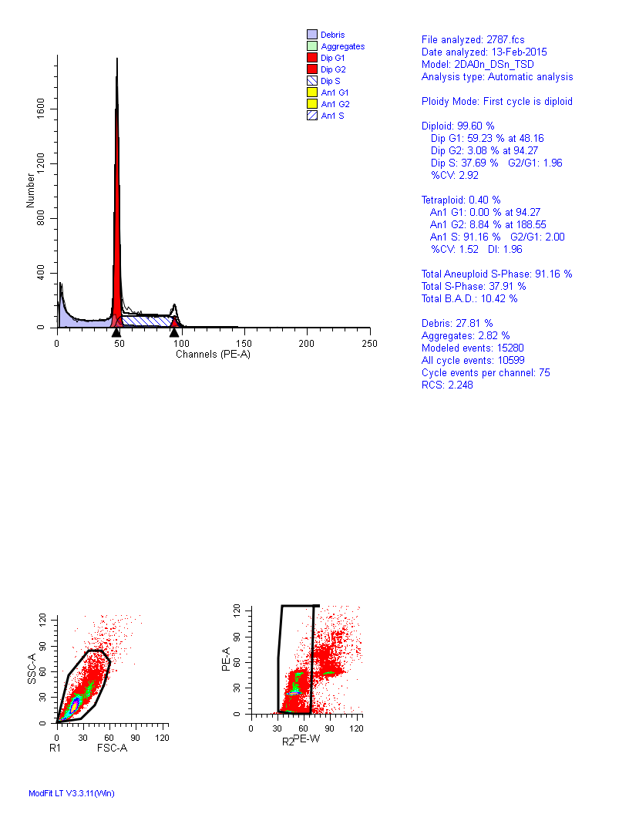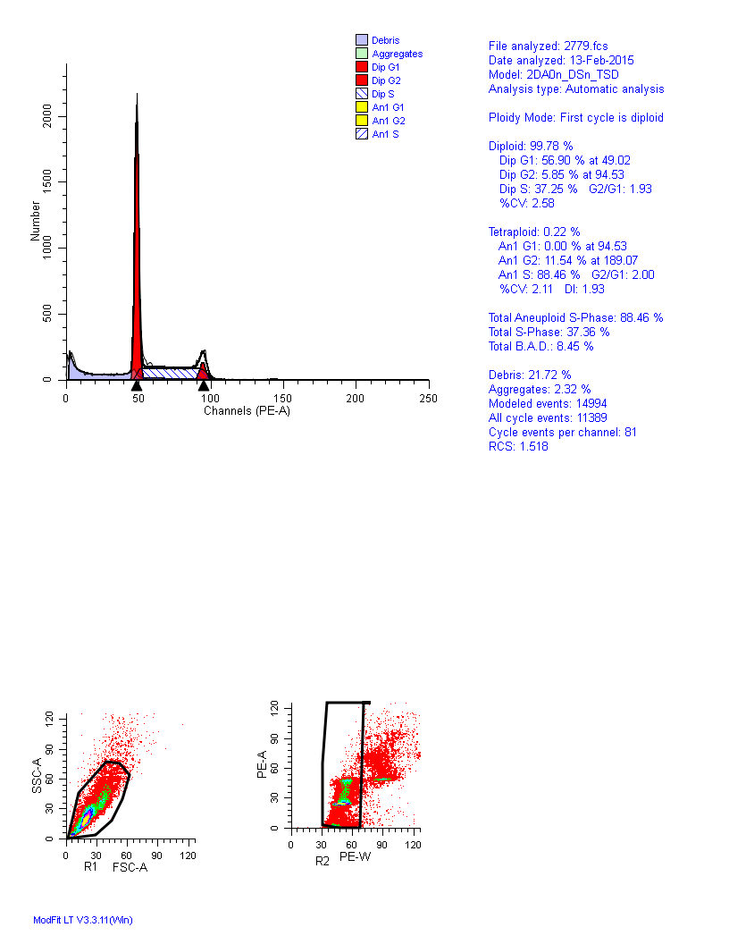
 | HEP-2/100nM-TR | HEP-2/100nMN-CR | M2E/100nM-TR | M2E/100nMN-CR | TU212/100nM-TR | TU212/100nMN-CR
G1 | 69 | 55 | 66 | 57 | 65 | 59
S | 23 | 37 | 26 | 37 | 27 | 38
G2/M | 8 | 8 | 8 | 6 | 8 | 3

Transwell Assay
100nMN-T |  |  | 100nMN-C |  |  |  |  |  | PBS-C
212. | 201. | 229. | 226. |  | 207. |  | 239. |  | 228. | 211. |  | 242.
Parameter
Table Analyzed |  |  |  | Data 1
One-way analysis of variance
P value |  |  |  | 0.5804
P value summary |  |  |  | ns
Are means signif. different? (P < 0.05) |  |  |  | No
Number of groups |  |  |  | 3
F |  |  |  | 0.5966
R squared |  |  |  | 0.1659
ANOVA Table |  |  |  | SS |  | df |  | MS
Treatment (between columns) |  |  |  | 278.0 |  | 2 |  | 139.0
Residual (within columns) |  |  |  | 1398 |  | 6 |  | 233.0
Total |  |  |  | 1676 |  | 8
Tukey's Multiple Comparison Test |  |  |  | Mean Diff. |  | q |  | Significant? P < 0.05? |  |  | Summary |  | 95% CI of diff
100nMN-T vs 100nMN-C |  |  |  | -10.00 |  | 1.135 |  | No |  |  | ns |  | -48.24 to 28.24
100nMN-T vs PBS-C |  |  |  | -13.00 |  | 1.475 |  | No |  |  | ns |  | -51.24 to 25.24
100nMN-C vs PBS-C |  |  |  | -3.000 |  | 0.3404 |  | No |  |  | ns |  | -41.24 to 35.24
50nM-TR |  |  | 100nM-TR |  |  |  |  |  | 150nM-TR |  |  |  |  | 100nMN-CR |  |  |  | PBS-CR
121. | 132. | 116. | 41. |  | 37. |  | 42. |  | 40. | 39. |  | 42. |  | 168. |  | 154. | 172. | 187. | 175. | 193.

Parameter
Table Analyzed | Data 1
One-way analysis of variance
P value | < 0.0001
P value summary | ***
Are means signif. different? (P < 0.05) | Yes
Number of groups | 5
F | 278.4
R squared | 0.9911
ANOVA Table | SS | df | MS
Treatment (between columns) | 55600 | 4 | 13900
Residual (within columns) | 499.3 | 10 | 49.93
Total | 56100 | 14
Tukey's Multiple Comparison Test | Mean Diff. | q | Significant? P < 0.05? | Summary | 95% CI of diff
50nM-TR vs 100nM-TR | 83.00 | 20.34 | Yes | *** | 64.01 to 102.0
50nM-TR vs 150nM-TR | 82.67 | 20.26 | Yes | *** | 63.68 to 101.7
50nM-TR vs 100nMN-CR | -41.67 | 10.21 | Yes | *** | -60.65 to -22.68
50nM-TR vs PBS-CR | -62.00 | 15.20 | Yes | *** | -80.99 to -43.01
100nM-TR vs 150nM-TR | -0.3333 | 0.08170 | No | ns | -19.32 to 18.65
100nM-TR vs 100nMN-CR | -124.7 | 30.56 | Yes | *** | -143.7 to -105.7
100nM-TR vs PBS-CR | -145.0 | 35.54 | Yes | *** | -164.0 to -126.0
150nM-TR vs 100nMN-CR | -124.3 | 30.48 | Yes | *** | -143.3 to -105.3
150nM-TR vs PBS-CR | -144.7 | 35.46 | Yes | *** | -163.7 to -125.7
100nMN-CR vs PBS-CR | -20.33 | 4.984 | Yes | * | -39.32 to -1.346

Survival Fraction
Gy | HEP-2 non-transfection | 100nMN-CR | 100nM-TR
0. | 1 | 1 | 1
0. | 1 | 1 | 1
0. | 1 | 1 | 1
0. | 1 | 1 | 1
0. | 1 | 1 | 1
0. | 1 | 1 | 1
0. | 1 | 1 | 1
0. | 1 | 1 | 1
0. | 0 | 0 | 0
0. | 1 | 0 | 0
0. | 1 | 0 | 0
0. | 1 | 0 | 0
0. | 1 | 1 | 0
2. | 1 | 1 | 1
2. | 1 | 1 | 1
2. | 1 | 1 | 1
2. | 1 | 1 | 1
2. | 1 | 1 | 1
2. | 1 | 1 | 0
2. | 1 | 0 | 0
2. | 0 | 0 | 0
2. | 0 | 0 | 0
2. | 0 | 0 | 0
2. | 1 | 1 | 0
2. | 1 | 0 | 0
2. | 1 | 0 | 0
2. | 1 | 1 | 0
4. | 1 | 1 | 1
4. | 1 | 1 | 1
4. | 1 | 1 | 1
4. | 1 | 1 | 0
4. | 1 | 0 | 0
4. | 0 | 0 | 0
4. | 0 | 0 | 0
4. | 0 | 0 | 0
4. | 0 | 0 | 0
4. | 0 | 0 | 0
4. | 1 | 0 | 0
4. | 1 | 1 | 0
4. | 1 | 0 | 0
4. | 1 | 1 | 0
6. | 1 | 1 | 1
6. | 1 | 1 | 1
6. | 1 | 0 | 0
6. | 1 | 0 | 0
6. | 0 | 0 | 0
6. | 0 | 0 | 0
6. | 0 | 0 | 0
6. | 0 | 0 | 0
6. | 0 | 0 | 0
6. | 0 | 0 | 0
6. | 1 | 0 | 0
6. | 1 | 1 | 0
6. | 1 | 0 | 0
6. | 1 | 1 | 0
8. | 1 | 1 | 0
8. | 1 | 0 | 0
8. | 1 | 0 | 0
8. | 0 | 0 | 0
8. | 0 | 0 | 0
8. | 0 | 0 | 0
8. | 0 | 0 | 0
8. | 0 | 0 | 0
8. | 0 | 0 | 0
8. | 0 | 0 | 0
8. | 1 | 0 | 0
8. | 1 | 1 | 0
8. | 1 | 0 | 0
8. | 1 | 1 | 0

Gy | M2E non-transfection | 100nMN-CR | 100nM-TR
0. | 1 | 1 | 1
0. | 1 | 1 | 1
0. | 1 | 1 | 1
0. | 1 | 1 | 1
0. | 1 | 1 | 1
0. | 1 | 1 | 1
0. | 1 | 1 | 1
0. | 1 | 1 | 1
0. | 0 | 0 | 0
0. | 1 | 0 | 0
0. | 1 | 0 | 0
0. | 1 | 0 | 0
0. | 1 | 1 | 0
0. | 1 | 1 | 0
0. | 1 | 0 | 0
2. | 1 | 1 | 1
2. | 1 | 1 | 1
2. | 1 | 1 | 1
2. | 1 | 1 | 1
2. | 1 | 1 | 1
2. | 1 | 1 | 0
2. | 1 | 0 | 0
2. | 0 | 0 | 0
2. | 0 | 0 | 0
2. | 0 | 0 | 0
2. | 1 | 1 | 0
2. | 1 | 0 | 0
2. | 1 | 0 | 0
2. | 1 | 1 | 0
2. | 1 | 0 | 0
2. | 1 | 1 | 0
4. | 1 | 1 | 1
4. | 1 | 1 | 1
4. | 1 | 1 | 1
4. | 1 | 1 | 0
4. | 1 | 0 | 0
4. | 0 | 0 | 0
4. | 0 | 0 | 0
4. | 0 | 0 | 0
4. | 0 | 0 | 0
4. | 0 | 0 | 0
4. | 1 | 0 | 0
4. | 1 | 1 | 0
4. | 1 | 0 | 0
4. | 1 | 1 | 0
4. | 1 | 0 | 0
4. | 1 | 1 | 0
6. | 1 | 1 | 1
6. | 1 | 1 | 1
6. | 1 | 0 | 0
6. | 1 | 0 | 0
6. | 0 | 0 | 0
6. | 0 | 0 | 0
6. | 0 | 0 | 0
6. | 0 | 0 | 0
6. | 0 | 0 | 0
6. | 0 | 0 | 0
6. | 1 | 0 | 0
6. | 1 | 1 | 0
6. | 1 | 0 | 0
6. | 1 | 1 | 0
6. | 1 | 0 | 0
6. | 1 | 1 | 0
8. | 1 | 1 | 0
8. | 1 | 0 | 0
8. | 1 | 0 | 0
8. | 0 | 0 | 0
8. | 0 | 0 | 0
8. | 0 | 0 | 0
8. | 0 | 0 | 0
8. | 0 | 0 | 0
8. | 0 | 0 | 0
8. | 0 | 0 | 0
8. | 1 | 0 | 0
8. | 1 | 1 | 0
8. | 1 | 0 | 0
8. | 1 | 1 | 0
8. | 1 | 0 | 0
8. | 1 | 1 | 0
Gy | TU212 non-transfection | 100nMN-CR | 100nM-TR
0. | 1 | 1 | 1
0. | 1 | 1 | 1
0. | 1 | 1 | 1
0. | 1 | 1 | 1
0. | 1 | 1 | 1
0. | 1 | 1 | 1
0. | 1 | 1 | 1
0. | 1 | 1 | 1
0. | 0 | 0 | 0
0. | 1 | 0 | 0
0. | 1 | 0 | 0
0. | 1 | 1 | 0
0. | 1 | 1 | 0
0. | 1 | 1 | 0
0. | 1 | 0 | 0
2. | 1 | 1 | 1
2. | 1 | 1 | 1
2. | 1 | 1 | 1
2. | 1 | 1 | 1
2. | 1 | 1 | 1
2. | 1 | 1 | 1
2. | 1 | 1 | 0
2. | 0 | 0 | 0
2. | 0 | 0 | 0
2. | 0 | 0 | 0
2. | 1 | 1 | 0
2. | 1 | 0 | 0
2. | 1 | 0 | 0
2. | 1 | 1 | 0
2. | 1 | 0 | 0
2. | 1 | 1 | 0
4. | 1 | 1 | 1
4. | 1 | 1 | 1
4. | 1 | 1 | 1
4. | 1 | 1 | 0
4. | 1 | 0 | 0
4. | 0 | 0 | 0
4. | 0 | 0 | 0
4. | 0 | 0 | 0
4. | 0 | 0 | 0
4. | 0 | 0
4. | 1 | 1 | 0
4. | 1 | 1 | 0
4. | 1 | 0 | 0
4. | 1 | 1 | 0
4. | 1 | 0 | 0
4. | 1 | 1 | 0
6. | 1 | 1 | 1
6. | 1 | 1 | 1
6. | 1 | 0 | 0
6. | 1 | 0 | 0
6. | 0 | 0 | 0
6. | 0 | 0 | 0
6. | 0 | 0 | 0
6. | 0 | 0 | 0
6. | 0 | 0 | 0
6. | 0 | 0 | 0
6. | 1 | 0 | 0
6. | 1 | 1 | 0
6. | 1 | 0 | 0
6. | 1 | 1 | 0
6. | 1 | 1 | 0
6. | 1 | 1 | 0
8. | 1 | 1 | 1
8. | 1 | 0 | 0
8. | 1 | 0 | 0
8. | 0 | 0 | 0
8. | 0 | 0 | 0
8. | 0 | 0 | 0
8. | 0 | 0 | 0
8. | 0 | 0 | 0
8. | 0 | 0 | 0
8. | 0 | 0 | 0
8. | 1 | 0 | 0
8. | 1 | 1 | 0
8. | 1 | 0 | 0
8. | 1 | 1 | 0
8. | 1 | 0 | 0
8. | 1 | 1 | 0

Comet Assay
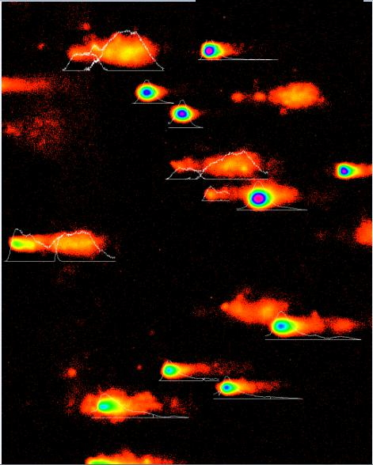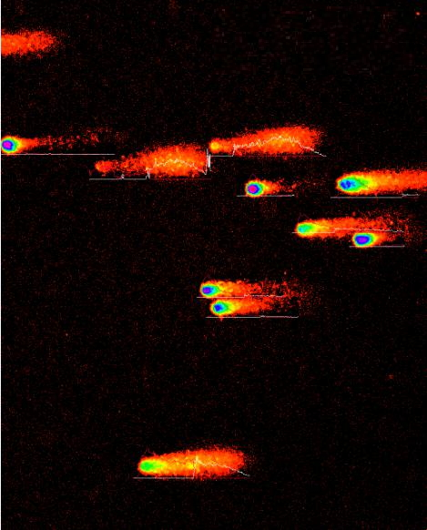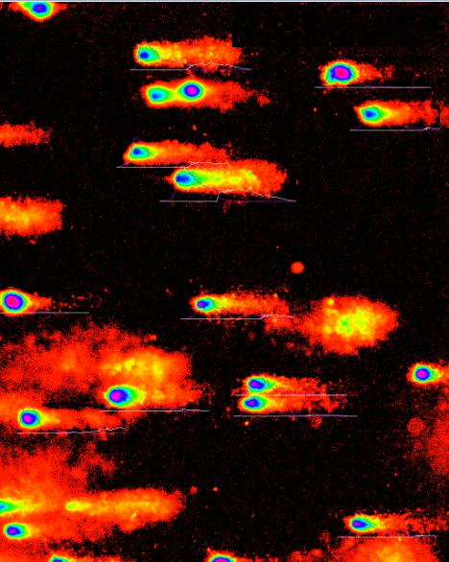
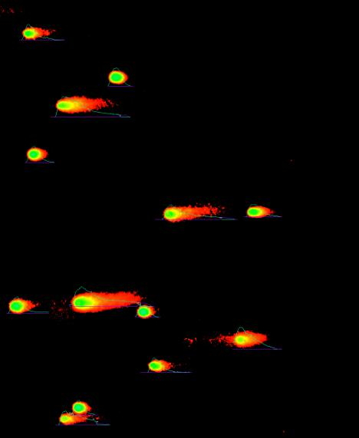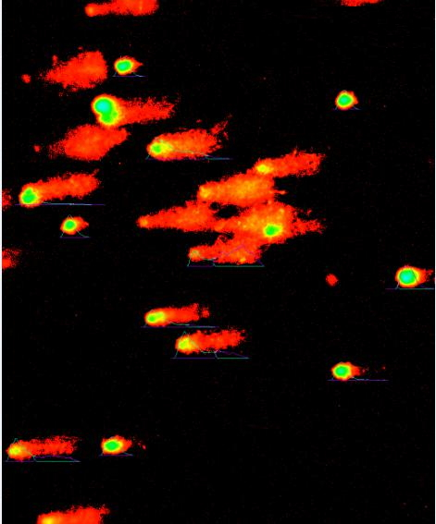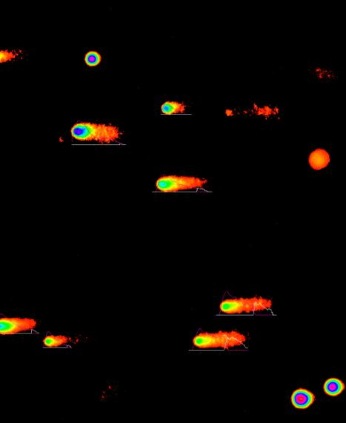

Western Blotting
 | HEP-2 |  |  |  |  |  | M2E |  |  |  |  |  | TU212
catenin | 58.2 | 56.42 | 54.43 | 123.07 | 129.6 | 127.74 | 71.61 | 75.22 | 76.17 | 183.2 | 175.28 | 178.35 | 85.02 | 77.31 | 85.5 | 144.44 | 139.76 | 143.12
actin | 183.17 | 181.98 | 205.08 | 246.5 | 244.2 | 245.49 | 223.76 | 242.33 | 253.63 | 254.21 | 244.99 | 247.82 | 231.58 | 243.23 | 244.01 | 253.36 | 253.47 | 254.01
catenin | 0.31774 | 0.31003 | 0.26541 | 0.49927 | 0.53071 | 0.52035 | 0.32003 | 0.3104 | 0.30032 | 0.72066 | 0.71546 | 0.71968 | 0.36713 | 0.31785 | 0.3504 | 0.5701 | 0.55139 | 0.56344
yap1 | 98.37 | 98.49 | 96.27 | 157.24 | 163.61 | 159.8 | 142.07 | 159.45 | 171.01 | 240.15 | 236.51 | 244.61 | 178.62 | 175.17 | 172.93 | 241.36 | 251.69 | 247.88
actin | 230.44 | 226.93 | 231.58 | 231.02 | 230.55 | 228.9 | 235.39 | 228.49 | 237.07 | 249.57 | 249.78 | 251.62 | 252.91 | 252.03 | 253.02 | 250.91 | 252.27 | 252.74
yap1 | 0.42688 | 0.43401 | 0.41571 | 0.68063 | 0.70965 | 0.69812 | 0.60355 | 0.69784 | 0.72135 | 0.96226 | 0.94687 | 0.97214 | 0.70626 | 0.69504 | 0.68346 | 0.96194 | 0.9977 | 0.98077
jnk1 | 241.69 | 239 | 234.84 | 215.83 | 215.01 | 214.13 | 227.23 | 225.51 | 227.06 | 219.66 | 219.66 | 218.95 | 216.47 | 227.8 | 226.93 | 203.94 | 202.28 | 203.02
p38 | 253.4 | 253.07 | 235.95 | 224.29 | 236.37 | 221.76 | 226.5 | 226.79 | 226.21 | 212.82 | 204.04 | 210.65 | 230.54 | 237 | 231.62 | 217.31 | 216.9 | 216.58
actin | 254.85 | 254.07 | 254.89 | 252.51 | 250.83 | 252.6 | 251.65 | 253.21 | 253.39 | 254.08 | 254.58 | 254.58 | 247.2 | 250.43 | 251.35 | 250.43 | 252.32 | 253.04
jnk1 | 0.94836 | 0.94069 | 0.92134 | 0.85474 | 0.85719 | 0.8477 | 0.90296 | 0.8906 | 0.89609 | 0.86453 | 0.86283 | 0.86004 | 0.87569 | 0.90964 | 0.90284 | 0.81436 | 0.80168 | 0.80232
p38 | 0.99431 | 0.99606 | 0.92569 | 0.88824 | 0.94235 | 0.87791 | 0.90006 | 0.89566 | 0.89273 | 0.83761 | 0.80148 | 0.82744 | 0.93261 | 0.94637 | 0.9215 | 0.86775 | 0.85962 | 0.85591

