Supplementary Material

Table S1. The detailed positive/negative information about each PTM or kinase group on S/T/Y sites.
Kinase group/PTM | S |  | T |  | Y
 | positive | negative | positive | negative | positive | negative
TKL | 15 | 3224 | 44 | 1993 | 83 | 1797
AGC | 640 | 2599 | 163 | 1874 | - | -
Atypical | 212 | 3027 | 57 | 1980 | - | -
CAMK | 249 | 2990 | 76 | 1961 | - | -
CK1 | 90 | 3149 | 43 | 1994 | - | -
CMGC | 642 | 2597 | 240 | 1797 | 53 | 1827
STE | 163 | 3076 | 48 | 1989 | 66 | 1814
Other | 322 | 2917 | 82 | 1955 | 89 | 1791
O-GalNAc | 837 | 2402 | 1261 | 776 | - | -
O-GlcNAc | 243 | 2996 | 165 | 1872 | - | -
Acetylation | 472 | 2767 | 64 | 1973 | - | -
TK | - | - | - | - | 466 | 1414
nitration | - | - | - | - | 1062 | 818
sulfation | - | - | - | - | 273 | 1607

Table S2. Comparison of AUC values between the proposed method and other methods for kinase groups on S/T sites by cross validation of BLASTClust-grouped data sets.
sites | Kinase groups | proposed(%) | PPSP(%) | Wang et al.(%)
S | AGC | 90.0 | 79.4 | 86.2
 | Atypical | 92.9 | 72.7 | 92.8
 | CAMK | 86.7 | 69.1 | 86.2
 | CK1 | 82.4 | 67.1 | 83.8
 | CMGC | 91.7 | 81.0 | 89.3
 | STE | 88.8 | 68.0 | 88.7
 | Other | 83.6 | 73.9 | 84.8
 | TKL | 64.1 | 25.9 | 71.2
T | AGC | 88.9 | 72.8 | 89.2
 | Atypical | 87.0 | 63.3 | 83.3
 | CAMK | 86.7 | 73.4 | 84.8
 | CK1 | 92.1 | 78.0 | 92.8
 | CMGC | 93.7 | 82.6 | 94.5
 | STE | 91.8 | 65.0 | 86.4
 | Other | 76.7 | 63.5 | 78.7
 | TKL | 88.1 | 73.2 | 85.6

Table S3. Performance comparison of different methods for kinase groups CAMK and CMGC at the high stringency level (Sp = 99.0%).
Kinase groups | Methods | Sp(%) | Sn(%) | Acc(%) | Pre(%) | MCC
CAMK | proposed | 99.0(threshold:8.5e-4) | 22.5 | 93.1 | 65.1 | 0.356
 | GPS 3.0 | 99.0 | 10.4 | 92.2 | 46.4 | 0.193
 | PPSP | 99.0 | 2.81 | 91.6 | 18.9 | 0.045
 | NetPhos 3.1 | 99.0 | 2.81 | 91.7 | 20.6 | 0.049
 | Wang et al. | 99.0 | 20.5 | 92.9 | 63.7 | 0.334
CMGC | proposed | 99.0(threshold:4.7e-3) | 50.4 | 93.3 | 87.1 | 0.632
 | GPS 3.0 | 99.0 | 16.3 | 89.2 | 68.4 | 0.298
 | PPSP | 99.0 | 13.7 | 88.9 | 64.7 | 0.263
 | NetPhos 3.1 | 99.0 | 15.0 | 89.1 | 66.7 | 0.281
 | Wang et al. | 99.0 | 38.7 | 91.9 | 83.7 | 0.536

Table S4. Performance comparison with PTMPred for phosphorylation kinase groups by using all S and T site data.
sites | Kinase groups | Methods | Sn(%) | Sp(%)* | Acc(%) | Pre(%) | MCC
T | AGC | proposed | 93.2 | 78.1 | 79.2 | 26.9 | 0.432
 |  | PTMPred | 67.5 | 78.1 | 77.3 | 21.1 | 0.284
 | CAMK | proposed | 40.8 | 97.1 | 94.9 | 34.8 | 0.351
 |  | PTMPred | 26.3 | 97.1 | 94.5 | 26.3 | 0.235
 | CK1 | proposed | 69.7 | 96.4 | 95.8 | 29.4 | 0.436
 |  | PTMPred | 2.33 | 96.4 | 94.5 | 1.39 | -0.010
 | CMGC | proposed | 86.7 | 92.1 | 91.5 | 59.6 | 0.674
 |  | PTMPred | 73.7 | 92.1 | 89.9 | 55.6 | 0.584
 | STE | proposed | 95.8 | 68.1 | 68.7 | 6.74 | 0.205
 |  | PTMPred | 60.4 | 68.1 | 67.9 | 4.37 | 0.092
 | TKL | proposed | 100 | 1.71 | 3.83 | 2.20 | 0.019
 |  | PTMPred | 97.7 | 1.71 | 3.78 | 2.15 | -0.63
 | Atypical | proposed | 100 | 3.38 | 6.09 | 2.89 | 0.031
 |  | PTMPred | 98.2 | 3.38 | 6.04 | 2.84 | 0.015
 | Other | proposed | 23.2 | 97.3 | 94.3 | 26.4 | 0.218
 |  | PTMPred | 23.1 | 97.3 | 94.3 | 26.4 | 0.217
S | AGC | proposed | 99.6 | 32.8 | 46.1 | 26.8 | 0.295
 |  | PTMPred | 20.2 | 32.8 | 30.3 | 6.88 | -0.379
 | CAMK | proposed | 98.8 | 14.4 | 20.8 | 8.77 | 0.103
 |  | PTMPred | 100 | 14.4 | 21.0 | 8.87 | 0.113
 | CK1 | proposed | 98.9 | 4.95 | 7.56 | 2.89 | 0.029
 |  | PTMPred | 100 | 4.95 | 7.59 | 2.92 | 0.038
 | CMGC | proposed | 100 | 11.6 | 29.1 | 21.9 | 0.159
 |  | PTMPred | 96.1 | 11.6 | 28.3 | 21.2 | 0.102
 | STE | proposed | 100 | 13.4 | 17.8 | 5.78 | 0.088
 |  | PTMPred | 100 | 13.4 | 17.7 | 5.77 | 0.087
 | TKL | proposed | 73.3 | 84.8 | 84.7 | 2.20 | 0.109
 |  | PTMPred | 40.0 | 84.8 | 84.6 | 1.21 | 0.047
 | Atypical | proposed | 73.1 | 95.1 | 93.6 | 51.2 | 0.579
 |  | PTMPred | 37.2 | 95.1 | 91.2 | 34.6 | 0.312
 | Other | proposed | 58.7 | 90.8 | 87.6 | 41.4 | 0.425
 |  | PTMPred | 58.4 | 90.8 | 87.6 | 41.4 | 0.424
*: Unlike GPS and NetPhos, PTMPred does not give any prediction scores while provides binary prediction results, therefore we compared the Sn, Acc, Pre and MCC measurements at the same level of Sp value obtained by PTMPred.
Table S5. Information of top ten ranked candidate sites for O-GalNAc.
Ranking | UniProt ID | Protein name | position | Probability
1 | P38936 | CDKN1A | 98 | 0.776
2 | Q99700 | ATXN2 | 1150 | 0.748
3 | P35222 | CTNNB1 | 45 | 0.743
4 | Q9BRQ5 | ORAI3 | 191 | 0.731
5 | P55957 | BID | 64 | 0.723
6 | P24844 | MYL9 | 20 | 0.722
7 | Q8N3V7 | SYNPO | 120 | 0.703
8 | P13473 | LAMP2 | 207 | 0.702
9 | Q92934 | BAD | 99 | 0.701
10 | P52565 | ARHGDIA | 101 | 0.699

Figure S1. The ROC curves of different method for kinase group on S and T sites, respectively. Red, blue, purple and green lines represent the proposed method, GPS, PPSP and NetPhos, respectively. The upper part is the performance comparison on S sites and the lower part is the performance comparison on T sites. A, B and C are kinase groups AGC, CMGC and STE, respectively. D, E and F are kinase groups Atypical, CAMK and CK1, respectively.
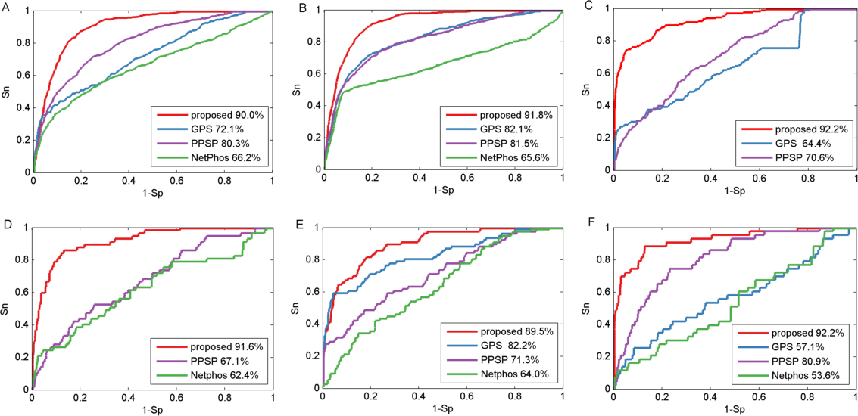

Figure S2. The ROC curves of different method for kinase group on Y sites. Red, blue, purple and green lines represent the proposed method, GPS, PPSP and NetPhos, respectively. A, B, C and D are kinase groups TK, CMGC, STE and Other, respectively.
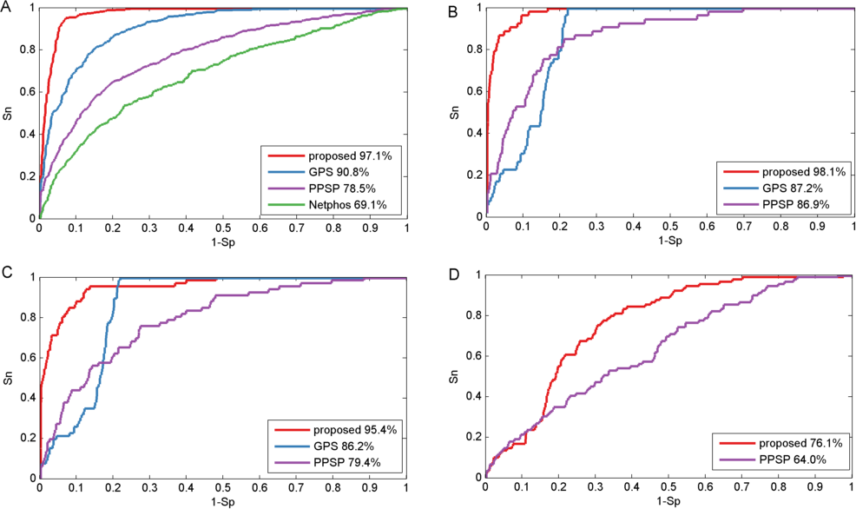

Figure S3. The fraction of predicted target sites for kinase group CAMK (A) and CMGC (B).
