I send additional information for data set.
I send graphs of CFA model and SEM model in AMOS program for reviewers convenience.
The results were calculated in AMOS 22 (this is important as other versions differ slightly in estimations for example: 0,722 instead of 0,723). Maximum Likelihood estymator was used.

In order to calculate, please, click:
File – Data Set – File name (select file) – OK.
Analyze – calculate estimates
If You would like to see numbers in the graph please click red arrow.
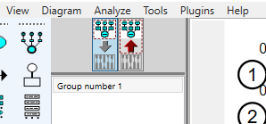
If You want standardized estimates please click this option.
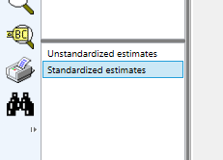
To see whole results

View – text output
And you will see this

