Population | Body | Head
A. ervi - APA | 43,733,854 | 38,876,038
A. ervi - APP | 40,189,908 | 38,403,840
A. ervi - SA | 66,280,364 | 53,068,010
Supplementary Table 2: Final number of reads from each library used in DE analysis.

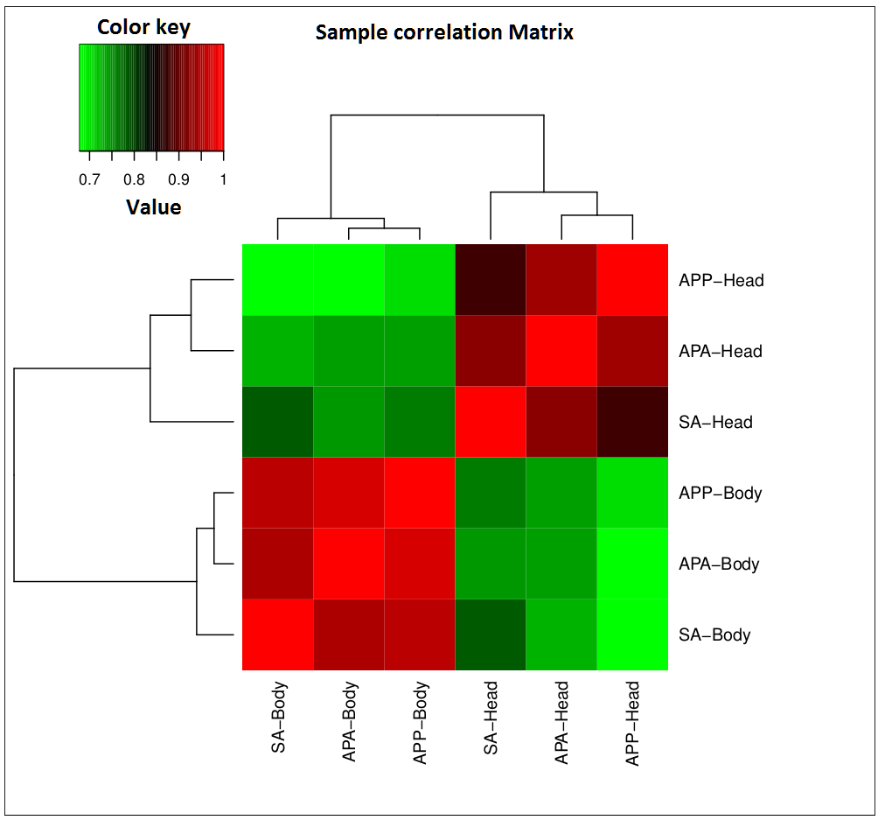
Supplementary Fig 1. Sample correlation matrix heatmap for all A. ervi libraries.

