Supplementary material to:

Candidate genes for shell colour polymorphism in Cepaea nemoralis
Jesse Kerkvliet, Tjalf de Boer, Menno Schilthuizen, Ken Kraaijeveld

Data S1-3 are provided as separate files.

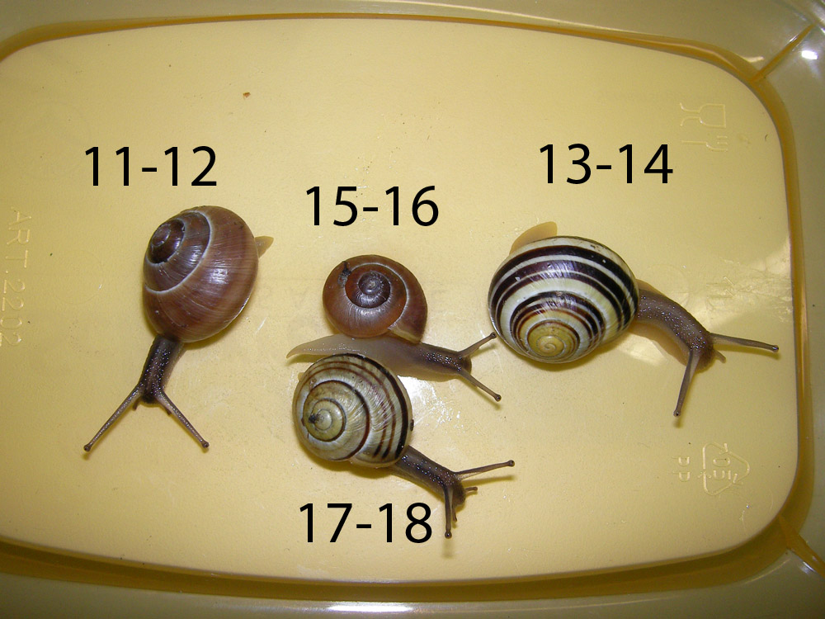

Figure S1 Snails used in this study. Numbers correspond to those in Table 1.

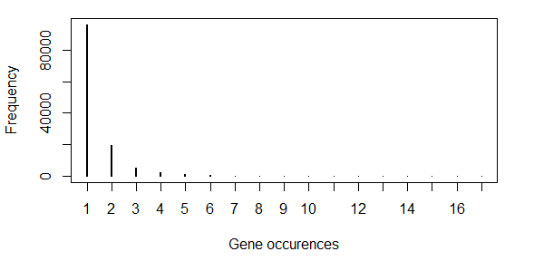

Figure S2 Frequency distribution of the number of isoforms per gene.

Table S1 Overview of the alignment statistics for each sample.

Sample | Reads aligned at least once | Properly paired reads
11 | 38,337,898 (53.6%) | 33,244,620 (46.4%)
12 | 52,000,948 (72.6%) | 45,560,146 (63.6%)
13 | 50,780,782 (65.9%) | 44,080,380 (57.2%)
14 | 47,651,676 (71,4%) | 41,350,714 (62.0%)
15 | 47,852,396 (74.9%) | 42,796,990 (67.0%)
16 | 54,298,143 (78.1%) | 49,089,688 (70.6%)
17 | 91,448,178 (75.1%) | 82,673,624 (67.9%)
18 | 106,823,206 (76.6%) | 96,221,182 (69.0%)

Table S2 Number of SNPS after filtering on sequence depth (>10) for each sample.

Sample | SNPs
11 | 81,233
12 | 132,825
13 | 135,232
14 | 117,458
15 | 155,511
16 | 98,933
17 | 200,068
18 | 155,360
Total | 1,076619
Total (unique) | 461,799
Total (filtered) | 73,817

Table S3 Annotations and predicted SNP effects. For each transcript, we report only the best hit based on e-value.
Contig name | Functional annotationKolom2 | SNPEff effect
c264073_g1_i1 | Camelus bactrianus mucin-2-like | frameshift_variant&stop_gained
 |  | inframe_insertion
c280576_g1_i1 | Biomphalaria glabrata glycine and methionine-rich –like | synonymous_variant
c280925_g1_i2 | Parasteatoda tepidariorum keratin-associated 6-2-like | synonymous_variant
c321814_g1_i1 | Euhadra herklotsi mRNA for Dermatopontin1 | intergenic_region
c323639_g1_i1 | Aplysia californica multiple coagulation factor deficiency | synonymous_variant
 |  | 5_prime_UTR_variant
c344946_g1_i1 | Physa acuta G-type lysozyme mRNA, complete cds | missense_variant
c348138_g1_i1 | Biomphalaria glabrata annexin A7-like | chromosome_number_variation
c350256_g1_i1 | Anas platyrhynchos BPI fold-containing family B member 3 | synonymous_variant
c354311_g1_i1 | Biomphalaria glabrata sorting nexin-5-like | 5_prime_UTR_variant
c355427_g1_i1 | Euhadra herklotsi mRNA for Dermatopontin1 | stop_gained
 |  | missense_variant
c356371_g1_i1 | Aplysia californica tyramine beta-hydroxylase-like | missense_variant
c357948_g1_i2 | Aplysia californica nucleoside-diphosphatase | missense_variant
c358175_g7_i1 | AF109924Helix pomatia sulfatase 1 precursor | intergenic_region
c358705_g4_i1 | Aplysia californica carbonic anhydrase 1-like | stop_gained
 |  | missense_variant
c358903_g6_i2 | Aplysia californica toll-like receptor 3 | 5_prime_UTR_variant
c360655_g1_i2 | AF109924Helix pomatia sulfatase 1 precursor | disruptive_inframe_insertion
 |  | missense_variant
 |  | synonymous_variant
 |  | 5_prime_UTR_premature_start_codon_gain_variant
c360728_g7_i2 | Aplysia californica UPF0462 C4orf33 homolog | missense_variant
c361453_g1_i1 | Biomphalaria glabrata peroxidasin-like | 3_prime_UTR_variant
 |  | missense_variant
c361590_g1_i1 | Aplysia californica aquaporin-4-like | missense_variant
 |  | synonymous_variant
c362006_g8_i2 | Helix pomatia Cd-specific metallothionein gene | intergenic_region
c362358_g3_i1 | AF109924Helix pomatia sulfatase 1 precursor | intergenic_region
c362887_g2_i1 | AF109924Helix pomatia sulfatase 1 precursor | 3_prime_UTR_variant
c363384_g6_i1 | Helix pomatia Cd-specific metallothionein gene | intergenic_region
c363875_g1_i3 | Lepisosteus oculatus ficolin-2-like | missense_variant
c365069_g1_i1 | Biomphalaria glabrata tyrosinase | 5_prime_UTR_variant
c365850_g1_i1 | Biomphalaria glabrata formin BNR1-like | missense_variant
 |  | synonymous_variant
c366293_g1_i1 | Biomphalaria glabrata mucin-2-like | missense_variant
c367319_g1_i1 | Aplysia californica sodium-coupled monocarboxylate transporter | 5_prime_UTR_variant
c368154_g1_i1 | Lethenteron camtschaticum clone BAC 238J5 homeobox Hox-delta3 (Hox-delta3) and homeobox Hox-delta2 (Hox-delta2) genes | missense_variant
 |  | 3_prime_UTR_variant
c368572_g1_i1 | Aplysia californica epithelial splicing regulatory 1-like | synonymous_variant
c368766_g1_i1 | Aplysia californica mesenchyme-specific cell surface glyco -like | missense_variant
c369092_g1_i1 | Biomphalaria glabrata perivitellin-2 67 kDa subunit-like | synonymous_variant
 |  | missense_variant
c369237_g1_i2 | Biomphalaria glabrata amine oxidase | synonymous_variant
c369245_g1_i1 | Helix pomatia Cd-specific metallothionein gene | 3_prime_UTR_variant
 |  | synonymous_variant
 |  | missense_variant
c369506_g2_i1 | Aplysia californica solute carrier family 2, facilitated glucose transporter member | 5_prime_UTR_premature_start_codon_gain_variant
 |  | 5_prime_UTR_variant
c369765_g4_i2 | Biomphalaria glabrata ferric-chelate reductase 1-like | synonymous_variant
c369942_g2_i3 | Aplysia californica ATP-binding cassette sub-family G member 2-like | missense_variant
c371799_g2_i1 | Biomphalaria glabrata sushi, von Willebrand factor type A, EGF and pentraxin domain-containing 1-like | synonymous_variant

Table S4 Transcripts with hits on the four RAD tags near the supergene.

RAD tag ID | Contig | Blastn annotation
Cne_RAD02 | c364559_g2_i4 | None
Cne_RAD02 | c366252_g1_i1 | None
Cne_RAD02 | c366252_g1_i2 | None
Cne_RAD02 | c366252_g1_i6 | None
Cne_RAD08 | c365766_g3_i1 | Helix pomatia methallothionein
Cne_RAD08 | c363423_g3_i1 | Helix pomatia methallothionein
Cne_RAD08 | c337572_g1_i1 | Helix pomatia methallothionein
Cne_RAD10 | c360230_g9_i1 | Helix pomatia methallothionein
Cne_RAD10 | c360230_g8_i1 | Helix pomatia methallothionein
Cne_RAD10 | c367196_g3_i3 | Helix pomatia methallothionein
Cne_RAD10 | c367196_g3_i1 | Helix pomatia methallothionein
Cne_RAD10 | c325228_g1_i1 | Helix pomatia methallothionein

