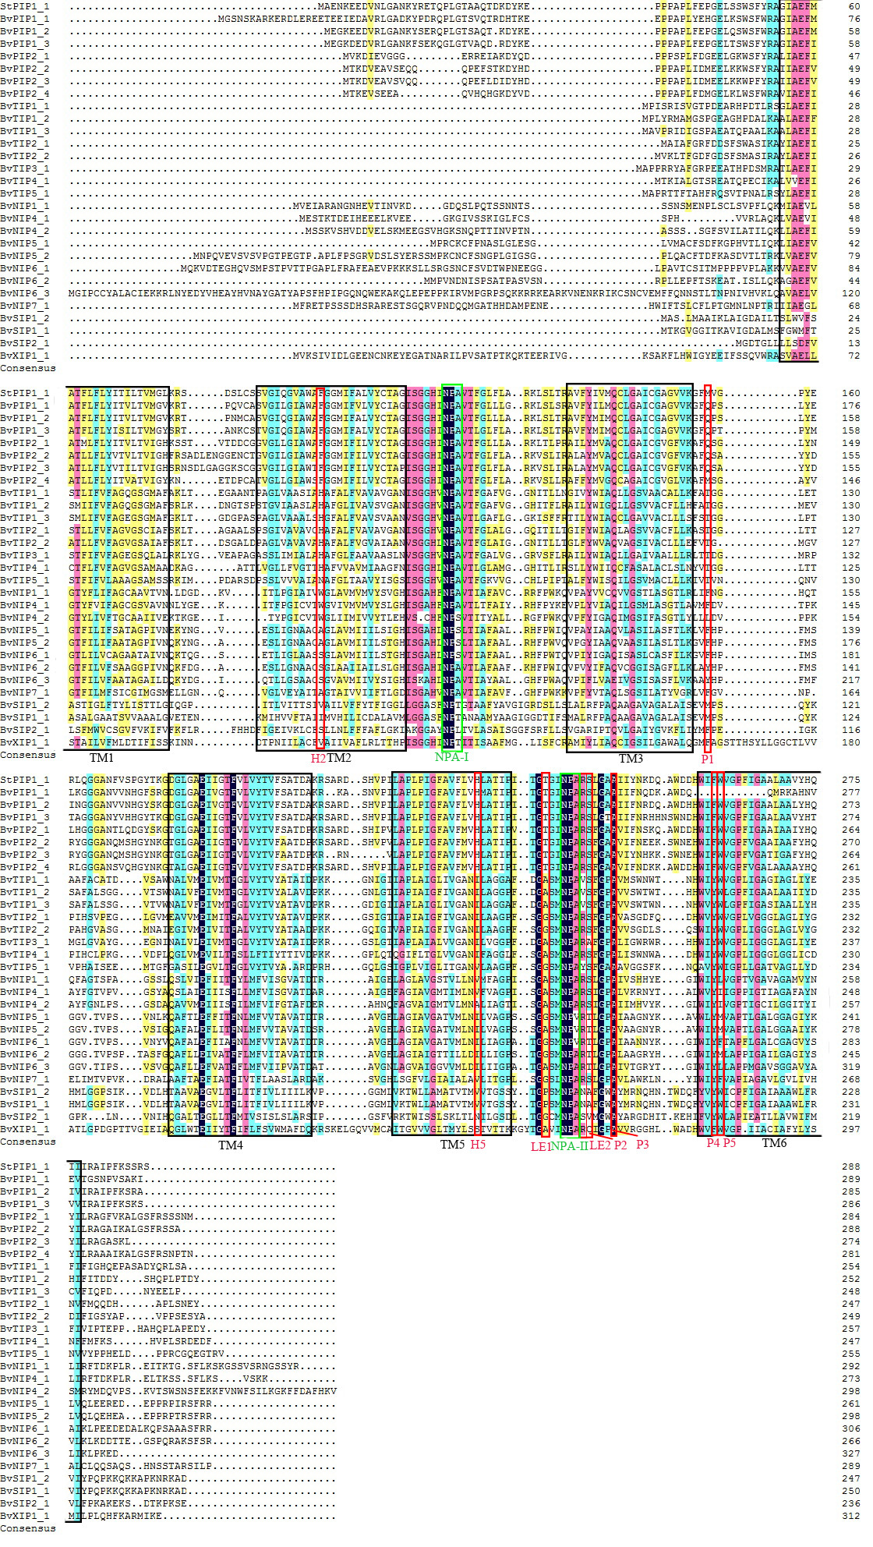
Alignment of deduced amino acid sequences of BvAQPs

