Levels of plasma Fsh were low and very similar among all groups of fish (means ranged between 0.73 and 1.03 ng/ml, Figure S1).

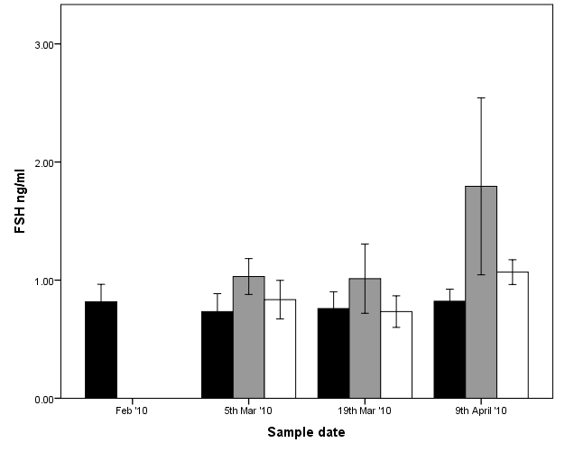
Figure S1. Mean ± SE plasma Fsh levels in maiden spawning female Atlantic salmon throughout reproductive development. Values that were below the limit of reliable detection (LOD) were graphed as 0.6 ng/ml (equal to LOD). Black, grey, and white bars represent maiden fish reared at 14 °C (no hormonal treatment), 22 °C (no hormonal treatment), and E2-treated fish maintained at 22 °C respectively.

