Table S2: Correlation among all ecological and geographical variables used in K select modelling and habitat suitability analysis using Mahalanobis distance probability function. All values depict the Pearson correlation coefficients.

 | Ana Pen | BamMxfor | Bar Lan | DEM | Den Mx For | Dis Hu Set | Dis Wat Sou | Gras Lan | NDVI | Open Mx For | Pur Tk For | Riv For | Scr Lan | Slope | Tk Mx For | DistNP
Ana Pen | 1.00
Bam For | - 0.01 | 1.00
Bar Lan | - 0.02 | - 0.02 | 1.00
DEM | - 0.12 | - 0.04 | - 0.07 | 1.00
Den Mx For | - 0.05 | - 0.07 | - 0.14 | 0.01 | 1.00
Dis Hu Set | 0.01 | 0.05 | 0.24 | - 0.11 | 0.03 | 1.00
Dis Wat Sou | - 0.09 | - 0.04 | 0.17 | 0.51 | - 0.12 | - 0.13 | 1.00
Gras Lan | 0.00 | - 0.01 | - 0.01 | - 0.03 | - 0.03 | 0.02 | - 0.03 | 1.00
NDVI | 0.02 | 0.20 | - 0.24 | 0.01 | 0.33 | - 0.02 | - 0.21 | - 0.03 | 1.00
Open Mx For | - 0.06 | - 0.06 | - 0.14 | 0.23 | - 0.32 | 0.00 | 0.09 | - 0.03 | - 0.03 | 1.00
Pur Tk For | - 0.01 | - 0.01 | - 0.02 | - 0.18 | - 0.07 | - 0.05 | - 0.08 | 0.00 | 0.07 | - 0.07 | 1.00
Riv For | - 0.01 | - 0.01 | - 0.01 | - 0.12 | - 0.04 | - 0.01 | - 0.10 | 0.00 | - 0.10 | - 0.04 | - 0.01 | 1.00
Scr Lan | - 0.04 | - 0.04 | - 0.08 | - 0.08 | - 0.24 | 0.30 | 0.10 | - 0.02 | - 0.30 | - 0.24 | - 0.04 | - 0.03 | 1.00
Slope | 0.04 | 0.14 | - 0.11 | - 0.09 | 0.33 | 0.14 | - 0.15 | - 0.01 | 0.29 | - 0.11 | 0.03 | 0.00 | - 0.13 | 1.00
Tk Mx For | - 0.02 | - 0.02 | - 0.05 | - 0.02 | - 0.13 | - 0.02 | - 0.11 | - 0.01 | 0.33 | - 0.16 | - 0.03 | - 0.02 | -0.10 | 0.01 | 1.00
Dist NP | - 0.09 | - 0.03 | 0.16 | 0.35 | - 0.17 | - 0.14 | 0.87 | - 0.05 | - 0.27 | 0.04 | - 0.07 | - 0.05 | 0.14 | -0.14 | -0.13 | 1.00

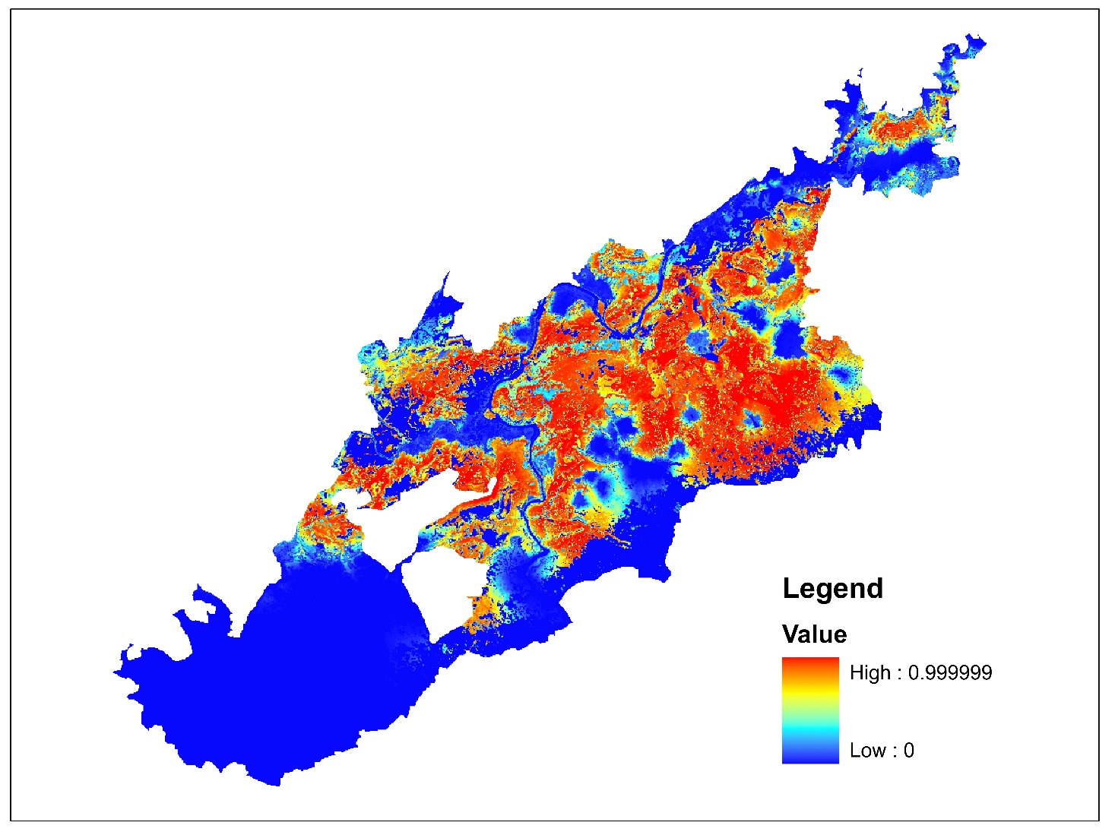
Figure S1: The continuous scale of habitat suitability map generated from Mahalanobish D² method

