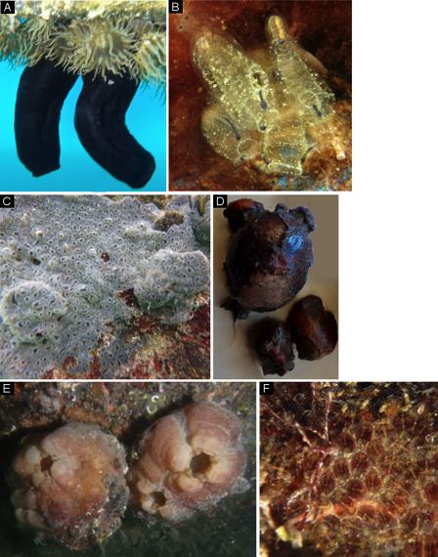
S.D. Fig. 1 (A-F). Ascidians: (A) Phallusia nigra in Marina #34; (B) Clavelina oblonga in Marina #34; (C) Diplosoma listerianum in Marina #23; (D) Microcosmus squamiger in Marina #20; (E) Styela plicata in Marina #14; (F) Symplegma cf. brakenhielmi in Marina #32. Photo credits: Aylin Ulman.

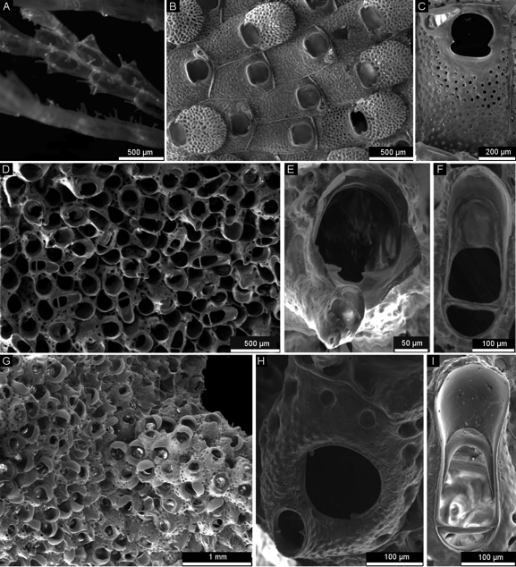

S.D. Fig. 2 (A-I). Bryozoans Part 1: (A) Tricellaria inopinata from Marina #5; (B-C) Hippopodina aff. feegeensis: (B) colony with ovicelled autozooids from Marina #26, (C) close-up of the autozooid with avicularia from Marina #32; (D-F) Celleporaria brunnea from Marina #5: (D) colony, (E) close-up of the orifice and the sub-oral adventitious avicularium, (F) close-up of the interzooidal avicularium; (G-I) Celleporaria vermiformis from Marina #33: (G) colony with ovicelled zooids; (H) close-up of the orifice and the sub-oral adventitious avicularium; (I) gigantic vicarious avicularium. Photo credits: Maria Pia Riccardi and Ilenia Tredici (CISRiC-Arvedi Laboratory) at the University of Pavia assisted Jasmine Ferrario with the use of the Scanning Electronic Microscope (SEM).
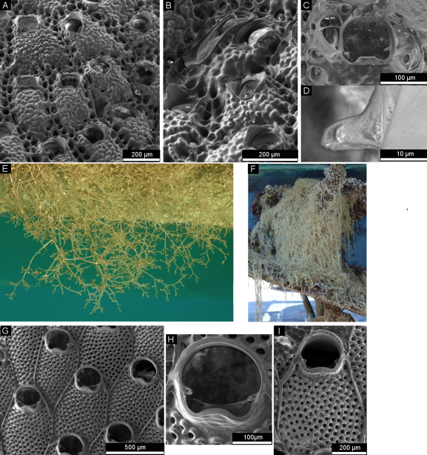
S. D. Fig. 3 (A-I). Bryozoans Part II: (A-B) Parasmittina egyptiaca on boat hull from Marina #25: (A) colony, (B) autozooid with a gigantic spatulate avicularium with triangular flaps; (C-D) Parasmittina egyptiaca from Marina #33: (C) close-up of the orifice with two small avicularia, (D) condyle; (E-F) Amathia verticillata: (E) colony in Marina #30, (F) colony on boat hull in Marina #12; (G-H) Watersipora arcuata from Marina #18: (G) colony, (H) close-up of the orifice; (I) Waterispora arcuata from Marina #22: autozooid. Photo credits: (A-C, G-I) Maria Pia Riccardi and Ilenia Tredici (CISRiC-Arvedi Laboratory) at the University of Pavia assisted Jasmine Ferrario with the use of the Scanning Electronic Microscope (SEM); (E, F) Aylin Ulman.

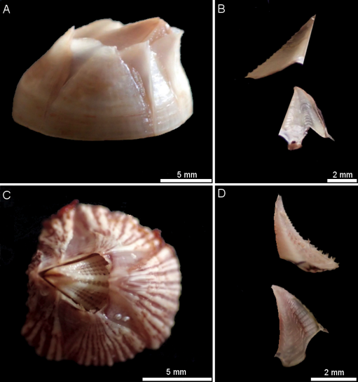
S.D. Fig. 4. (A-D). Cirripeds: (A-B) Amphibalanus improvisus on boat hull in Marina #5: (A) complete specimen, (B) scutum and tergum; (C-D) Baluns trigonus on boat hull in Marina #33: (C) complete specimen, (D) scutum and tergum. Photo credits: Aylin Ulman.

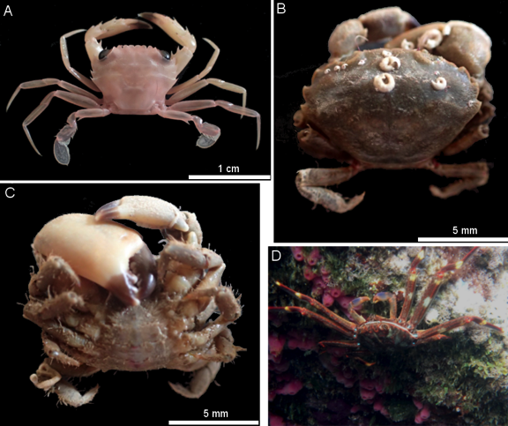

S.D. Fig. 5 (A-D). Decapods: (A) Charybdis (Gonioinfradens) paucidentatus in Marina #34; (B-C) Dyspanopeus sayi dorsal and ventral view in Marina #24; (D) Percnon gibbesi in Marina #24. Photo credits: Aylin Ulman.

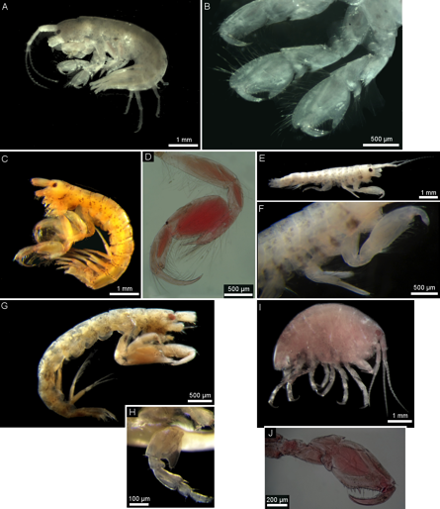
S. D. Fig. 6 (A-J). Amphipods: (A-B) Amphithoe bizseli in Marina #34: (A) male specimen, (B) right and left gnathopod 2; (C-D) Aoroides longimerus in Marina #5: (C) male specimen, (D) merochelate gnathopod 1; (E-F) Bemlos leptocheirus in Marina #24: (E) male specimen, (F) gnathopods 1 and 2; (G-H) Ericthonius cf. pugnax in Marina #5: (G) male specimen, (H) pereopod 5; (I-J) Stenothoe georgiana in Marina #14: (I) male specimen, (J) gnathopod 2 with conspicuous lobe on the propodus palm. Photo credits: (A-B) Agnese Marchini; (C-J): Gemma Martinez-Laiz.
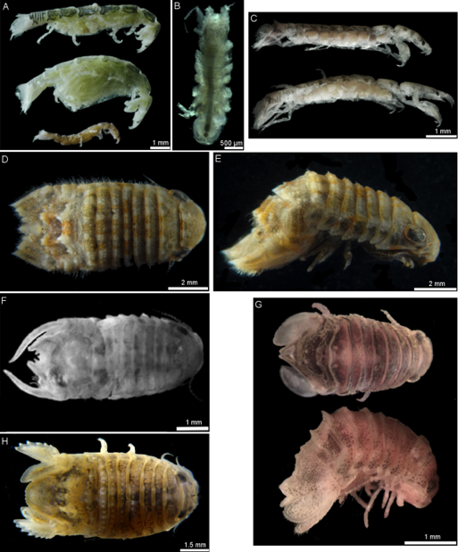
S. D. Fig. 7 (A-H). Isopods: (A) Mesanthura sp. in (from top to bottom) Marinas #1, #16 and #22: female specimens; (B) Ianiropsis serricaudis in Marina #5; (C) Paranthura japonica specimens in (from top to bottom) Marinas #1 and #21: female specimens; (D-E) Cymodoce aff. fuscina in Marina #24: (D) frontal and (E) lateral view of a male specimen, (F) Paracerceis sculpta in Marina #22: male specimen; (G) Paradella dianae in Marina #15: male specimen; (H) Sphaeroma walkeri in Marina #24: male specimen. Photo credits: (A, B, C); Agnese Marchini; (D, E, F, H): Gemma Martinez-Laiz; (G) Giovanni Scribano.

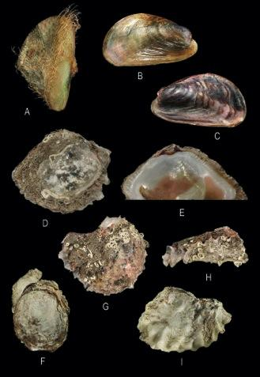
S.D. Fig. 8 (A-I). Molluscs: (A) Septifer cumingii in Marina #25, L= 8,5 mm; (B-C) Arcuatula senhousia in Marina #2, L=19 mm; (D-E) Saccostrea glomerata in Marina #10, L= 40 mm; (F) Pseudochama cf. corbierei in Marina #20, L= 21 mm; (G-H) Saccostrea cf. cucullata in Marina #24, L= 25 mm; (I) Dendostrea folium sensu lato in Marina #33, L= 25mm. Photo credit: Cesare Bogi.

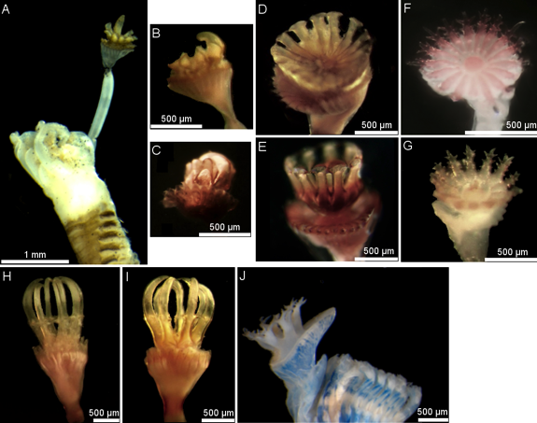
S.D. Fig. 9 (A-J). Serpulids- Close-ups of the serpulid’s opercula: (A-C) Hydroides brachyacantha sensu lato in Marina #2; (D-E) Hydroides dirampha in Marina #23; (F-G) Hydroides elegans in Marina #18; (H-I) Hydroides homoceros in Marina #33; (J) Spirobranchus tetraceros sensu lato in Marina #18. Photo credits: (A, J) Giorgos Chatzigeorgiou; (B-I) Aylin Ulman.
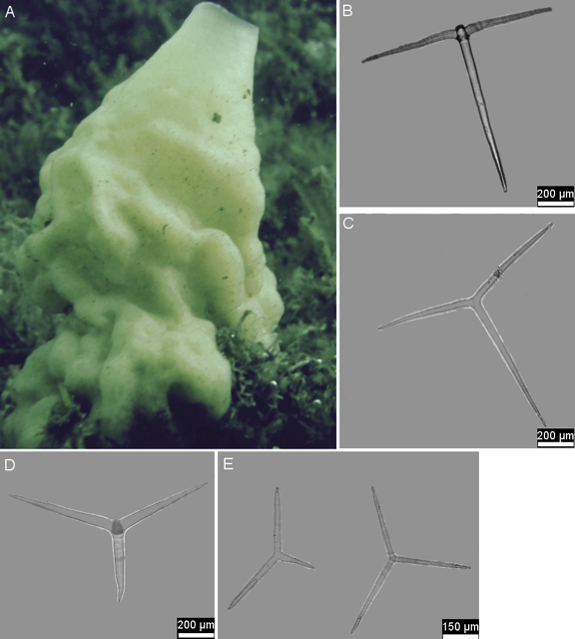

S.D. Figure 10 (A-E). Porifera: Paraleucilla magna (A) Live colony in Marina #24. (B) cortical tetractine; (C) subatrial triactine; (D) subatrial tetractine; (E) atrial triantine (left) and cortical triactine (right). Photo credits: (A) Aylin Ulman; (B-E) Marco Bertolino.

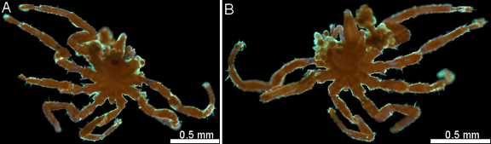
S.D. Fig. 11 (A-B). Pycnogonida: (A & B) Achelia sawayai sensu lato Marcus,1940, ♂ (ovigerous) from Malta in Marina #23, (A) dorsal view; (B) ventral view. Photo credits: Cengiz Koçak.

