SUPPLEMENTARY FILE
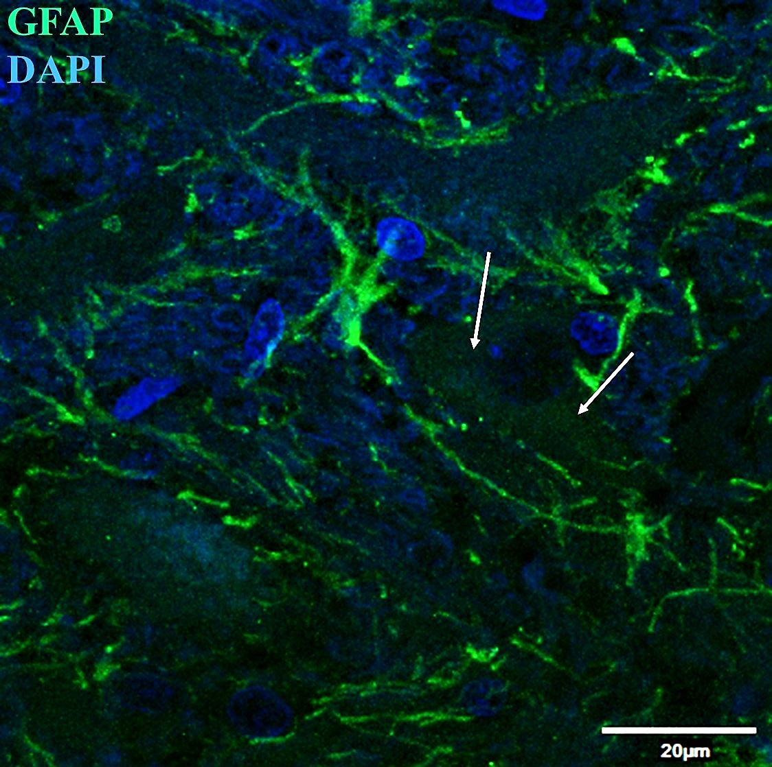
Astrocytes are often found in association with neighboring neurons (white arrows) in dorsal horn spinal cord in horses.

