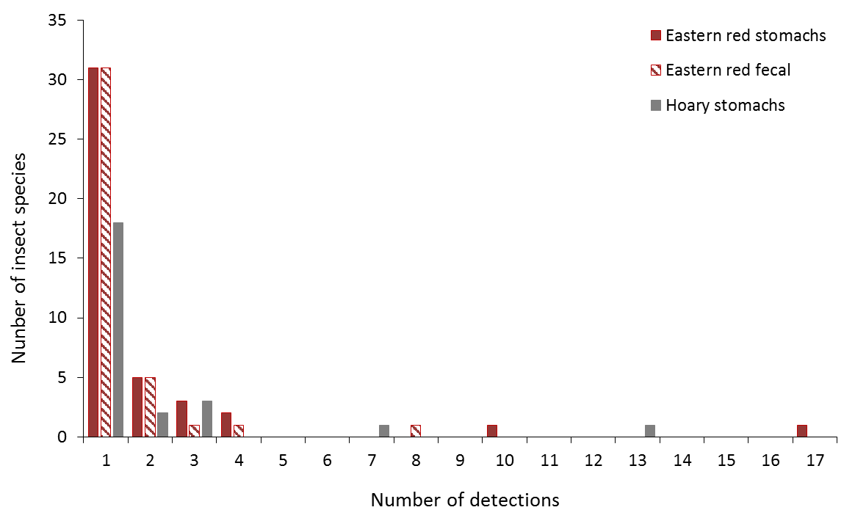
Figure S3. Detection frequency of insect species in bat stomachs and fecal pellets.
Detection frequency of each insect species in eastern red bat stomachs (n = 45), eastern red bat fecal pellets (n = 23), and hoary bat stomachs (n = 23) collected from the Wolf Ridge wind farm.

