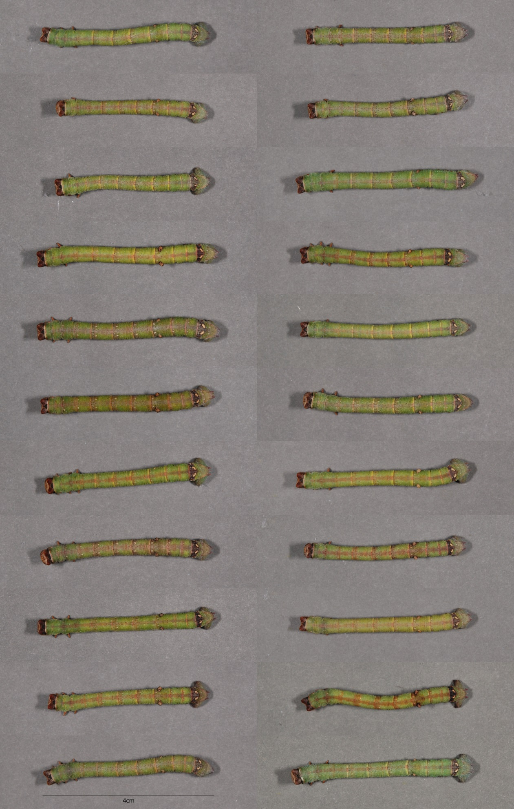
Fig. S3A. Heterogeneous environment treatment. Photographs of the final instar larvae under treatment 100G (100% Green, 0% brown dowel proportions).
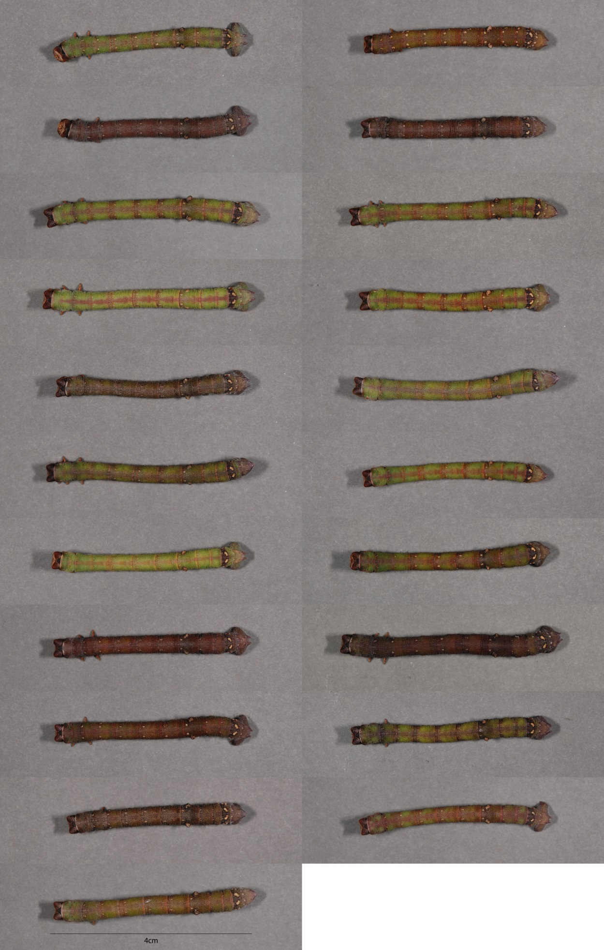
Fig. S3B. Heterogeneous environment treatment. Photographs of the final instar larvae under treatment 70G (70% Green, 30% brown dowel proportions).
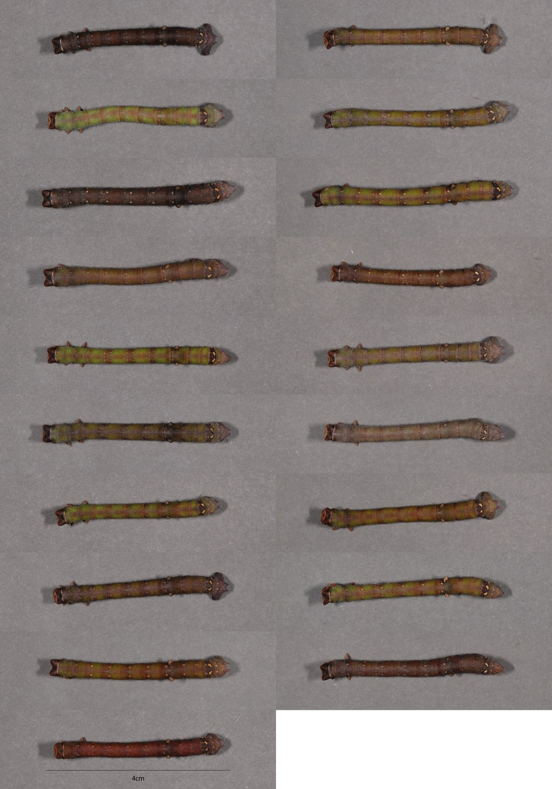
Fig. S3C. Heterogeneous environment treatment. Photographs of the final instar larvae under treatment 50G (50% Green, 50% brown dowel proportions).

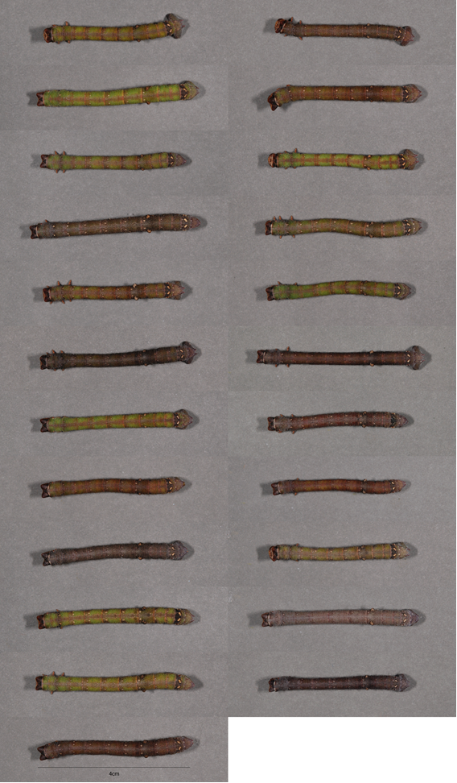
Fig. S3D. Heterogeneous environment treatment. Photographs of the final instar larvae under treatment 30G (30% Green, 70% brown dowel proportions).

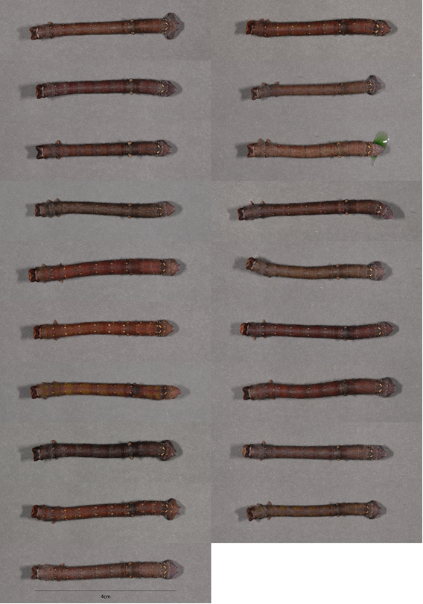
Fig. S3E. Heterogeneous environment treatment. Photographs of the final instar larvae under treatment 0G (0% Green, 100% brown dowel proportions).

