Supplemental Information S1

Specimens used
Below are the full details of the specimens used and their accession numbers. All specimen data are available from the Natural History Museum’s Data Portal at http://dx.doi.org/10.5519/0082274 (Page & Cooper 2017) (Table S1).

Table S1. Accession numbers and species of specimens sampled. Taxonomic names follow that of Rice (1998).
Accession number | Species | Cranium | Mandible | Both
NHMUK_1933.10.13.2 | Delphinapterus_leucas | x
NHMUK_1933.10.13.4 | Delphinapterus_leucas |  |  | x
NHMUK_1933.10.13.1 | Delphinapterus_leucas | x
NHMUK_1952.10.30.2 | Delphinapterus_leucas | x
NHMUK_SW.1932.60 | Delphinapterus_leucas | x
NHMUK_1973.107 | Delphinus_delphis |  | x
NHMUK_1888.5.20.2 | Delphinus_delphis |  |  | x
NHMUK_1946.12.24.3 | Delphinus_delphis |  |  | x
NHMUK_1973.106 | Delphinus_delphis |  |  | x
NHMUK_1946.12.24.1 | Delphinus_delphis |  |  | x
NHMUK_SW.1927.25 | Grampus_griseus |  |  | x
NHMUK_SW.1929.7 | Grampus_griseus |  |  | x
NHMUK_SW.1933.14 | Grampus_griseus |  |  | x
NHMUK_SW.1938.7 | Grampus_griseus |  |  | x
NHMUK_SW.1940.6 | Grampus_griseus | x
NHMUK_GERM 1169b | Inia_geoffrensis |  |  | x
NHMUK_1856.8.2.1 | Inia_geoffrensis |  |  | x
NHMUK_1937.5.26.1 | Inia_geoffrensis |  |  | x
NHMUK_1939.5.13.1 | Inia_geoffrensis |  |  | x
NHMUK_SW.1926.17 | Lagenorhynchus_acutus |  |  | x
NHMUK_SW.1929.25 | Lagenorhynchus_acutus |  |  | x
NHMUK_1920.6.28.1 | Lagenorhynchus_acutus |  |  | x
NHMUK_1944.11.30.1 | Lagenorhynchus_australis |  |  | x
NHMUK_1961.6.12.1 | Lagenorhynchus_australis |  |  | x
NHMUK_1944.11.16.1 | Lagenorhynchus_obscurus |  |  | x
NHMUK_1944.11.16.2 | Lagenorhynchus_obscurus |  |  | x
NHMUK_1949.5.30.1 | Lagenorhynchus_obscurus |  |  | x
NHMUK_1922.6.22.1 | Lipotes_vexillifer |  |  | x
NHMUK_1908.2.28.1 | Mesoplodon_bidens |  | x
NHMUK_1920.12.20.1 | Mesoplodon_bidens |  | x
NHMUK_SW.1964.6.3.7 | Mesoplodon_bidens | x
NHMUK_1949.8.19.1 | Mesoplodon_hectori |  |  | x
NHMUK_1937.10.30.2 | Monodon_monoceros | x
NHMUK_1885.2.20.1 | Monodon_monoceros | x
NHMUK_1937.10.30.1 | Monodon_monoceros | x
NHMUK_1949.11.2.1 | Monodon_monoceros | x
NHMUK_1889.8.6.1 | Neophocaena_phocaenoides | x
NHMUK_1902.6.10.65 | Neophocaena_phocaenoides |  |  | x
NHMUK_1903.9.12.3 | Neophocaena_phocaenoides |  |  | x
NHMUK_1950.9.19.1 | Phocoena_phocoena |  | x
NHMUK_SW.1928.49 | Phocoena_phocoena |  | x
NHMUK_SW.1928.49 | Phocoena_phocoena | x
NHMUK_SW.1933.50 | Phocoena_phocoena | x
NHMUK_1957.6.4.1 | Phocoenoides_dalli |  |  | x
NHMUK_1965.1.19.2 | Phocoenoides_dalli |  |  | x
NHMUK_1843.8.18.5 | Platanista_gangetica | x
NHMUK_1874.6.1.1 | Platanista_gangetica |  |  | x
NHMUK_1884.3.29.1 | Platanista_gangetica |  |  | x
NHMUK_1884.3.29.1 | Platanista_gangetica |  | x
NHMUK_GERM 344a | Platanista_gangetica |  |  | x
NHMUK_1866.12.13.1 | Pontoporia_blainvillei | x
NHMUK_1925.11.21 | Pontoporia_blainvillei |  |  | x
NHMUK_1939.4529 | Pontoporia_blainvillei |  |  | x
NHMUK_1961.6.14.4 | Pseudorca_crassidens |  |  | x
NHMUK_1961.6.14.86 | Pseudorca_crassidens |  |  | x
NHMUK_1961.6.14.27 | Pseudorca_crassidens |  |  | x
NHMUK_1984.1759 | Sousa_chinensis |  |  | x
NHMUK_1957.5.9.7 | Stenella_attenuata |  |  | x
NHMUK_1959.12.13.2 | Stenella_attenuata |  |  | x
NHMUK_1959.12.31.5 | Stenella_attenuata |  |  | x
NHMUK_1869.5.21.2 | Stenella_attenuata |  |  | x
NHMUK_1882.1.2.1 | Stenella_clymene |  |  | x
NHMUK_1948.3.13.2 | Stenella_clymene | x
NHMUK_1954.9.9.5 | Stenella_clymene |  |  | x
NHMUK_1992.92 | Stenella_clymene |  |  | x
NHMUK_1970.1509 | Stenella_clymene |  |  | x
NHMUK_1938.2.5.1 | Stenella_coeruleoalba |  |  | x
NHMUK_1961.5.31.1 | Stenella_coeruleoalba |  |  | x
NHMUK_SW.1934.1 | Stenella_coeruleoalba |  |  | x
NHMUK_1949.1.7.2 | Steno_bredanensis |  |  | x
NHMUK_1952.8.1.1 | Steno_bredanensis |  |  | x
NHMUK_GERM 345e | Steno_bredanensis |  |  | x
NHMUK_GERM 345f | Steno_bredanensis |  |  | x
NHMUK_1954.6.25.2 | Steno_bredanensis |  |  | x
NHMUK_1949.10.27.3 | Tursiops_aduncus |  |  | x
NHMUK_1954.9.9.4 | Tursiops_aduncus |  |  | x
NHMUK_1970.1512 | Tursiops_aduncus |  |  | x
NHMUK_1964.9.2.2 | Tursiops_aduncus |  |  | x
NHMUK_1952.7.30.3 | Tursiops_truncatus |  |  | x
NHMUK_1952.7.30.6 | Tursiops_truncatus |  |  | x
NHMUK_1960.5.11.10 | Tursiops_truncatus |  |  | x
NHMUK_1960.5.11.7 | Tursiops_truncatus |  |  | x
NHMUK_1960.5.11.9 | Tursiops_truncatus |  |  | x

Figure S1. Phylogeny of the Odontoceti, adapted from Steeman et al. (2009). Genera in blue represent those included in this study. River dolphin genera are highlighted by the use of cartoons depicting each species.

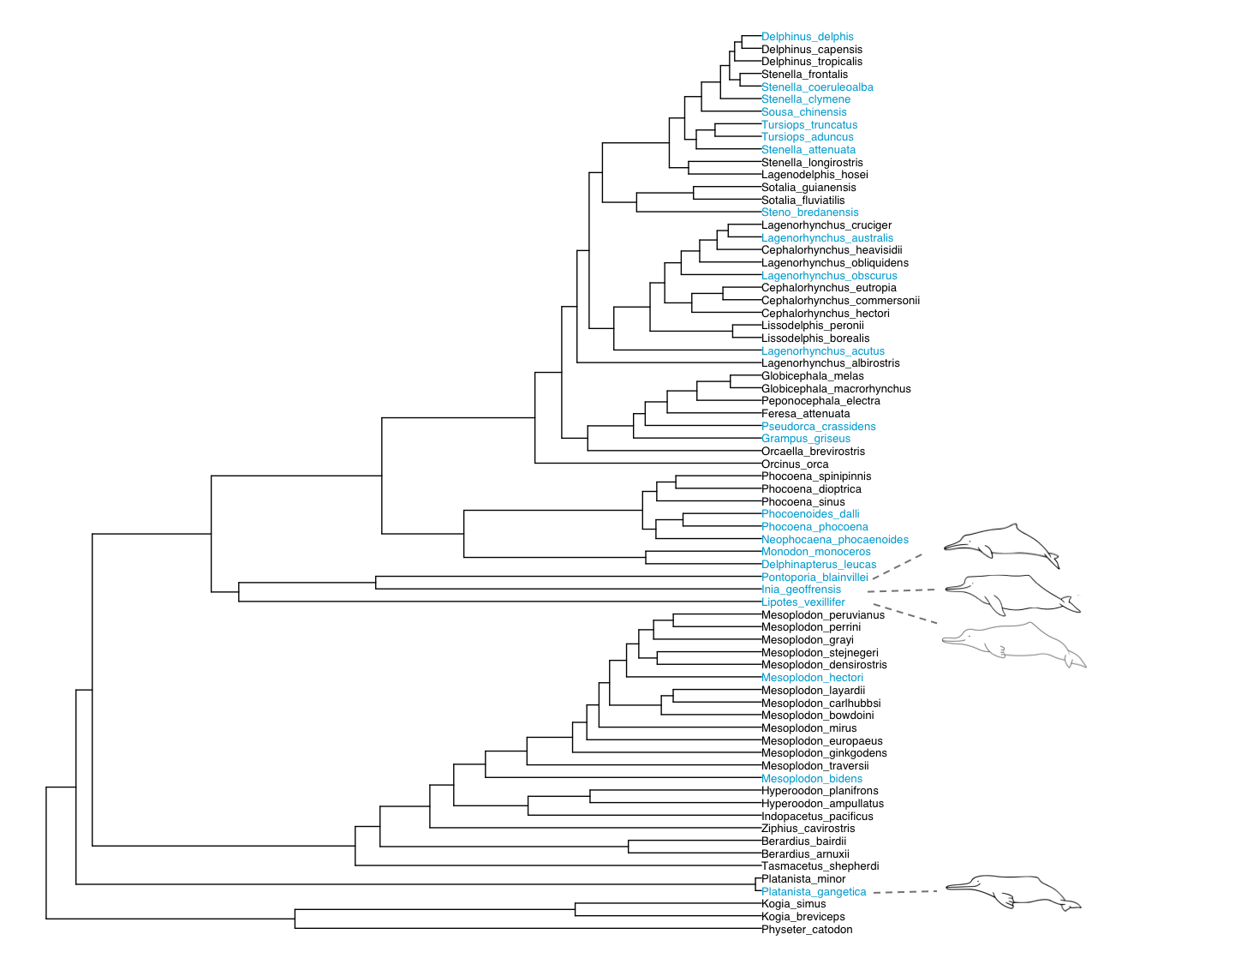

References

Page EC, and Cooper N. 2017. Dataset: Crania and mandible data from 'river dolphins' and other odontocetes. Natural History Museum Data Portal (data.nhm.ac.uk). http://dx.doi.org/10.5519/0082274.
Rice C. 1998. Marine mammals of the world, systematics and distributuion. Society for Marine Mammalogy Special Publications 4:1-231.
Steeman ME, Hebsgaard MB, Fordyce RE, Ho SY, Rabosky DL, Nielsen R, Rahbek C, Glenner H, Sørensen MV, and Willerslev E. 2009. Radiation of extant cetaceans driven by restructuring of the oceans. Systematic Biology 58:573-585.

