SUPPLEMENTAL MATERIAL
Transcriptomic profiling of mTOR and ryanodine receptor signaling molecules in developing zebrafish in the absence and presence of PCB 95
Daniel F. Frank^{1,2}, Galen W. Miller³, Richard E. Connon¹, Juergen Geist², and Pamela J. Lein³*
¹ Department of Anatomy, Physiology and Cell Biology, University of California, Davis, School of Veterinary Medicine, Davis, CA 95616, USA
² Aquatic Systems Biology, Department of Ecology and Ecosystem Management, Technical University Munich, Mühlenweg 22, D-85354 Freising, Germany
³ Department of Molecular Biosciences, University of California, Davis, School of Veterinary Medicine, Davis, CA 95616, USA
* Corresponding author

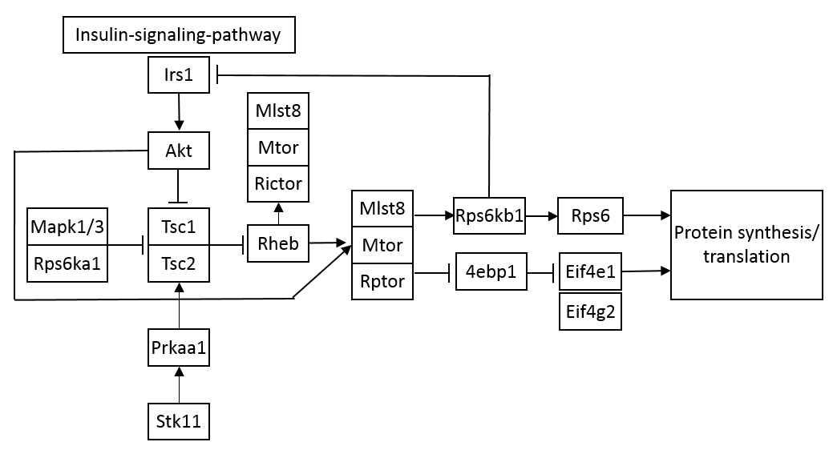

Figure S1: Schematic of mTOR signaling. Schematic illustrating the functional relationship of the mTOR signaling molecules analyzed in this study. Eif4g2 is not directly affected by upstream members of the signaling pathway, but is part of a complex formed with eif4e1.
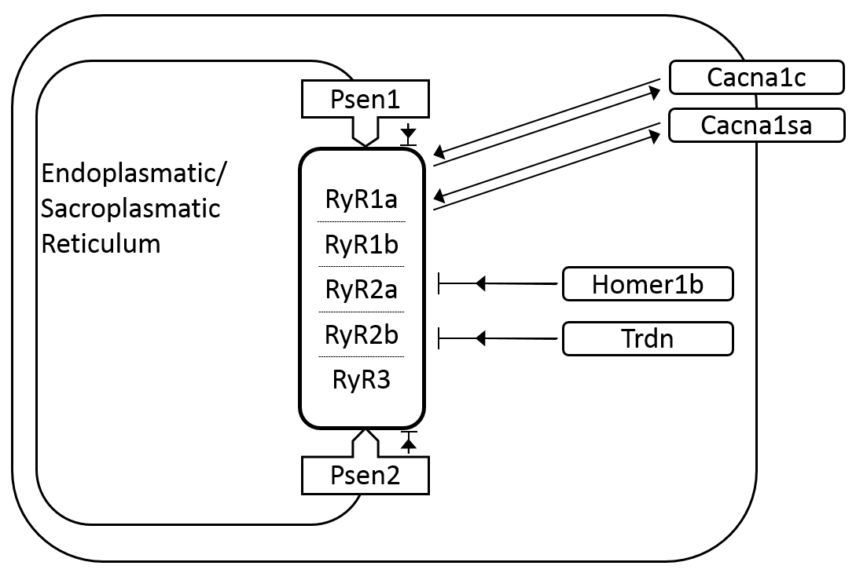
Figure S2: Ryanodine receptor (RyR) signaling molecules in the zebrafish. Schematic listing all the zebrafish ryanodine receptors (RyR) paralogs and regulatory proteins investigated in this study. Arrows highlight regulatory proteins that stabilize the RyR in its open configuration, which increases release of Ca²⁺ from internal stores; whereas blunt ends identify protein interactions that inhibit RyR activity.

Figure S3. Electrophoresis run file summary. Bioanalyzer output corresponding to Table S3 RIN scores. Illustrated are all 24 hpf, 72 hpf and 120 hpf samples, with the exception of one 72hpf sample (72-3).
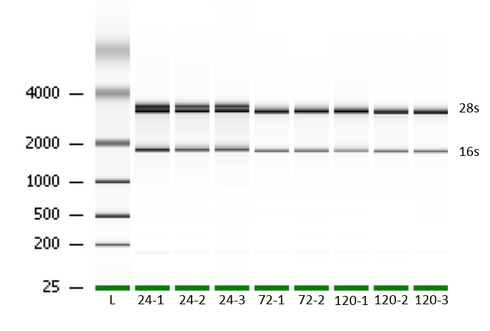

Table S1: Genes from mTOR signaling selected for transcriptomic analysis. Transcripts indicated in bold font were quantified in the PCB 95 exposure studies.
Gene name | Gene code | Primer (5'->3') | Accession # | Efficiency % | Amplicon  lengths | Exon | Chromo  some
Target genes  Insulin receptor substrate 1 | irs1 | F: GCTCAGTGCCTATGCCAGTA  R: AAGCAGCGGCGGATTTTTAC | XM_682610 | 91.2 | 99 | 1-2 | 15
V-akt murine thymoma viral oncogene homolog 1 | akt1 | F: TAAGGAGCGACCGCAAGATG  R: TGCAGGCAGCGTATGATGAA | NM_001281801 | 91.9 | 123 | 1-4 | 17
Tuberous sclerosis 1a | tsc1a | F: TCACGACACCCATGGGAAAG  R: TGCAGGCACAAGACCTTTCAA | NM_200052 | 96.9 | 88 | 14-16 | 5
Tuberous sclerosis 2 | tsc2 | F: AGTATGACGTGGCTGGTTGG  R: TCTTTGGTCTGTCGGGTGTG | XM_009294973 | 91.3 | 155 | 24-25 | 1
Ras homolog enriched in brain | rheb | F: TTGGACATGGTGGGGAAAGT  R: TTCACAGCTGATCACTCGCT | NM_200729 | 95.9 | 87 | 1-3 | 24
mTOR associated protein | mlst8 | F: ACATGCTCTGCTGACCAGAC  R: CACAATCCCACATCCAGCCT | NM_199877 | 101.5 | 121 | 7 | 12
Mechanistic target of Rapamycin | mtor | F: ATGGTCACTGGCCTGAAGTG  R: GTGCACGTGGCGTATCAATC | NM_001077211 | 102.1 | 117 | 41-42 | 8
Rptor regulatory associated protein of MTOR | rptor | F: TTCATCAAGCTGGCGGATCTC  R: CATCTTCCTGGTGCGTGGA | XM_005157354 | 96.5 | 170 | 23-24 | 6
Rptor independent companion of mTOR, complex 2a | rictora | F: ATCTGATCCGTGACAGCAGC  R: CCAATCGGAGGGCTTGAGTT | XM_009301197 | 102.2 | 123 | 5-6 | 5
eukaryotic translation initiation factor 4E binding protein 1 | eif4ebp1 | F: ACATGGGGGACGTTTTCACA  R: GGAGTTGGATTTCCCCCACA | NM_199645 | 102.4 | 149 | 4 | 21
p70 ribosomal S6 kinase a (p70s 6ka) | rps6kb1a | F: ACAGCCCTGATGACACGAAG  R: TTCTTGGGCTTCCCAGAACC | XM_685634 | 101.8 | 153 | 13-14 | 10
p70 ribosomal S6 kinase b (p70s 6kb) | rps6kb1b | F: TGACTGATTTCGGGCTGTGT  R: CGATTGTGTCCGCTCCTCAT | NM_213076 | 94.9 | 115 | 8-9 | 15
Eukaryotic translation initiation factor 4e1a | eif4e1a | F: TCGTATTGCAGCTTGAGAATGT  R: TGACATGAGGAATGTGGAACA | NM_131733 | 108.7 | 97 | 8 | 14
Eukaryotic translation initiation factor 4e1b | eif4e1b | F: GGTCAAAGAGTCATCATCTTGTATTG  R: TCACAAAGTCTTGCATATTTCAAGTT | NM_131454 | 97.0 | 95 | 7 | 5
Eukaryotic translation initiation factor 4e1c | eif4e1c | F: TTCGGAGCCGCGAGGA  R: AGATGAGACGCAGGTTTTCTGT | NM_001017851 | 91.9 | 170 | 1-3 | 13
Eukaryotic translation initiation factor 4, gamma 2a | eif4g2a | F: GAAAGAAGACATTACCCAGGAG  R: CAGCCACATCAGCCACTG | NM_001014289 | 100.2 | 76 | 21-22 | 7
Eukaryotic translation initiation factor 4, gamma 2b | eif4g2b | F: GGTGCTTCTCGTTTCAGTGC  R: TGCCGACAGTCTTGGGATA | NM_001013443 | 101.5 | 79 | 2-3 | 18
Ribosomal protein S6 kinase 1 (s6) | rps6 | F: TCTGAGCCCTTACGCTTTCG  R: TCTGTTGGGTGGGGAGATGAT | EF373681 | 100.9 | 99 | 1-2 | 1
AMP-activated, alpha 1 catalytic subunit (ampk) | prkaa1 | F: AGAGCAGGCCGAATGACATC  R: GACTGGGTTCTTCCTTCGCA | NM_001110286 | 90.6 | 113 | 8-9 | 5
serine/threonine kinase 11 (lkb1) | stk11 | F: CACATGGATGCAGTTCCCGTA  R: ACTGGAGATCCGGACATCTCT | NM_001017839 | 93.3 | 70 | 2 | 2
Mitogen-activated protein kinase 3 (erk1) | mapk3 | F: TGACCGACTCCTCTTCGACT  R: CGATTCCGCCATCGTTTCTG | NM_201507 | 102.7 | 158 | 1 | 3
Mitogen-activated protein kinase 1 (erk2) | mapk1 | F: GCTTTTCGCCGTGTTTCACT  R: CTGAAGCTGCCTTCACAAGC | NM_182888 | 90.1 | 92 | 1 | 5
Ribosomal protein S6 kinase a, polypeptide 1 (rsk) | rps6ka1 | F: AATGCAGTTGTGGACCGGAT  R: TCAGCCAATCAGCTCCCTTG | NM_001077775 | 92.4 | 166 | 8 | 17

Table S2: Genes from RyR signaling selected for transcriptomic analysis and in situ analysis. Transcripts indicated in bold font were quantified in the PCB 95 exposure studies.
Gene name | Gene code | Primer (5'->3') | Accession # | Efficiency % | Amplicon  lengths | Exon | Chromo some
Reference genes

Beta-actin | actb2 | F: AAGCAGGAGTACGATGAGTC  R: TGGAGTCCTCAGATGCATTG | NM_181601 | 101.7 | 238 | 6 | 3
Elongation factor 1 alpha | eef1a1 | F: GATGCACCACGAGTCTCTGA  R: TGATGACCTGAGCGTTGAAG | NM_131263 | 99.1 | 158 | 6 | 19
Target genes

Ryanodine receptor 1a | ryr1a | F: TCCTGCTACCGAATCATGTG  R: GCCTCTCTGCATGTGGAGTT | XM_009305502 | 97.0 | 67 | 67-68 | 10
Ryanodine receptor 1b | ryr1b | F: AAGAAATCGGGCATCTGGCA  R: TGAGTTGTTCGGAGGTGACG | NM_001102571 | 90.6 | 157 | 55 | 18
Ryanodine receptor 2a | ryr2a | F: AGGACTCAAGCCAAATCGAG  R: TCACGACCATGTCCTTCTGA | XM_009300703 | 107.0 | 63 | 6-7 | 12
Ryanodine receptor 2b | ryr2b | F: TCCTTTAGTCATTTTTAAGCGAGA  R: GTCCATCGAACTCCAGTTTACG | XM_017351708 | 97.9 | 59 | 93 | 17
Ryanodine receptor 3 | ryr3 | F: TCTTCGCTGCTCATTTGTTG  R: AGACAGGATGGTCCTCAAGGT | AB355791 | 103.9 | 62 | 97 | 20
Homer homolog 1b | homer1b | F: GGAGGGAAAAACAACAGCAA  R: GGGGTCTATCTGGAAGACGTG | XM_005157295 | 91.7 | 75 | 1-2 | 5
calcium channel, voltage-dependent,  L type, alpha 1C subunit | cacna1c | F: ATATCTTCAGGCGGTCTGGTG  R: GACTGTGGGAAGGAGACGTG | NM_131900 | 100.3 | 85 | 42-43 | 4
calcium channel, voltage-dependent,  L type, alpha 1S subunit, a | cacna1sa | F: GATAGCAGAGCGGACAGGAC  R: TGCATGCTGGGAAATGTGGT | NM_001146150 | 97.8 | 115 | 42-23 | 22
Presenilin 1 | psen1 | F: TTGACATCGGGAGCATCGTT  R: TACAAAACACTCGCGTTTCCTT | NM_131024 | 90.6 | 180 | 11 | 17
Presenilin 2 | psen2 | F: TCAAATACGGCGCGAAACAC  R: GTCCGCTCTTCTCGGTGTAG | NM_131514 | 91.4 | 111 | 3 | 1
Triadin | trdn | F: AAGGAAGCAGGCAGCCTTAG  R: TTCTTCCGGCGCTACCAAAT | XM_009294909 | 94.8 | 135 | 3-4 | 20
Wingless-type 2ba | wnt2ba | F: AAGTACAACGCTGCTGTGGA  R: GAACCTGCTGATCGGTCCAT | NM_182876 | 92.2 | 149 | 4-5 | 6
Wingless-type 2bb | wnt2bb | F: TTCGTCATCACCGCTGGAAT  R: TCCACGTTTCTGTGGGTCAC | NM_001044344 | 92.3 | 191 | 2-3 | 8
Probe for in situ hybridization | Primer (5'->3') |  |  | Accession # | Amplicon  lengths | Exon | Chromo some
Ryanodine receptor 3 | F: CCTTGCTCTGCGTCTTTGGA  R: CATTAACCCTCACTAAAGGGAAGCCACAACGGTGTAGAGGTAA |  |  | AB355791 | 601 | 92-97 | 20

Sample | RIN
24-1 | 8.50
24-2 | 8.70
24-3 | 8.50
72-1 | 10
72-2 | 9.90
120-1 | 9.80
120-2 | 10
120-3 | 10
Table S3: Bioanalyzer results. RNA integrity ratio (RIN) scores above 8 were considered good quality.
CT-values for the ontogenetic profile of gene expression
 | 24 - 1 | 24-2 | 24 - 3 | 72-1 | 72-2 | 72-3 | 120-1 | 120-2 | 120-3
actb2 | 13.72664 | 13.84284 | 13.78229 | 14.67406 | 13.77039 | 14.8818 | 14.31989 | 13.54781 | 13.70186
eef1a1 | 11.78943 | 11.81506 | 11.69878 | 12.98444 | 12.46467 | 11.35629 | 12.61911 | 12.0681 | 11.93378
ryr1a | 22.51039 | 21.05069 | 21.48023 | 21.58823 | 21.64727 | 21.88504 | 21.45028 | 21.69171 | 21.66002
ryr 1b | 19.4976 | 19.3478 | 19.20753 | 20.79686 | 19.69899 | 20.37269 | 19.44418 | 19.42794 | 18.52753
ryr2a | 25.18421 | 24.68323 | 24.31422 | 22.53933 | 22.18175 | 23.0569 | 22.0339 | 21.9991 | 22.0031
ryr2b | 25.73279 | 24.63189 | 25.08385 | 21.81379 | 25.55721 | 26.7313 | 24.09973 | 25.8489 | 25.92664
ryr3 | 25.51072 | 23.13439 | 23.05046 | 22.32243 | 22.01386 | 19.34913 | 19.93659 | 19.33287 | 19.35913
homer1b | 23.39763 | 22.30726 | 21.71593 | 21.74192 | 20.30429 | 20.70009 | 20.69878 | 20.14123 | 19.84086
cacnac1c | 24.78385 | 23.97956 | 24.01378 | 23.06017 | 21.74773 | 22.61156 | 21.63266 | 21.78646 | 21.87678
cacnac1sa | 23.50158 | 22.76859 | 22.05743 | 21.57031 | 21.20989 | 21.26385 | 22.2285 | 22.05453 | 21.94775
psen1 | 23.61253 | 22.62173 | 23.63443 | 22.34947 | 22.86818 | 22.58382 | 23.55399 | 23.33145 | 23.89983
psen2 | 18.94463 | 18.71563 | 18.84544 | 18.8242 | 18.6667 | 18.78965 | 18.84897 | 19.03766 | 18.84691
trdn | 18.55669 | 17.87031 | 17.85886 | 18.69736 | 17.50456 | 18.02566 | 17.9914 | 17.94229 | 17.99253
wnt2ba | 25.60267 | 24.96852 | 24.9272 | 24.30795 | 24.27728 | 24.17033 | 23.88881 | 22.93738 | 22.01935
wnt2bb | 22.44901 | 22.01574 | 22.05962 | 23.53335 | 22.68696 | 23.10041 | 23.14674 | 23.6249 | 23.14696
irs1 | 20.75614 | 20.96163 | 20.96935 | 22.74458 | 21.19034 | 20.06044 | 21.64484 | 20.77017 | 21.29776
akt1 | 21.15625 | 20.93731 | 20.30514 | 22.50157 | 21.51923 | 22.1004 | 22.13722 | 20.85499 | 21.78861
tsc1a | 23.32317 | 22.80225 | 23.02401 | 23.48926 | 22.09123 | 22.63692 | 22.58711 | 22.38968 | 21.35034
tsc2 | 21.30718 | 20.49048 | 20.61872 | 21.28084 | 19.60084 | 22.15566 | 20.6867 | 19.03718 | 20.31987
rheb | 21.68246 | 23.06439 | 23.09804 | 21.71885 | 21.65687 | 21.59007 | 21.24458 | 21.14368 | 21.09227
mlst8 | 21.17114 | 21.69932 | 21.86005 | 21.79732 | 21.73501 | 22.36708 | 22.31334 | 22.25386 | 21.91824
mtor | 21.79581 | 20.83639 | 20.38849 | 22.86695 | 21.16189 | 21.40873 | 21.60065 | 21.55669 | 21.49572
rptor | 23.08695 | 22.76144 | 23.80133 | 24.95673 | 23.86857 | 24.38265 | 23.93254 | 24.07232 | 24.07001
rictora | 19.45717 | 20.51325 | 19.45178 | 21.44015 | 20.39925 | 22.04105 | 19.54233 | 18.68876 | 18.38026
eif4ebp1 | 20.33786 | 20.26522 | 20.53935 | 21.22676 | 20.84071 | 21.12321 | 21.15043 | 21.43518 | 20.14032
rps6kb1a | 22.20109 | 21.83982 | 21.89656 | 21.97604 | 21.21313 | 21.49565 | 21.42315 | 22.14746 | 21.50527
rps6kb1b | 18.65267 | 19.37857 | 18.65882 | 19.5104 | 19.54416 | 20.01148 | 20.19964 | 20.44261 | 19.82265
eif4e1a | 21.45664 | 22.59849 | 23.10565 | 21.25996 | 23.13968 | 24.59979 | 23.76182 | 24.8119 | 24.50423
eif4e1b | 28.48961 | 27.99437 | 28.31032 | 29.68151 | 28.97203 | 30.43099 | 28.79792 | 29.31764 | 28.39821
eif4e1c | 19.13912 | 17.72278 | 18.07906 | 20.50353 | 17.85354 | 19.21854 | 19.35947 | 19.16192 | 20.70317
eif4g2a | 20.74799 | 20.39486 | 19.74132 | 22.03249 | 20.60574 | 20.97386 | 22.31593 | 21.65899 | 20.26669
eif4g2b | 18.18206 | 17.17442 | 17.46095 | 19.42931 | 17.59898 | 18.75553 | 17.83813 | 17.77436 | 17.78073
rps6 | 21.99504 | 23.1802 | 23.53114 | 22.09121 | 23.99747 | 26.11466 | 23.07566 | 25.19126 | 24.68419
prkaa1 | 21.75832 | 21.40698 | 20.92536 | 21.94039 | 20.73427 | 21.43921 | 21.75981 | 21.79776 | 20.1247
stk11 | 21.44071 | 21.29941 | 20.91631 | 21.59753 | 21.03212 | 21.4459 | 21.25372 | 20.88585 | 21.49167
mapk3 | 17.79698 | 17.89578 | 17.95972 | 18.81617 | 17.87005 | 18.32353 | 18.79679 | 17.44108 | 17.98195
mapk1 | 21.24384 | 20.8862 | 20.4871 | 20.96638 | 19.33732 | 20.32095 | 20.31909 | 20.22053 | 19.00896
rps6ka1 | 22.22298 | 21.72043 | 22.07399 | 20.08908 | 20.01569 | 20.05586 | 20.19429 | 20.37231 | 20.22468

CT-values for the PCB95 exposure study:

 | actb2 | eef1a1 | mtor | rptor | rictora | mlst8 | rps6
72-1-dmso | 14.68519 | 13.34043 | 21.47908 | 23.49884 | 21.22138 | 21.54427 | 23.10684
72-1-0.1 | 14.98128 | 14.22077 | 21.52462 | 24.1039 | 21.53748 | 21.95176 | 23.54168
72-1-0.3 | 14.79923 | 13.45915 | 21.49316 | 23.69937 | 21.80255 | 21.97251 | 23.08783
72-1-1.0 | 14.86704 | 13.90054 | 21.83134 | 24.22452 | 22.2325 | 21.84172 | 23.45149
72-1-3.0 | 15.08526 | 13.9519 | 21.66972 | 24.52133 | 22.2266 | 22.11789 | 23.23497
72-1-10.0 | 15.10167 | 14.36444 | 22.22737 | 25.79081 | 22.17169 | 21.66137 | 22.93566
72-2-dmso | 14.8466 | 13.76666 | 21.56612 | 23.97287 | 21.80739 | 21.92094 | 23.26845
72-2-0.1 | 15.01117 | 13.94358 | 21.72335 | 23.97296 | 21.89125 | 21.53627 | 23.09022
72-2-0.3 | 14.40841 | 13.92387 | 21.59 | 24.16887 | 21.30178 | 21.72232 | 23.42518
72-2-1.0 | 15.05858 | 14.01102 | 21.71728 | 24.32576 | 22.0416 | 22.14021 | 23.44266
72-2-3.0 | 14.96282 | 14.00707 | 22.01779 | 24.86734 | 22.13723 | 21.91939 | 23.37404
72-2-10.0 | 14.8702 | 14.10744 | 21.84276 | 25.30812 | 21.80993 | 21.55936 | 23.11228
72-3-dmso | 13.35047 | 13.29042 | 21.27483 | 23.80408 | 21.35091 | 21.76362 | 23.27171
72-3-0.1 | 13.59782 | 13.73892 | 20.89305 | 23.22045 | 21.15394 | 21.18453 | 22.87158
72-3-0.3 | 14.71382 | 13.69286 | 21.43231 | 23.65576 | 21.80541 | 21.75507 | 23.39066
72-3-1.0 | 14.84718 | 13.22551 | 21.4965 | 23.88741 | 21.34238 | 21.73286 | 23.34588
72-3-3.0 | 14.93224 | 13.9176 | 21.49784 | 24.36126 | 21.51039 | 21.36623 | 22.66808
72-3-10.0 | 14.50926 | 12.98636 | 21.04477 | 24.5075 | 21.09175 | 21.18884 | 22.6378
120-1-dmso | 14.62455 | 13.43891 | 21.84645 | 23.89682 | 21.21622 | 21.87665 | 23.50016
120-1-0.1 | 14.74216 | 13.40048 | 21.62999 | 23.88057 | 21.182 | 21.53005 | 22.91563
120-1-0.3 | 14.25444 | 13.5683 | 21.73482 | 24.20011 | 21.61442 | 21.75118 | 22.94169
120-1-1.0 | 13.56497 | 12.82785 | 21.23527 | 24.28485 | 21.25745 | 21.8066 | 22.76389
120-1-3.0 | 14.55749 | 12.88863 | 21.33303 | 24.90198 | 21.24337 | 21.99675 | 23.04947
120-1-10.0 | 15.1301 | 13.92025 | 21.98581 | 25.51365 | 21.74669 | 22.38849 | 23.0653
120-2-dmso | 14.98583 | 13.19768 | 21.90735 | 24.04222 | 22.07656 | 22.25399 | 23.66646
120-2-0.1 | 13.95884 | 12.63348 | 21.9237 | 23.77004 | 21.41178 | 21.73003 | 23.49548
120-2-0.3 | 14.88289 | 13.61427 | 21.86662 | 24.22769 | 21.55571 | 21.90129 | 23.43539
120-2-1.0 | 14.7598 | 13.5797 | 21.91445 | 24.55876 | 21.47965 | 21.83218 | 23.54177
120-2-3.0 | 15.44692 | 14.02251 | 22.2112 | 25.27382 | 22.01824 | 22.14386 | 23.08174
120-2-10.0 | 14.95425 | 14.04371 | 22.27522 | 25.85607 | 21.9371 | 22.44353 | 24.08389
120-3-dmso | 14.52348 | 12.92704 | 21.39418 | 23.43069 | 21.22625 | 21.58492 | 23.1202
120-3-0.1 | 14.151 | 13.90857 | 21.88882 | 24.4729 | 21.39214 | 22.06254 | 23.70301
120-3-0.3 | 14.40291 | 12.72141 | 21.43071 | 23.83032 | 21.29306 | 21.57149 | 23.26682
120-3-1.0 | 14.81479 | 13.79213 | 22.01532 | 24.7902 | 22.15145 | 22.24179 | 23.45776
120-3-3.0 | 15.21333 | 14.13882 | 22.30159 | 25.55404 | 22.0247 | 22.03243 | 23.32257
120-3-10.0 | 14.7008 | 13.49178 | 21.78264 | 25.33345 | 21.19056 | 21.61818 | 23.17982

 | eif4ebp1 | ryr1a | ryr 1b | ryr2a | ryr2b | ryr3 | wnt2ba
72-1-dmso | 20.66015 | 21.69773 | 20.19932 | 22.30695 | 24.81088 | 20.50408 | 23.01835
72-1-0.1 | 20.82525 | 22.2189 | 20.62988 | 22.72796 | 25.15827 | 20.96602 | 23.52431
72-1-0.3 | 20.97774 | 21.85977 | 20.45428 | 22.56317 | 24.74801 | 20.66306 | 23.00072
72-1-1.0 | 20.86102 | 22.06641 | 20.78848 | 22.98522 | 25.21059 | 20.81267 | 23.53021
72-1-3.0 | 20.87895 | 22.05544 | 20.54416 | 22.63654 | 24.55034 | 20.86942 | 22.96894
72-1-10.0 | 21.13125 | 22.06765 | 20.82214 | 22.66275 | 23.91958 | 21.1711 | 22.42716
72-2-dmso | 21.25023 | 21.96913 | 20.64156 | 22.671 | 25.02934 | 20.62955 | 23.34655
72-2-0.1 | 20.94125 | 21.84458 | 20.53378 | 22.92567 | 24.66081 | 20.78065 | 23.19858
72-2-0.3 | 20.86431 | 22.17745 | 20.71266 | 22.76683 | 25.13466 | 20.87597 | 23.36054
72-2-1.0 | 21.06222 | 22.08502 | 20.56841 | 22.70431 | 24.97572 | 20.93803 | 23.5641
72-2-3.0 | 20.91841 | 22.06619 | 20.90415 | 22.8005 | 24.83784 | 20.95613 | 23.34849
72-2-10.0 | 20.76094 | 21.93378 | 20.68048 | 22.74902 | 24.46411 | 20.91498 | 22.96442
72-3-dmso | 20.53361 | 21.59452 | 19.93883 | 22.4109 | 24.68173 | 20.61698 | 22.97388
72-3-0.1 | 20.30644 | 21.43117 | 19.81826 | 22.02061 | 24.49696 | 20.25707 | 22.91836
72-3-0.3 | 20.8102 | 21.7551 | 20.22651 | 22.46152 | 25.17404 | 20.4037 | 23.34087
72-3-1.0 | 20.90088 | 21.91696 | 20.28874 | 22.65494 | 24.73076 | 20.45826 | 23.14229
72-3-3.0 | 20.61425 | 21.61337 | 20.14891 | 22.33578 | 24.15008 | 20.71102 | 22.56212
72-3-10.0 | 20.40542 | 21.17654 | 19.76212 | 22.1064 | 23.93717 | 20.1188 | 22.34961
120-1-dmso | 20.90247 | 22.30588 | 20.21812 | 22.57459 | 25.17103 | 20.02108 | 23.40214
120-1-0.1 | 20.78569 | 21.76109 | 19.90602 | 22.2901 | 24.84759 | 19.93727 | 22.94018
120-1-0.3 | 20.86502 | 22.01787 | 20.04695 | 22.45709 | 24.66563 | 20.16909 | 23.00896
120-1-1.0 | 20.38754 | 21.5804 | 19.56055 | 22.13743 | 24.6136 | 19.5923 | 22.65974
120-1-3.0 | 20.69693 | 21.77081 | 19.89614 | 22.21744 | 24.79831 | 19.77448 | 23.00591
120-1-10.0 | 21.17063 | 22.03223 | 20.59187 | 22.54759 | 24.59109 | 20.75662 | 22.96616
120-2-dmso | 21.09998 | 22.35442 | 20.53305 | 22.26226 | 25.11628 | 20.32128 | 23.47201
120-2-0.1 | 20.70559 | 22.28285 | 20.39975 | 22.64434 | 24.96739 | 20.43465 | 23.38632
120-2-0.3 | 20.95442 | 22.44162 | 20.59395 | 22.28493 | 24.84576 | 20.42891 | 23.35277
120-2-1.0 | 20.97036 | 22.37042 | 20.5085 | 22.62453 | 25.22594 | 20.35144 | 23.43907
120-2-3.0 | 21.14825 | 22.33062 | 20.69029 | 22.34038 | 24.26096 | 20.67543 | 22.8081
120-2-10.0 | 21.03551 | 22.5301 | 21.11663 | 23.11973 | 25.49439 | 21.11901 | 23.79692
120-3-dmso | 20.70459 | 21.912 | 20.18827 | 21.95744 | 24.75588 | 19.92775 | 22.95448
120-3-0.1 | 21.2562 | 22.50382 | 20.55401 | 22.57015 | 25.00438 | 20.48607 | 23.66652
120-3-0.3 | 20.7042 | 22.0136 | 20.27387 | 22.20374 | 24.89158 | 19.97381 | 23.14522
120-3-1.0 | 21.05866 | 22.54522 | 20.82768 | 22.73667 | 24.86723 | 20.78724 | 23.40476
120-3-3.0 | 21.17576 | 22.51461 | 20.99032 | 22.65776 | 24.67053 | 20.86155 | 23.10949
120-3-10.0 | 20.70863 | 21.96247 | 20.40139 | 22.25757 | 24.70481 | 20.67187 | 23.03124

R-code:
library(stats)
library(multcomp)
library(lme4)
library(nlme)
library(pgirmess)
library(coin)
library(PMCMR)
setwd('')
house_qpcr<-read.csv('', header=T)
house_qpcr
house_qpcr$hpf<-factor(house_qpcr$hpf)
house_qpcr$rep<-factor(house_qpcr$rep)
str(house_qpcr)
Test for Normality:
shapiro.test(house_qpcr$genecode)
bartlett.test(genecode~hpf, data= house_qpcr)
significance test for nonparametric data (not normally distributed), followed by a post hoc test (comparing the single treatments)
Kruskal Wallis
kruskal.test(genecode~hpf, data= house_qpcr)
kruskalmc(house_qpcr$genecode, house_qpcr$hpf)
Dunn's test:
attach(house_qpcr)
posthoc.kruskal.nemenyi.test(x=genecode, g=treatment, method="Tukey")
detach(house_qpcr)
##significance test for parametric data ( normally distributed), followed by a post hoc test (comparing the single treatments)
gene codealm<-lm(p70s6kb~hpf, data=house_qpcr)
summary(gene codealm)
par(mfrow=c(2,2))
plot(gene codealm)
gene codealmtukey<-glht(gene codealm,linfct=mcp(hpf="Tukey"))
summary(gene codealmtukey)
Graphs:
library(ggplot2)
library(bear)
library(Rmisc)
##Dataset including the Handling Control and the Tank Control
setwd('')
graph<-read.csv('', header=T)
graph
graph$hpf<-factor(graph$hpf)
graph$gene<-factor(graph$gene)
#graph$conc<-factor(graph$conc)
str(graph)
head(graph)
#summarySE provides the standard deviation, standard error of the mean, and a (default 95%) confidence interval
graphc<-summarySE(graph, measurevar="CT", groupvars=c("hpf","gene"))
graphc
pd <- position_dodge(0.1)
ggplot(graphc, aes(x=hpf, y=CT, group=gene, colour=gene, linetype=gene)) +
geom_errorbar(aes(ymin=CT-se, ymax=CT+se), colour="black", width=.3, position=pd, linetype=1) +
geom_line( size=1.2, position=pd) +
geom_point(position=pd, size=3, shape=21, fill="white") +
expand_limits(y=5:-3) +
theme_bw(base_size = 20) +
theme(panel.grid.major = element_line(color = "black", linetype = "dotted"), legend.justification=c(0,1), legend.position = c(0,1), legend.title=element_blank()) +
labs(x = "hours post fertilization",y="Log2(-\u0394\u0394CT ")

