Figure S1: Photos characterizing Podocnemis unifilis nesting areas. Representative examples showing (A-B): potential nesting areas with suitable habitat conditions for nesting, but no nests (i.e., locations that females could use for nesting but nests were not found); (C-D): actual nesting areas (i.e., locations where females actually nested), and (E-F): unsuitable habitat areas for nesting (i.e., where substrate conditions were not appropriate for females to nest). Photo credit Fernanda Michalski.

A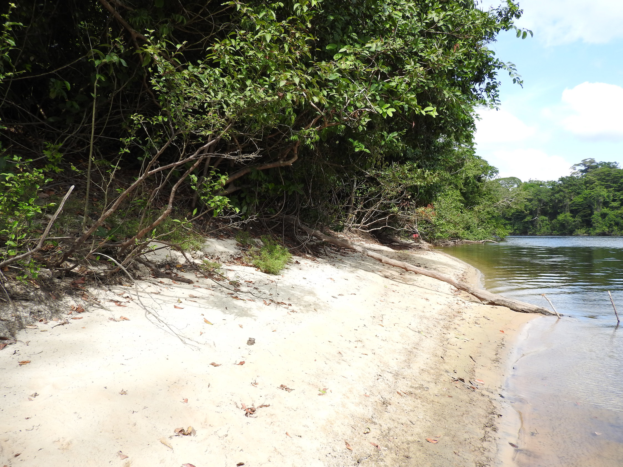 | B  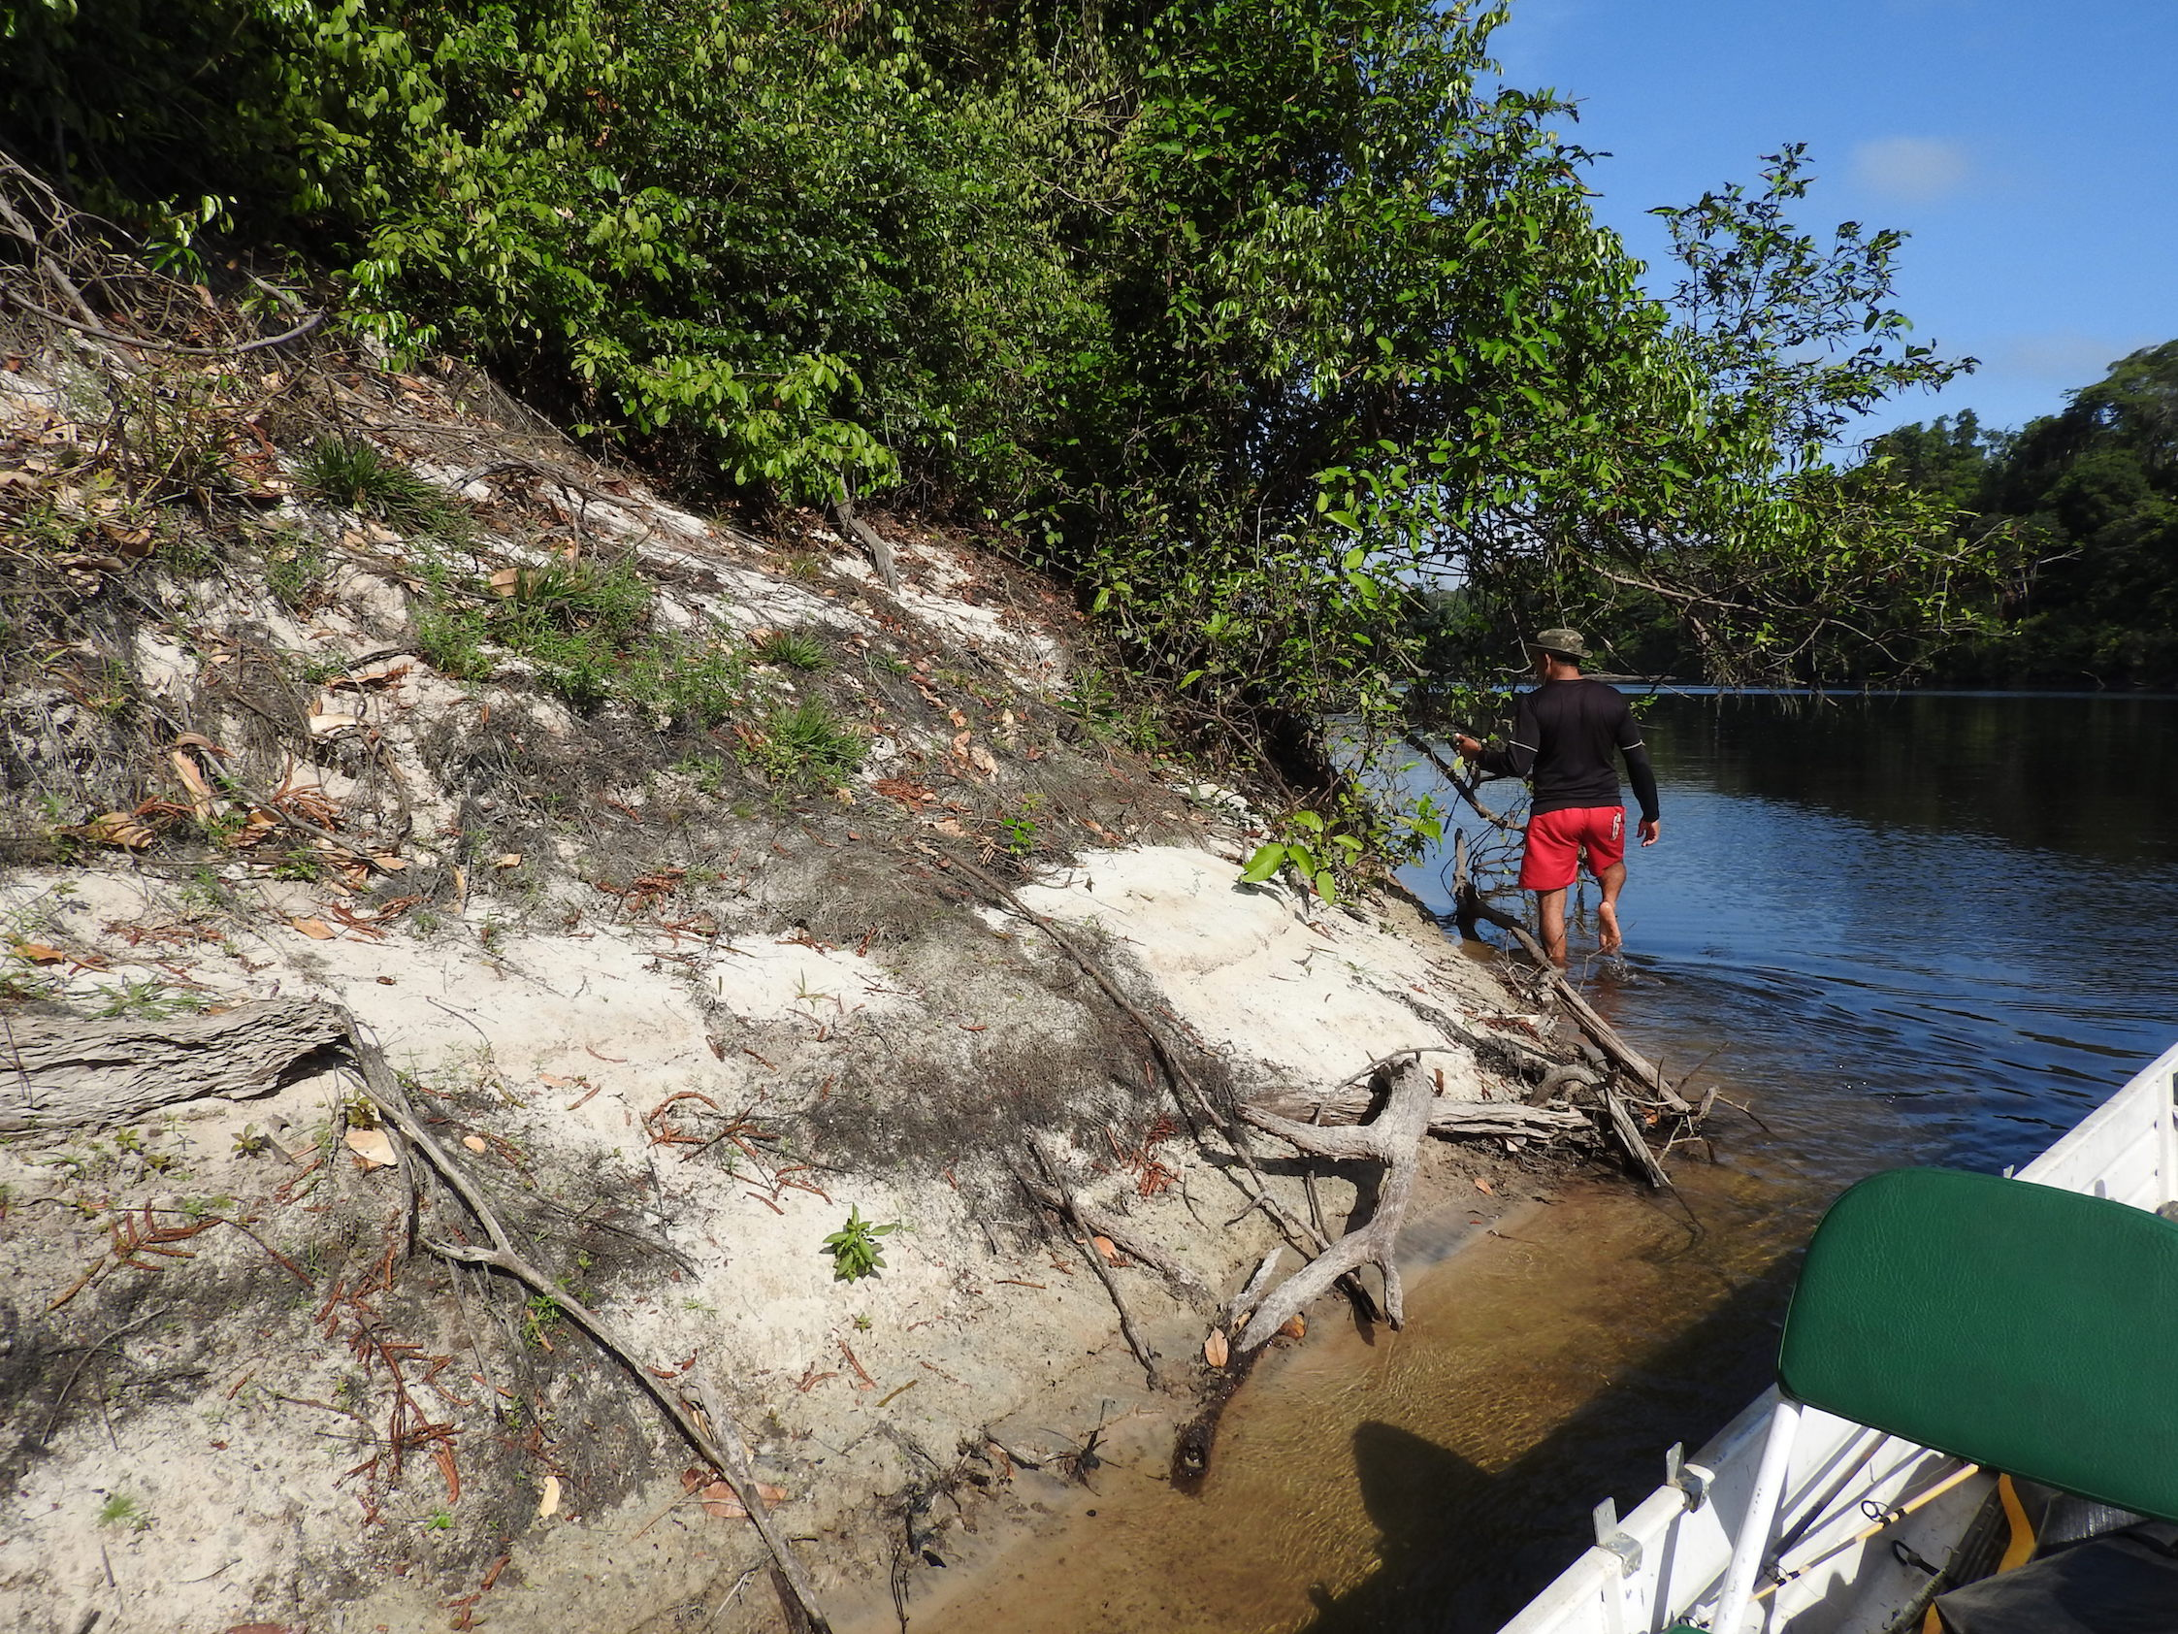
C  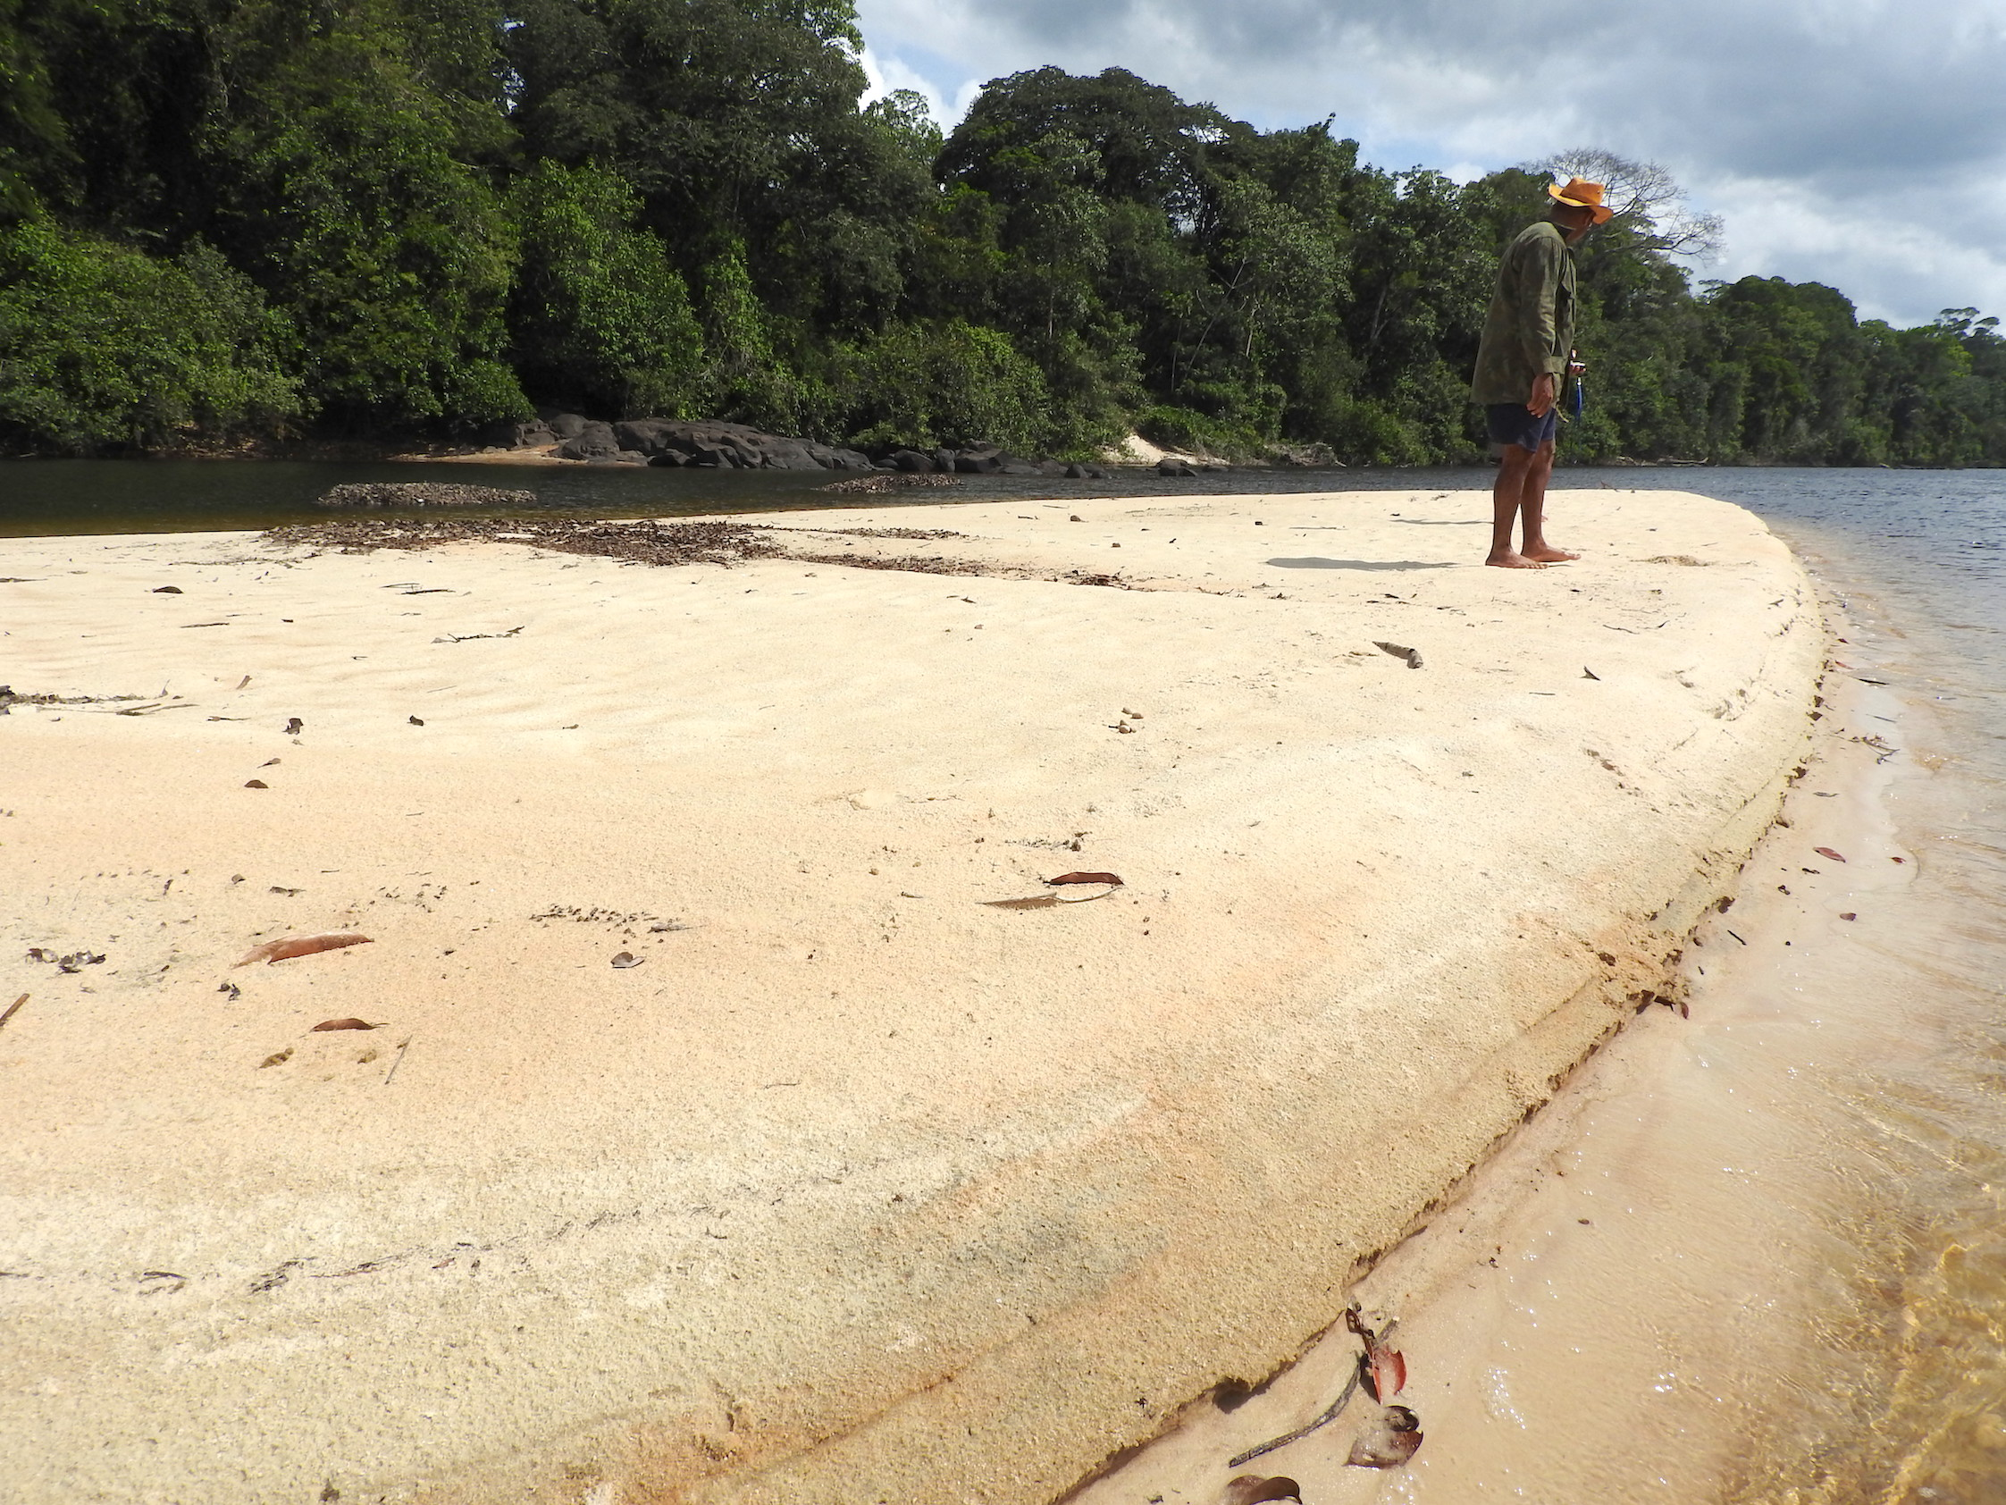 | D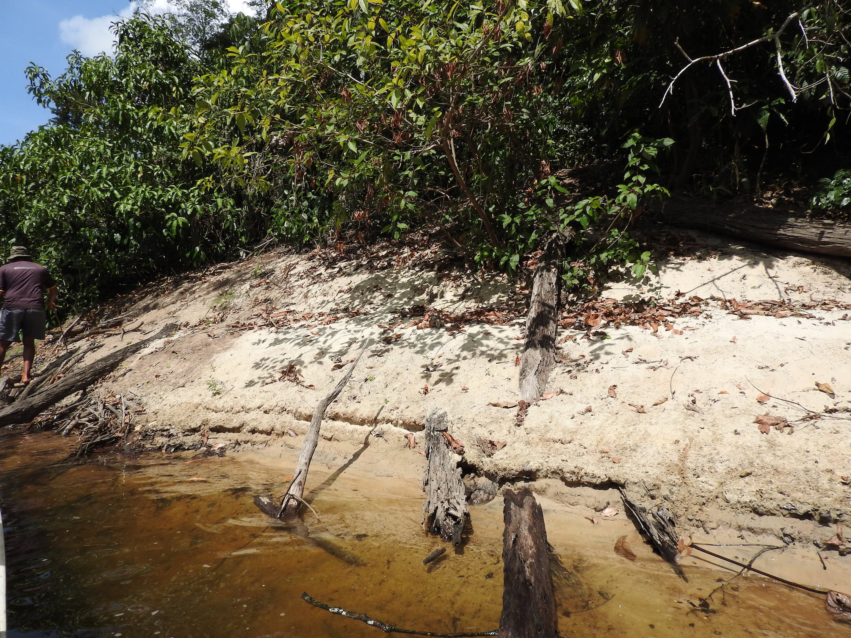
E  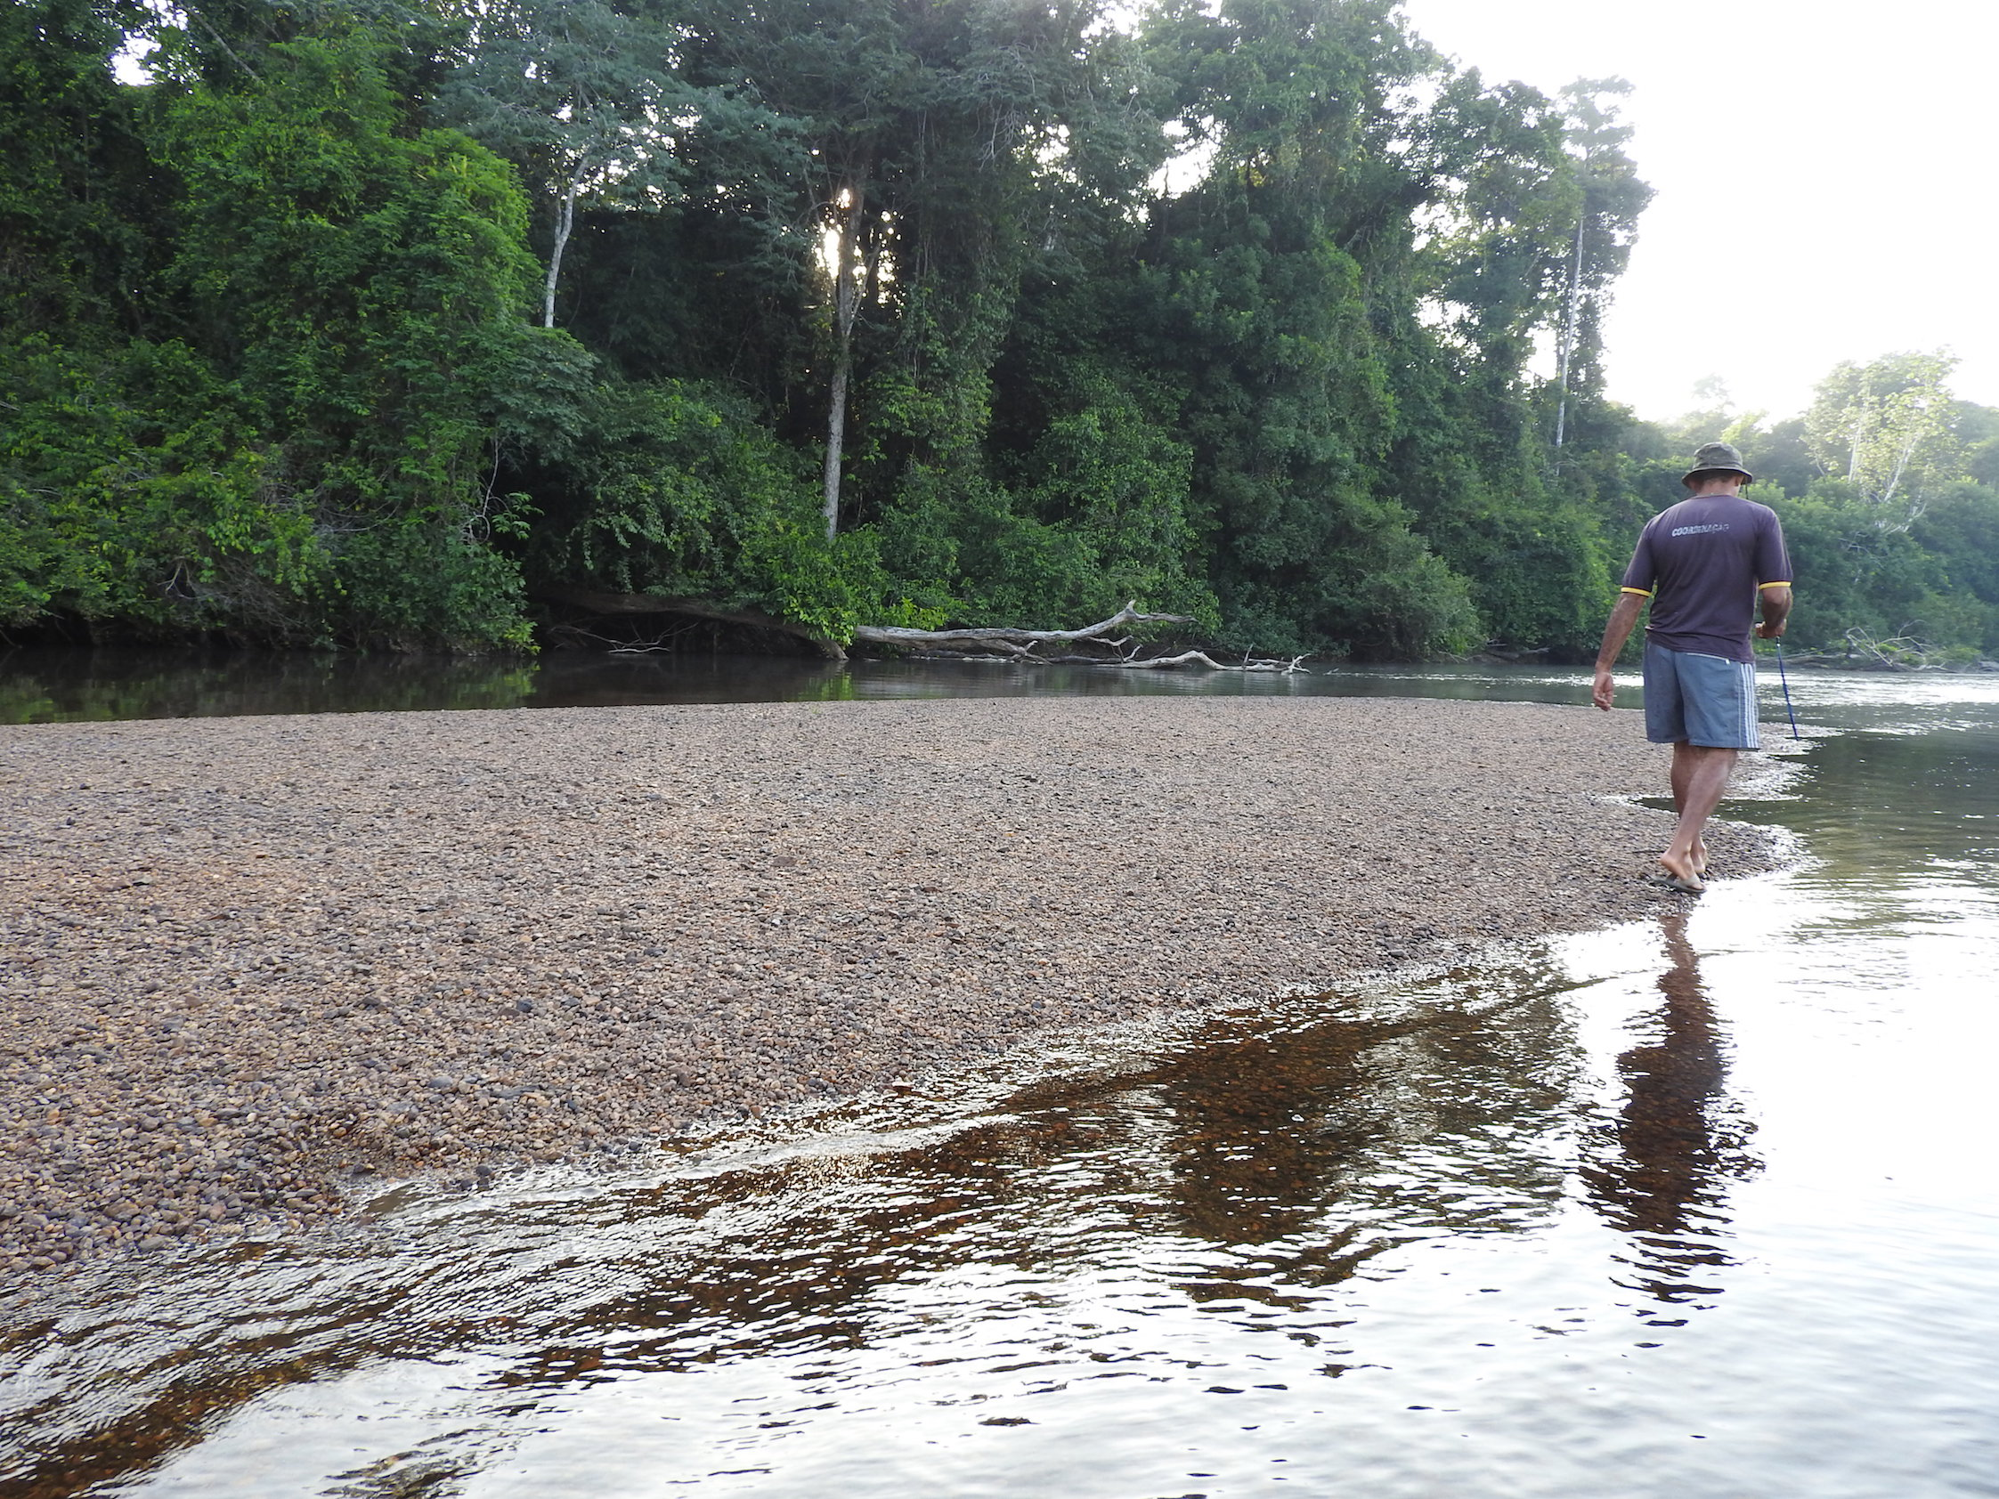 | F  