miRNA | has-miR-647 | has miR-135b | has-miR-1229
Transcript position | 407-423 | 352-374 | 207-226
Position on chromosome | 2:97427022-97427039 | 2:97426967-97426990 | 2:97423252-97423272
Conserved species | panTro2 | panTro2 | panTro2, rheMac2, danRer6
Binding area | 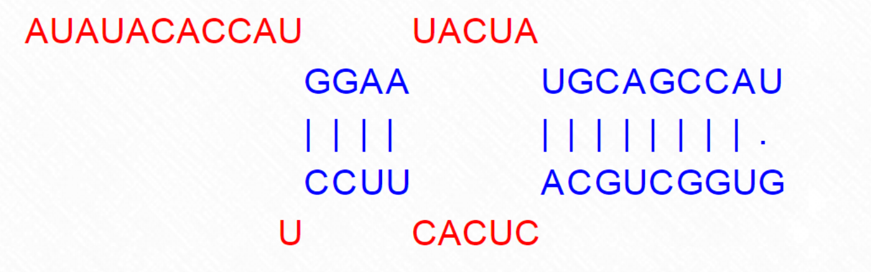 | 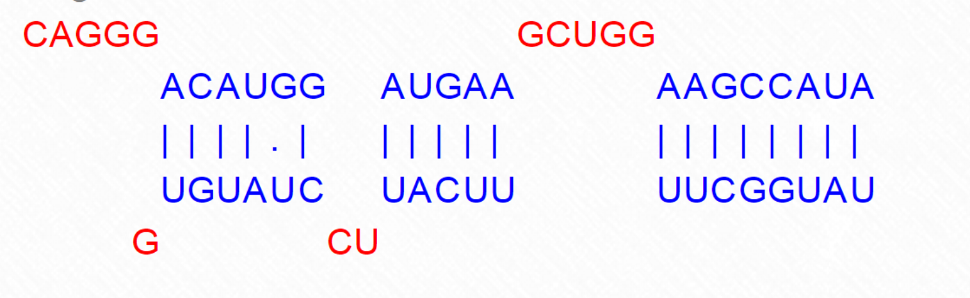 | 