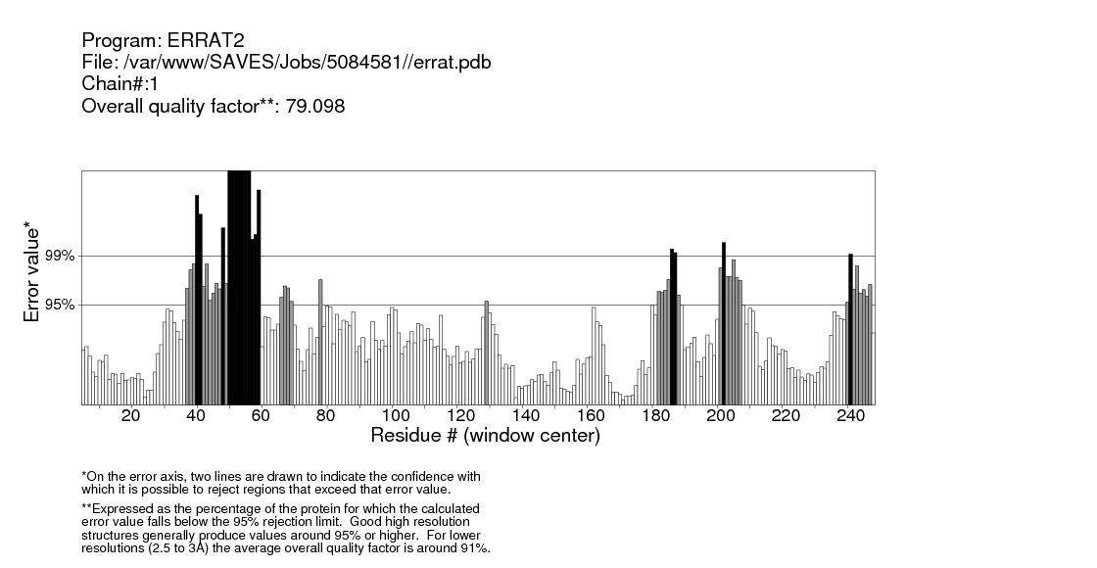
Raw data: Quality verification plot of the energy minimized model (AMX8-em1) of the ∆9-fatty acid desaturase performed using ERRAT. The two lines drawn on the error axis show the confidence with which it is possible to reject regions that exceed that error value. Good high resolution structures generally produce values around 95% or higher whereas lower resolution (2.5- -3Å) have an average overall quality factor around 91%.
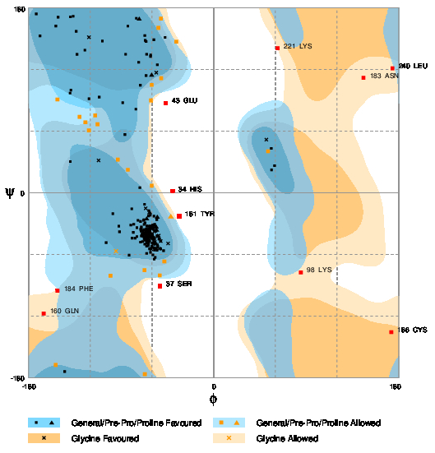

Evaluation of residues
Residue [ 7 :LEU] ( -83.39, 22.36) in Allowed region
Residue [ 8 :ASP] (-130.40, 73.84) in Allowed region
Residue [ 10 :SER] ( -60.98, 89.94) in Allowed region
Residue [ 33 :LEU] ( -60.24, 6.87) in Allowed region
Residue [ 35 :ARG] (-100.35, -80.71) in Allowed region
Residue [ 36 :TYR] ( -67.23, -75.26) in Allowed region
Residue [ 63 :ALA] ( 52.96, 40.36) in Allowed region
Residue [ 65 :ARG] ( -53.75, 160.46) in Allowed region
Residue [ 66 :GLU] ( -51.21, 169.54) in Allowed region
Residue [ 80 :THR] (-124.74, 68.56) in Allowed region
Residue [ 82 :ASP] (-121.27, 60.66) in Allowed region
Residue [ 88 :VAL] (-112.91, 66.69) in Allowed region
Residue [ 92 :LEU] ( -66.86,-176.49) in Allowed region
Residue [ 99 :GLY] ( -95.01, -56.74) in Allowed region
Residue [ 103 :TYR] (-115.19, 75.28) in Allowed region
Residue [ 118 :LYS] ( -47.91, -66.78) in Allowed region
Residue [ 134 :PRO] ( -41.61, -22.73) in Allowed region
Residue [ 185 :GLU] (-151.87, 90.80) in Allowed region
Residue [ 199 :ILE] ( -93.22, 32.25) in Allowed region
Residue [ 200 :VAL] ( -52.42, -80.38) in Allowed region
Residue [ 220 :VAL] ( -51.03, 111.52) in Allowed region
Residue [ 224 :GLU] ( -60.17, 104.96) in Allowed region
Residue [ 239 :ARG] (-153.64,-167.47) in Allowed region
Residue [ 247 :ALA] ( -36.30, 146.98) in Allowed region
Residue [ 34 :HIS] ( -39.91, 1.52) in Outlier region
Residue [ 37 :SER] ( -52.05, -90.69) in Outlier region
Residue [ 43 :GLU] ( -46.42, 87.37) in Outlier region
Residue [ 98 :LYS] ( 84.92, -77.47) in Outlier region
Residue [ 160 :GLN] (-165.27,-117.55) in Outlier region
Residue [ 181 :TYR] ( -33.51, -22.81) in Outlier region
Residue [ 183 :ASN] ( 145.83, 111.91) in Outlier region
Residue [ 184 :PHE] (-151.84, -95.34) in Outlier region
Residue [ 186 :CYS] ( 172.89,-135.57) in Outlier region
Residue [ 221 :LYS] ( 62.40, 140.72) in Outlier region
Residue [ 240 :LEU] ( 174.01, 121.09) in Outlier region
Number of residues in favoured region (~98.0% expected) : 214 ( 85.9%)
Number of residues in allowed region ( ~2.0% expected) : 24 ( 9.6%)
Number of residues in outlier region : 11 ( 4.4%)

Raw data: Ramachandran plot of Pseudomonas sp. AMS8 ∆9-fatty acid desaturase model (AMX8-em1) generated by RAMPAGE server.

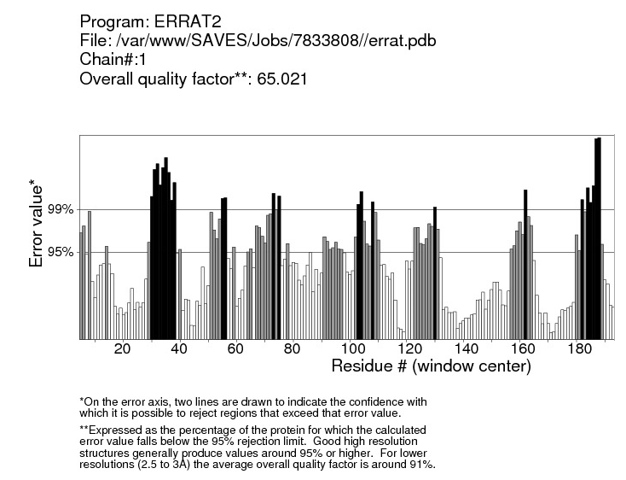
Raw data: Quality verification plot of the energy minimized model (AMX8-em2) of the ∆9-fatty acid desaturase performed using ERRAT. The two lines drawn on the error axis show the confidence with which it is possible to reject regions that exceed that error value. Good high resolution structures generally produce values around 95% or higher whereas lower resolution (2.5- -3Å) have an average overall quality factor around 91%.
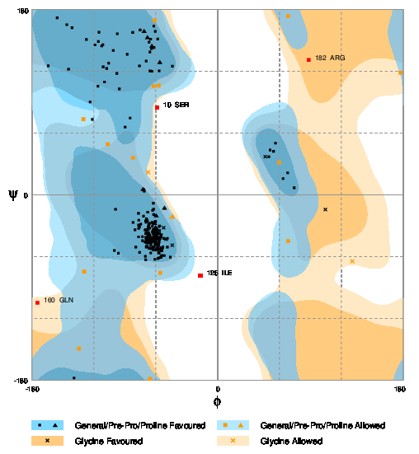

Evaluation of residues
Residue [ 47 :GLY] ( 130.71, -64.45) in Allowed region
Residue [ 63 :ALA] ( 59.76, 31.53) in Allowed region
Residue [ 65 :ARG] ( -65.54,-178.63) in Allowed region
Residue [ 77 :LYS] (-130.07, 73.54) in Allowed region
Residue [ 85 :THR] (-106.51, 49.19) in Allowed region
Residue [ 86 :VAL] ( -57.04, 106.09) in Allowed region
Residue [ 90 :LYS] ( 68.44, 173.56) in Allowed region
Residue [ 95 :TYR] ( 68.46, -44.82) in Allowed region
Residue [ 103 :TYR] (-134.41,-149.25) in Allowed region
Residue [ 134 :PRO] ( -43.91, -20.77) in Allowed region
Residue [ 162 :MET] ( -55.58, -75.71) in Allowed region
Residue [ 180 :GLY] ( -67.37, 21.94) in Allowed region
Residue [ 183 :ASN] ( 177.50, 118.62) in Allowed region
Residue [ 184 :PHE] (-129.31, -74.52) in Allowed region
Residue [ 190 :ALA] ( -61.10, 169.36) in Allowed region
Residue [ 205 :LEU] ( -81.92, 35.97) in Allowed region
Residue [ 224 :GLU] ( -62.01, 105.63) in Allowed region
Residue [ 10 :SER] ( -58.52, 84.81) in Outlier region
Residue [ 125 :ILE] ( -16.49, -78.37) in Outlier region
Residue [ 160 :GLN] (-174.67,-104.78) in Outlier region
Residue [ 182 :ARG] ( 88.42, 131.00) in Outlier region
Number of residues in favoured region (~98.0% expected) : 228 ( 91.6%)
Number of residues in allowed region ( ~2.0% expected) : 17 ( 6.8%)
Number of residues in outlier region : 4 ( 1.6%)

Raw data: Ramachandran plot of Pseudomonas sp. AMS8 ∆9-fatty acid desaturase model (AMX8-em2) generated by RAMPAGE server.

