Supplementary Material
a | Tukey multiple comparisons of means 95% family-wise confidence level  Fit: aov(formula = distances ~ group, data = df)  $group diff lwr upr p adj  CP-MA 0.10 -0.17 0.37 0.71  PO-MA 0.10 -0.17 0.37 0.67  SN-MA 0.12 -0.15 0.39 0.54  PO-CP 0.01 -0.26 0.27 1.00  SN-CP 0.03 -0.24 0.29 0.99  SN-PO 0.02 -0.25 0.29 1.00
b |  | $group diff lwr upr p adj  CP-MA 0.2 -0.1 0.5 0.28  PO-MA 0.2 -0.1 0.5 0.39  SN-MA -0 -0.3 0.3 1.00  PO-CP -0 -0.4 0.3 0.99  SN-CP -0.2 -0.6 0.1 0.26  SN-PO -0.2 -0.5 0.1 0.37
R-codes (abbreviated) provided by the vegan package (Oksanen et al. 2007, see bibliography in the main text)
disJ <- vegdist(Windows16 ,method="jaccard" and “morisita”)
groups <- "MA" "CP","PO","SN"
modJ <- betadisper(disJ, groups)
anova(modJ)
permutest(modJ, pairwise = TRUE, permutations = 999)
mod.HSD <- TukeyHSD(modJ)
Figure S1a&b. Permutation test for homogeneity of multivariate dispersion using Jaccard (a) and Morisita-Horn (b) Compositional Dissimilarity did not reveal significant differences between mountains. MA-La Malinche, CP – Cofre de Perote, PO – Pico de Orizaba, SN-Sierra Negra.

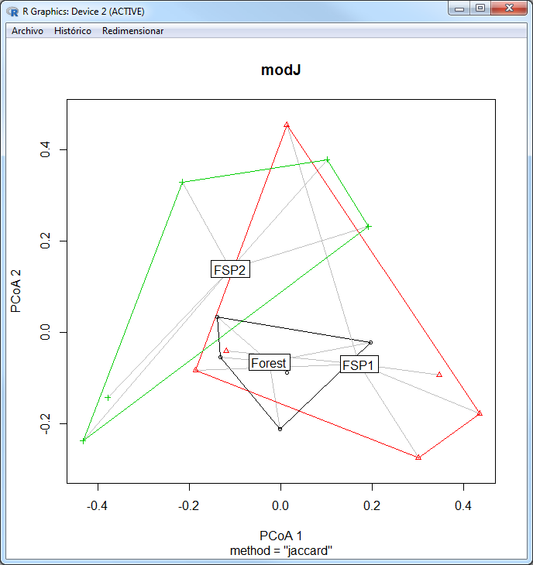  c | Tukey multiple comparisons of means 95% family-wise confidence level  Fit: aov(formula = distances ~ group, data = df)  $group diff lwr upr p adj  FSP1-Forest 0.06 -0.07 0.20 0.43  FSP2-Forest 0.07 -0.07 0.21 0.43  FSP2-FSP1 0.00 -0.13 0.14 1.00
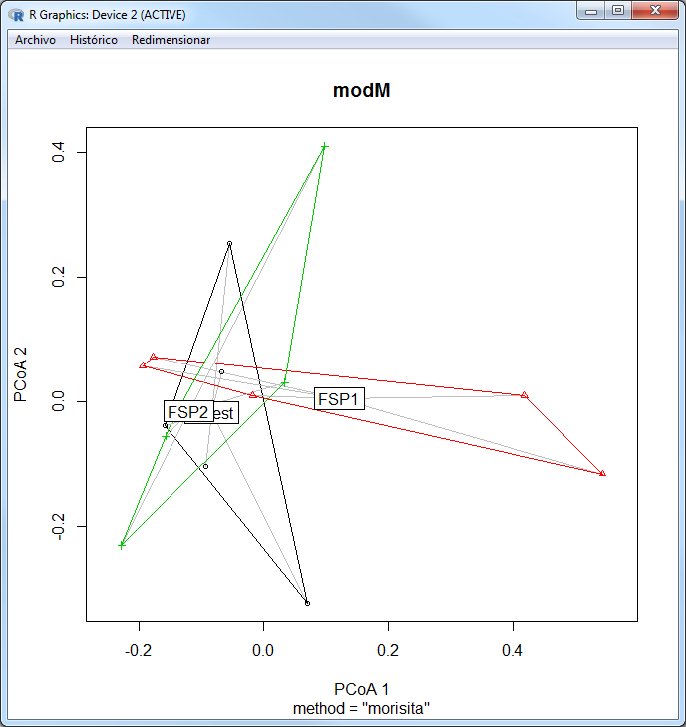  d |  | $group diff lwr upr p adj  FSP1-Forest 0.18 -0.09 0.45 0.22  FSP2-Forest 0.16 -0.12 0.44 0.33  FSP2-FSP1 -0.02 -0.29 0.25 0.98
R-codes (abbreviated) provided by the vegan package (Oksanen et al. 2007, see bibliography in the main text)
disJ <- vegdist(Windows16 ,method="jaccard" and “morisita”)
groups <- "Forest" "FSP1","FSP2"
modJ <- betadisper(disJ, groups)
anova(modJ)
permutest(modJ, pairwise = TRUE, permutations = 999)
mod.HSD <- TukeyHSD(modJ)
Figure S1c&d. Permutation test for homogeneity of multivariate dispersion using Jaccard (c) and Morisita-Horn (d) Compositional Dissimilarity did not reveal significant differences between FSP mosaic types. Forest: POWI, MAES, MAWS, CPEI, CPWS; FSP1: CPES, MAEI, MAWI, SNWS, POES; FSP2: POEI, CPWI, SNEI, SNES, SNWI, POWS. Forest – forest dominated sampling unit, FSP1 – Forest had a similar area as scrubland and pasture. FSP2 – forest was less abundant than scrubland and pasture. Classification was based on visual revision at each sampling site.
MA-La Malinche, CP – Cofre de Perote, PO – Pico de Orizaba, SN-Sierra Negra; W- western leeward side, E – eastern windward side, I- inferior elevation (2700 MASL), S – superior (3400 MASL).
a
b
Figure S2 a) Species taxonomic affiliation per mountain; S-Scarabaeinae; A- Aphodiinae; G- Geotrupinae; b) Dispersion patterns according to richness and abundance; NT- Neotropical, NA- Nearctic, MP- Montane Paleoamerican, MM- Meso-American Montane, HP- Mexican High Plateau. Mountains abbreviations: MA - Malinche, CP - Cofre de Perote, PO - Pico de Orizaba, SN - Sierra Negra

Table S1. Number of individuals per species per years at each volcano (sampling months at MA: June 2011, Aug 2012, July 2013; CP: Aug 2011, July 2012, June 2013; PO July 2011, June 2012, Aug 2013; SN: July 2011, June 2012, Aug 2013).
Species | MA11 | MA12 | MA13 | CP11 | CP12 | CP13 | PO11 | PO12 | PO13 | SN11 | SN12 | SN13
Agrilinellus azteca | 1 | 0 | 1 | 0 | 17 | 85 | 4 | 46 | 51 | 0 | 0 | 13
Agrilinellus ornatus | 0 | 0 | 22 | 4 | 2 | 0 | 1 | 3 | 44 | 0 | 0 | 43
Blackburneus charmionus | 0 | 0 | 0 | 0 | 0 | 0 | 0 | 0 | 1 | 0 | 0 | 0
Blackburneus guatemalensis | 1 | 0 | 0 | 0 | 0 | 0 | 2 | 32 | 0 | 0 | 0 | 0
Blackburneus saylorea | 0 | 0 | 0 | 0 | 0 | 0 | 0 | 0 | 2 | 0 | 0 | 0
Cephalocyclus hogei | 0 | 0 | 0 | 0 | 138 | 139 | 4 | 32 | 1 | 0 | 1 | 0
Ceratotrupes bolivari | 17 | 12 | 1 | 0 | 4 | 5 | 0 | 1 | 0 | 1 | 0 | 0
Copris armatus | 39 | 31 | 28 | 0 | 0 | 0 | 0 | 0 | 0 | 0 | 2 | 2
Gonaphodiellus bimaculosus | 0 | 0 | 0 | 0 | 0 | 0 | 4 | 9 | 3 | 0 | 0 | 0
Gonaphodiellus ophisthius | 0 | 0 | 13 | 0 | 0 | 2 | 1 | 11 | 90 | 0 | 0 | 0
Halffterius rufoclavatus | 0 | 0 | 0 | 0 | 9 | 15 | 0 | 0 | 4 | 0 | 0 | 0
Labarrus pseudolividus | 0 | 0 | 0 | 0 | 0 | 0 | 0 | 0 | 0 | 0 | 0 | 1
Neotrichonotulus inurbanus | 0 | 0 | 0 | 1 | 0 | 0 | 0 | 0 | 0 | 0 | 0 | 0
Onthophagus mexicanus | 2 | 4 | 5 | 0 | 0 | 0 | 0 | 0 | 0 | 0 | 0 | 0
Onthophagus aureofuscus | 0 | 0 | 0 | 89 | 25 | 0 | 13 | 0 | 0 | 0 | 0 | 0
Onthophagus bolivari n.sp. | 81 | 7 | 84 | 0 | 0 | 0 | 0 | 0 | 0 | 0 | 0 | 0
Onthophagus ch. chevrolati | 118 | 90 | 112 | 145 | 250 | 185 | 154 | 179 | 89 | 27 | 115 | 31
Onthophagus lecontei | 108 | 7 | 12 | 3 | 4 | 0 | 0 | 0 | 0 | 0 | 0 | 0
Onthotrupes herbeus | 12 | 3 | 4 | 4 | 6 | 1 | 226 | 42 | 26 | 1 | 0 | 1
Onthotrupes nebularum | 5 | 0 | 0 | 0 | 2 | 0 | 32 | 24 | 50 | 0 | 0 | 0
Onthotrupes sallei | 0 | 0 | 0 | 5 | 0 | 0 | 0 | 0 | 0 | 0 | 0 | 0
Oscarinus indutilis | 0 | 0 | 0 | 1 | 0 | 0 | 1 | 0 | 0 | 0 | 0 | 0
Oxyomussetosopunctatus | 0 | 0 | 0 | 0 | 0 | 0 | 0 | 9 | 7 | 0 | 0 | 0
Phanaeus amethystinus | 0 | 0 | 0 | 0 | 0 | 0 | 0 | 0 | 2 | 0 | 0 | 0
Phanaeus quadridens | 0 | 0 | 4 | 0 | 0 | 0 | 0 | 0 | 0 | 0 | 0 | 0
Planolinellus vittatus | 0 | 0 | 0 | 0 | 0 | 1 | 0 | 0 | 5 | 0 | 0 | 0
Trichonotuloides alfonsinae n. sp. | 0 | 0 | 0 | 0 | 0 | 0 | 0 | 6 | 0 | 0 | 2 | 0
Trichonotuloides feryi n. sp. | 0 | 0 | 0 | 0 | 1 | 0 | 0 | 0 | 0 | 0 | 0 | 0
Trichonotuloides glyptus | 0 | 0 | 0 | 4 | 8 | 0 | 0 | 0 | 0 | 0 | 0 | 0
Richness per year | 10 | 7 | 11 | 9 | 12 | 8 | 11 | 12 | 14 | 3 | 4 | 6
Abundance | 394 | 161 | 297 | 265 | 478 | 441 | 453 | 406 | 389 | 32 | 124 | 97

Table S2. Number of individuals sampled via direct collection inside gopher nests, species per years at the four volcanoes combined.
SPECIES | Y2011 | Y2012 | Y2013
Onthophagus hippopotamus Harold 1869 | 21 | 127 | 74
Geomyphilus barrerai (Islas 1955) | 0 | 67 | 52
Geomyphilus pierai (Lobo & Deloya 1995) | 2 | 89 | 28
Neotrichonotulus perotensis (Deloya & Lobo 1996) | 0 | 102 | 3
Richness | 3 | 4 | 4
Number of individuals | 23 | 385 | 157

Table S3 a and b. Temporal dynamics between pairs of mountains and years. Table a indicates values for Jaccard Similarity Index (⁰CS, mean = 0.3), and the last row indicates species richness at each mountain at each year.Table b shows: lower left values indicate Morisita-Horn compositional similarity (²CS) of the whole community (mean =0.62), upper right values show ²CS excluding the most abundant species (half of the total individuals) Onthophagus c. chevrolati from analysis (mean=0.16).
a  Jaccard | MA2011 | MA2012 | MA2013 | CP2011 | CP2012 | CP2013 | PO2011 | PO2012 | PO2013 | SN2011 | SN2012 | SN2013
MA2011
MA2012 | 0.700
MA2013 | 0.615 | 0.636
CP2011 | 0.188 | 0.231 | 0.250
CP2012 | 0.375 | 0.267 | 0.353 | 0.400
CP2013 | 0.286 | 0.250 | 0.357 | 0.133 | 0.429
PO2011 | 0.313 | 0.125 | 0.294 | 0.333 | 0.438 | 0.357
PO2012 | 0.375 | 0.188 | 0.353 | 0.167 | 0.412 | 0.429 | 0.643
PO2013 | 0.200 | 0.105 | 0.250 | 0.150 | 0.368 | 0.467 | 0.471 | 0.529
SN2011 | 0.300 | 0.429 | 0.273 | 0.200 | 0.250 | 0.375 | 0.167 | 0.250 | 0.133
SN2012 | 0.167 | 0.222 | 0.154 | 0.083 | 0.143 | 0.200 | 0.154 | 0.231 | 0.125 | 0.167
SN2013 | 0.333 | 0.300 | 0.417 | 0.250 | 0.286 | 0.273 | 0.308 | 0.286 | 0.250 | 0.286 | 0.250
Richness | 10 | 7 | 11 | 9 | 12 | 8 | 11 | 12 | 14 | 3 | 4 | 6

b  Morisita | MA2011 | MA2012 | MA2013 | CP2011 | CP2012 | CP2013 | PO2011 | PO2012 | PO2013 | SN2011 | SN2012 | SN2013
MA2011 | 1 | 0.558 | 0.699 | 0.027 | 0.029 | 0.008 | 0.082 | 0.058 | 0.034 | 0.139 | 0.182 | 0.015
MA2012 | 0.725 | 1 | 0.485 | 0.010 | 0.019 | 0.011 | 0.079 | 0.045 | 0.017 | 0.293 | 0.587 | 0.039
MA2013 | 0.834 | 0.811 | 1 | 0.015 | 0.010 | 0.008 | 0.041 | 0.052 | 0.191 | 0.037 | 0.199 | 0.230
CP2011 | 0.527 | 0.794 | 0.637 | 1 | 0.177 | 0.000 | 0.101 | 0.019 | 0.021 | 0.031 | 0.000 | 0.044
CP2012 | 0.549 | 0.813 | 0.659 | 0.785 | 1 | 0.894 | 0.072 | 0.409 | 0.071 | 0.050 | 0.322 | 0.049
CP2013 | 0.475 | 0.697 | 0.575 | 0.630 | 0.941 | 1 | 0.030 | 0.542 | 0.212 | 0.026 | 0.282 | 0.149
PO2011 | 0.400 | 0.546 | 0.444 | 0.518 | 0.515 | 0.433 | 1 | 0.443 | 0.230 | 0.694 | 0.006 | 0.031
PO2012 | 0.599 | 0.832 | 0.712 | 0.747 | 0.867 | 0.846 | 0.687 | 1 | 0.559 | 0.309 | 0.161 | 0.168
PO2013 | 0.385 | 0.498 | 0.533 | 0.448 | 0.492 | 0.528 | 0.465 | 0.703 | 1 | 0.131 | 0.003 | 0.397
SN2011 | 0.525 | 0.867 | 0.647 | 0.805 | 0.800 | 0.667 | 0.544 | 0.762 | 0.430 | 1 | 0.000 | 0.016
SN2012 | 0.515 | 0.859 | 0.640 | 0.797 | 0.795 | 0.662 | 0.511 | 0.746 | 0.418 | 0.998 | 1 | 0.029
SN2013 | 0.364 | 0.541 | 0.557 | 0.499 | 0.513 | 0.506 | 0.338 | 0.577 | 0.590 | 0.516 | 0.511 | 1

