The row data of the study:
Table S1 Toxicity of TS solution in 3rd-instar Ectropis obliqua larvae
Concentration of TS (mg/mL) | Total number of E. obliqua  larvae | Mortality of E. obliqua  larvae
300 | 30 | 22
 | 30 | 20
 | 30 | 18
150 | 30 | 13
 | 30 | 15
 | 30 | 11
75 | 30 | 10
 | 30 | 8
 | 30 | 9
37.5 | 30 | 8
 | 30 | 9
 | 30 | 8
18.5 | 30 | 5
 | 30 | 3
 | 30 | 4
0 | 30 | 0
 | 30 | 1
 | 30 | 0

Table S2 Toxicity of TS solution in Ebrechtella tricuspidata adults after 48 h of treatment using different reagents
Treatment | Concentration  (mg/mL) | Total number of  E. tricuspidata | Mortality of  E. tricuspidata
10% Bi EC | 0.01 | 20 | 14
 |  | 20 | 16
 |  | 20 | 18
50% Di SC | 1.2 | 20 | 8
 |  | 20 | 8
 |  | 20 | 10
TS | 300 | 20 | 2
 |  | 20 | 4
 |  | 20 | 4
Control |  | 20 | 0
 |  | 20 | 0
 |  | 20 | 0

Table S3 Toxicity of TS solution in Evarcha albaria adults after 48 h of treatment using different reagents
Treatment | Concentration  (mg/mL) | Total number of  E. albaria | Mortality of  E. albaria
10% Bi EC | 0.01 | 20 | 14
 |  | 20 | 16
 |  | 20 | 14
50% Di SC | 1.2 | 20 | 6
 |  | 20 | 6
 |  | 20 | 10
TS | 300 | 20 | 2
 |  | 20 | 4
 |  | 20 | 6
Control |  | 20 | 0
 |  | 20 | 0
 |  | 20 | 0

Table S4 The controlling efficacy of 30%TS (w/v) and chemical insecticides against the Ectropis obliqua larvae
Treatment | Dose  (g a.i. ha-1) | Pre-treatment count | Post-treatment count
 |  |  | 1 d | 3 d | 5 d | 7 d
10% Bi EC | 7.5 | 12 | 2 | 1 | 3 | 5
 |  | 10 | 2 | 2 | 4 | 4
 |  | 10 | 1 | 1 | 4 | 5
50% Di SC | 45 | 11 | 7 | 2 | 5 | 4
 |  | 14 | 7 | 1 | 4 | 4
 |  | 10 | 6 | 2 | 5 | 6
30% TS WG | 362.5 | 10 | 8 | 4 | 2 | 4
 |  | 15 | 12 | 6 | 3 | 5
 |  | 12 | 10 | 7 | 4 | 4
CK |  | 10 | 9 | 9 | 11 | 8
 |  | 10 | 10 | 9 | 10 | 9
 |  | 12 | 12 | 11 | 13 | 11

Table S5 The number and identification (families) of collected spiders in different treatment plots
Spider  families | Treatment
 | 10% Bi EC |  | 50% Di SC |  | 30% TS WG |  | CK
 | Pre-C | Post-C | Pre-C | Post-C | Pre-C | Post-C | Pre-C | Post-C
Salticidae | 2 | 1 | 2 | 0 | 1 | 1 | 2 | 1
 | 1 | 0 | 1 | 0 | 2 | 2 | 1 | 2
 | 2 | 0 | 1 | 0 | 0 | 1 | 2 | 1
Thomisidae | 1 | 0 | 2 | 0 | 2 | 1 | 0 | 1
 | 2 | 1 | 1 | 0 | 1 | 0 | 3 | 0
 | 1 | 1 | 2 | 0 | 1 | 1 | 1 | 2
Theridiidae | 1 | 1 | 0 | 1 | 0 | 1 | 1 | 1
 | 2 | 0 | 1 | 0 | 1 | 1 | 1 | 1
 | 1 | 0 | 1 | 1 | 1 | 1 | 2 | 2
Araneidae | 0 | 0 | 0 | 0 | 1 | 0 | 0 | 0
 | 1 | 1 | 1 | 0 | 0 | 1 | 0 | 0
 | 0 | 0 | 1 | 0 | 1 | 0 | 0 | 0
Linyphiidae | 0 | 0 | 1 | 1 | 0 | 1 | 1 | 1
 | 0 | 0 | 0 | 1 | 2 | 1 | 0 | 2
 | 0 | 1 | 0 | 1 | 1 | 0 | 1 | 1
Agelenidae | 0 | 0 | 0 | 0 | 1 | 0 | 0 | 0
 | 0 | 0 | 1 | 0 | 0 | 0 | 0 | 0
 | 1 | 0 | 0 | 0 | 0 | 1 | 0 | 0
Tetragnathidae | 0 | 0 | 0 | 0 | 1 | 0 | 1 | 0
 | 0 | 0 | 0 | 0 | 0 | 0 | 0 | 1
 | 0 | 0 | 0 | 0 | 0 | 1 | 0 | 0
Gnaphosidae | 1 | 1 | 0 | 0 | 0 | 0 | 0 | 0
 | 0 | 1 | 0 | 0 | 0 | 0 | 1 | 0
 | 0 | 0 | 0 | 0 | 0 | 0 | 0 | 0
Oxypidae | 1 | 0 | 0 | 0 | 0 | 0 | 0 | 1
 | 0 | 0 | 0 | 0 | 1 | 0 | 0 | 1
 | 1 | 0 | 1 | 0 | 0 | 0 | 0 | 1
Clubionidae | 0 | 0 | 0 | 0 | 0 | 0 | 0 | 0
 | 1 | 0 | 0 | 0 | 0 | 0 | 0 | 0
 | 0 | 0 | 1 | 0 | 0 | 0 | 1 | 0
Pre-C, Pre-treatment count; Post-C, Post-treatment count (7 d).
Spiders were identified from the reference keys and catalogues provided by Yin et al. (2012) and the World Spider Catalog.
Table S6 The effects of 30% (w/v) TS on GST activity in 3rd-instar Ectropis obliqua larvae at different times
Treatment | The activities of GST at different times (U/mg)
 | 6 | 12 | 24 | 48 | 96
TS | 0.8042 | 0.8815 | 0.7759 | 0.4656 | 0.3615
 | 0.7965 | 0.8479 | 0.7591 | 0.4199 | 0.3144
 | 0.8137 | 0.8831 | 0.7867 | 0.4597 | 0.3395
 | 0.7828 | 0.8471 | 0.7559 | 0.4472 | 0.3378
CK | 0.4597 | 0.4663 | 0.4739 | 0.4818 | 0.4557
 | 0.4779 | 0.4487 | 0.4493 | 0.4604 | 0.4718
 | 0.4882 | 0.4701 | 0.4902 | 0.5003 | 0.4669
 | 0.5118 | 0.4529 | 0.4570 | 0.4733 | 0.4580

Table S7 The effects of 30% TS (w/v) on CES activity in 3rd-instar Ectropis obliqua larvae at different times
Treatment | The activities of CES at different times (U/mg)
 | 6 | 12 | 24 | 48 | 96
TS | 0.0597 | 0.0569 | 0.0499 | 0.0502 | 0.0502
 | 0.0605 | 0.0531 | 0.0522 | 0.0511 | 0.0466
 | 0.0629 | 0.0577 | 0.0485 | 0.0479 | 0.0449
 | 0.0702 | 0.0555 | 0.0522 | 0.0488 | 0.0479
CK | 0.0799 | 0.0769 | 0.0807 | 0.0792 | 0.0647
 | 0.0817 | 0.0807 | 0.0819 | 0.0777 | 0.0599
 | 0.0788 | 0.0794 | 0.0843 | 0.0758 | 0.0616
 | 0.08 | 0.075 | 0.0827 | 0.0765 | 0.0638

Table S8 The effects of 30% TS (w/v) on AChE activity in 3rd-instar Ectropis obliqua larvae at different times
Treatment | The activities of AChE at different times (U/mg)
 | 6 | 12 | 24 | 48 | 96
TS | 0.0633 | 0.0661 | 0.0579 | 0.0594 | 0.0589
 | 0.0609 | 0.0639 | 0.0586 | 0.0538 | 0.0593
 | 0.0641 | 0.0647 | 0.0607 | 0.0587 | 0.0611
 | 0.0629 | 0.0681 | 0.0628 | 0.0585 | 0.0615
CK | 0.0825 | 0.1102 | 0.0855 | 0.0733 | 0.0713
 | 0.0817 | 0.1134 | 0.0861 | 0.0729 | 0.0685
 | 0.0778 | 0.0886 | 0.0810 | 0.0688 | 0.0702
 | 0.0816 | 0.0938 | 0.0842 | 0.0706 | 0.0688

Table S9 The effects of 30% TS (w/v) on POD activity in 3rd-instar Ectropis obliqua larvae at different times
Treatment | The activities of POD at different times (U/mg)
 | 6 | 12 | 24 | 48 | 96
TS | 9.2873 | 9.4582 | 9.5102 | 10.0082 | 9.5587
 | 9.0105 | 9.0973 | 9.4928 | 10.1217 | 9.7206
 | 8.9976 | 9.4435 | 9.3997 | 9.9965 | 9.6964
 | 9.1490 | 9.5974 | 9.4909 | 9.9720 | 9.7031
CK | 7.7792 | 7.7565 | 9.9233 | 10.3167 | 9.5164
 | 7.6933 | 8.2074 | 9.8024 | 9.9906 | 9.3815
 | 7.4899 | 7.9931 | 9.9215 | 9.8452 | 9.4907
 | 7.6104 | 7.7334 | 9.760 | 9.7619 | 9.4674

Fig. S1 The photograph of Wang Dazhen tea plantation
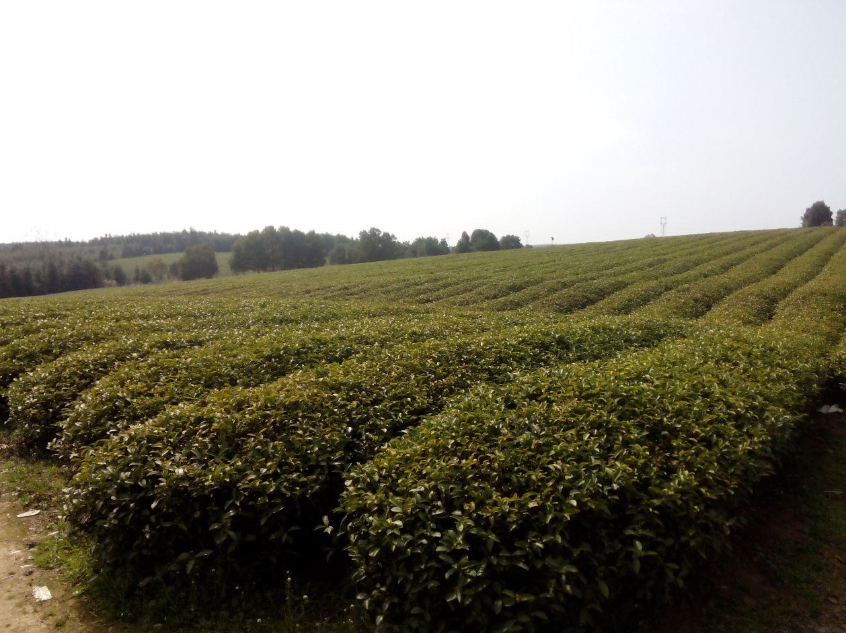
The total area of the collection site is about 6.5 ha with parallel rows of tea plants about 100 m long and 1 m apart. Each tea bush is 80 cm length × 80 cm width (Photograph credit: Chi Zeng).

Supplementary references
World Spider Catalog, Natural History Museum Bern. Available at http://wsc.nmbe.ch/ (accessed on 5 February 2018).
Yin CM, Peng XJ, Yan HM, Bao YH, Xu X, Tang G. 2012. Fauna Hunan: Araneae in Hunan, China. Changsha: Hunan Science and Technology Press.

