Supplementary Figure 4. Boxplot of the misclassification error rate based on cross-validation in comparison with that based on external validation when using the PAM method (left column) or the LASSO method (right column) for building a classifier. The simulated training data possess confounding handling effects. The test data were frozen normalized to the training data using the matched normalization method.
X-axis indicates the normalization method for the training data; y-axis indicates the misclassification error rate as a percentage. The three panels display the misclassification error when handling effects in the simulated training data were not amplified (A), amplified by location shift (B), and amplified by scale change (C).
A.
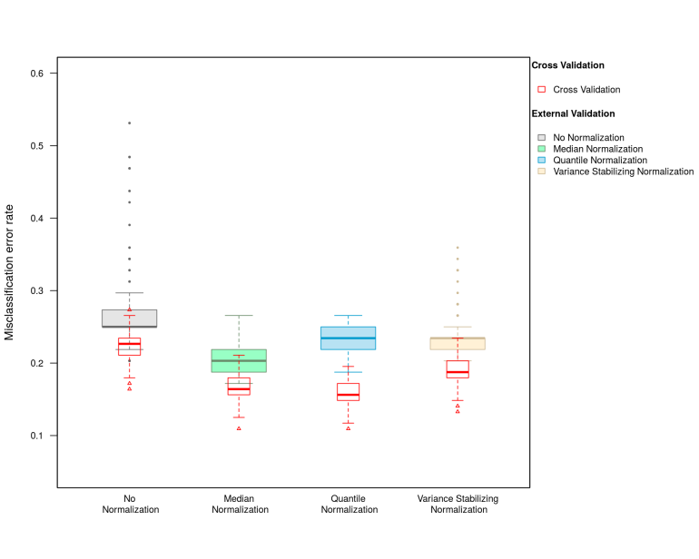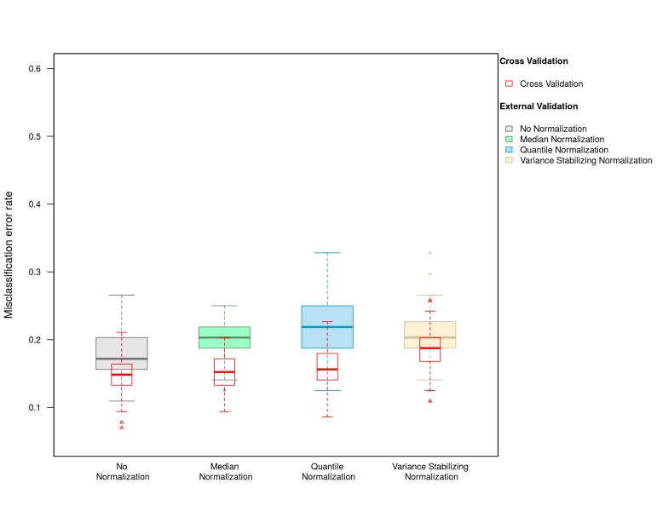
B.
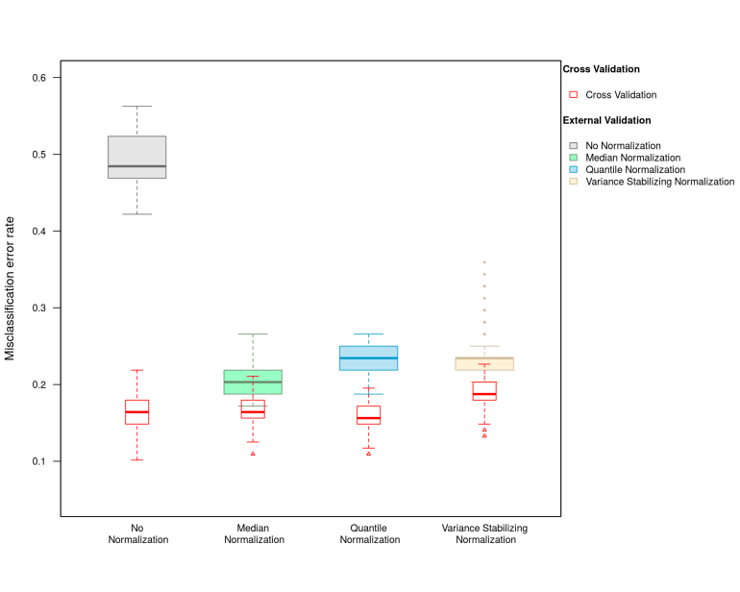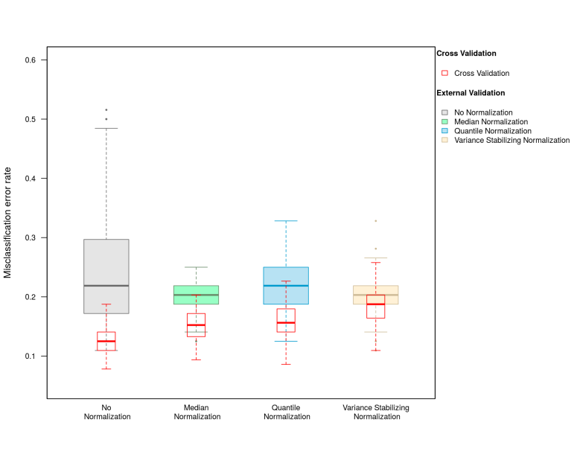

C.
