Supporting information
Table S1. Percentage of records obtained from fieldwork and online databases.
% | T. cyrtopsis | T. eques | T. melanogaster | T. scalaris | T. scaliger
GBIF | 13.44 | 15.79 | 9.56 | 5.83 | 5.82
iNaturalist | 26.56 | 16.10 | 23.48 | 12.62 | 22.09
Fieldwork | 60 | 68.11 | 66.96 | 81.55 | 72.09

Figure S1. Graphics of the most important variables for each Thamnophis species: (A) T. cyrtopsis, (B) T. eques, (C) T. melanogaster, (D) T. scalaris and (E) T. scaliger.
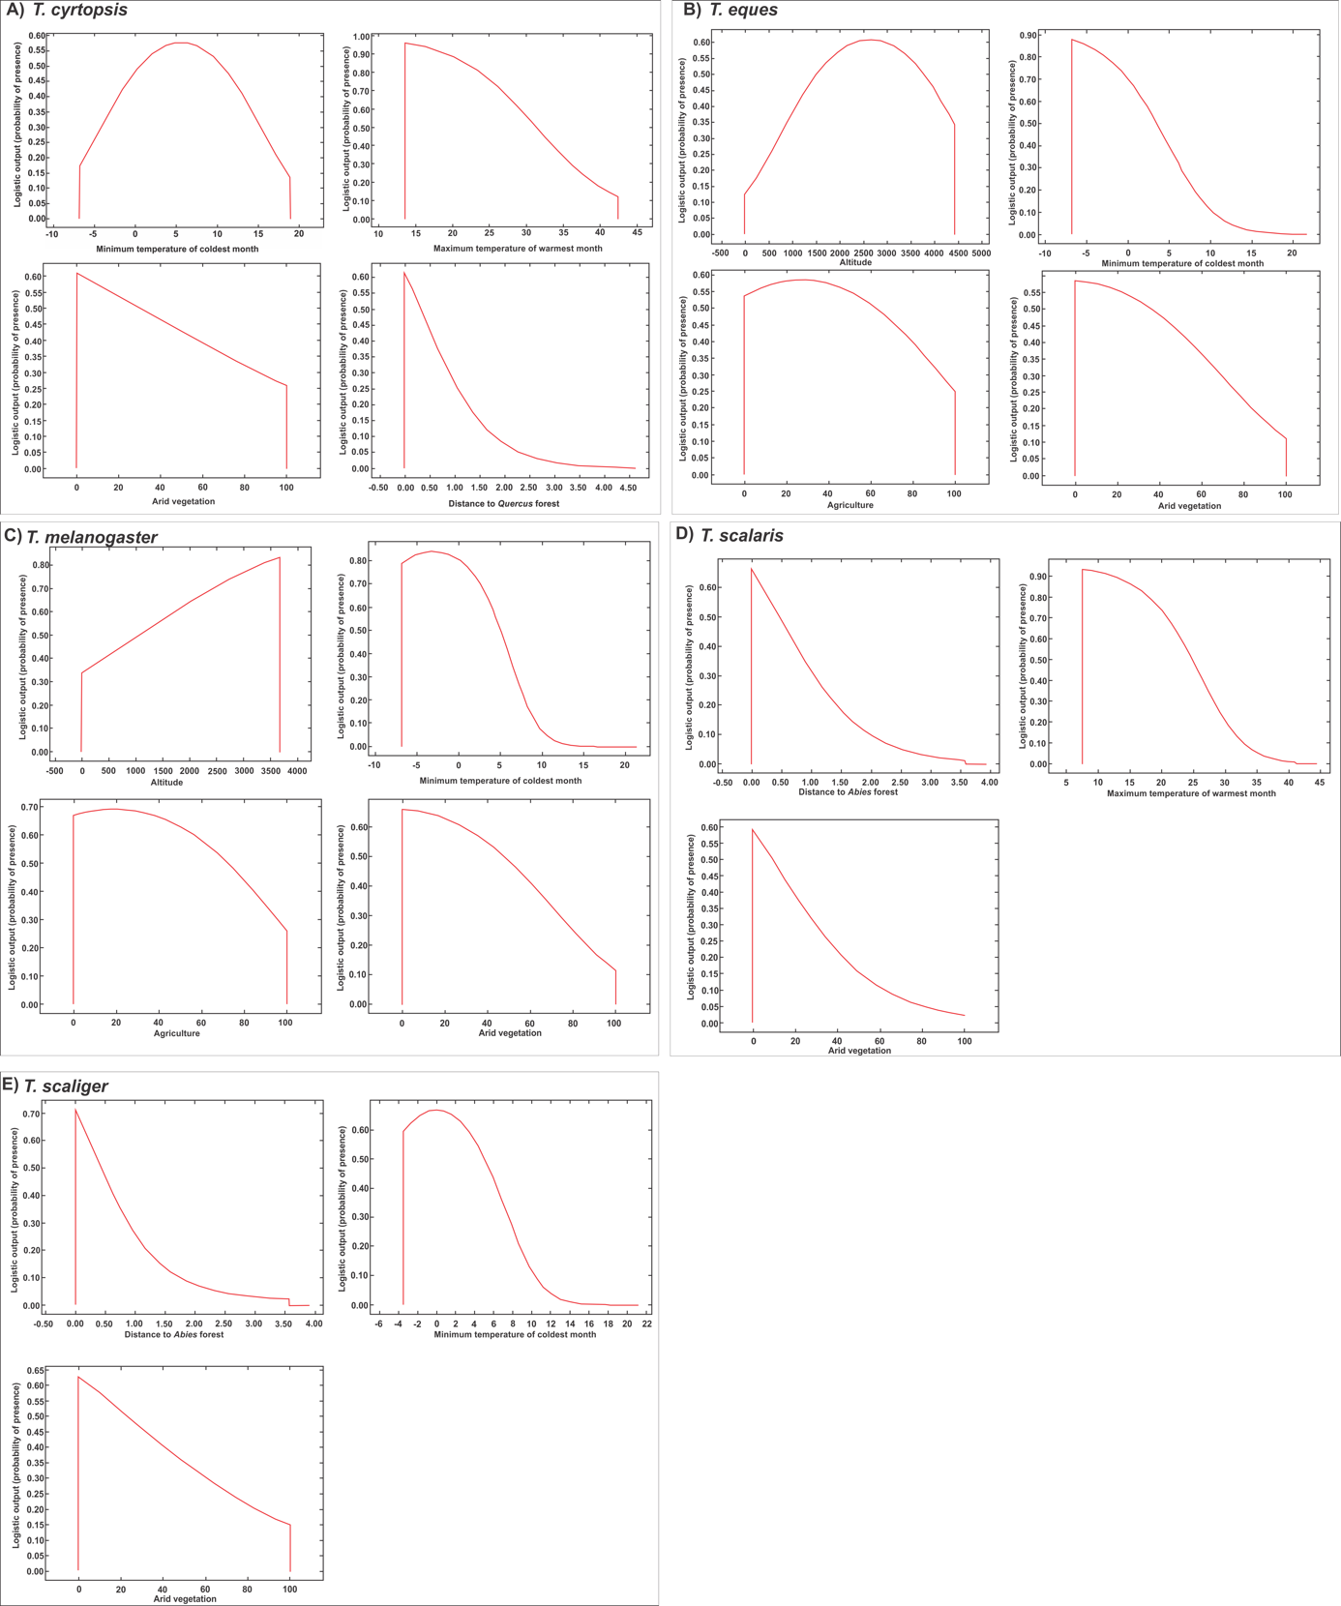

Figure S2. Partial-ROC values and graphics; null model (red distribution), distribution of expectations created via bootstrapping replacement of 50% of the total available points and 1,000 resampling replicates (blue distribution).
T. cyrtopsis
Mean AUC ratio after 1000 simulations: 1.49695
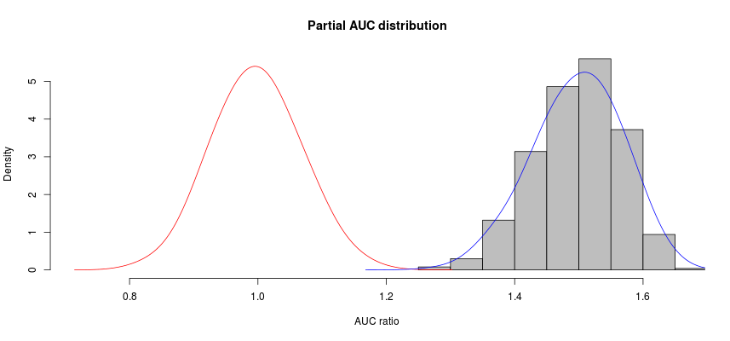

T. eques
Mean AUC ratio after 1000 simulations: 1.682837
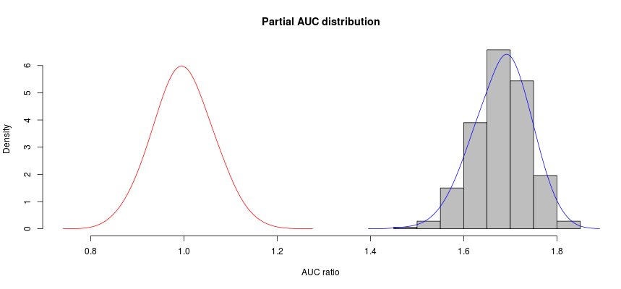

T. melanogaster
Mean AUC ratio after 1000 simulations: 1.758803
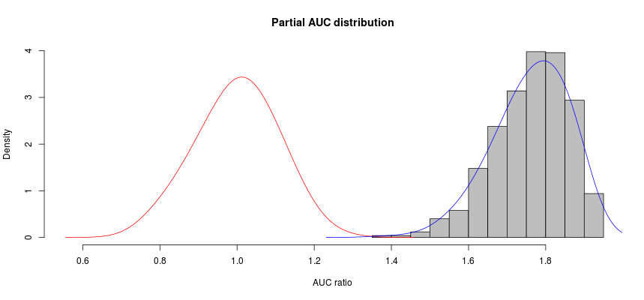

T. scalaris
Mean AUC ratio after 1000 simulations: 1.846627
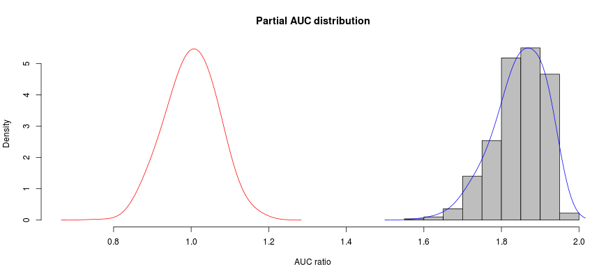

T. scaliger
Mean AUC ratio after 1000 simulations: 1.875488
