Table 1. Details of the 28 anatomical reflective markers used to determine the position and orientation of the body segments during walking trials.
# | Label | Name | Description
1 | R.ASIS | Right Anterior Superior Iliac Spine | Right anterior superior iliac spine
2 | L.ASIS | Left Anterior Superior Iliac Spine | Left anterior superior iliac spine
3 | R.PSIS | Right Posterior Iliac Spine | Right posterior superior iliac spine
4 | L.PSIS | Left Posterior Iliac Spine | Left posterior superior iliac spine
5 | R.Iliac.Crest | Right Iliac Crest | Uppermost margin of the right iliac crest
6 | L.Iliac.Crest | Left Iliac Crest | Uppermost margin of the left iliac crest
7 | R.Heel.Bottom | Right Heel Bottom | Aspect of the Achilles tendon insertion on the right calcaneous
8 | L.Heel.Bottom | Left Heel Bottom | Aspect of the Achilles tendon insertion on the left calcaneous
9 | R.GTR | Right Greater Trochanter | Most lateral prominence of the right greater trochanter
10 | R.Knee | Right Knee | Most lateral prominence of the right lateral femoral epicondyle
11 | R.Knee.Medial | Right Knee Medial | Most medial prominence of the right lateral femoral epicondyle
12 | R.HF | Right Head of Fibula | Proximal tip of the head of the right fibula
13 | R.TT | Right Tibial Tuberosity | Most anterior border of the right tibial tuberosity
14 | R.Ankle | Right Ankle | Lateral prominence of the right lateral malleolus
15 | R.Ankle.Medial | Right Ankle Medial | Most medial prominence of the right medial malleolus
16 | R.MT1 | Right 1st Metatarsal | Dorsal margin of the right 1st metatarsal head
17 | R.MT5 | Right 5th Metatarsal | Dorsal margin of the right 5th metatarsal head
18 | R.MT2 | Right 2nd Metatarsal | Dorsal margin of the right 2nd metatarsal head
19 | L.GTR | Left Greater Trochanter | Most lateral prominence of the left greater trochanter
20 | L.Knee | Left Knee | Most lateral prominence of the left lateral femoral epicondyle
21 | L.Knee.Medial | Left Knee Medial | Most medial prominence of the left lateral femoral epicondyle
22 | L.HF | Left Head of Fibula | Proximal tip of the head of the left fibula
23 | L.TT | Left Tibial Tuberosity | Most anterior border of the left tibial tuberosity
24 | L.Ankle | Left Ankle | Lateral prominence of the left lateral malleolus
25 | L.Ankle.Medial | Left Ankle Medial | Most medial prominence of the left medial malleolus
26 | L.MT1 | Left 1st Metatarsal | Dorsal margin of the left 1st metatarsal head
27 | L.MT5 | Left 5th Metatarsal | Dorsal margin of the left 5th metatarsal head
28 | L.MT2 | Left 2nd Metatarsal | Dorsal margin of the left 2nd metatarsal head

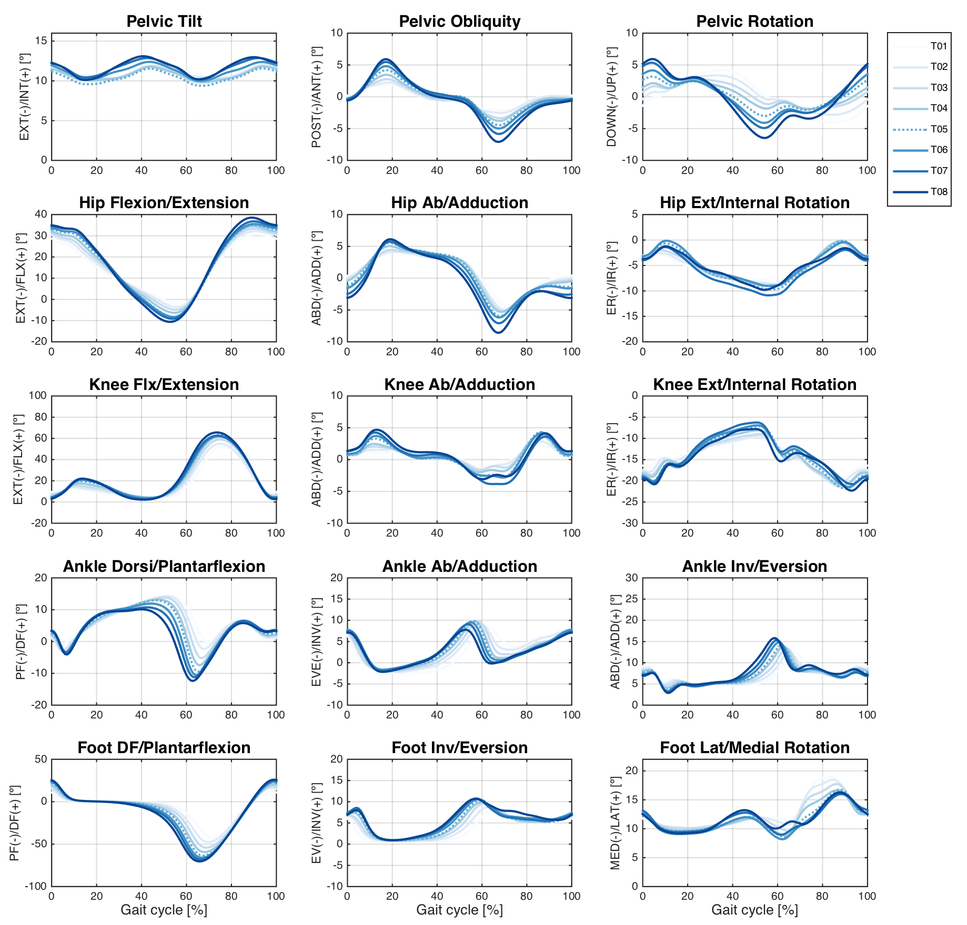
Figure 1. Ensemble average across Older group participants of the pelvis, hip, knee, ankle, and foot angles during the treadmill walking condition. Each waveform represents a walking speed (see legend).
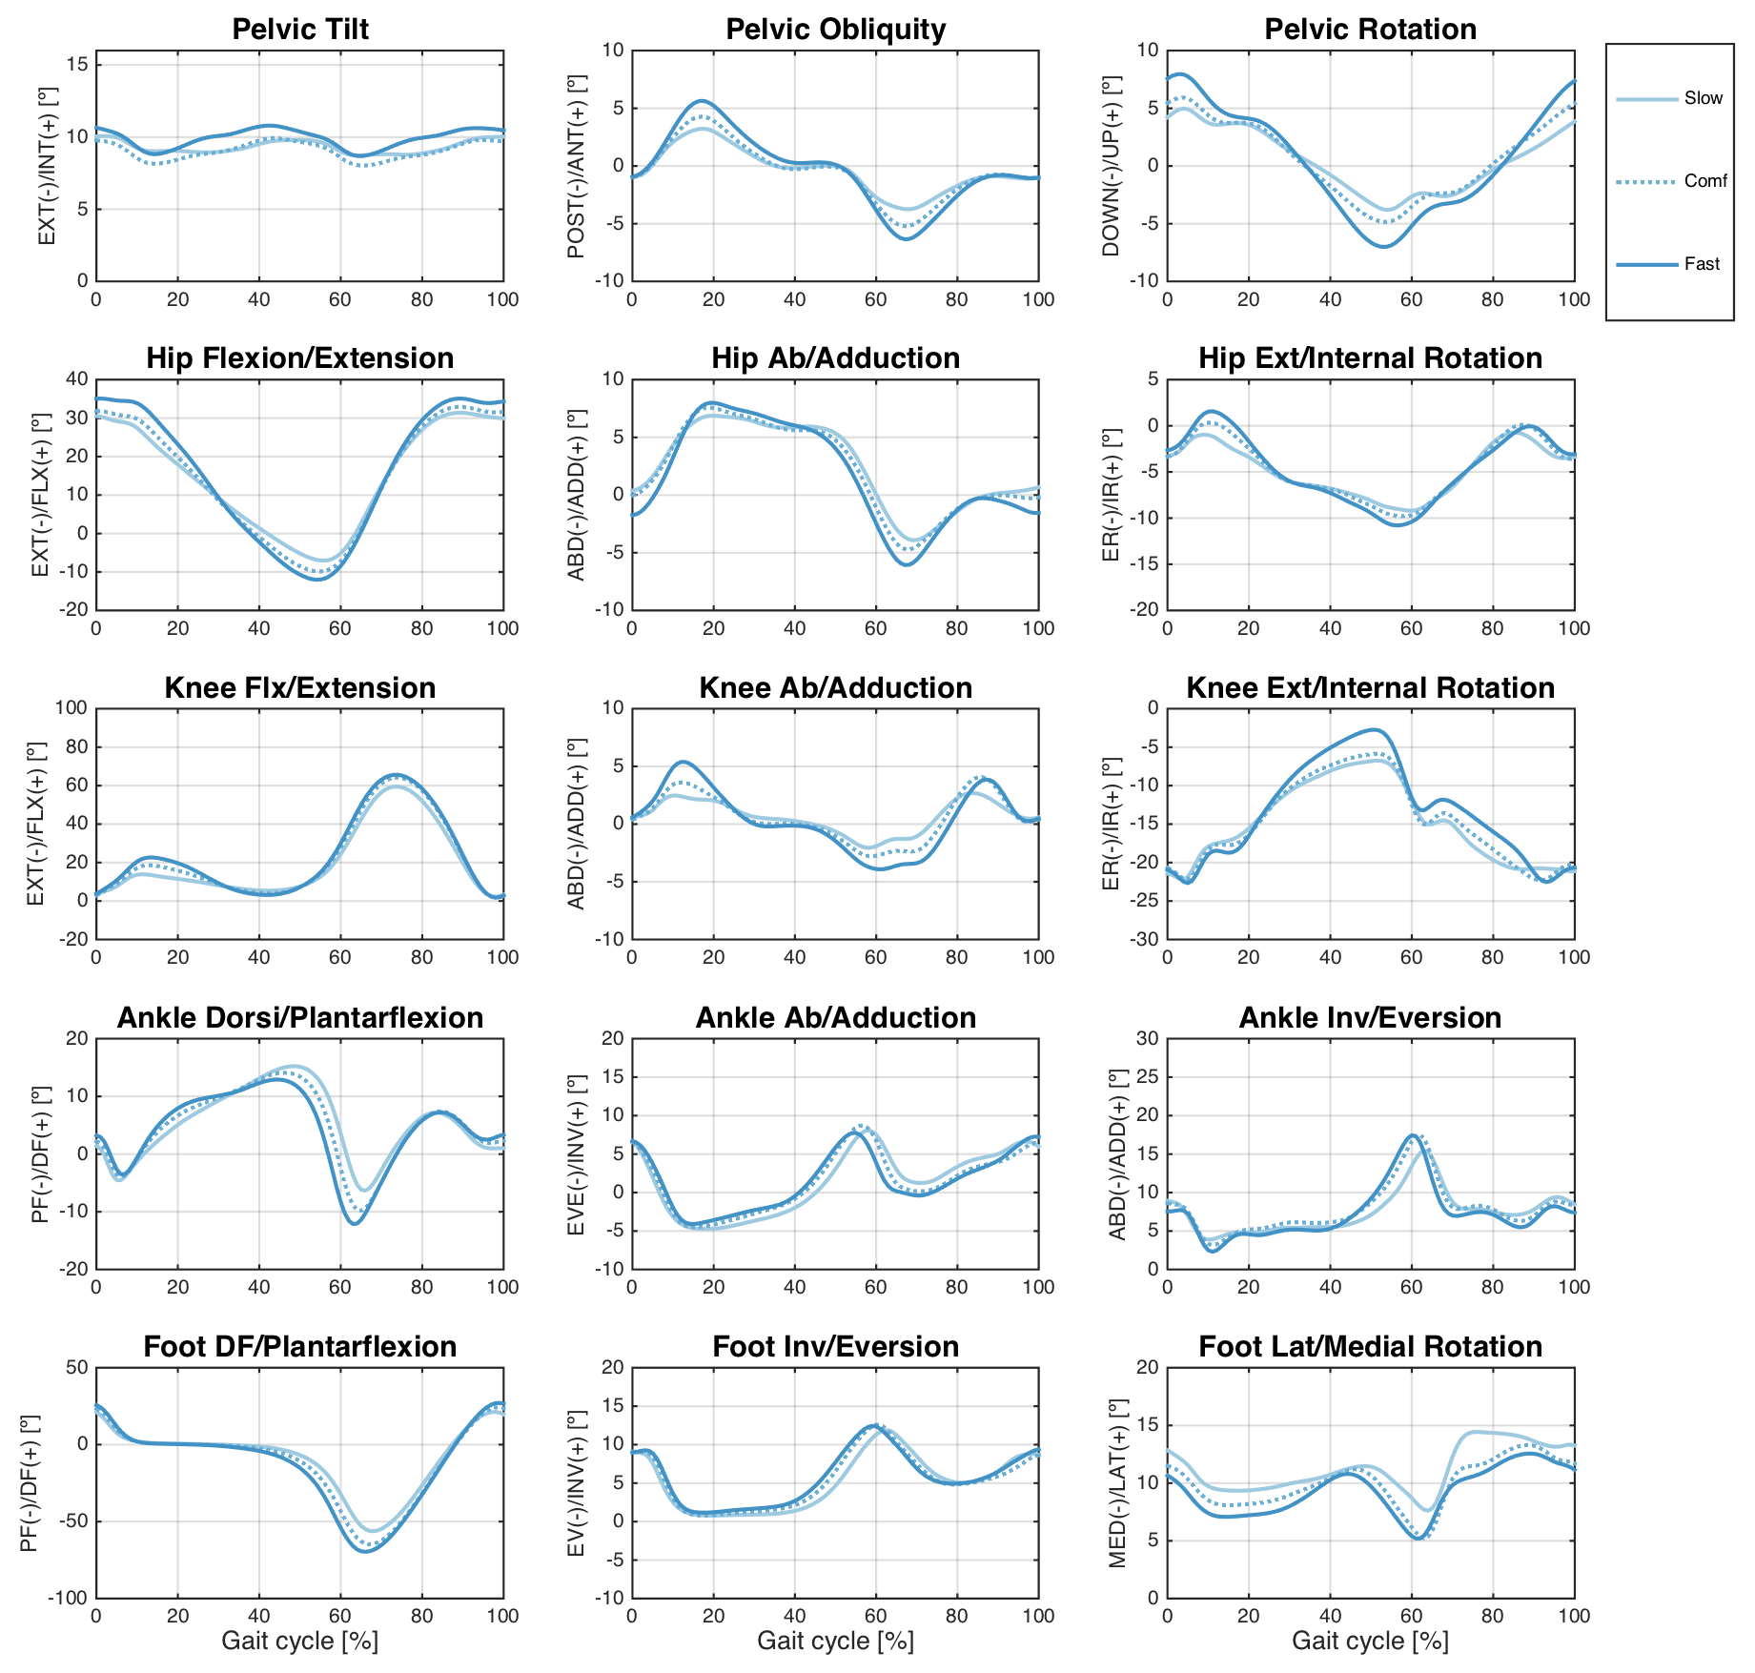
Figure 2. Ensemble average across Older group participants of the pelvis, hip, knee, ankle, and foot angles during the overground walking condition. Each waveform represents a walking speed (see legend).
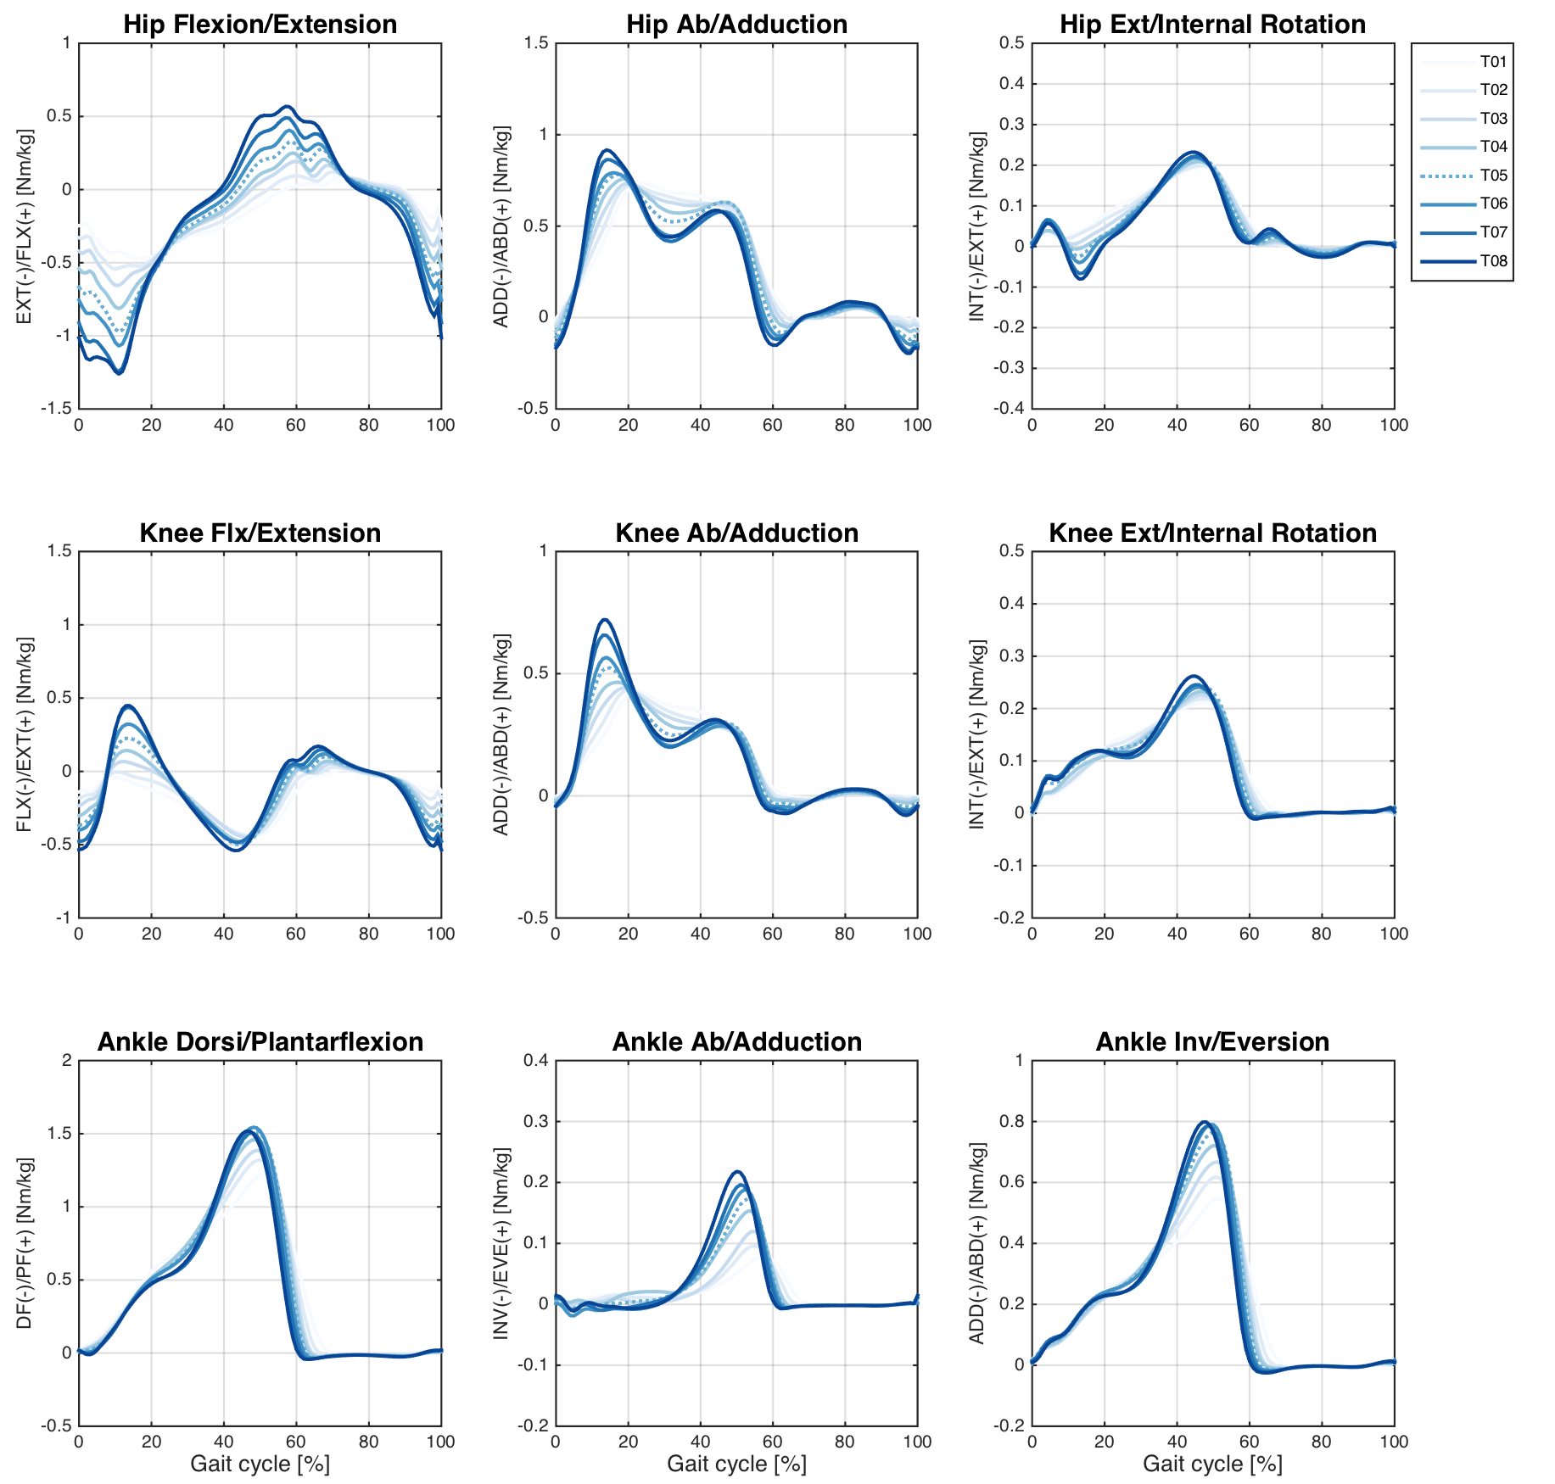
Figure 3. Ensemble average across Older group participants of the hip, knee, and ankle joint moments during the treadmill walking condition. Each waveform represents a walking speed (see legend).
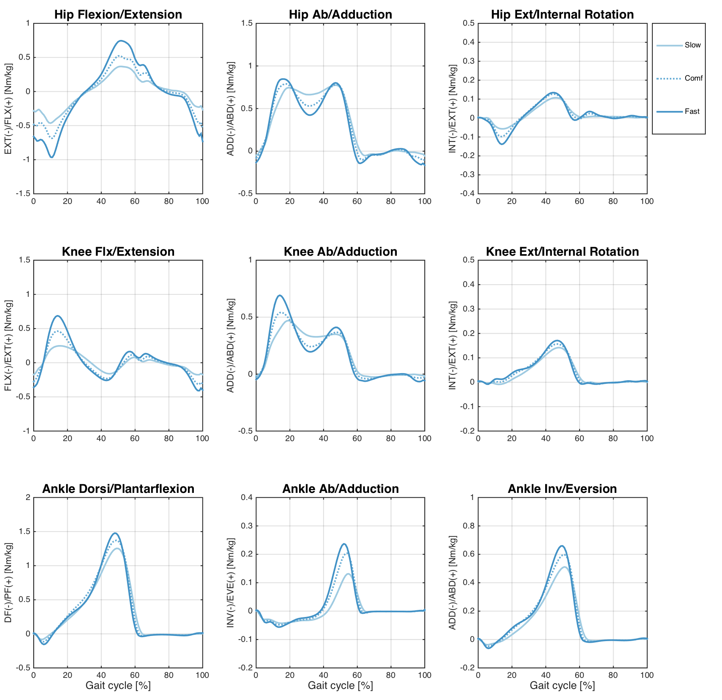
Figure 4. Ensemble average across Older group participants of the hip, knee, and ankle joint moments during the overground walking condition. Each waveform represents a walking speed (see legend).
Figure 5. Ensemble average across Older group participants of the ground reaction force (GRF) on the treadmill (top) and overground (bottom) walking conditions. Each waveform represents a walking speed (see legend).

