











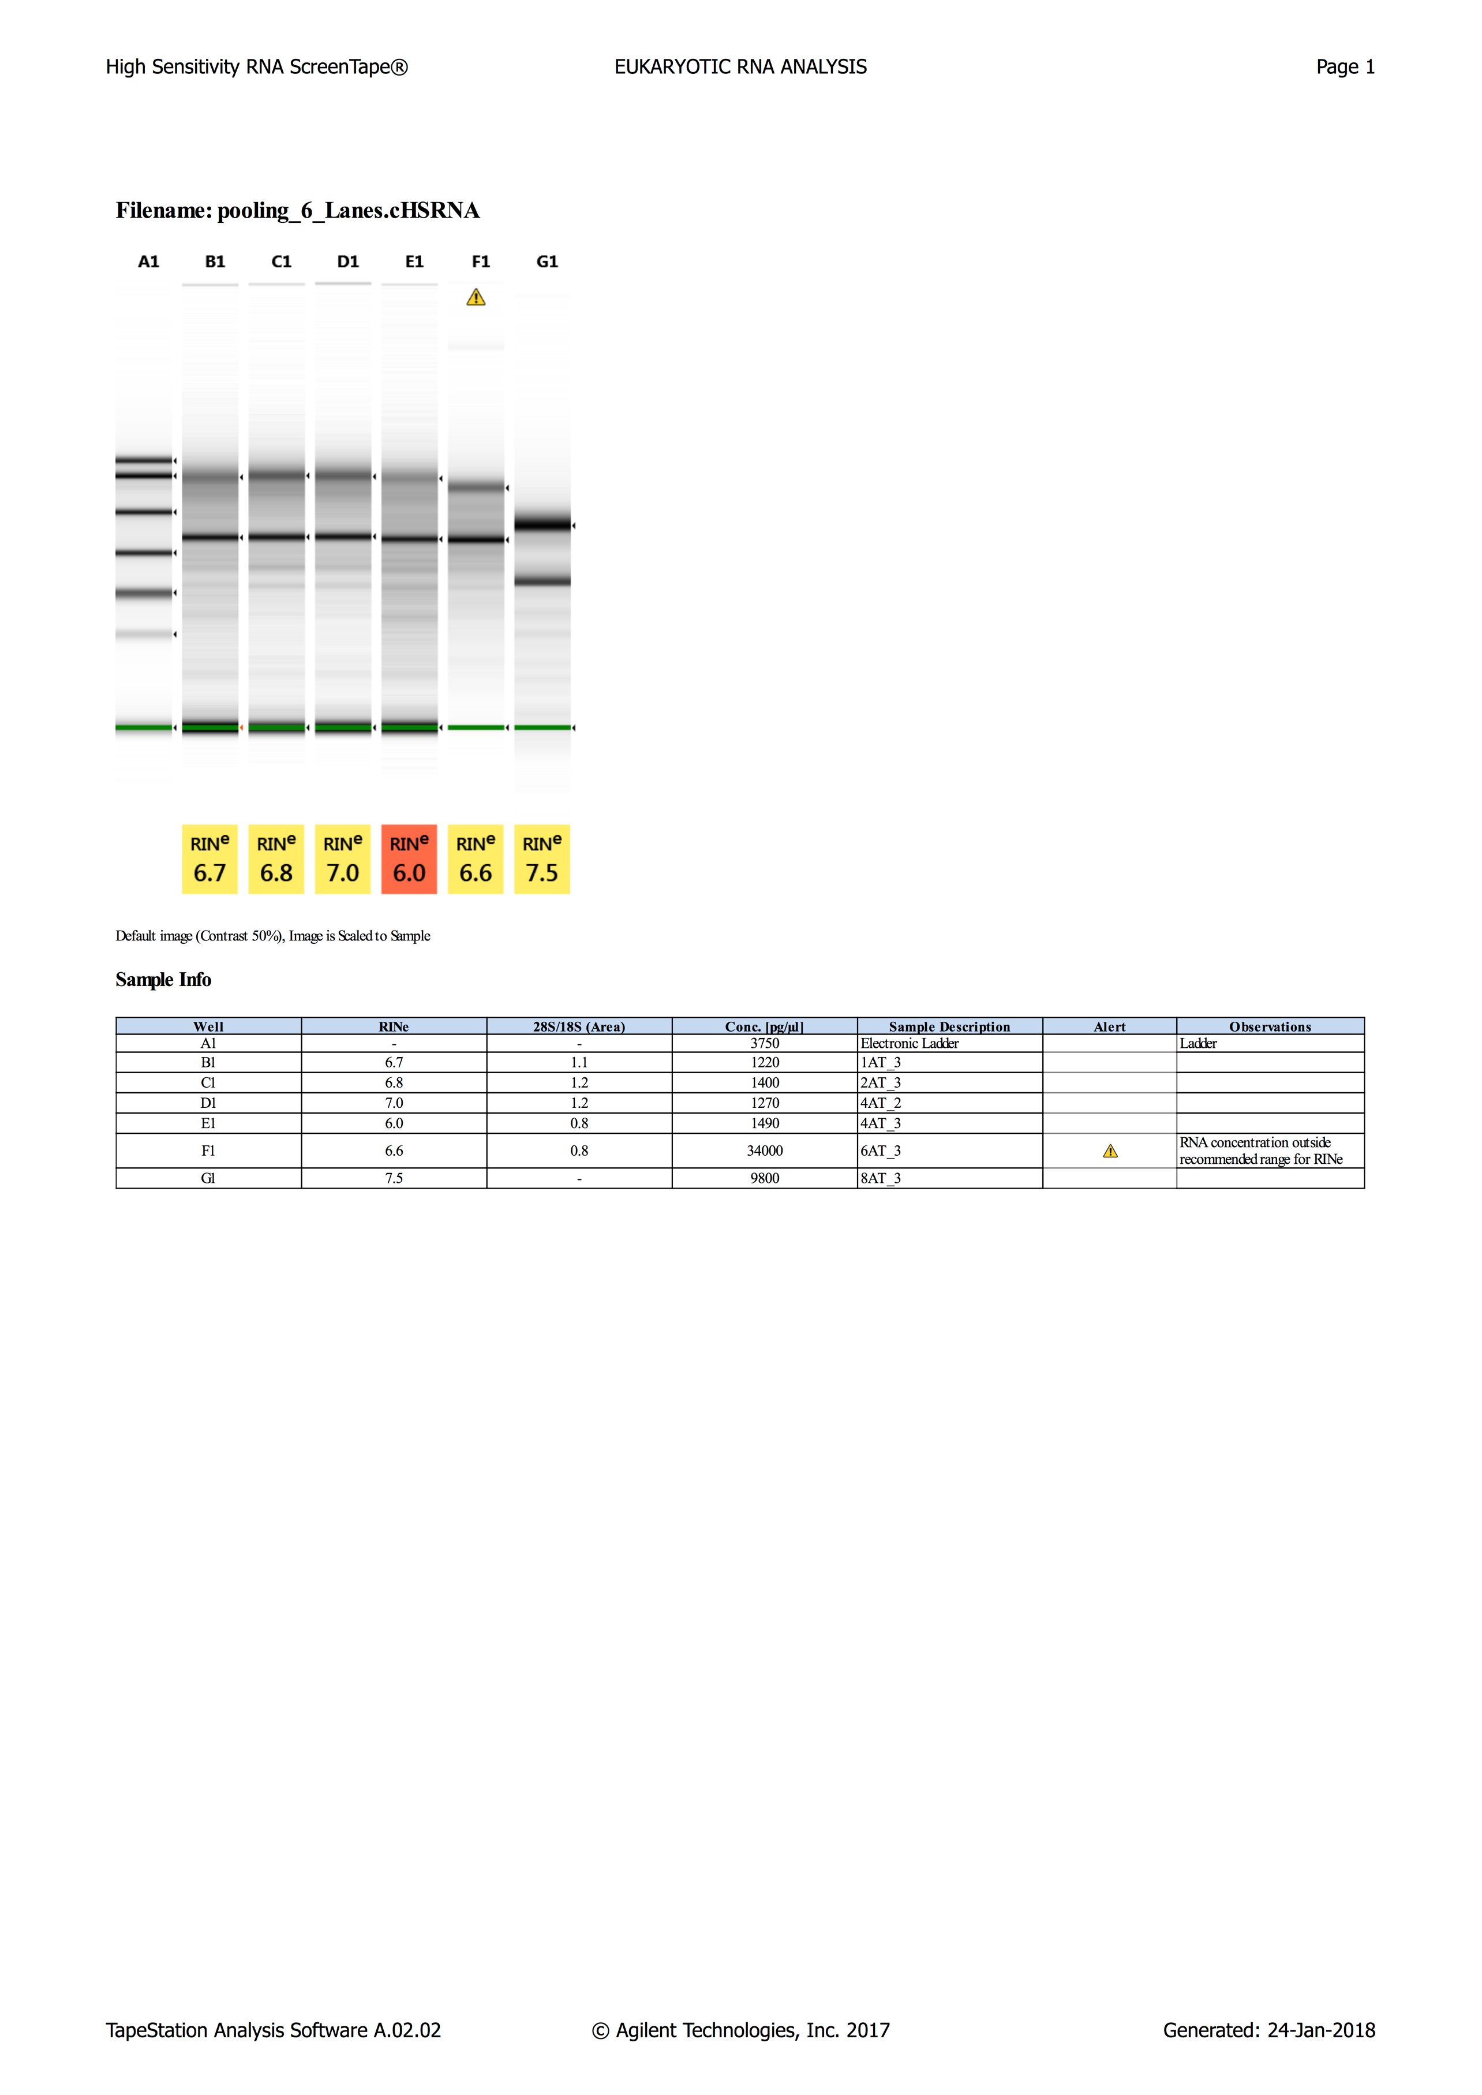

\*run on Agilent TapeStation HighSensitivity RNA screen tape